Now You See It, Now You Dont
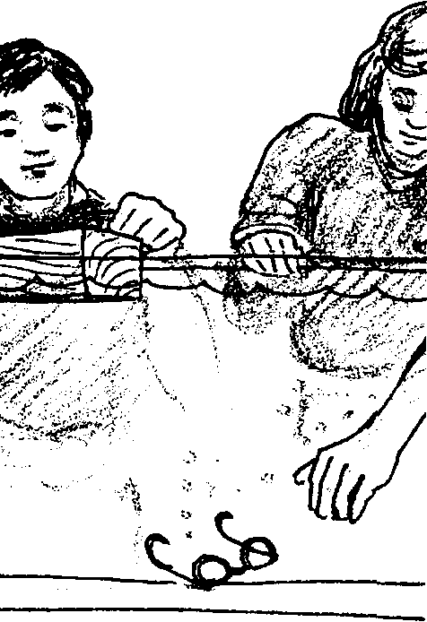

Key Concepts
1. An object floats if the weight of the fluid it displaces equals the weight of the object.
2. An object sinks if the weight of the fluid it displaces is less than the weight of the object.
3. Objects are more buoyant in salt water than in fresh water because salt water is more dense.

Background

It is a mystery to many people why some things float and others sink. An object floats in a fluid only if its weight is less than the weight of an equal volume of the fluid. An object sinks if it weighs more than an equal volume of the fluid. To state this in another way, if the density of the object is less than that of the fluid, the object floats; if the density of the object is greater than that of the fluid, the object sinks.

A floating object sinks deep enough to displace a weight of liquid equal to its own weight. A chicken egg is often used to explore this concept. An “egg amount” of fresh water does not equal the weight of the egg, so the egg will sink. An “egg amount” of the denser salt water will equal the weight of the egg, so the egg floats. In both cases, the volume (an egg amount) of the displaced water is the same but the weight of the water is changed by adding salt.

Materials

For each group of 3-4 students:

• drinking glass or beaker (400 ml.)

• fresh egg

• table salt

• teaspoon

• tap water

• marking pen or tape

• eye dropper

• paper cup (for excess salt water)

Teaching Hints

“Now You See It, Now You Don’t” investigates salt water and buoyancy. This activity introduces the concept of displacement in relation to sinking and floating.

Avoid the temptation to do this activity as a demonstration. Caution students to gently place the egg into the beaker or glass. Groups of two or three are ideal. Be sure to try it first yourself! Water in a few locales has such a high mineral content that the salt tends to form other compounds rather than immediately dissolving. If this is the case, addition of extra salt plus allowing one or two minutes time to pass before adding the egg usually corrects any odd results.

This is an important concept that many students never quite understand. Be sure to go over the questions with the groups at the end of the activity, and probe their understanding. The common student answer to why the egg floats is : “The salt water is more dense, so the egg floats.” Insist on an explanation of WHY making the water more dense allows the egg to float: the water that the egg displaces is now heavier (more dense), and the weight of the displaced water now equals the weight of the egg.

To reinforce understanding, remind the students that water is a fluid, and so is AIR. Ask them to explain why a blimp floats in air: The weight of the air the blimp displaces is greater than the weight of the blimp.

Procedure

1. Begin by asking students if they have ever floated in the ocean, the Great Salt Lake, a river or lake. Which was the easiest? Tell students that today they will be investigating how things float.

2. Distribute the student worksheets and have students complete the investigation on their own or in teams of three to four.

3. When all have finished the investigation and questions, allow time to discuss the results (see Teaching Hints).

Key Words

displace - the volume of a fluid that an object “moved aside” by a floating object

dissolve - to cause to pass into a solution, become a liquid

SCUBA - (Self-Contained Underwater Breathing Apparatus)

(Key Words - cont.)

solution - a homogeneous mixture of two or more substances, retaining its constitution in subdivision to molecular volumes, which shows no settling

volume - the amount of space occupied by an object, expressed in cubic units

Answer Key

Text Questions

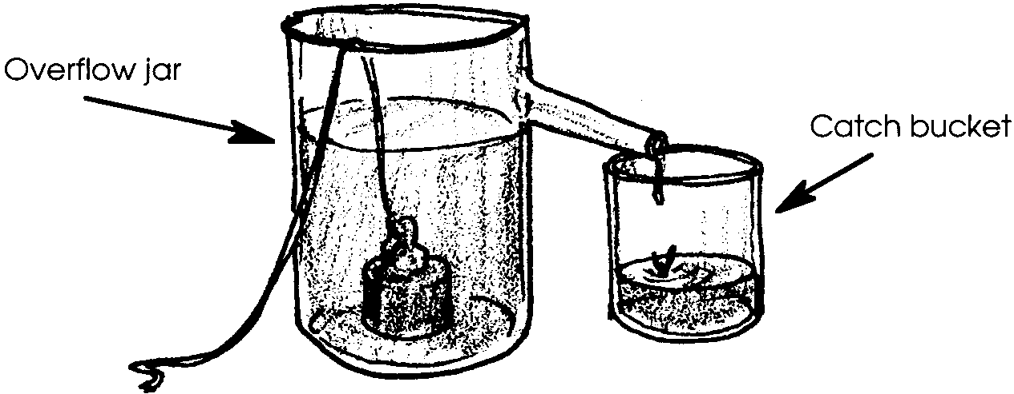
1. Answers will vary. The following is a diagram of one technique.

2. Since the question calls for an opinion, any answer (i.e. equal to, less than, greater than) is acceptable.

3. The water weighs the same as the individual. The answer, then, should be whatever the student’s weight happens to be.

4. Since it sinks, a ten pound cement block must displace less than ten pounds of water.

Analysis and Interpretation

Part I

1. While answers depend upon experimental results, the egg should sink.

2. The water level will rise.

3. The weight of the water displaced by the egg equaled the weight of the egg/was less than the weight of the egg. (The correct answer is underlined).

Part II

1. While answers depend upon experimental results, the egg should float in the salt water solution.

2 a. The water level will rise.

b. The water level of the salt solution should be about the same as the original high water mark.

3. The weight of the water displaced by the egg equaled the weight of the egg/was less than the weight of the egg. (The correct answer is underlined).

4. The weight of the water must have increased.

5 a. The “equal volume of water” from the salt solution weighed the most. While the volume of the water displaced remained equal, the weight of the water changed. Whether the egg floats or not dependent upon the weight (not volume) of the water displaced.

b. The fact that the same volume of salt water weighed more means that the weight of the displaced saltwater was able to equal the weight of the egg, whereas the weight of the displaced fresh water was less than the weight of the egg.

6 a. No, the steel ball bearing would not float; the weight of the water displaced by the ball bearing is not as heavy as the ball bearing itself.

b. A steel-hulled ship is shaped to displace enough water to equal the weight of the ship. A 50,000 ton tanker must displace 50,000 tons of water in order to float.

7. If you were going to dive in salt water, you would need more weight since you are more buoyant. You displace “heavier” water and hence float more easily in salt water - just like the egg.

Now You See It, Now You Don't
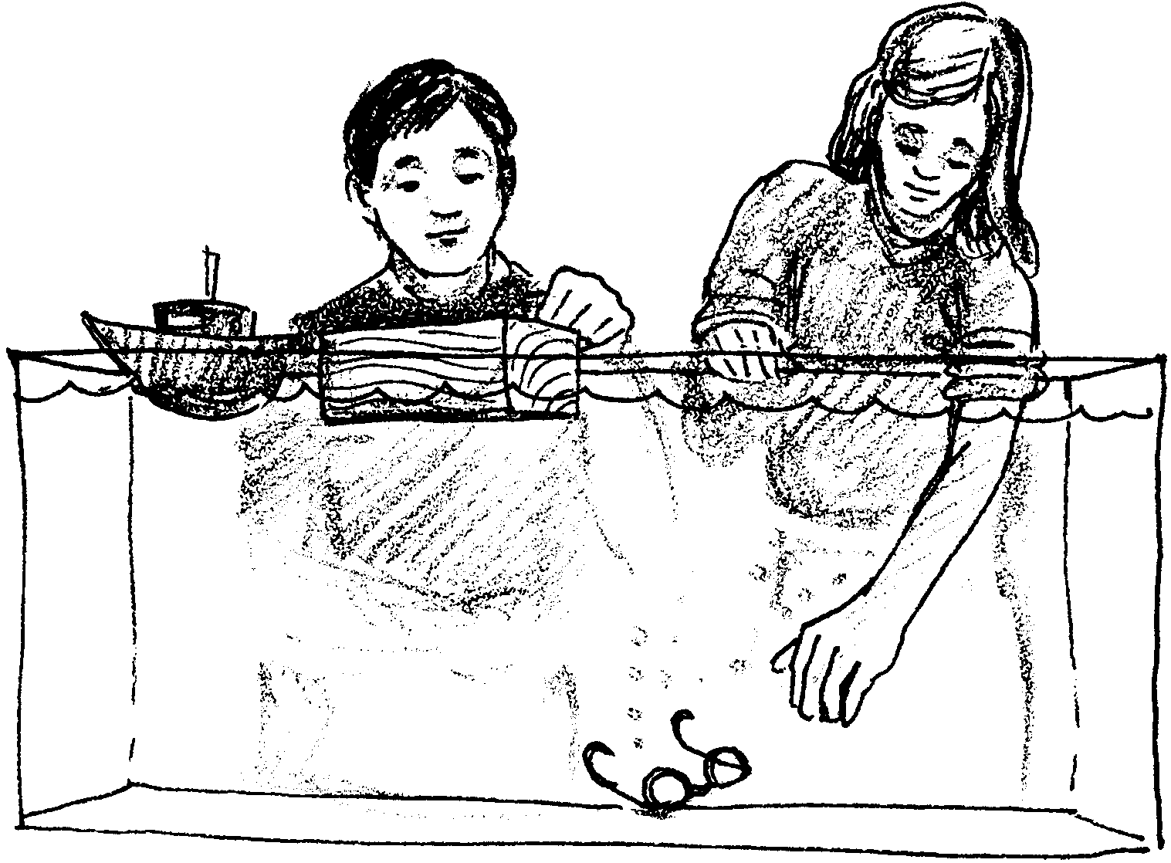

Why do some things float, while others sink? Next time you drop an ice cube into a glass of water, notice what happens to the water level in the glass - the water level rises. When an object is placed in a liquid, the object displaces, or pushes out of the way, some water. The weight of the water pushed out of the way determines whether the object sinks or floats.

Archimedes, an ancient Greek scientist, was interested in why things float also. He tried to float all kinds of things. He weighed the water displaced (pushed out of the way) by each of the objects.

1. What is one way Archimedes might have collected and weighed the water displaced by an object?

Archimedes also weighed all of the objects he had tested.

2. Before you read on, how do you think the weight of an object that floats compares to the weight of the water it pushes out of the way?

Wonder of wonders, Archimedes found that the weight of the water displaced by the floating object equals the weight of the object.
3. When you float in the water, how much does the water weigh that you are displacing?

Well, what about those objects that sink? Archimedes found that an object sinks if the weight of the water displaced by the object is less than the weight of the object.

4. A ten pound cement block dropped into a lake goes straight to the bottom. The block must displace less than pounds of water.

From past experience you probably have a good idea of which things float and which sink. Does an object always behave the same way in all liquids? Let’s explore this question.

Materials
• drinking glass or beaker (400 ml.)
• fresh egg
• table salt (sodium chloride)
• teaspoon
• tap water
• marking pen or tape
• eye dropper
• paper cup (for excess salt water)

Part I

Procedure:

1. Fill the drinking glass with tap water until it is about 2/3 full.

2. Make a marking pen line on the glass or beaker to show the water level.

3. Carefully lower the egg into the water, using the teaspoon.

Analysis and Interpretation

1. What happened to the egg when you lowered it into the water?

2. What happened to the water level in the glass?

3. The weight of the water displaced by the egg equaled the weight of the egg / was less than the weight of the egg.

Circle the correct choice. (Hint: Reread what Archimedes found out from
his tests.)

Part II

In this part, you will explore the egg’s behavior in a different liquid.

Procedure:

1. Carefully remove the egg from the glass.

2. Check your original water level line. The water level should match the line. If not, add water as needed.

3. Add five heaping (very full) teaspoons of salt to the water.

4. Check the water level. Use an eye dropper to remove water until your original water level line is reached.

5. Stir the water until the salt is dissolved, or thoroughly mixed.

6. Carefully lower the egg into the water.

Analysis and Interpretation

1. What happened to the egg when you lowered it into the salt water solution?

2 a. What happened to the water level?

b. Find the mark you made to show the change in water level when you added the egg to fresh water. How does the present water level compare with your mark?

3. The weight of the water displaced by the egg equaled the weight of the egg / was less than the weight of the egg.

Circle the correct choice. (Hint: Again reread what Archimedes found out from his tests.)

4. We can assume that the weight of the egg did not change during the course of the experiment. What, then, must have happened to the weight of the water displaced to cause the results you observed?

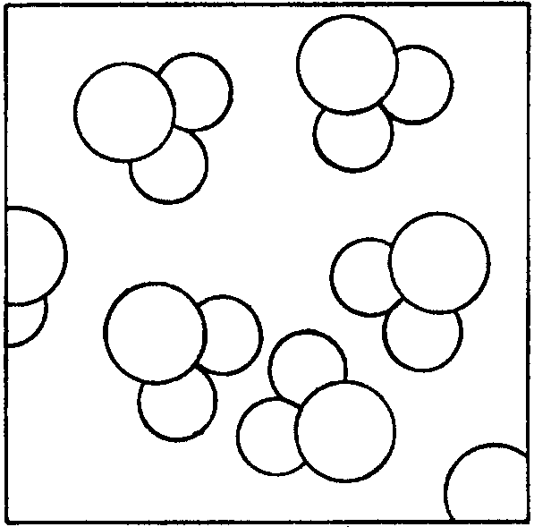

When we look at a glass of water, water seems to be pretty “solid”. If we had super powerful eyes, we would see that water is made up of tiny particles called molecules. We would also see that the molecules have lots of space between them. Water might look something like this:

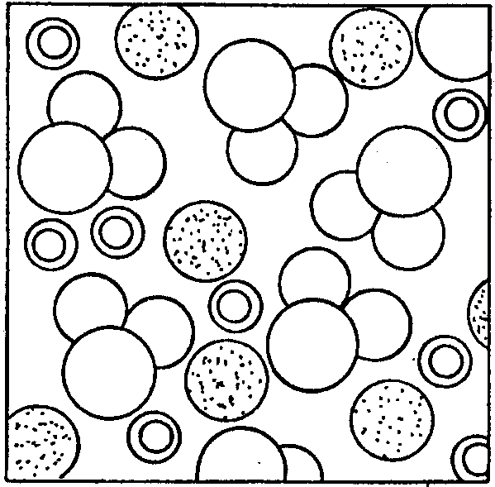
When salt dissolves in water, the atoms which form the salt “squeeze” in between water molecules. They can squeeze in so well they hardly change the volume, or amount, of the water. Water with dissolved salt might look something like this:

A liter of salt water, then, weighs more than a liter of fresh water.

5 a. The egg displaced about the same volume of water in fresh water and in salt water. Which of the two equal amounts of water, salt or fresh, weighed the most?

b. How does this piece of information explain why the egg behaved differently in the two solutions?

6 a. If you dropped a steel ball bearing into the beaker of salt water, would it float?

b. How, then, can huge steel-hulled cargo ships float?

7. SCUBA divers wear weight belts to help them to stay underwater. If you were going to dive in salt water, would you need more or less weight than you would need in fresh water? Explain your answer.

