Glowing in the Dark: Bioluminescence
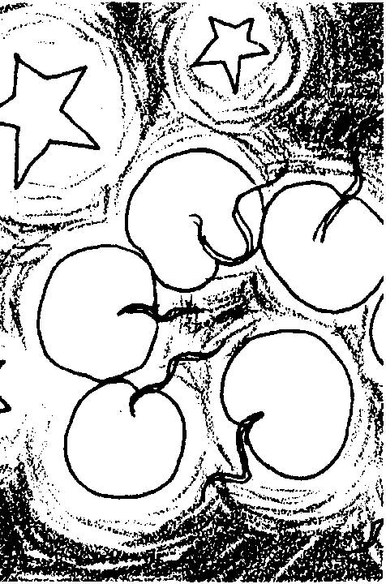

Key Concepts
1. Bioluminescence, the ability of an organism to produce light, is a special adaptation found in many deep sea organisms which helps them survive in their habitat.
2. Bioluminescence can be used to attract, distract, communicate, or conceal a deep sea animal.

Background

Eighty five percent of the species and ninety percent of the individual animals living in the deep sea have the ability to produce bioluminescent light. Just like coloration strategies for animals living on land, bioluminescence is used by the deep sea organisms to attract, distract, communicate, or conceal.

Bioluminescent fish have two ways to produce “living light.” In each case, the fish have small spots on their bodies called photophores. One group of fish have special photogenic cells which produce light. These fish can turn the photophores on and off by controlling the blood flow to the area.

Other fish have developed a symbiotic relationship with bioluminescent bacteria. When the fish is very young, it has pores or openings through which water can flow. Naturally occurring Vibrio photobacteria get trapped in these pores where they can live quite comfortably. Both the fish and bacteria benefit from their symbiotic relationship. The fish uses the bioluminescence to help it find food and mates. Everything the bacteria needs to survive, food and oxygen, is delivered by the fish’s blood system. The blood system removes the bacteria’s wastes. The photobacteria bioluminesce continually. To turn the photophores on and off, these fish tighten muscles surrounding the photophore so the light cannot escape.

Bioluminescence gives off no heat. It is the result of a chemical reaction between luciferin and an enzyme called luciferase.

Materials

• small flashlights or penlights for each student

• one free-standing lamp with a 25-watt light bulb
Teaching Hints

In “Glowing in the Dark - Bioluminescence”, your students simulate the effects of bioluminescence on communication and concealment. Since the effects of the simulation are more visible and more dramatic if students are wearing dark clothing, suggest on the day prior to this activity that students wear dark clothing the next day.

1. For the simulation activities in steps 1 to 3, divide the class into a “movement group” and a “mapping group”.

2. After step 3, have students in the two groups switch roles and repeat steps 1-3.

3. Step 4 requires re-grouping the students into four groups. Each group will be given a light “flash pattern”. Groups will separate in the dark room and try to re-group using these patterns. Any “flash patterns” can be used for step 4 of this activity. To simplify the process, however, you may choose to have students repeat a steady 4-count, turning their lights on and off according to one of the following counts:

1 2 3 4
on - on - on off
on off on off
on - on off - off
on off - off - off

You may wish to have students practice all four rhythms before assigning a “flash pattern” for the activity to each of the four groups. For ease in determining the success of the re-grouping, give each group the name of a deep sea fish.

4. If dark rooms sufficiently large to accommodate your class are not available, you may elect to have a few students carry out the activities; have them videotaped; then share the tape with the rest of the class.

Key Words

adaptation - a structure or behavior that helps the animal survive

appendage - subordinate body parts attached to the main body; tails, fins, legs, etc.

bioluminescence - the ability some animals have to produce their own light

lateral line - a row of sense organs on the sides of fishes

photophore - a cup shaped light organ on some deep sea animals

Extensions

1. Try crushing wintergreen lifesavers as a simulation of bioluminescence. When candy is crushed, nitrogen, that adheres to the sucrose crystals, is released as the sugar crystal breaks. The nitrogen released is in a high-energy state and emits small amounts of light. The light emission is stronger in the presence of oil of wintergreen.

2. Freeze-dried sea fireflies (Cypridina hilgendorfii) are available from biological supply companies such as:

Carolina Biological Supply Co
2700 York Road
Burlington, NC 27215
Telephone: 1- 800-334-5551
(order #20-3431)

Here’s how to use the flies: darken the room and give each student 4-5 dead sea fireflies to hold in the palm of her/his hand. Using an index finger, have the student crush the fireflies and then add a few drops of water to the crushed sea fireflies. As the water and crushed fireflies are stirred, a bioluminescent glow is released.

3. Have students conduct research into coloration patterns of various land animals. They can analyze the patterns to determine whether the pattern attracts, distracts, communicates, or conceals.

4. Have students match signalling patterns, but this time, place a few “predatory students” in the center of the room. The schools try to match up without being caught by predators. If a dark room is not available, all participants can wear gauzy blindfolds which restrict their vision.

5. Have students create and test their own bioluminescent patterns.

6. Have students add bioluminescent photophores to the fish they drew in the Simulated Light Activity.
Answer Key

Procedure Questions

1 a. Answers will vary depending upon experimental results.

2 a. Answers will vary depending upon experimental results. Generally, “fish” on the opposite side of the bright light are difficult to see.

2 b. Answers will vary depending upon experimental results. Generally, “fish” between the observer and the bright light are easier to see.

3 a. Answers will vary depending upon experimental results but if the room is really dark, having the lights extinguished generally increases the difficulty.

3 b. Answers will vary depending upon experimental results.

4 a., b., c. Answers will vary depending upon experimental results.

Analysis and Interpretation

1 a. Step 4 simulates the use of bioluminescence for communication.

1 b. Answers will vary depending upon experimental results.

1 c. A disadvantage of bioluminescence is that it may attract predators.

1 d. An advantage of bioluminescence is that it assists individuals in finding members of the same species, perhaps for mating or schooling (animals are better protected when swimming in a school).

2 a. All steps illustrate the use of bioluminescence for attraction.

2 b. Answers will vary depending upon experimental results.

2 c. The disadvantage of bioluminescence is that it may attract predators as well as prey.

2 d. Bioluminescence lets animals find each other in the otherwise total darkness of the deep sea.

3 a. Step 3 illustrates the use of bioluminescence for distraction.

3 b. Answers will vary depending upon experimental results.

3 c. In the case of collarbone jelly fish and others, a disadvantage to using bioluminescence for distraction is that the organism may lose some of its body parts.

3 d. Distraction increases the animal’s chance of escaping predators.

Glowing in the Dark: Bioluminescence
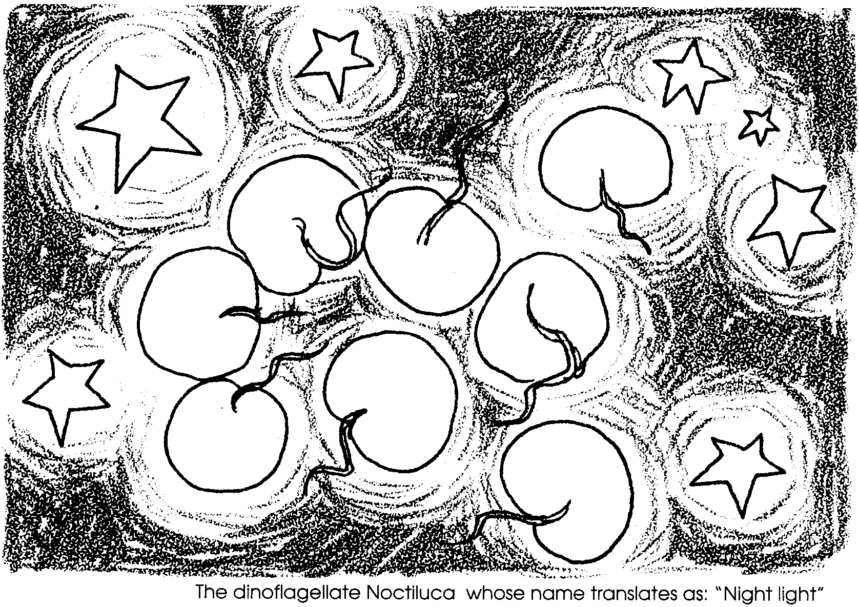

Even in the clearest ocean water, sunlight can reach only to a depth of about 200 meters. Below that, animals are in complete darkness. Animals have evolved many adaptations to survive in this habitat. Many animals produce their own light. This living light, or bioluminescence, is used by deep sea animals in different ways.

For example, the angler fish, has a bioluminescent “lure”. The “lure” dangles quite close to its sharp teeth. Unsuspecting fish are attracted to the lure. The angler fish quickly opens its mouth and dinner is served.

The lanternfish has glowing dots (photophores) along its sides. These photophores are in special patterns. The patterns help the lanternfish find others of its own kind. The patterns also helps it find members of the opposite sex.

The hatchetfish has photophores on its belly. The light helps hide the fish’s outline. When a predator looks up at the hatchetfish, it sees light. The hatchetfish is almost invisible.

Some jelly fish use bioluminescence to distract predators. The colobonema jelly can pulse its tentacles blue and red. When a predator appears, the jelly fish increase light output. Then, in an instant, it separates its lighted tentacles. The jelly fish swims off in another direction. The predator is left with some stringy tentacles. The jelly is free.

Ninety percent of the animals living in the deep sea can make this living light.

Materials

• small flashlights or penlights

Procedures:

“Glowing in the Dark” simulates the effects of bioluminescence. The class will be divided into groups. The activities will be directed by your teacher.

1. For the first activity, you will divided into a “movement group” and a “mapping group”. As directed, go into a darkened room. Allow your eyes to get used to the dark.

If you are in the “movement group”, turn on your penlight. Move around the room.

If you are in the “mapping group”, select one student. Map his or her movements.

a. What made this activity difficult?

b. What made it easy?

2. Allow your eyes to remain adjusted to the darkness. Repeat step 1 with this change. Your teacher will turn on one bright light in the center of the room.

If you are in the “movement group”, turn on your penlight. Move around the room again.

If you are in the “mapping group”, select one student. Map his or her movements.

a. What made this activity more difficult than step 1?

b. What made it easier?

3. Your teacher will turn off the light. Let your eyes get used to the darkness.

If you are in the “movement group”, your teacher will give you a pattern to flash. Flash your penlight on and off as you move around the room. Stop and start irregularly. One at a time, each person in your group will put his or her light down and move away.

If you are in the “mapping group”, you map their movements.

a. What made this activity more difficult than step 1?

b. What made it easier?

4. Switch roles and repeat steps 1 to 3.

5. Your teacher will now divide the class into four groups. You will receive a “flash pattern” from your teacher. Once again, go into a dark room. Let your eyes get used to the darkness. Walk away from your other group members. When your teacher gives the signal, turn your flashlight on and off according to the pattern. Try to find the rest of your group by matching the patterns.

a. How successful were you in finding your other group members?

b. What made it easy?

c. What made it difficult?

Analysis and Interpretation

1 a. Which of the activities simulates the use of bioluminescence for communication?

b. Did the method seem effective?

c. What would be some disadvantages for the fish using bioluminescence in this way.

d. What would be some of the advantages?

2. Which of the activities simulates the use of bioluminescence for attraction?

b. Did the method seem effective?

c. What would be some disadvantages for the fish using bioluminescence in this way?

d. What would be some of the advantages?

3 a. Which of the activities simulates the use of bioluminescence for distraction?

b. Did the method seem effective?

c. What would be some disadvantages for the fish using bioluminescence in this way?

d. What would be some of the advantages?

