Analysis of Animal Adaptations

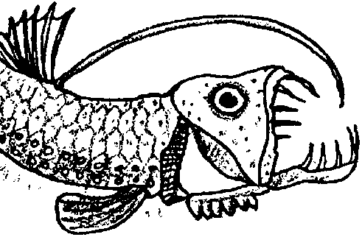
Key Concept
1. Deep sea animals have special adaptations which help them survive in their habitat.

Background

Much of what was collected in the trawls and bottom grabs reinforced our earlier assumptions about life in the deep sea. Many things that actually did survive under such immense pressure in a very cold, completely dark environment, with practically nothing to eat, were very strange indeed.

Deep sea animals have many physical adaptations which help them survive in an otherwise inhospitable environment. Adaptations may include structural variations of the fin, mouth, gut, body; special appendages; distinctive coloration patterns; variation or absence of sensory organs; presence or absence of bioluminescent patterns.

Materials

For each student:

• set of deep sea animal picture cards

• adaptation data sheet

• dice

• drawing paper

• markers

Teaching Hints

In Part I of “Analysis of Animal Adaptations”, your students analyze pictures of deep sea creatures to determine their special adaptations. In Part II, students create a new deep sea creature using their data sheets from Part I.

Key Word

adaptation - a structure or behavior that helps the animal survive

Extensions

1. Have students enter the adaptation information in a data base and sort according to various criteria.

2. Have students conduct additional research to find out about other oceanic fishes.

3. Have students use a grid to enlarge or reduce the animals on the picture cards to actual size. They may then wish to color and cut out their pictures to be used as part of a deep sea bulletin board.

4. Students can assume the role of a deep sea fish or an underwater reporter. The “reporter” can then interview the “fish”.

5. Have students use Venn diagrams to sort and categorize deep sea organisms.

Answer Key

1-2. Answers will vary depending upon the adaptations of the new fish.

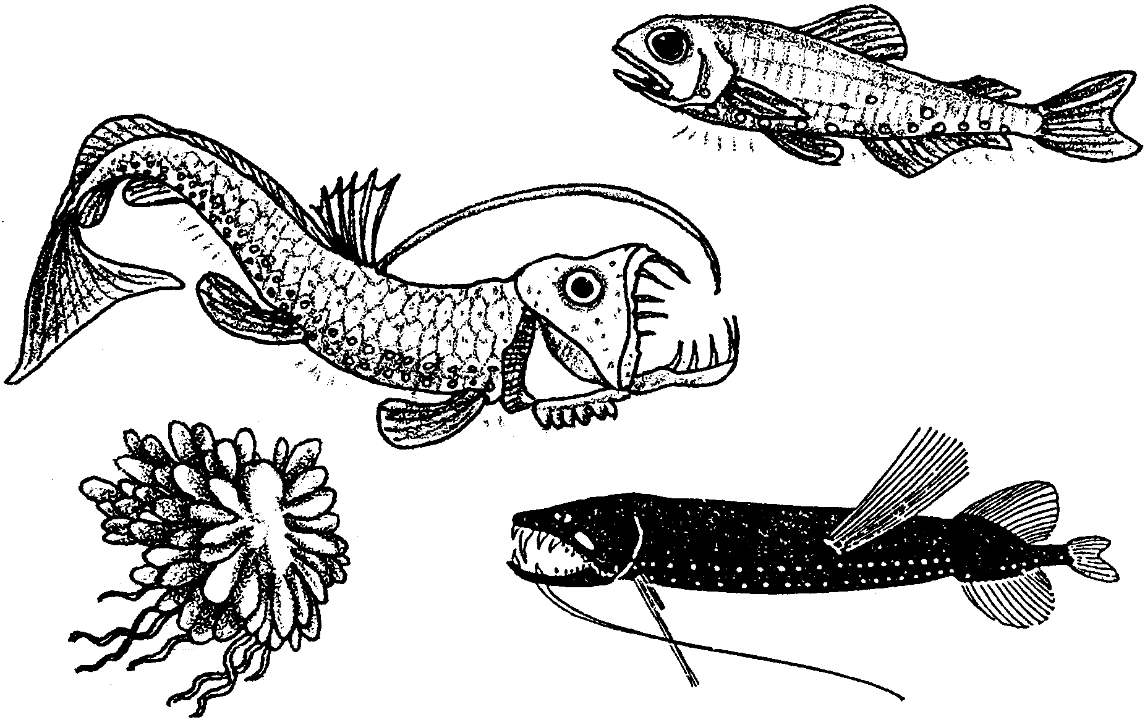
Analysis of Animal Adaptations

To observe animals of the deep sea, we put out trawls and took bottom samples. What we found matched our earlier guesses. Animals that could survive under great pressure in the cold and dark with little to eat, were very strange indeed.

Even the common names that we gave to the deep sea fish were strange: lantern fish, eelpout, spookfish, file tail cat shark, rattail, blobfish, gulper eel, hatchetfish, pacific viperfish, anglerfish, and snipe eel.

In the following activities, you will have a chance to learn about these interesting animals.

Materials
• deep sea animal picture cards
• adaptation Data Sheet
• dice, pair
• drawing paper
• markers

Procedure

Part OneAnalysis of Deep Sea Fish Adaptations

In Part I, you will study pictures of deep sea creatures. As you do, look for their special adaptations.

1. Examine the pictures of the deep sea fish.

2. Obtain a data sheet. Describe the adaptations shown by each fish.
For example, look at the mouth.
It may:
point upward, as in the hatchetfish
be oversized, as in the viperfish
be beak-shaped, as in the snipe eel

You may not know these words:

photophore - a cup shaped light organ on some deep sea animals

lateral line - a row of sense organs on the sides of fishes

appendage - body parts attached to the main body; tails, fins, legs, etc.

3. Record your findings for each fish in the data sheet.

Part TwoA new species of Deep Sea Fish

In Part II, you will create a new deep sea creature using you data sheet from Part I.

1. Be sure your data sheet is complete. Get a pair of dice from your teacher.

2. Use the dice to determine the adaptations for your new fish.Here's how:
a. Roll the dice once.
b. Add the amounts shown by both dice.
c. The first roll of the dice determines the type of mouth your fish will have:

If your total is: 2 use the adaptation of the viperfish
3 use the adaptation of the hatchetfish
4 use the adaptation of the snipe eel
5 use the adaptation of the eelpout
(cont. on next page)
6 use the adaptation of the gulper eel
7 use the adaptation of the tripodfish
8 use the adaptation of the lanternfish
9 use the adaptation of the anglerfish
10, 11, or 12 free choice

Circle the results on your data sheet to keep track.

3. The second roll of the dice determines the teeth for your new fish. Use the number table above.

4. The third roll determines the size. Repeat rolling the dice until you have determined each of the adaptations of your new fish.

5. Draw and name your new fish. Share your illustrations with the class.

Analysis and Interpretation

1. The adaptations you've listed help fish survive in the deep sea.
a. Which adaptations would help them survive if they moved to shallow waters?

b. Which adaptations would reduce their chances of survival if they moved to shallow waters?

2. Look at your newly created deep sea fish. Look at the fish that really live in the deep sea. How do they compare?



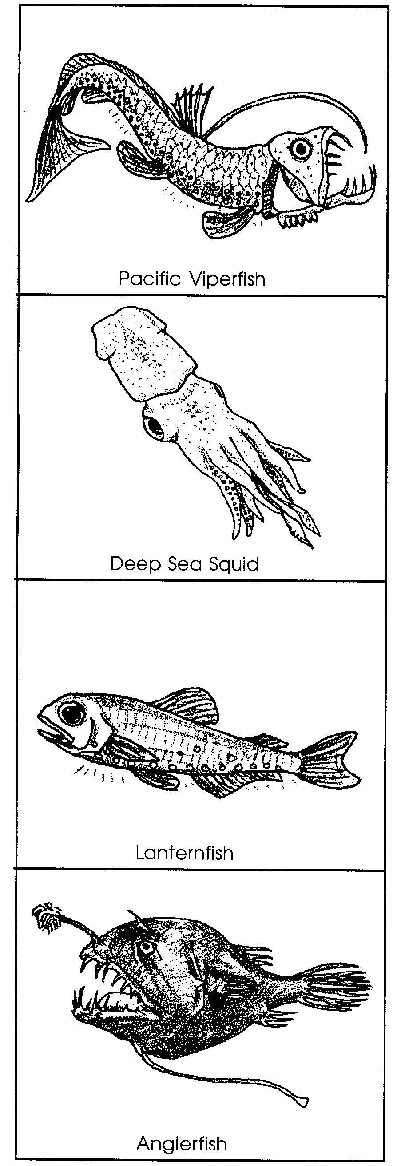
Pacific Viperfish
The Pacific viperfish feeds on lanternfish and squid. It has a very large mouth and fang-like teeth. Once the viperfish catches something, it won't get away. Its size ranges from 22-30 cm. Notice the two rows of photophores. Look at the long, thin ray on the back (dorsal) fin. How might the ray help attract a tasty meal?

Deep Sea Squid
This squid can grow to 30 cm in length. Its photophores adjust to match the ocean twilight. It can move very quickly forward or backward. The two longest tentacles grab and hold its prey. The smaller tentacles move the prey to its mouth. The eyes are of different sizes. Scientists don't know why. Do you have any ideas?

Lanternfish
The lanternfish is very common in the deep water. It lives where there is some light. It has very large eyes. The lanternfish swims up and down every day. It stays in the deep water during the day. It moves closer to the surface at night. Scientists think lanternfish may move like this to feed. They are not sure. Its photophores may help it find and communicate with other lanternfish. It grows to about 13cm in length.

Anglerfish
The anglerfish can grow to 10 cm in length. It has an appendage that looks like a fishing pole and lure. The "lure" is a large photophore. It may help attract prey. It is hard to find and keep mates in the deep sea. The anglerfish has a solution. The adult male anglerfish attaches himself to the female by biting on to her. Once attached, his body becomes part of hers. They mate for life.

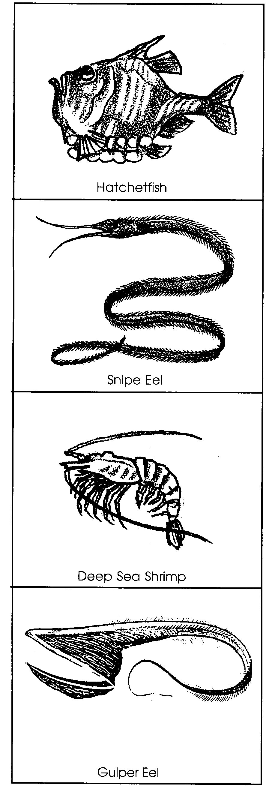
Hatchetfish
The small hatchetfish (to 6 cm) has upward facing eyes. They allow it to see its food in the dimly lit waters above. Once food is spotted, the hatchetfish makes a couple of quick strokes. Then its upward facing mouth can grab its prey. The hatchetfish has photophores on the bottom side. The light helps hide its outline. Other fish swimming below the hatchetfish see the light and not the hatchetfish's silhouette. This kind of coloring is called countershading.

Snipe Eel
The snipe eel grows to 140 cm in length. It is among the biggest deep sea fish. It has a very long beak-like mouth. The mouth has bristles along the edges. For a long time scientists wondered how the snipe eel used these bristles. Finally, they observed the snipe eel feeding. The snipe eel waves its head back and forth in the water. The bristles act like Velcro to snag deep sea shrimp by the antennae.

Deep Sea Shrimp
The bright red Deep Sea Shrimp is only 4 cm long. It seems much longer because of its very long antennae. These antennae may sense different chemicals in the water. The chemicals help the shrimp find food and mates. They may also help it avoid predators. The Deep Sea Shrimp has red photophores on its underside. The photophores countershade the shrimp.

Gulper Eel
The gulper eel has a very large mouth. It also has a stomach that can stretch. This lets the gulper eel eat prey equal to itself in size. The gulper eel can grow to 76 cm. Most gulper eels are about 40 cm long.

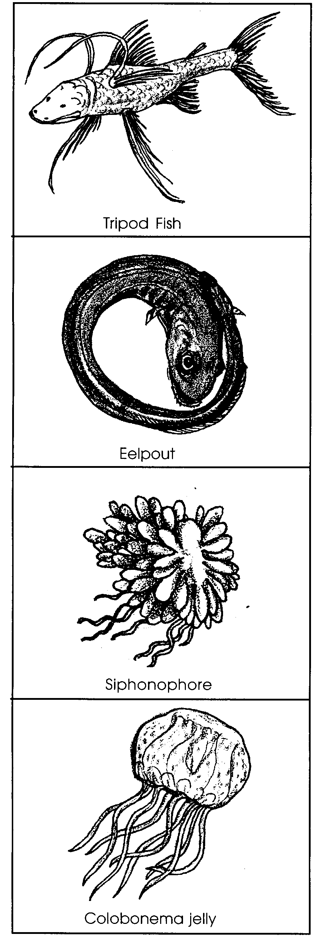
Tripod Fish
The dull brown tripod fish lives on the ocean floor. The pelvic fins are very long, about half the length of these fish which can grow to 29 cm. The pelvic fins and long tail help the tripod fish skim along the ocean floor. Tripod fish eat tiny animals (zooplankton). Threads on the fins sense the zooplankton in the water when they brush into the fins.

Eelpout
The translucent eelpout is a common deep water fish. It has a very uncommon behavior. When this fish is startled, it rolls up into a donut shape. Scientists wonder how this helps them survive. Some think it makes the eelpout look like a stinging jellyfish. The eelpout grows to 18 cm. It eats any animal it can fit into its mouth.

Siphonophore
Many different kinds of siphonophores live in the deep sea. This one can grow to 20 meters in length. A siphonophore is one animal made of many individual animals. Scientists call it a colony. The tentacles act as fishing lures. The lures attract the prey. The tentacles sting it. Then they pull it into one of the mouths.

Colobonema jelly
This 4 cm long jelly can glow (bioluminesce). Its tentacles pulse blue and red. They change color as it swims through the water. When a predator appears, the colobonema increases light output. Then, in an instant, it separates its lighted tentacles. The jelly swims off in a different direction. The predator is left with some stringy tentacles. The jelly is free.

