Deep Sea Trawl Simulation

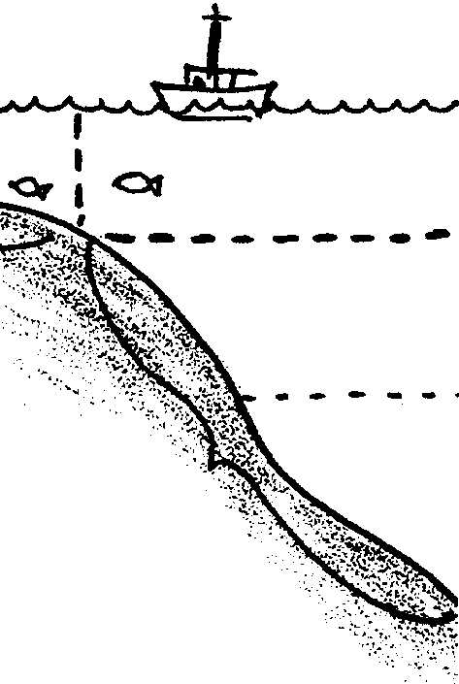
Key Concepts
1. The ocean environment is so large and complex that scientists who study the ocean divide it into zones. The deep sea may be divided into a pelagic or oceanic (water) zone and a benthic (bottom) zone.
2. Most of the information we have about the deep sea has been collected using indirect methods such as the midwater trawl and bottom grab.
3. Our information about the deep sea is incomplete.

Background

There are really two completely different habitats of the deep sea; one a water environment, the other a seafloor environment.

The pelagic zone or water environment of the ocean is divided into a coastal zone (those waters which lie above the continental shelf) and an oceanic zone (the deep waters away from the influence of land). As you might expect, the deep water oceanic zone is further divided. Sometimes it is divided on the basis of light penetration into a photic (light) zone which extends down to about 200 m and an aphotic (without light) zone which extends from about 200 m to the ocean floor. Sometimes a twilight zone which extends from 200 m to 1000 m is added to this system. As you can see from the following diagram, there are other ways to divide the oceanic zone. It is important to remember that the zones are constructs designed to help scientists and others make sense out of a complex system. The name of choice depends to a large extent upon what is being studied.

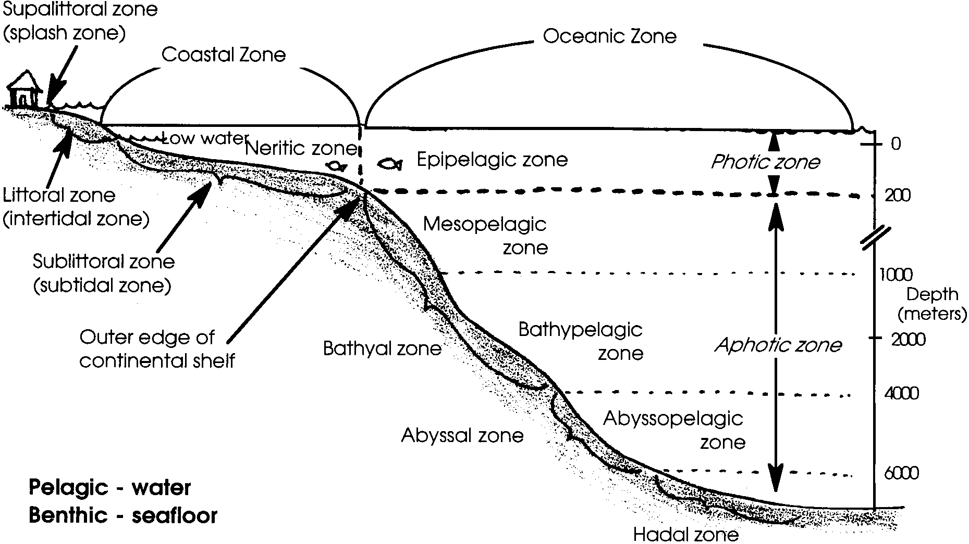

Animals living in the aphotic oceanic zone have no contact with any surface. They never experience a bottom to their habitat; they never experience a top to their habitat. They never run into a wall. They never have anything to rest upon. They are virtually weightless in their habitat.

Most of what we know about animals living in this zone comes from trawling the ocean water at a specific depth. Trawling involves deploying a net over the side of the boat and dragging it though the water, capturing anything in the path of the net that is not fast enough to avoid its forward movement.

The seafloor habitat of the deep sea is called the benthic zone. (Actually, any ocean floor is referred to as benthic.) Animals living in this deep sea zone actually live on or in the ocean floor. They fully experience gravity. All things that rain down from the waters above and which are not eaten or intercepted eventually land in this habitat.

Until recently, almost all of our knowledge of benthic animals come from samples taken with a mechanical grab, a device similar to a spring loaded metal bear trap but without the teeth. The grab’s spring releases once it hits the bottom, and a piece of the ocean floor, including the animals living in or on it, can then be pulled up to the surface.

You can readily see that this is a hit and miss way to learn about a habitat. Imagine floating in a hot air balloon a mile or two above the earth’s surface and trying to get a good picture of life on that surface from one foot square samples collected with a grab.
Given the great expanses and depths and our limited ability to sample, it is easy to see why the deep sea represents the largest and least known habitat on earth. So far, we have studied only about 1 percent of it. We have much more to discover.

Materials

For the class:

• miscellaneous objects to represent 10 different sites

• a general map of the area covered by the 10 study sites

Teaching Hints

In “Deep Sea Trawl Simulation”, students analyze items collected from “trawls” conducted in specific areas around the school. Their task is to build a picture of the environment sampled by the trawl.

Procedure:

1. Two approaches may be used to collect the ten trawl samples. You may wish to send 10 students out of the classroom, each to a different location on the campus: gym, math classroom, library, principal’s office, etc. While there, each student randomly “trawls” (collects) three objects from that location. If you choose this approach, you may want to “prime” the adults in the other rooms; or you may want to “plant” a set of objects for that student to pick up. Whatever the case, the students will return to the classroom with their “trawl” results concealed in a grocery bag. Living objects add an interesting dimension to the project.

Alternatively, you may wish to prepare the “trawl results” in advance and indicate on a map where they have been found. This approach is particulary effective if you prefer to have a broader study site (e.g. one that includes the ocean, a city street, the mountain, a junk drawer, a garbage dump, etc.).

2. It is necessary for you or the students to prepare a map of the study sites for the students to use in plotting each of their study sites. You may choose to use only one large map for the entire class, or smaller maps for each of the student groups.

3. Once the study sites are plotted, have groups of 3 or 4 students begin to analyze the contents of a trawl. Two trawls may be combined depending upon the number of students in your class. Note: If students collected the “trawl” samples, be sure that a collector is not placed in the group analyzing the “trawl” he or she collected.

4. Based upon their analysis, have each group prepare a written paper which describes the physical characteristics of the habitat, the organisms that live in that habitat, possible connections with other habitats, and the observations and thought processes that led to their conclusions.

5. The purpose of this activity is to stimulate the students to think creatively. There are no right or wrong answers.

Key Words

aphotic zone - the oceanic zone between 200 meters and the ocean floor

benthic - relating to the ocean floor

habitat - a specific location where plants and/or animals live

trawl - a net dragged behind a boat at a specified depth to collect marine organisms

Answer Key

1. Scientists cannot collect enough information using indirect methods.

2. Scientists could take more samples or use more direct methods to study the deep sea, such as using video cameras or actually visiting the site.

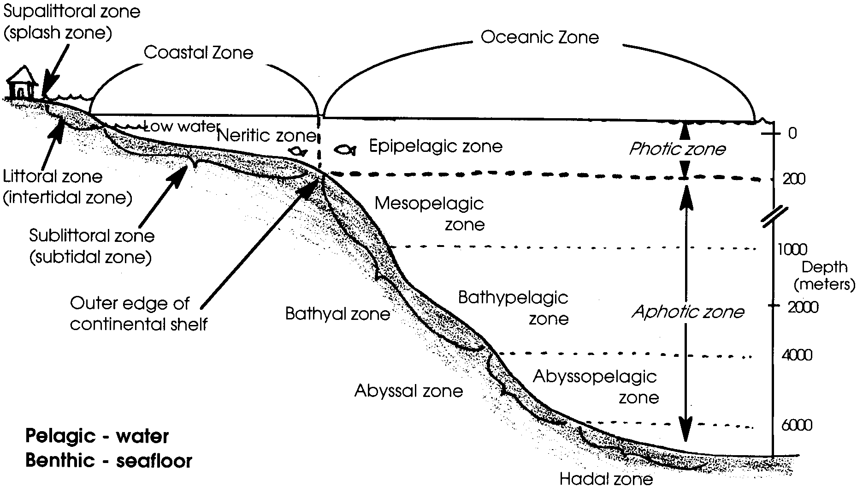
Deep Sea Trawl Simulation

Sometimes it is helpful to think of the deep sea as two habitats. One habitat is called the oceanic or water zone. The other is called the benthic or seafloor zone.

Animals living in the oceanic zone live in a habitat with no top or bottom. They never run in to a wall. They never have anything to rest upon. They are almost weightless in their habitat.

Animals of the benthic zone live on or in the ocean floor. They fully experience gravity. Things from the waters above rain down into this habitat.

Until recently, scientists could only study deep sea animals indirectly. They could not get into the deep sea. To study the oceanic animals, scientists would use a trawl net. The net was dragged through the ocean water at a specific depth. To study benthic animals, scientists send down a mechanical grab. A mechanical grab is similar to a metal bear trap without the teeth. The grab has a spring that releases when it hits the bottom. A piece of the ocean floor and the animals living there is “grabbed”. The sample is then pulled up to the surface. From these small “bites” of information, scientists began to piece together a picture of the deep sea.

There are some obvious problems with these ways to study the deep sea. It’s a little like visitors from another planet hovering over San Francisco. The city is covered with fog. The aliens drop a net through the fog. They drag it for a few blocks. The net mostly captures things that can’t run away. Even after many net trawls only limited information would be learned about the San Francisco environment.

You can see why the deep sea is one of the least known habitats on earth. So far, we have studied only about one percent of it. We have much more to discover.

In this activity, you are going to play the role of a scientist from another planet. Your research team has visited earth. You have taken some trawls and bottom samples. It is your job to analyze the results and try to make a picture of the environment you are studying. Remember, you have never actually visited earth before.

Materials
• trawl sample
• “Deep Sea Trawl Simulation” data sheet
• map

Procedure:

1. From your teacher, you will receive the location of your study site. Plot that location on the map.

2. With the members of your group, carefully analyze the contents of your sample. Identify each object with a number. List each object as living or non-living. Describe its probable function. Record your findings on the data sheet.

3. Share your findings with the rest of the scientists in your class.

4. Use this additional information to complete your picture of this mysterious environment. Illustrate your ideas. Share your illustrations with the rest of the class.

Analysis and Interpretation

1. Scientists created a picture of the deep sea. They have used information from limited, indirect research methods. What difficulties might scientists have in relying on these methods?

2. How might scientists overcome some of those difficulties?
