Design a Submersible Vehicle
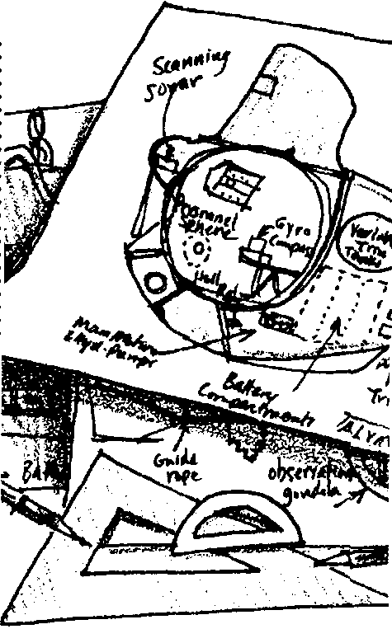

Key Concepts
1. Advances in the technology related to deep sea submersible vehicles have made the deep sea more accessible.
2. The buoyancy of a submersible vehicle can be changed by adding or removing water.

Background

For thousands of years people have dreamed about exploring the ocean floor. Within the last 500 years technologies have slowly, then rapidly developed which have begun to fulfill this dream.

In the early 1500’s, Leonardo Da Vinci designed the face mask, a tube for breathing underwater, and workable flippers. In 1620, Cornelius van Drebbel built two boats on the Thames River. Each boat carried 12 oarsmen and 12 passengers and could submerge for a short period of time. Also in the 1600’s, diving bells, actually barrels which were open at the bottom and lowered by cables, were developed for use in salvaging ships. The rigid helmet of the “hard hat” diving suit was actually just a smaller diving bell into which air was pumped through a hose. That 18th century design did not change much until the invention of SCUBA in the 1940’s.

In 1772, John Day built a small submarine where he spent 12 hours at a depth of 30 feet. Four years later, during the Revolutionary War, Sergeant Ezra Lee piloted the American Turtle, a small underwater boat during an attack on the HMS Eagle. The Civil War marked the first successful underwater military confrontation. The Yankee Housatonic was destroyed when the Confederate submarine, David of Hunley, rammed a gunpowder charge against the hull. The concussion from the explosion sank the Hunley as well.

In the 1920’s and 30’s advances in undersea vehicles proceeded rapidly. The Bathysphere, the first underwater vessel designed solely for research, was lowered to nearly 3000 feet off Bermuda in 1932. Unlike most modern deep sea vehicles, the Bathysphere was attached to the surface by a cable and had no means of propulsion. Subsequent bathyspheres (called bathyscaphs) were attached to buoyant tanks filled with gasoline.
The first successful unmanned dive occurred in 1948 when the Swiss physicist and balloonist August Piccard descended to a depth of 4600 feet in the FNRS II . Piccard would later pilot the 60-footTrieste to more than 10,000 feet in 1953 and, on January 23, 1960, with US Navy Lt. Don Walsh, set a depth record of 35,800 feet in the Marianas Trench.

Since that time, small manned submersibles, such as ALVIN and JASON, have provided direct access to the geology and biology of the ocean floor. Now, much of the ocean is being studied by remotely-operated vehicles (ROV’s) descending into the mid-water zone and equipped with sophisticated video equipment.

Most of these submersible vehicles share some common features. Basically, a submarine is a doubled-hulled vessel designed to withstand the pressures of the deep ocean. The machinery, equipment and living quarters are within the inner hull. Between the inner and outer hull are ballast tanks. The ballast tanks can be flooded with sea water, making the submarine heavier and allowing it to sink. When the crew wishes to resurface, compressed air is released into the ballast tanks forcing the water out. The submarine becomes lighter and floats back toward the surface.

The deep sea represents the largest and least known habitat on earth. So far, we have studied only about one percent of it. We have much more to discover.

Materials

For each group of 2-4 students:

• small waterproof containers

• miscellaneous “junk items”, including a few small balloons

• plastic tubing, at least 24"

• 10 gallon aquarium or 5 gallon bucket

Teaching Hints

In “Design a Submersible Vehicle”, students will design and test their own submarines.

For this activity to be successful, you will need to provide your students with a variety of “junk items” to use for their submarine construction. To avoid stifling original ideas, you may wish to encourage your students to brainstorm and design their submersible before you provide materials. Either way, allow them plenty of time to experiment with different materials and different designs.
If students cannot come up with a workable design, you might encourage them to insert a balloon in the container. They can then attach the balloon to the plastic tubing. Using their lungs like the compressed air tanks in a submersible, they can add or release air from the balloon using the tubing.

Key Words

pressure - exertion of a force upon a surface by a fluid

submersible - a vehicle designed to descend beneath the surface of the water

Extensions

1. Have students conduct research on the various designs of submarines and their designers.

2. Have students conduct research into the life of Allyn Vine of the Woods Hole Oceanographic Institute.

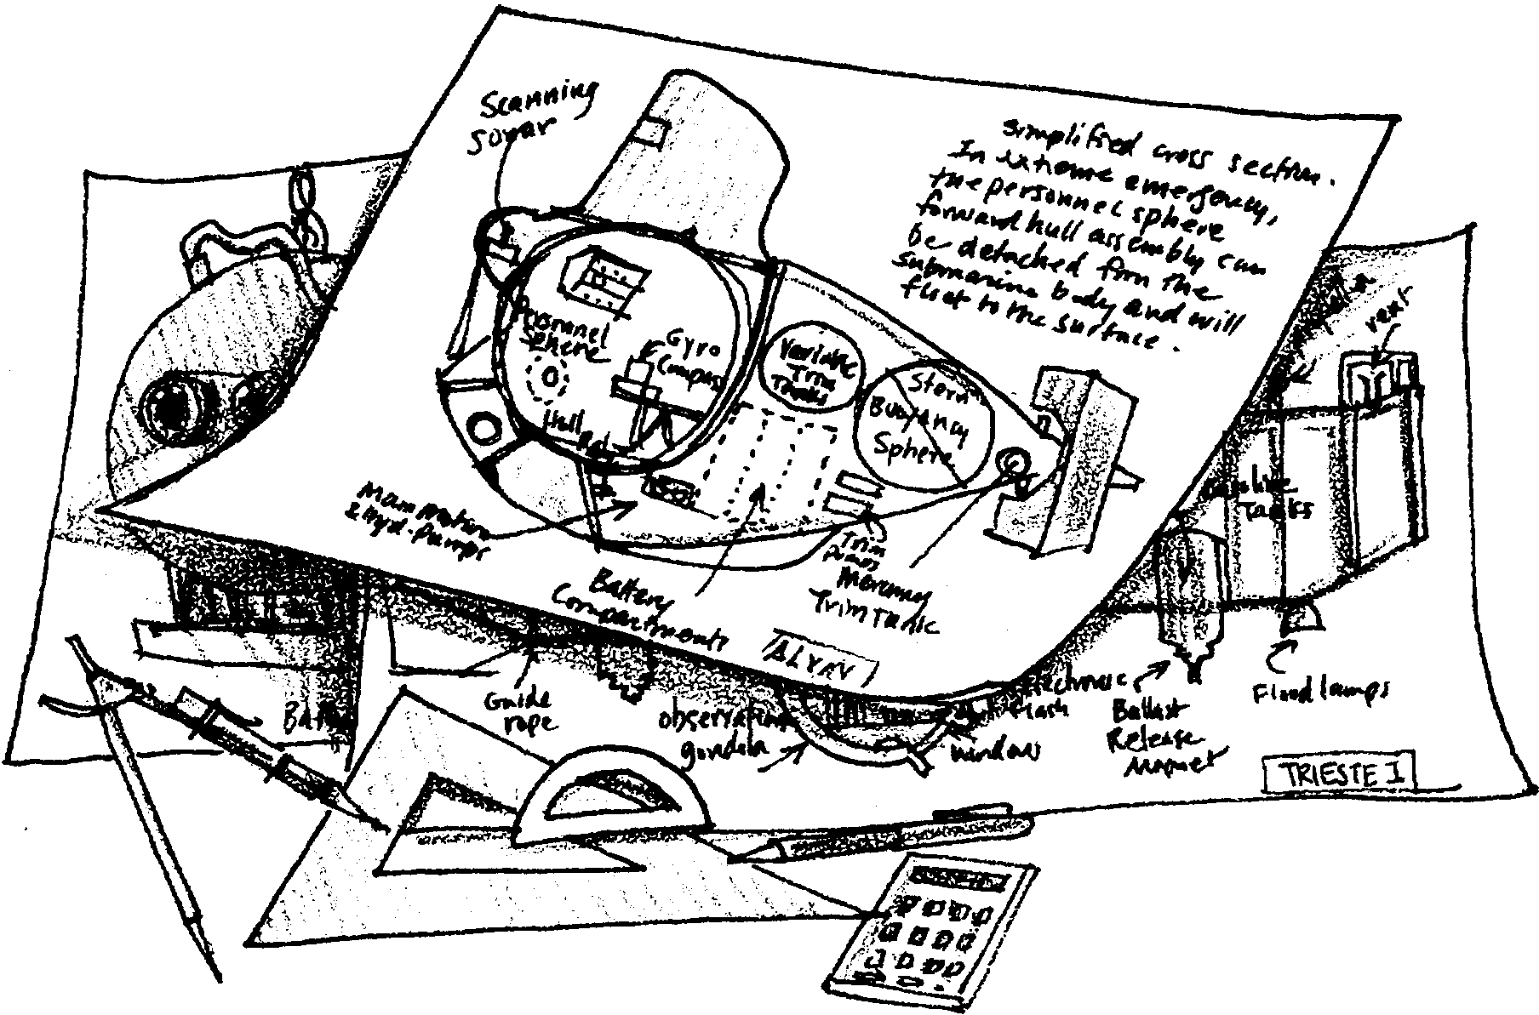
Design a Submersible Vehicle

Submersible vehicles are made to withstand the huge pressures of the deep sea. They are designed to sink to great depths and then return to the surface. They come in many different shapes. The shapes reflect their function.

The crew of a submarine is living in a closed environment. They must carry all their needs: food, water, oxygen, and so on. They must also provide for the needs of the submarine: fuel, electricity, and such. These supplies and equipment must be protected from the seawater surrounding the submarine. They cannot get wet.

In this activity, you and your group will design your own submarine.

Materials
• small waterproof containers
• miscellaneous “junk items”
• plastic tubing, at least 24"
• 10 gallon aquarium or 5 gallon bucket

Procedure:

1. Use the materials provided by your teacher. As a group, construct and test a submersible of your own design.

Your submersible must do three things. It must float on the surface of the water for 60 seconds. Then it must sink to the bottom of the water and remain there for at least 60 seconds. Finally it must return to the surface.

You may not touch the submersible once it has been placed on the water.

2. Test your submersible. Make any necessary changes. Demonstrate it to the rest of the class.

