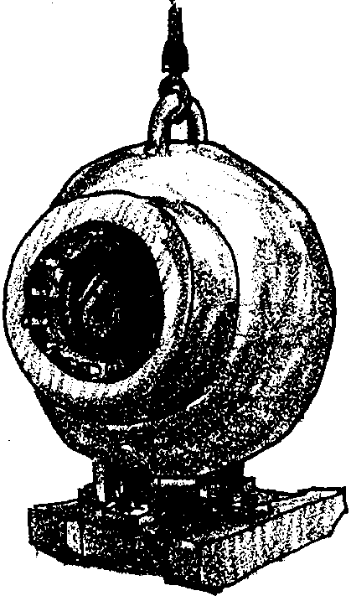
How Low Can You Go?

Key Concepts
1. Pressure increases with depth in the ocean.
2. Water pressure pushes on a submerged object EQUALLY IN ALL DIRECTIONS (not just from above).
3. Internal and external pressure must be balanced for an object to retain its shape.

Background

Water pressure in the deep sea is tremendous. At a depth of 10 meters, the pressure is twice the pressure at the surface. Each 10 meters adds one more atmosphere of pressure (one atmosphere = 14.7 pounds per square inch). By 4,000 meters, the pressure is 400 times the pressure found at the surface. It is important to note that this pressure is pushing from ALL DIRECTIONS.

Many deep sea organisms such as sea cucumbers, sea stars, worms and crustaceans are unaffected by these great pressures. These animals do not have lungs or other gas-filled cavities that would have to be protected against the pressure of the overlying water. Instead, cavities in these animals are filled with fluid at the same pressure as found in the surrounding waters.

Some fish have a swim bladder, an internal gas-filled bag. These fish use the swim bladder to adjust their buoyancy. If such a fish were to swim suddenly deeper, the increased water pressure compresses the air, the bladder shrinks and the fish sinks. If this loss of buoyancy isn’t compensated for, the fish has to continually expend energy by swimming upward. On the other hand, the swim bladder of a deep swimming fish brought quickly to the surface (say on the end of a fishing line) will expand with the decreasing pressure. A fish in this situation will often show bulging eyes and a distended body. Sometimes the expanded air bladder is forced out of the fish’s mouth.

How do marine mammals like the sperm whale which can dive to depths greater than 2000 m deal with the pressure? During their deep dives, the lungs of whales and other marine mammals collapse completely, forcing the air out. Marine mammals have a host of other adaptations for deep diving. Their blood is able to absorb more oxygen and tolerate higher levels of carbon dioxide than that of land mammals. Their circulatory system includes valves that permit blood flow to be shunted to the heart and brain during dives. Their muscles also store additional oxygen and are able to tolerate a larger build up of waste products than those of other mammals.
Humans have mechanically adapted to the pressures in the sea. Submarines provide protection from the pressure that would collapse human lungs. Scuba and “hard hat” diving gear provide air to the lungs at a pressure equal to the outside water pressure. Breathing gases under high pressures can pose serious problems including caisson disease (decompression sickness) and nitrogen narcosis. Decompression sickness is caused by ascending too rapidly. At the lower pressures of the shallower depths, nitrogen previously dissolved in the blood forms bubbles (in much the same way as the carbon dioxide bubbles form when a soda bottle is opened). The bubbles cause severe pain in the lungs and joints, neurological impairment, and sometimes death. Nitrogen dissolved in the blood stream may also have a narcotic effect, called nitrogen narcosis (rapture of the deep) which produces a semi-stupor, lightheadedness or euphoria.

Materials

For each student:

• “How Low Can You Go?” activity pages

Teaching Hints

In “How Low Can You Go?”, your students complete a mathematical exercise while exploring the environment of the deep sea Angler Fish. The student pages provide quite a bit of background information about the deep sea environment.

It is possible to do this activity in small groups. A period of discussion and review of the correct answers should be planned for the end of the exercise. The exercise provides an opportunity to emphasize the idea that structure and function are closely related.

Key Words

pressure - exertion of a force upon a surface by a fluid

surface area - extent or area of outer face

Answer Key

1. Answers will vary. Extreme temperatures, pressures, and darkness are possible answers.

2. The force on a fish with a surface area of one square foot at a depth of 300 feet would be:

64 pounds x 300 feet = 19,200 pounds per square foot
cubic foot

Note that pressure is often measured in terms of atmospheres (one atmosphere equals 14.7 pounds per square inch). For every 10 meters of depth in the ocean the pressure increases by one atmosphere. The angler fish at a depth of about 91.5 meters (300 feet) would face a pressure of about 9.15 atmospheres.

The concept of surface area can be demonstrated by using a sheet of paper. Hold the paper up and ask what the surfaces of the paper are. Since you can say the edges are negligible, the surfaces of interest are the front (top) and back (bottom). The area of one of these surfaces can be determined by multiplying length times width. The total surface area is the sum of the front and back areas. Next roll or fold the paper. Ask your class what the surface area is now. Has it changed? The area will be the same even if the shape is different. To find the surface area of a fish, then, you could physically take off the skin and lay it flat and measure it in the same fashion you measured the paper. In reality, we calculate the fish’s surface area mathematically, but the principles are the same.

3. The pressure on the angler fish:

64 pounds x 20,000 feet = 1,280,000 pounds per square foot
cubic foot 1

The angler fish at a depth of about 6,150 meters (20,000 feet) would face a pressure of a little over 615 atmospheres.

4.The outside pressure on a deep sea angler fish at one foot in depth would be 64 pounds per square foot. The outside pressure at about .3 meters (one foot) would be about .03 atmospheres.

5. If the internal pressure remained high, the fish would probably explode as it was brought to the surface.

6.The deep sea angler fish is usually black or dark gray. The dark color lets it remain hidden in spite of its light.

7. The angler fish teeth point backwards, toward the tail.
8. Once something is held in the teeth, it is very difficult for it to be lost.

9. Yes, the angler fish has eyes.

10. There are several kinds of experiments that students may suggest. Some are practical, some are not. Some possible suggestions: mark fish (either with dye or radioactive tracers) and follow their movements by radio or visually; put an angler fish in a pressurized aquarium and watch its behavior; fish for angler fish in lighted ocean zones, etc.

Originality here should be rewarded with a kind word and not with criticism about impracticality.

How Low Can You Go?

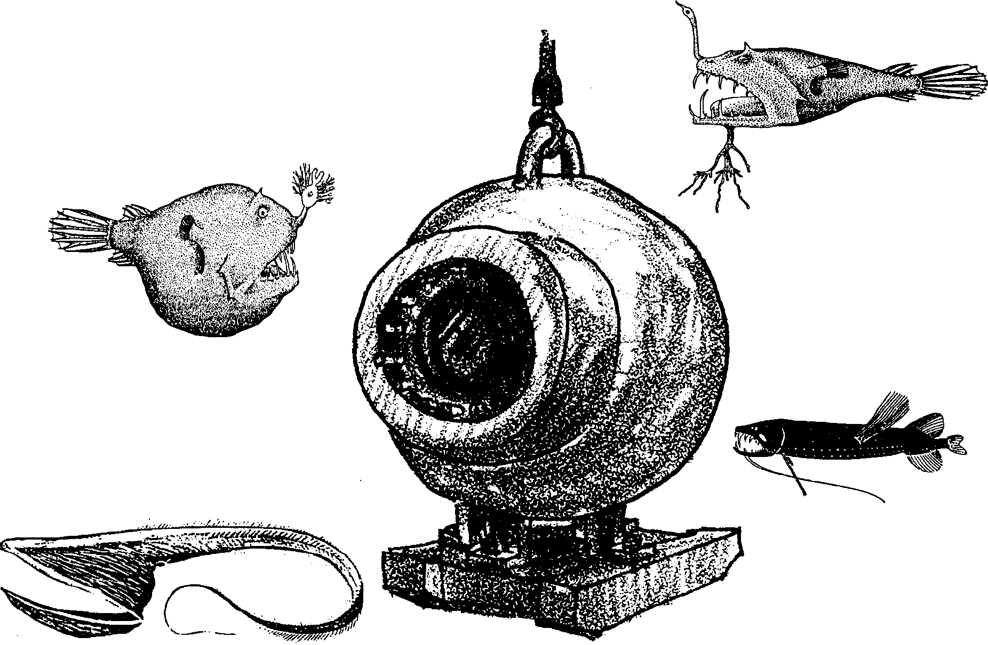
Hundreds of years ago, sailors on ocean going ships discovered that the ocean was thousands of feet deep. Scientists hypothesized (made a guess based on what they knew at that time) that conditions in the deep ocean were so unfavorable that living creatures would not be found there. Much to their surprise, many different kinds of creatures were found.

1. Why do you think scientists believed no life could exist?

Ocean waters reach greater depths than any fresh water body. For example, the Mariana Trench in the Pacific Ocean is about 35,800 feet deep (about 6,000 feet deeper than Mt. Everest is tall). What effect do these great depths have on the life found on the bottom? Let’s look at a bottom dwelling fish and see.
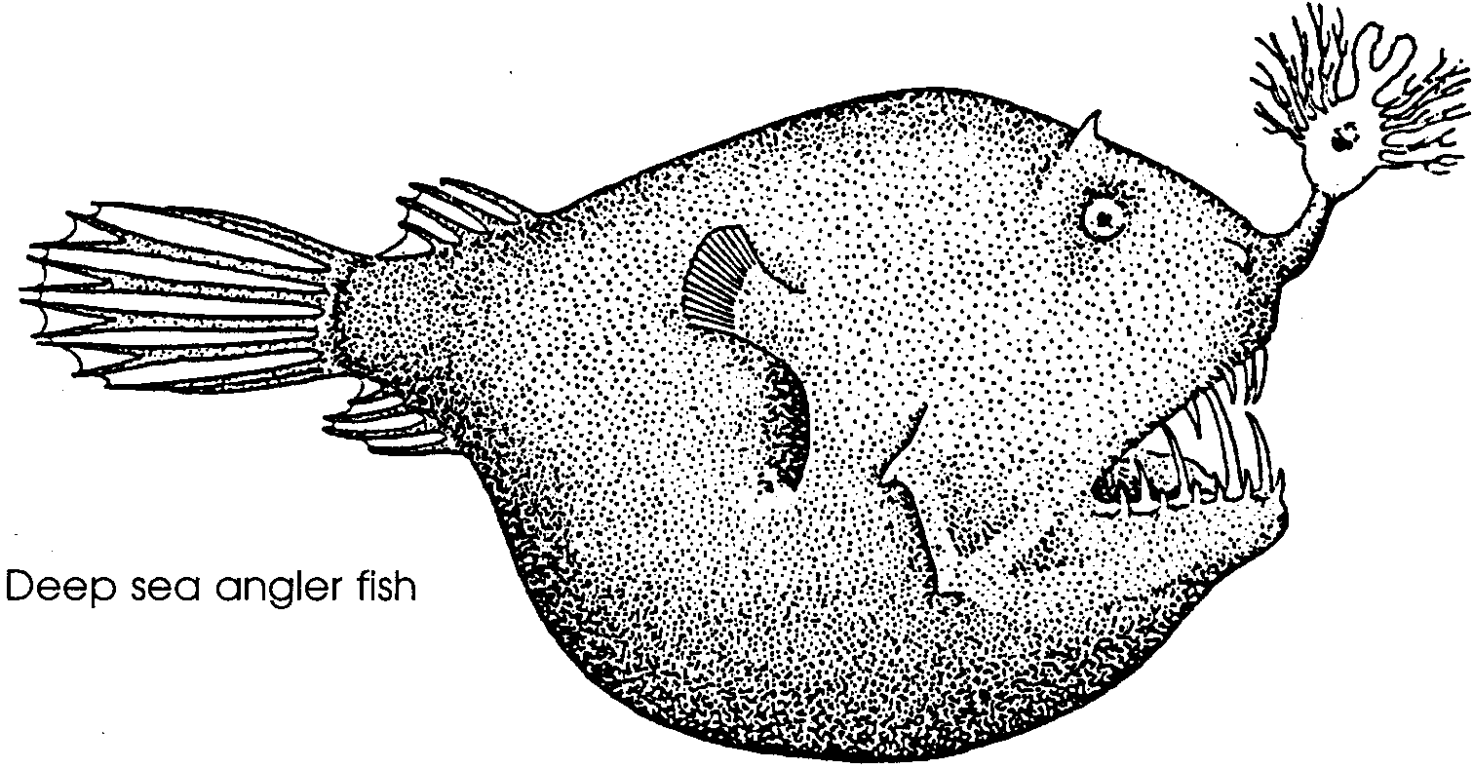

This fish is a deep-sea angler fish. It is found from 11,500 feet and deeper in both the Atlantic and Pacific Oceans.
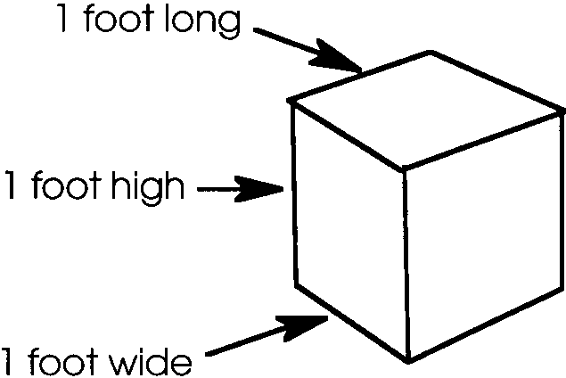
A cubic foot of fresh water weighs 62.4 pounds. Salt water weighs slightly more, about 64 pounds per cubic foot. A cubic foot is a block one foot high by one foot long by one foot wide.

A fish that has a surface area of one square foot will have a force of about 64 pounds pressing on it from all directions at a depth of one foot. The same fish would have a force of 640 pounds per square foot at a depth of ten feet.

2. What would the force be on this same fish at a depth of 300 feet? Please show your work.

3. If the angler fish shown in the drawing has a surface area of one square foot, how much pressure will the fish be under at a depth of 20,000 feet? Please show your work.

At a depth of 3,000 feet the pressure is high enough to squeeze a block of wood to half its volume so that it will sink. Why isn’t the deep-sea angler fish squeezed? The answer lies in the fact that there is pressure inside of the fish pushing outwards. The two pressures equal each other so the fish keeps its shape.
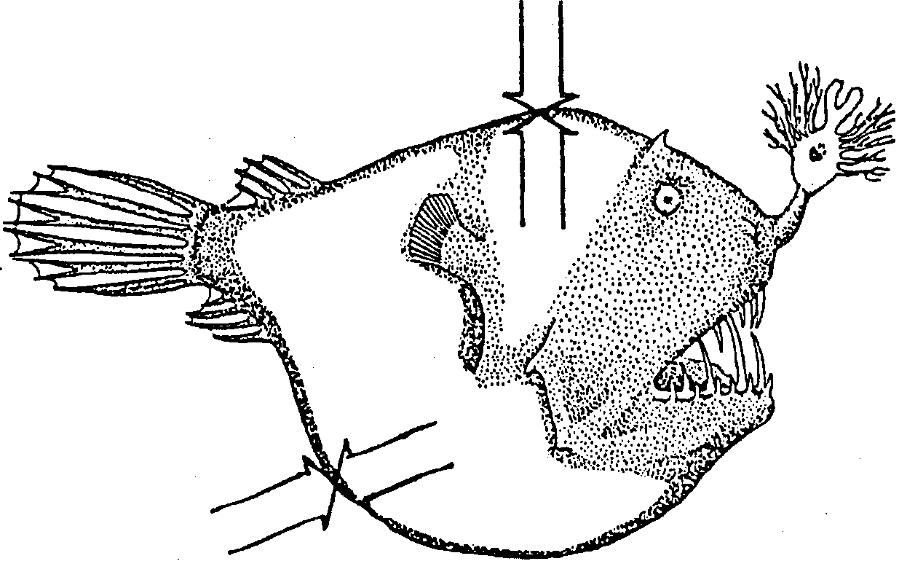

What happens as the fish moves up and down in the water? The pressure changes on the outside of the fish. To keep its shape, it must be able to change the internal pressure, too.

4. What would the outside pressure on a deep-sea angler fish be at one foot in depth?

5. If the fish could not change its inside pressure, what would probably happen to the fish if brought to the surface?

The sunlight never penetrates to the depths where the angler fish lives. If it’s always dark, how does the angler fish find its food? Look at the fish’s “nose.” The strange structure there glows in the dark. The angler fish remains still or slowly moves through the water. As it moves, it dangles the glowing structure.

6. What color do you think the rest of the deep-sea angler fish is? Why?

Curious fish move in for a closer look. The angler fish dangles the glowing “bait” more invitingly. The fish moves closer. Suddenly, the angler fish opens its mouth wide. This causes water to rush into the mouth and the curious fish is sucked in with the water. Hello, dinner!

7. Which way do the angler fish teeth point?

8. What is an advantage of this tooth arrangement?

Occasionally, an angler fish attracts a fish too big to eat. If the angler fish cannot let go of the big fish, both fish die.

There is no light at the depths which angler fish live.

9. Does the angler fish have eyes?

The eyes are sensitive to light. This fact makes scientists wonder if angler fish do occasionally move up into the lighted zones of the ocean.

10. Describe an experiment to test the hypothesis that angler fish move up into lighted ocean zones:

The tremendous pressure and no light coupled with very low temperatures help explain why scientists thought no life would be found in the deep ocean.

Angler fish are just one of many strange and fascinating creatures found at great depths of the ocean. For further information read Abyss by C.P. Idyll, published by Thomas Y. Crowell Company, New York (1964).

