Properties of the Deep Sea

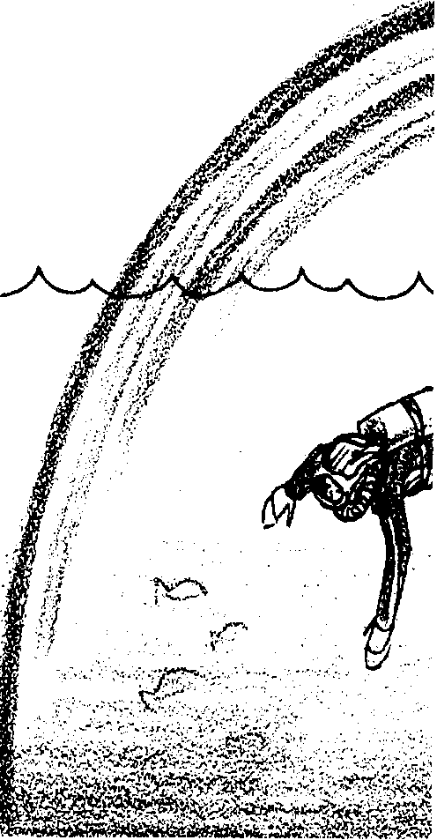
Key Concepts
1. Internal and external pressure must be balanced for an object to retain its shape.
2. Objects may reflect light, absorb light, or let light pass through; the light an object reflects determines the color of the object.
3. Colored filters allow only that color light to pass through.
4. Water absorbs different wavelengths of light at different depths. Water absorbs red light first making red fish look black under water because the red wavelengths have been absorbed by the water and cannot reflect into our eyes.

Background

Human curiosity has always stretched us to our limits and beyond. Not content to sail on just the surface of the ocean, underwater ships were being designed as early as the 1620’s; armored diving suits were in use by 1715. Experimental and not all that trustworthy, submarines and underwater diving suits did not become useful tools for oceanographic study until well into the 20th century.

In the meantime, scientists were restricted to the surface of the ocean, and their research methods were indirect. In 1872, the HMS Challenger set sail for a three and one half year oceanographic study. The Challenger sent devices down as far as 4000 meters into the ocean to take water samples, temperature measurements, and to collect animals.

For many years, our ideas about the deep sea were based on such indirect observations. We simply could not get to the deep sea and look around; we had to use what we dragged up into the boat and use our own thought processes to fill in the blanks. Once we reached the deep sea much, but not all, of what we found matched the assumptions we had made before.

It is very cold in the deep sea. Even in areas with surface water temperatures of 17°C, by 100 meters, the water temperature is only about 8°C and by 1000 meters it drops to between 2°C and 4°C.
The pressure of the water is tremendous. At a depth of 10 meters, the pressure is twice the pressure at the surface. Each 10 meters adds one more atmosphere of pressure (an atmosphere of pressure is about 14.7 pounds of force per square inch of surface area). By 4000 meters, you would experience 400 times the pressure you feel at the surface.

Sunlight does not penetrate the water well. The light we see is made of the different wavelengths or frequencies we call the visible spectrum. We recognize the different frequencies of that spectrum as different colors. An object can reflect light, like a mirror; absorb light, like a piece of black paper; or allow light to pass through it, like a pane of clear glass. We only see objects if they emit their own light or if light is reflected off them and enters our eyes.

When all the wavelengths of the visible spectrum are combined, they form white light. If an object reflects all the light that hits it, it appears white to us. If an object absorbs all the light, reflecting no light back to us, it appears black to us. Black is the absence of light. Objects with color absorb all frequencies of visible light except one. That one color is reflected by the object and enters our eyes. For example, a yellow rose appears yellow because the petals absorb all visible light except the yellow light. The petals reflect the yellow light. The reflected yellow light enters our eyes and we see the rose as yellow.

Water absorbs light. But it does not absorb all the light at the same time. Different wavelengths of sunlight penetrate different depths. The deeper the water, the more light it absorbs. Red light is quickly absorbed with little penetrating below 30 meters. At this depth, since there is no red light to reflect, anything that IS red, will absorb all light that hits it, and it will appear black. A red fish would virtually disappear. Below that depth, the only colors that will be reflected are orange, yellow, green, blue, indigo, and violet.

The next color to be absorbed by water is orange, then yellow, green, and so on. Blue light penetrates through water the furthest, which is why objects under water look blue. While it penetrates the deepest, even in the clearest waters blue light can only reach about 200 meters. By this depth, water has absorbed all the light of the visible spectrum, and the water looks black; it is completely dark. Photosynthesis rarely occurs in depths greater than 100 meters.

A colored filter only allows that color light to pass through, all other colors are absorbed.

Materials

Part I - Simulating Deep Sea Pressures

• a full sheet of newspaper

• 1000 ml beaker or a 4-cup measuring cup

Part II - Simulating Deep Sea Light

For the class:

• red, green, and blue acetate (plastic transparency, plastic sheeting, etc.), one sheet of each color

• scotch tape

• hole punch/scissors

• flashlights

• darkened room (it is not necessary that the room be completely dark)

For each student:

• a 3x5 index card

• black construction paper, one sheet

• white construction paper, one sheet

• red, green, and blue markers

• fish tessellation master

Teaching Hints

“Properties of the Deep Sea” introduces your students to pressure through a teacher demonstration and to light in the deep sea through student construction and manipulation of colored acetate filters.

Part I - Simulating Deep Sea Pressure

Emphasize to your students that this is only a model of what happens to objects as the descend in the deep water.

Procedure:

1. Take a full sheet of newspaper and loosely wad it up to fit into the measuring container. “Measure” the volume; how much of the container it “fills up”.

2. Remove the paper from the beaker and systematically wad it into a small ball. (Make sure that you exert “equal” pressure on all sides of the ball.) As you exert pressure, relate your efforts to the increase in pressure seen with increases in depth. “Measure” the volume again.

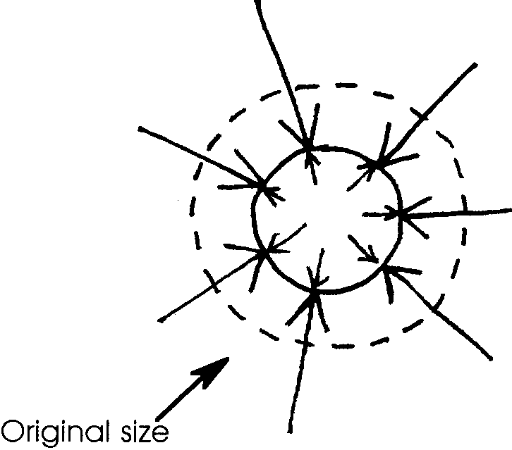
3. Explain to the students that this is similar to what happens to objects with air spaces in them when they descend into the ocean. The outside pressure pressing in is greater than the inside pressure pressing out. As a result, a solid object may collapse.

4. Tell the students that underwater, pressure comes from all sides equally, thus the newspaper is squashed into a ball shape. Use a diagram like the one on the right as an aid during discussion.

5. If pressure were exerted from only one direction, above for example, it would be like dropping a book on the crumpled newspaper. It would be flattened. Use a diagram like the following as an aid during discussion.
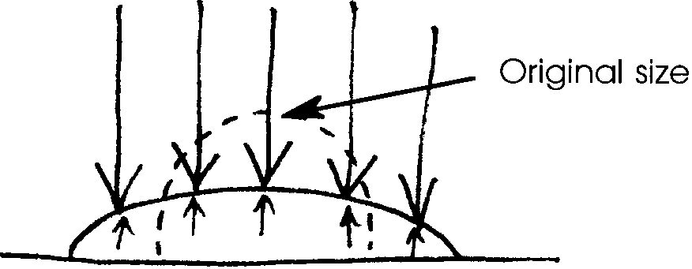

6. Say, “But fish live on the ocean bottom. How come they’re not flattened by the pressure?”.
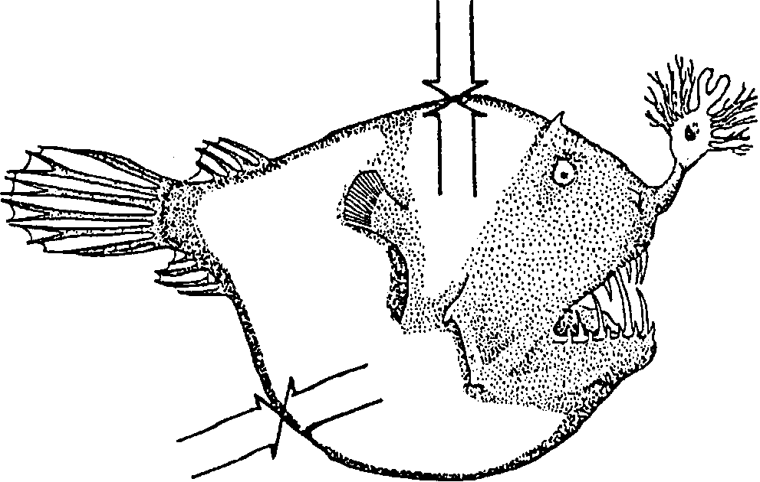
Elicit the answer that the outside pressure pressing in on the fish equals the inside pressure (within the fish’s body fluids) pressing out. Use a diagram like the one on the right as an aid during discussion.

7. With a newspaper, once the pressure is removed, the shape of the newspaper wad does not change substantially. Ask students what is likely to happen to the fish you’ve drawn if rapidly brought to the surface. Although not an accurate model, a novelty store peanut can where a snake “pops out” could easily demonstrate what might happen to a fish whose internal pressure was greater than the external pressure of the water around it.

Part II - Simulating Light in the Deep Sea

In “Part II - Simulating Light in the Deep Sea”, students make various color filters and view colored fish through the filters.

The transparency acetate you use must be fairly dark. If you cannot find the right color, multiple thicknesses may be used. Plastic report folders and colored index tabs work, too.

Make sure that students color their fish in completely. Any white spots will show through the filter.

Key Words

tessellation - a mosaic-like pattern of interlocking shapes

visible spectrum - the part of the energy given off by the sun that we can see

Extensions

1. M. C. Escher, was a Dutch artist and mathematician who is famous for his mosaic-type drawings called tessellations. Students can study Escher’s drawings and develop tessellations of their own.

2. This activity was created from information more fully developed in these sources:

Color Analyzers a GEMS activity published by Lawrence Hall of Science, University of California, Berkeley

Tessellations published by Creative Publications

Light Lab by Mike Guardino

For additional information and activities consult these publications.

Answer Key

Viewing the Drawing

1. Students should see nine fish; three rows of three fish each.

2 a. Students should see three fish.
b. The red fish should look the same as the white paper.
c. The other fish should look black.

3 a. Students should see three fish.
b. The green fish should look the same as the white paper.
c. The other fish should look black.

4 a. Students should see three or six fish.
b. The blue fish should look the same as the white paper.
c. The red fish should look black.
d. The green fish may look lighter, possibly yellow.

5. When the fish look black, they should practically disappear against the black background.

Discussion questions

1. White paper appears red when viewed through a red filter because white paper reflects all colors of the visible spectrum but the red filter allows only red light to pass through to your eyes.

2. Through a red filter, red objects appear the same as white objects. Green or blue objects appear black, because they do not reflect any red light which could pass through the filter.

Through a green filter, green objects appear the same as white objects, red or blue objects appear black, because they do not reflect any green light.

Through a blue filter, blue objects appear the same as white objects, red objects appear black because they do not reflect any blue light. Since green ink contains some blue pigments, the green objects reflect some blue light and are visible through the blue filter.

3. Yes, the red fish would look black and virtually disappear in their environment. In that way, they cannot be seen by their predators.

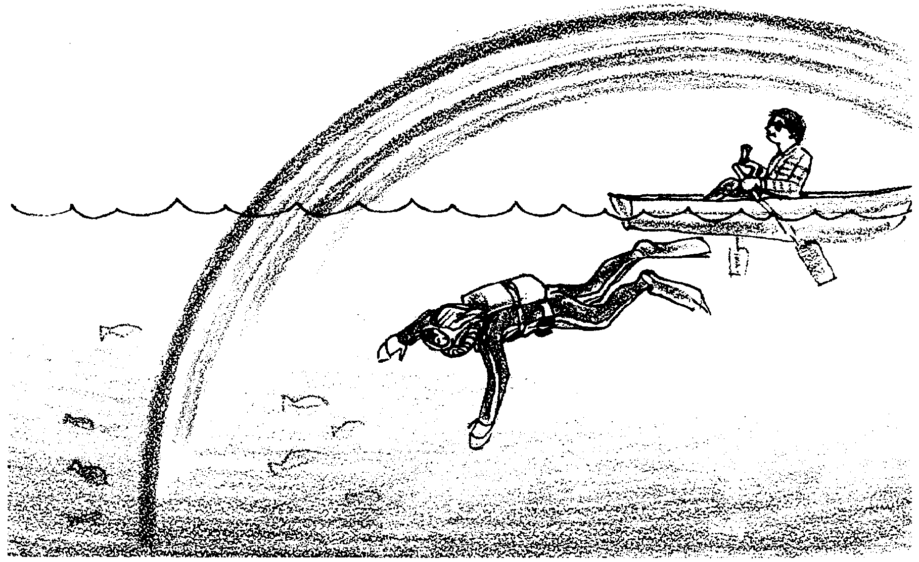
Properties of the Deep Sea

Simulating Deep Sea Light

We only see objects if they emit their own light or if light is reflected off them and enters our eyes. The light we see is made of the different wave lengths. We call all the wave lengths that we can see “the visible spectrum”. We recognize the different wave lengths as different colors.

An object can reflect light (like a mirror) absorb light (like a piece of black paper) or allow light to pass through it (like a pane of clear glass).

White objects reflect all the visible light that hits them. Black objects absorb all the visible light that hits them. Colored objects absorb all the visible light except one. That one is reflected by the object and enters our eyes. That is the color we see. For example, a yellow rose appears yellow because the petals absorb all visible light except the yellow light. The petals reflect the yellow light. The reflected yellow light enters our eyes. We see the object as a yellow rose.

Water absorbs light. But it does not absorb all the light at the same time. The deeper the water, the more light it absorbs. At about 200 m, water has absorbed all of the light. The water looks black.

The first color that water absorbs is red. Below that depth, the only colors that will be reflected are orange, yellow, green, blue, indigo, and violet. What do you think a red fish would look like if no red light could hit it?

The next color to be absorbed by water is orange. Next yellow is absorbed, then green, and so on. Blue light goes through water the furthest. This is why objects under water look blue.

Materials
• red, green, and blue transparency paper, small pieces of each
• scotch tape
• hole punch
• 3x5 index card
• black construction paper
• white construction paper
• red, green, and blue markers
• “Fish Tessellation” sheet

Procedure:

Part 1 - Preparing the Filter
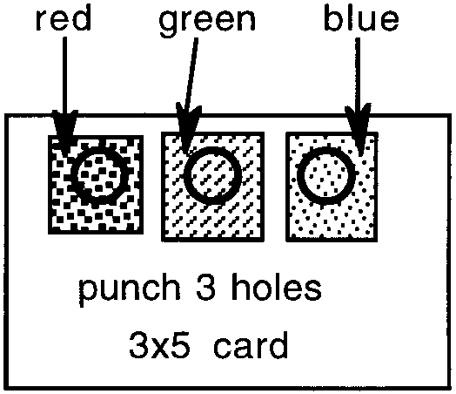
1. Using the hole punch. Punch three holes along the top of the index card. Each hole should be at least half an inch from the top edge of the card. Each hole should be at least half an inch from the other holes.

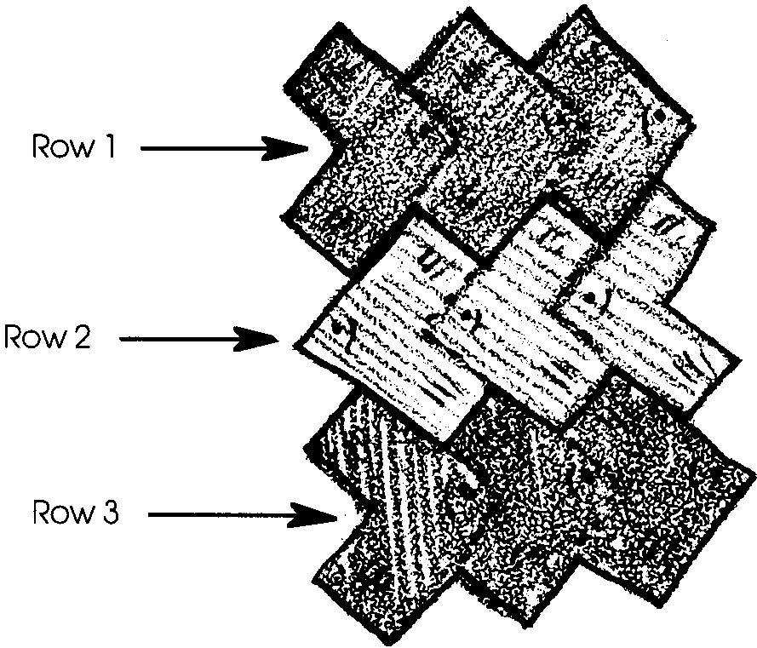
2. Cut a piece of red transparency paper just large enough to fit over one of the holes. Use scotch tape to tape it in place. Repeat with green and blue transparency paper.

Part 2 - Making the Drawing

1. Use your blue felt marker to completely color in one row of fish on the “Fish Tessellation” sheet.

2. Color the second row of fish red and the third row of fish green.

3. Carefully cut out the group of nine fish.
Part 3 - Viewing the Drawing

1. Lay the cut tessellation on the sheet of white construction paper. How many individual fish do you see?

2. Look at the drawing through the red filter.

a. Now how many fish do you see?

b. How do the red fish look?

c. What happened to the blue and green fish?

3. Look at the drawing through the green filter.

a. Now how many fish do you see?

b. How do the green fish look?

c. What happened to the blue and red fish?

4. Finally, look at the drawing through the blue filter.

a. Now how many fish do you see?

b. How do the blue fish look?

c. What happened to the red fish?

d. What happened to the green fish?

5. Now, place your tessellation on the black construction paper. Look at it through each of the different colored filters. What happens to the fish?

Discussion Questions

1. Why does white paper look red when viewed through a red filter?

2. Why do the fish “disappear” when you look through the different colored transparencies?

3. Many fish and invertebrates living below about 30 meters are bright red in color. Would this be an advantageous color for them? Why or why not?

Fish Tesselation Sheet
