Density Currents in a Model Ocean

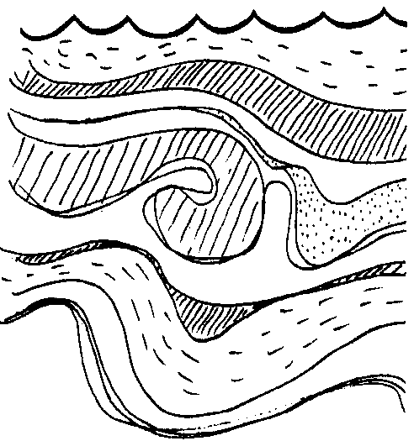
Key Concepts
1. Temperature influences the differences in water density which cause deep water currents.
2. Very cold, dense, polar water sinks to the bottom of the oceans at the poles and moves toward the equator.
3. This polar bottom current is the primary source of oxygen for the deep sea.

Background

Ocean currents have been used as an aid to navigation for thousands of years. Ocean currents affect climates and influence plant and animal populations on land, as well as in the oceans. What causes these influential currents?

Surface currents are largely driven by the earth’s winds. Deep currents of the world’s oceans are caused by other forces. Caused by differences in temperature and salinity, the varying densities of ocean waters are major forces in producing deep ocean currents.

Consider the water in an environment such as that deep under the ice around the antarctic. It is so cold that salt water is taken up to form ice. But, there is no room in the structure of the ice crystal for the atoms which make up salt. As a result, the salt is left behind in the water, and a very cold, salty water is formed. Because of its density, this water sinks.

In an entirely different part of the world, another phenomenon occurs. In the Mediterranean region, evaporation is so much greater than precipitation, the level of the Mediterranean is actually lower than the level of the Atlantic. This high rate of evaporation creates a constant and significant current flowing into the Mediterranean past the Rock of Gibraltar. German submarines made use of this current during World War II. The captains would submerge the U-boat a few feet below the surface, shut down the engines, and slide undetected into the Mediterranean.

The rapid evaporation of water from the surface of the Mediterranean leaves behind very salty water. Even though this very salty water is warm, the density is sufficient to cause it to sink to the bottom. This very salty, warm water is subsequently pushed along the bottom of the sea moving past the Rock of Gibraltar and into the Atlantic. The German U-boats, having completed a mission, would simply shut off the engines, drop down to that very dense current heading out to the Atlantic, and slide silently out to safety. Eventually, the allies installed huge submarine nets to prevent this maneuver.

Humans have, for thousands of years, used currents and surface currents to aid in navigation. The warm Japanese currents that swing down the coast of North America have been utilized by peoples of both Asia and America.

We are not the only hitchhikers, however. Consider the drifters, phytoplankton and zooplankton, or the 20-ton swimmers, the California gray whale, who catch the currents in their migrations. The huge volumes of moving water play a significant role in the life of the seas.

Additional background information for this activity is found in the preceding activity entitled “Ocean Currents”.

Materials

For each group of four students:

• large, clear rectangular baking dish or plastic shoebox

• four aquarium thermometers

• paper cup with a number of small pinholes in the bottom

• masking tape

• crushed ice (enough to fill paper cup)

• food coloring

• eye dropper or straw

• bits of paper

• water

Teaching Hints

In “Density Currents in a Model Ocean”, your students make a small “ocean” and observe the currents caused by density differences due to temperature. This experiment is best done in groups of three or four rather than as a classroom demonstration.

Note that data is collected for 30 minutes. Be sure that the students observe the cold current by looking through the side of the pan. Have students stoop down to make their eyes level with the table.

Key Words

bottom currents - density currents in the deepest part of the ocean

currents - large-scale water movements driven by wind or density differences of adjacent water masses

density - mass per unit volume of a substance; increased density = more molecules in the same space, decreased density = fewer molecules in the same space. More dense seawater tends to sink, less dense seawater tends to rise in the ocean.

Extensions

1. What would happen if warm water were used in the cup? Have students write their predictions and try it. (Since warm water is less dense and tends to rise, you would expect nothing to sink through the holes in the cup to the bottom of the pan.)

2. Movement of air behaves in the same way as water: both are “fluids”. Discuss with students what the air currents would look like at the poles, and where some rising and sinking air masses would be in our atmosphere. (Cold, dense air sinks at the poles and moves out away from that region. Air at the equator tends to rise because the sun’s rays are more direct there and the warming effect is greater.)

Answer Key

5 a. Students should see a current of cold, colored water falling from the holes in the paper cup and moving along the bottom of the pan. They should note that it does not mix with the pan water, but stays close to the bottom because it is more dense (“heavier”) than the surrounding water, and therefore tends to sink.

5 b. Answers will vary. Some students may say the cold water is “heavier” or more dense.

6 a. At the end of half an hour the cold current usually will have moved across the bottom of the pan to the opposite side, and perhaps begin to rise as it warms slightly and is pushed along by the cold water behind it. The thermometers will have dropped in temperature as the cold current moves past them.

Analysis and Interpretation

1. The answer depends upon the experimental results. If all went well, the paper should move out of the corner and toward the ice.
2. The paper shows a surface current.

3. The answer depends upon the experimental results. The thermometer nearest the ice probably will show the greatest change.

4. The answer again depends upon the experimental results. The thermometer nearest the ice probably will show the fastest change.

5. The answer again depends upon the experimental results. Most likely all of the thermometers will record a drop in temperature.

6. Depends upon results. Most likely, the thermometer farthest from the ice will be the last to record a temperature drop.

7. The changes in the four thermometers reflect the movement of different temperature waters. The ice cooled the water in the cup. The dense, cool water flowed out of the cup, sank and moved out across the bottom of the tray. The warm, light water flowed back toward the cup of ice at the surface.

8. The answer depends upon the experimental results. The dye should move across the bottom away from the ice.

9. The dye traces the movement of the water current.

10. The dye movement begins as a bottom current.

11. While answers depend upon experimental results, the dye usually curves at the other side and may move back across the surface. The current runs into the wall and moves accordingly.

12. The counterparts of the cup of ice are the polar ice caps.

13. A general statement might be that cold water is more dense than warmer water.

14. One would expect to find cold water currents moving away from the polar regions. One would also expect cold water currents to be deep currents.

Density Currents In a Model Ocean

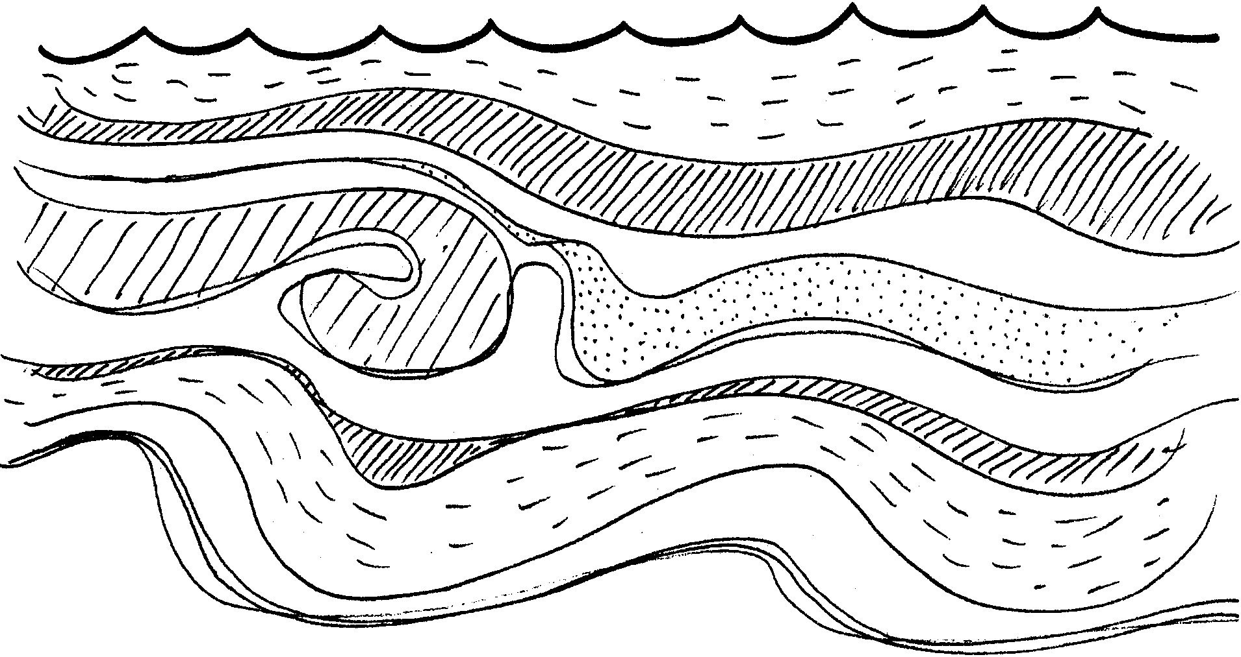

We have seen that differences in the density of sea water can cause currents. In this experiment you will make a model ocean and study its currents.

Materials

• large, clear rectangular baking dish or plastic shoebox
• four aquarium thermometers
• paper cup with several small pinholes in the bottom
• masking tape
• crushed ice (enough to fill paper cup)
• food coloring
• eye dropper or straw
• bits of paper
• water

Procedure:

1. Tape the paper cup (be sure there are pinholes in the bottom) in one corner of the baking dish. Leave about one inch between the bottom of the dish and the cup.

2. Place the thermometers at regular intervals along the bottom of the baking dish. Be sure the bulbs are facing the same direction. Tape the thermometers in place.

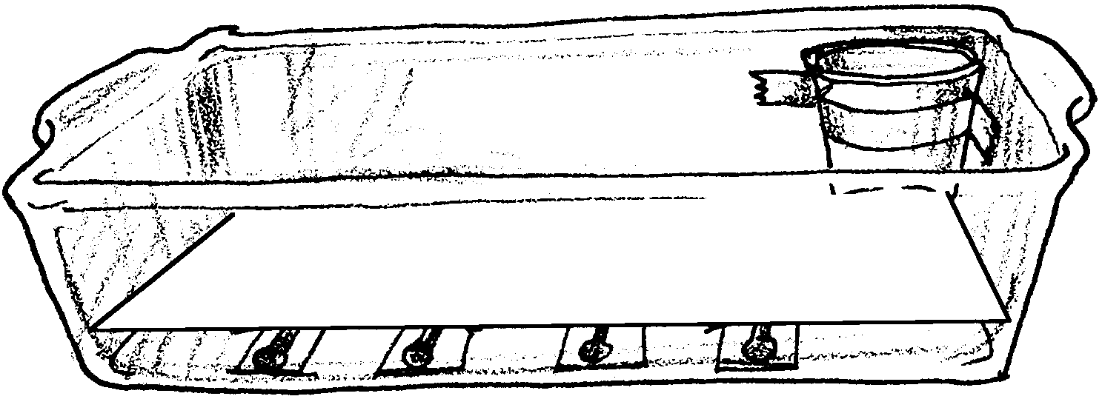
3. Add enough water so that the bottom of the paper cup is covered. Let the apparatus sit until there is no movement in the water. Your set-up should look something like this:

4. Read each thermometer and record the temperature at time zero on the data chart. This is important because we are concerned with how much the temperature changes.

5. Fill the cup with ice and add 5-10 drops of food coloring. Observe what happens by looking from the side of the pan. Be sure your eyes are at table level.

a. Record what you see happening:

b. What do you think is causing what you see?

6. Record the thermometer readings at five minute intervals for half an hour on the data sheet.

a. After 10 minutes make a prediction: What will the setup look like at the end of half an hour?
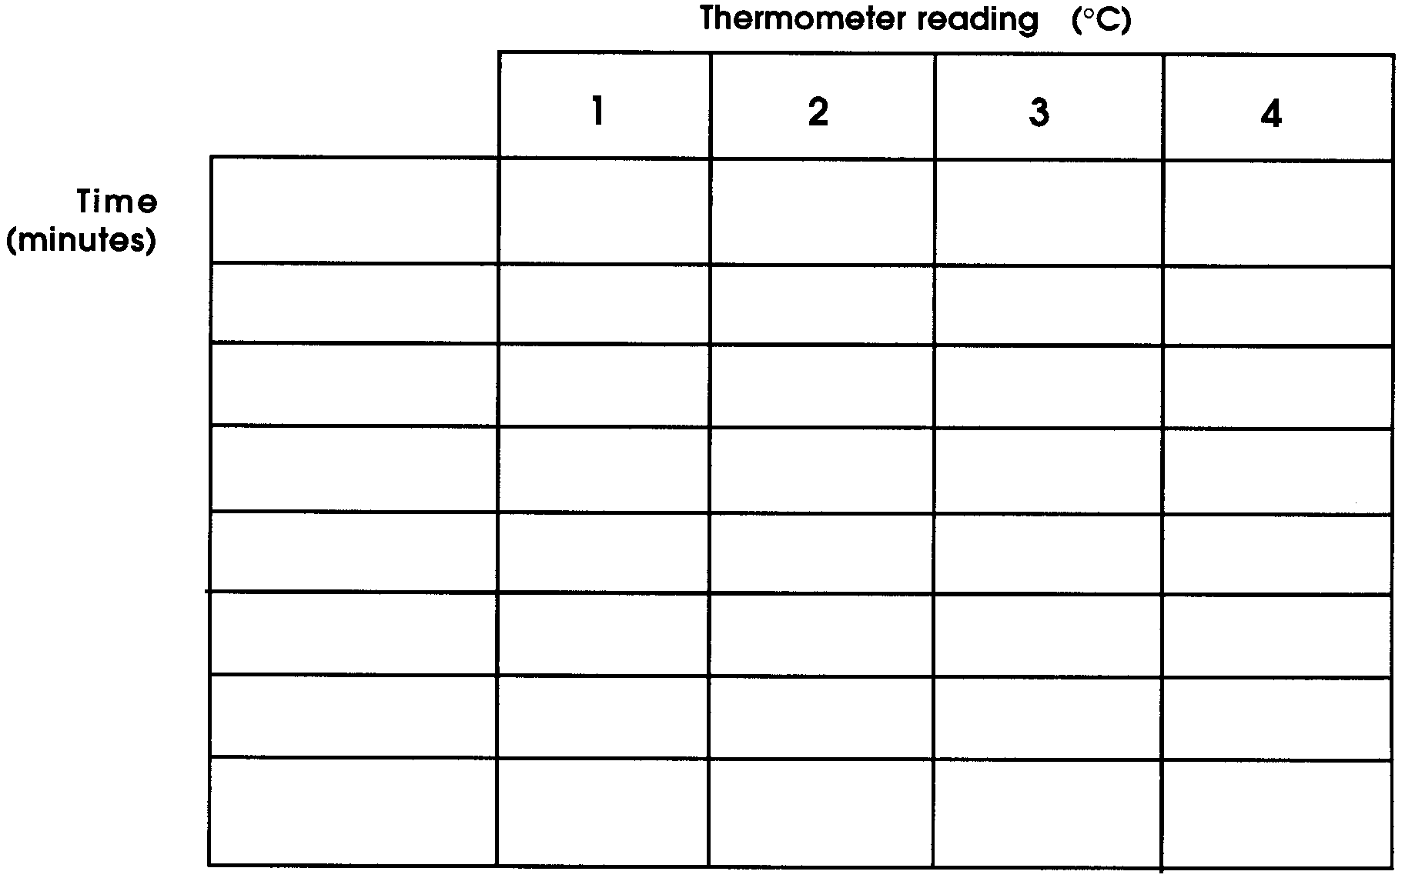

7. If you cannot see a bottom current after 25 minutes, gently heat the dish opposite the ice. Carefully place a large beaker of hot water inside the dish next to the edge.

8. After 30 minutes place a small piece of paper (about 1 cm square) on top of the water in the corner opposite the ice.

Analysis and Interpretation

1. In which direction does the paper move?

2. Does the paper movement show a deep current or a surface current?

3. Which thermometer changed the most during the time you read it?

4. Which thermometer had the fastest change?

5. Did all of the thermometers change temperature in the same direction? (Did they all get colder or hotter?)

6. Which was the last thermometer to show a temperature drop?

7. What could have happened to cause the changes you saw in the temperatures of the four thermometers?

8. What happened to the dye in the ice cup?

9. What does the dye movement tell you?

10. Is the dye movement a surface current or a bottom current?

11. What happens to the dye when it reaches the other side of the dish? Why?

12. A model imitates the real world. What is the counterpart of your cup of ice in the real world?

13. Make a general statement about how cold affects the density of water.

14. Where would you expect to find cold water currents in the ocean?

