Ocean Currents

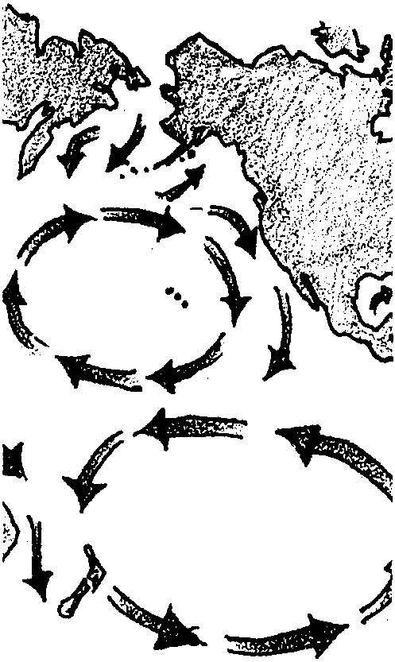
Key Concepts
1. Currents are large-scale water movements in the sea.
2. Both salinity and temperature influence the differences in water density which cause deep water currents.
3. Cold, salty water is more dense and tends to sink, while warm fresh water is less dense and tends to rise.
4. Currents affect living organisms by influencing food supply, water temperature and weather patterns.

Background

Currents are large-scale water movements that occur everywhere in the ocean. The surface currents are driven by winds, while deep subsurface currents are driven by density differences in the ocean water. Ocean currents transport heat from the equator toward the poles, thereby partially equalizing surface temperatures over the earth. Ocean currents, winds, and weather patterns are closely linked. Currents can affect the food chain by transporting nutrients and plankton from one area to another. Fish congregate in high plankton areas to feed, attracting larger predators such as tuna, birds and marine mammals (and humans!).

Wind Driven Currents

The ocean and atmosphere of the earth are heated unevenly by the sun. More heating takes place at the equator than at the poles. This difference in temperature at the equator and the poles causes warm air to rise along the equator, and cold air to sink at the poles. Rising and sinking air creates wind, as adjacent air masses move in response.

Wind blowing over long distances of ocean tends to drag surface water along with it. The rotation of the earth causes oceanic wind patterns to create large circular currents, or gyres. The “bending” caused by the earth’s rotation is called the Coriolis Effect. In the northern hemisphere the gyres flow clockwise, in the southern hemisphere gyres flow counterclockwise. These large wind-driven currents are year-around, constant patterns. The Trade Winds are part of this wind-driven surface pattern, and so is the California Current along the west coast of the U.S.
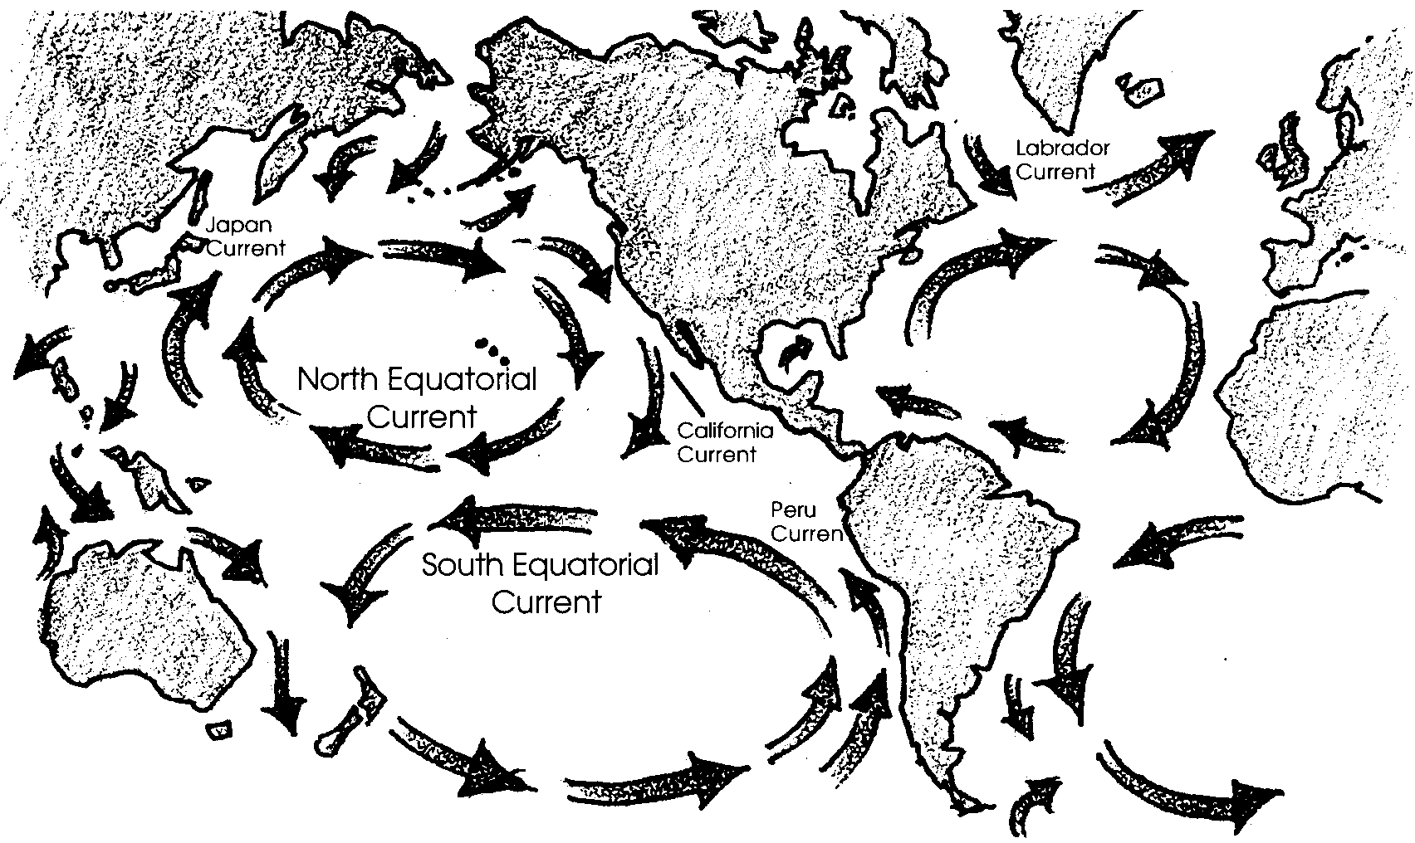
Density Currents

Density currents are caused by differences in temperature and/or salinity of adjacent water masses. At the North and South Poles, ocean water is cooled by the polar ice caps and by the lack of sun. Very cold, dense water sinks and flows along the bottom of the ocean toward the equator. Antarctic bottom currents flow past the equator into the northern hemisphere. These polar bottom currents are very slow moving. It may take 600 years for Antarctic bottom water to reach into the northern hemisphere. This very cold water is full of oxygen and is the primary source of oxygen in the deep sea.

At the equator, waters warmed by the tropical sun rise, expand, and flow out away from the equator and toward the poles. Remember that the atmosphere is moving in much the same pattern, also due to unequal heating by the sun.

El Niño

Normal wind and current patterns in the Pacific Ocean create a flow of water near the equator that moves from the coast of the Americas toward the west. In the Northern Hemisphere, the North Equatorial Current flows toward the west. In the southern hemisphere, the westward flowing current is called the South Equatorial Current. The winds that blow along this route are called the Trade Winds. In a normal pattern, cold, nutrient-rich water from the Antarctic flows up along the coast of South America (the Peru Current). The Peru Current joins the South Equatorial Current near the equator and flows west across the Pacific.

Every few years this pattern of wind and currents changes. For reasons that are only beginning to be understood, the Trade Winds die down and become weak. The westward-flowing equatorial current slows and is pushed aside by the equatorial counter-current running in the opposite direction. This means that lots of warm, nutrient-poor water moves east along the equator from the western Pacific. This warmer water reaches the coast of South America, pushing the Peru current further south.

Many organisms cannot tolerate warmer water. Plankton die from lack of nutrients in the warm water. Fish, such as anchovies, that feed on plankton, scatter to find food somewhere else. The food chain is disrupted by this change in ocean currents.

Because this event often happens during the Christmas season, the people of South America have named it “El Niño”, or “the child”. El Niño is devastating to the fishing industry of coastal countries such as Peru.

El Niño also affects weather patterns. Movements of large pools of warm water along the equator affect the atmosphere over the entire South Pacific. Warmer tropical waters bring rain. Rainfall that normally would drop on Southeast Asia and Australia is brought to the central Pacific and the coast of the Americas. These changes in weather patterns can be devastating, causing severe droughts in areas of Indonesia and Australia that depend on high annual rainfall for agriculture. Conversely, in the normally dry areas along the coast of the Americas severe flooding and storm damage can be the result of heavy rainfall.

Materials

For each group of 4:

• 2 clear soda bottles (8 oz.) (remove labels)

• 3x5 cards

• table salt

• teaspoon measure

• food coloring (preferably, red for warm water; blue for cold)

• paper towels or rags to wipe up spills

• plastic dishpan to catch water

• stirring rod (spoon handle, popsicle stick)

• ice water
Teaching Hints

“Ocean Currents” deals with temperature and salinity currents (density currents). This activity is designed to emphasize that currents do exist and that they play an important and not all together understood role in the life of the oceans. While this experiment can be done as a demonstration, it is recommended that the class be divided into small groups and that each group perform the investigations.

It is important that you do this experiment before your class performs it. This will give you a chance to anticipate any difficulties. Try the 3x5 card on the top of the flask inversion trick for yourself. It really does work. Be sure your flasks or bottles have flat lips. Also, be sure the colored salty water is well mixed before doing the test with it.

Encourage careful observation and require written observations from the groups. Encourage students to try other configurations of fresh/warm/cold/salty water in the bottles. They should :

a. Show the configurations of each of their additional set-ups on the first bottle diagram of a three bottle diagram series on the “Thinking Further” sheet.

b. Indicate on the second diagram what their predicted outcome is.

c. Show on the third diagram their actual results.

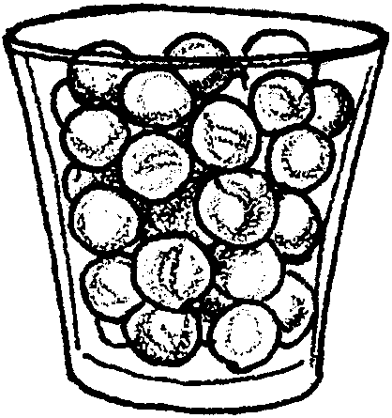
Students (and others) often have difficulty with the concept of density. During the discussion of experimental results provide as many concrete examples as possible. A useful demonstration of how salt increases density in water uses a clear plastic cup filled with marbles:

Tell the class that the plastic cup filled with marbles is a model of a cup of water.

The marbles represent the water molecules. Tell the class you are going to add salt to this cup of water. Ask the class to predict what will happen. Pour some salt into the cup of marbles. Ask the class to observe what happened and to compare their observations to their predictions. Point out to the class that the salt fits between the marble “water molecules”. This is a model of what happens when salt dissolves in water. Now the water is MORE DENSE because there are more molecules in the cup. You have added more “stuff” to the cup, making it heavier and more densely packed with molecules.

Another illustration of increasing density occurs when people get on an elevator: as more people get on, they are more closely packed together and the population density increases in the elevator. There are more “molecules” of people packed into the same space. Ask, “If you weighed the elevator, would it weigh more with the extra people inside?”

Solicit other examples of increasing density from the class. Remind students that the increase must represent more molecules of “stuff” IN THE SAME SPACE. The elevator and the cup did not change size when the extra “molecules” were added; the molecules were packed in more tightly together.

Key Words

adjacent - immediately next to

current - large-scale movement of ocean waters

density - mass per unit volume of a substance; increased density = more molecules in the same space, decreased density = fewer molecules in the same space. More dense seawater tends to sink, less dense seawater tends to rise in the ocean.

salinity - measure of the quantity of dissolved salts in seawater

Answer Key

Part I - Salinity Currents

1. Salt water is heavier (more dense). The answer comes from the observation that colored salt water sank into the clear fresh water in experimental set up “a”.

2. Since river water is fresh, it floats on top of the salt water until waves and currents cause the two waters to mix.

3. Freddy was fishing where the fresh water was standing in a layer above the salt water. Near the surface the water was the lighter river water, near the bottom the water was the more dense sea water.

Part II - Temperature Currents

1. Warm water is lighter (less dense) than cool water. The answer comes from the observation that the warm, colored water remained in the upper flask in experimental set up “a”.

2. Answers will vary depending upon the results from the configurations tested. Set-up, predictions and results from each trial should be shown on the “Thinking Further” data sheet.
3. Most heating of ocean water occurs at the surface.

4. Most dilution of ocean water occurs at the surface.

5. It is easier for the salmon to float in salt water. The salt water makes the salmon more buoyant. The salmon displaces the same volume as in fresh water but since salt water is more dense, the volume of salt water displaced by the salmon weighs more and the fish floats more readily.

6. Animals, including humans, find it easier to float in cool water. The animal displaces the same volume as in warm water but since the water is cooler and more dense it weighs more and the person floats more readily. A word of warning may be in order here. While a person will float more readily in cool water, the chance of excessive body heat loss increases. Cold water can lead to hypothermia. You may wish to discuss this so that your students use caution when experimenting on their own.

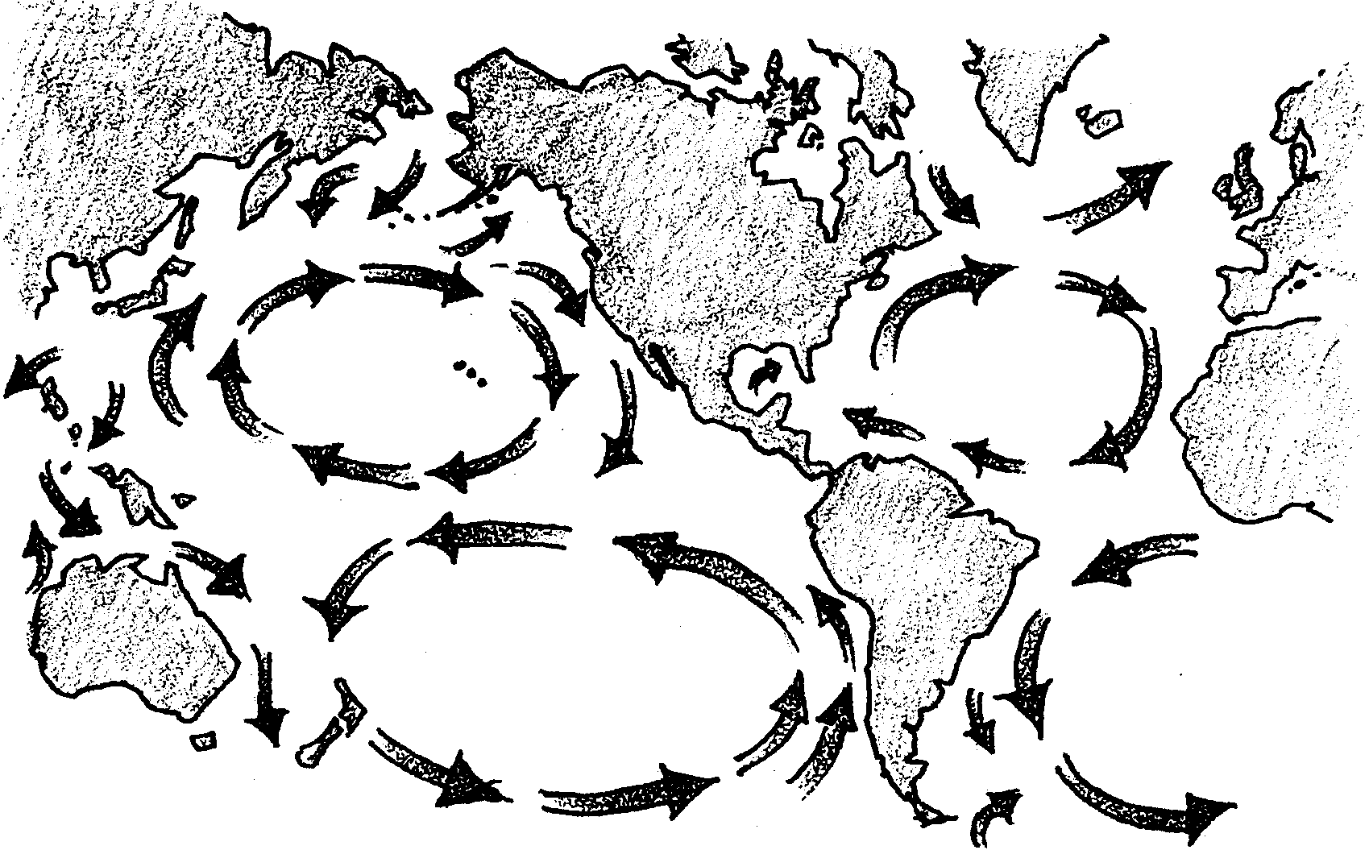
Ocean Currents

People have observed ocean currents for many years. Currents are masses of water that flow in a definite direction. Ocean currents are important in many ways. They affect the climate of the lands nearby. The best fishing is often found where two currents come together. Currents can help transport boats. They also transport fish and shellfish that are too young to swim great distances. Larger fish follow these currents to feed.

There are several types of currents. The best known are wind caused currents where the wind actually pushes the water along the surface. There are also deep currents beneath the surface. These currents are caused mainly by differences in the density of adjacent waters. Adjacent waters are waters which are right next to each other. Density refers to the number of molecules in a given space. In the ocean, differences in density may be caused by differences in salinity or water temperature.

The following experiment looks at two of the factors that cause currents. You will observe what happens because of differences in salinity and temperature densities between two masses of water.

Materials

For each group:
• 2 clear soda bottles (8 oz.) (remove labels)
• 3x5 cards
• table salt
• teaspoon measure
• food coloring
• paper towels or rags to wipe up spills
• plastic dishpan to catch water
• stirring rod (spoon handle, popsicle stick)
• ice water

Part I - Salinity Currents

1. Add water to one of the bottles until it is about half full. Dissolve one teaspoon of salt in the water and add several drops of food coloring. Stir well with the stirring rod to be sure all salt is dissolved.

2. Fill both bottles with water to the brim.

3. Place a 3 x 5 card on top of the salt water bottle and carefully invert it over the dishpan. The upward pressure of air will hold the card in place (most of the time).

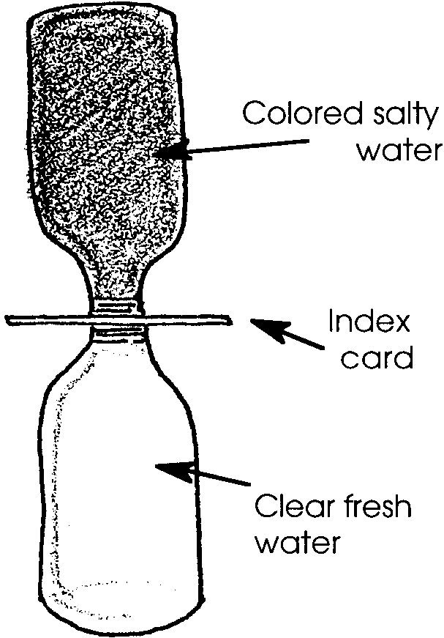
4. Place the salt water bottle on top of the fresh water bottle and have someone remove the card. Observe the results.

a. What is happening to the salt water?

b. What is happening to the fresh water?

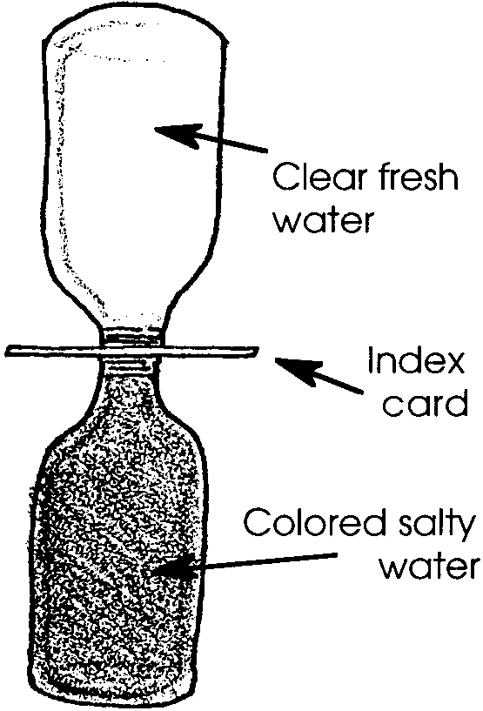
5. Repeat steps 1 to 4 but this time place the fresh water bottle on top of the salt water bottle. Remove card and observe.

a. What is happening to the salt water?

b. What is happening to the fresh water?

6. Repeat steps 1 to 4 but this time place both bottles horizontally. Remove card and observe.
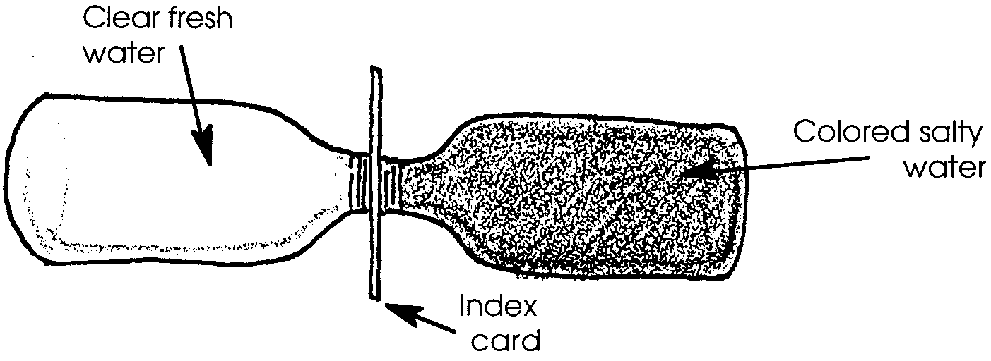
a. What is happening to the salt water?

b. What is happening to the fresh water?

Interpretation and Analysis

1. Is salt water “heavier” or “lighter” (higher or lower density) than fresh water? Explain your answer in terms of the results you obtained from the experiment.

2. Rivers carry fresh water to the sea. What happens to river water when it flows into the ocean?

3. Freddy Fisherman was fishing at a spot near the mouth of a river. Five feet down he caught a fresh water perch. His luck was so good he let out more line. At thirty feet he caught a salt water cod. Freddy is so excited about this strange occurrence he is going to call the Sports Editor of the Post-Intelligencer. What would you tell Freddy to save him from embarrassment?

Part II - Temperature Currents

1. Fill one bottle with tap water and the other with ice water. Fill both bottles to the brim. Add a drop of food coloring to the tap water.

2. Place a 3 x 5 card on top of the warm water bottle and carefully invert it over the dishpan. The upward pressure of air will hold the card in place (most of the time).
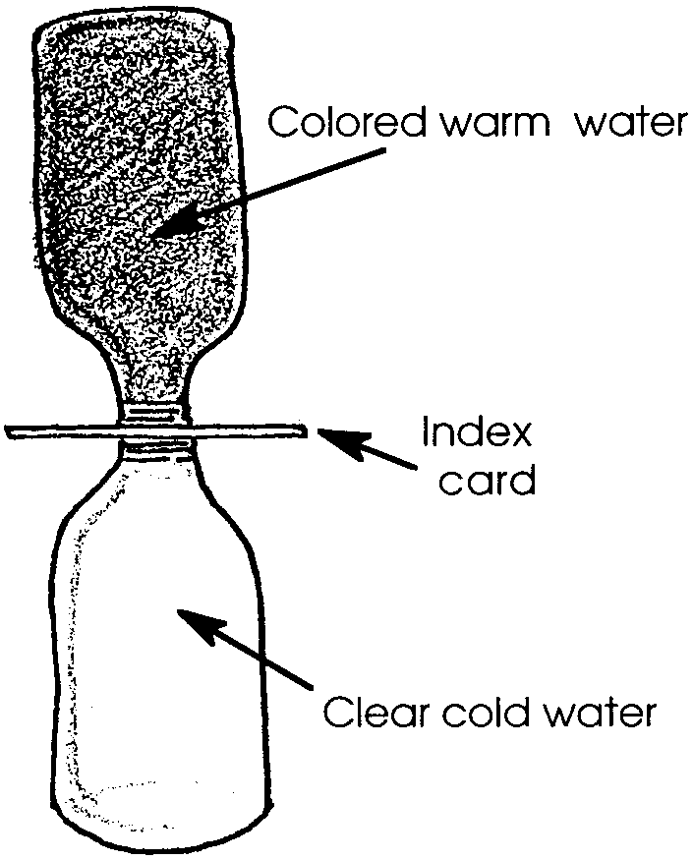
3. Place the warm water bottle on top of the cold water bottle and have someone remove the card. Observe the results.

a. What is happening to the warm water?

b. What is happening to the cold water?

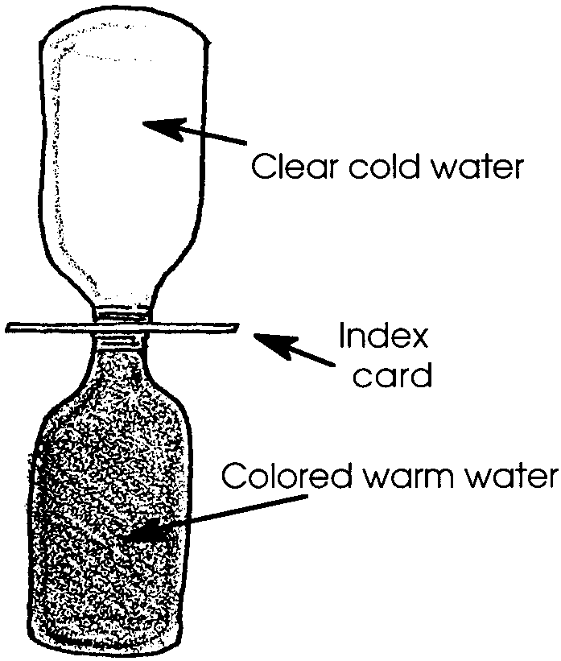
4. Repeat steps 1 to 3 but this time place the cold water bottle on top of the warm water bottle. Remove card and observe.

a. What is happening to the warm water?

b. What is happening to the cold water?

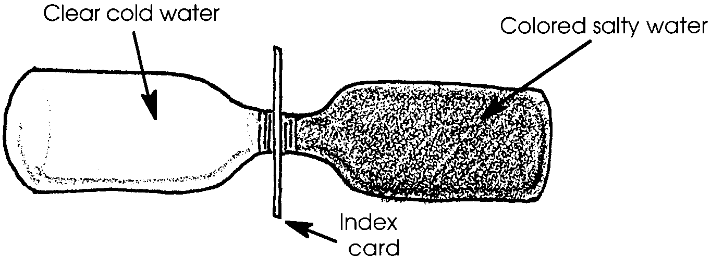
5. Repeat steps 1 to 3 but this time place both bottles horizontally. Remove card and observe.

a. What is happening to the warm water?

b. What is happening to the cold water?

Interpretation and Analysis

1. Is warm water heavier or lighter (higher or lower density) than cold water? Explain your answer in terms of the results you obtained on the above experiment.

2. What would happen if your setup used WARM SALTY water and COLD FRESH water? Try it! Use the “Thinking Further” page to show your set-up, your prediction of what you expect, and the actual results. Try other combinations of warm, cold, fresh, and salty water. What happens using ice water?

3. Where does most heating of ocean water take place?

4. Where does most dilution of sea water occur?

5. Some fish like salmon spend time in both fresh and salt water. Is it easier for a salmon to float in salty water or fresh water? Please explain your choice.

6. Other animals, including humans, spend time in both cold and warm water. Is it easier for these animals to float in cold water or in warm water? Please explain your choice.
“Thinking Further” DATA SHEET
