Water, Water Everywhere
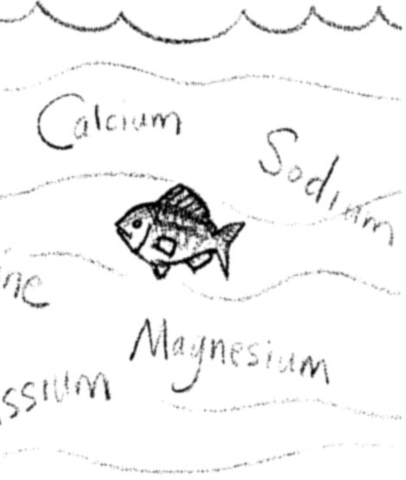

Key Concepts
1. Sea water differs from fresh water in that it contains greater quantities of dissolved salts.
2. Water is a very effective solvent; it is able to dissolve many substances.
3. Sodium and chlorine, the most abundant dissolved substances, combine to form common table salt.

Background

For billions of years, rains have washed into streams and rivers emptying into the sea. This moving water erodes salts and minerals from rocks and soils. These salts and minerals find their way into the seas. Over time, the concentration of these salts and minerals has increased, creating the salty ocean waters we know today.

Oceanographers measure the water’s salt content, or salinity, in grams of salt per kilogram of sea water (g/kg) which is usually expressed as parts per thousand (‰). This designation may be more readily understood if one relates parts per thousand (‰) to percent which is parts per hundred (‰). The two differ by a factor of ten which is reflected by the extra “o” in parts per thousand.

Average seawater salinity is approximately 35 grams of salt per thousand grams of water. Salinity values range from nearly zero at river mouths to over 40 part per thousand in some areas of the Red Sea. Notice the variation of salinity in these bodies of salt water:

Red Sea = 40 ‰
Mediterranean Sea = 38 ‰
“Average” sea water = 35 ‰
Black Sea = 18 ‰
Baltic Sea = 8 ‰

Salinity is altered by processes that add or remove salts or water from the sea. Generally, it is the removal or addition of water, rather than salt, that causes the changes in salinity that we observe. Except in unusual cases, changes due to the addition of salt take a very long time (i.e. tens of thousands of years) to effect. Salinities near shore vary due to the addition of fresh water by rivers and rainfall. Local conditions of temperature and water circulation may also increase or decrease salinity. Salinity also may vary at different depths due to the layering of waters of different densities.

The primary mechanisms of salt and water addition or removal are evaporation, precipitation, river runoff, and the freezing and thawing of sea ice. In spite of the great volumes of water that are moved in these processes, the salinity of sea water in the open oceans is amazingly constant. On the other hand, salinity changes in local environments, such as tidepools, can be dramatic.

While all chemical elements are represented, eight chemical elements comprise almost 99% of the elements found in sea water.

Major Constituents of Sea Water
(Salinity = 35 ‰)

1. Chlorine (as chlorides)19.40 ‰
2. Sodium10.56 ‰
3. Sulfur (as sulfates)2.71 ‰
4. Magnesium1.27 ‰
5. Calcium0.40 ‰
6. Potassium0.38 ‰
7. Bromine (as bromides)0.065 ‰
8. Carbon (as carbonates)0.028 ‰

Total salinity34.183 ‰

Salinity is one of the factors which determines where animals and plants live in an aquatic habitat. Each organism has its own range of tolerance. Like land animals, aquatic animals must maintain a constant salt concentration in their bodies. For example, fresh water fish have special adaptations allowing them to retain salts and excrete water so that the fresh water does not dilute their body fluids. Marine fish, on the other hand, excrete salts while retaining water so that they do not lose fluids to the salt water around them. Most marine fish cannot tolerate sudden changes in salinity. Organisms that may withstand only limited changes in salinity and are said to be stenohaline. Those which may tolerate wide fluctuations in salinity are called euryhaline.

Teaching Hints

Beginning with “Water, Water Everywhere”, your students will explore the physical characteristics of the ocean environment, and how this affects the organisms that live in the sea. It is important to relate physical conditions (salinity, pressure, currents, etc.) to the ways that animals and plants that live in the ocean have adapted to deal with these conditions.

“Water, Water Everywhere” focuses on salinity and provides practice in graph reading skills. As you teach, emphasize the “universal solvent” aspect of water; everything dissolves in water to a greater or lesser degree! Help students relate parts per thousand (‰) to percent which is parts per hundred (o/o). Note that the two differ by a factor of ten which is reflected by the extra “o” in parts per thousand.

Small groups are effective for this activity. After all have completed the exercise, spend a few minutes going over the answers to the questions. The process, or how the answers were obtained, should be emphasized as well as the answers themselves.

Key Words

dissolve - to make a solution of, as by mixing with a liquid; pass into solution; to separate into parts or elements, disintegrate

parts per thousand - ratio or proportion per thousand; in this case, number of parts of a substance per thousand parts of water, usually expressed as grams per kilogram and written as ‰, ppt, or g/kg

per cent - ratio or proportion per hundred

salinity - salt content of a given water

Extensions

1. For an interesting account of gold mining ocean water have your students read: “The Man Who Ploughed the Sea” in Prelude to Mars by Arthur C. Clarke. Published by Harcourt and Brace in 1965.

Answer Key

1. Chlorine has the greatest abundance (18.98 parts per thousand).

2. Sodium has the second greatest abundance (10.56 ppt).

3. Carbon is the least abundant element shown ( .028 ppt).

4. If all of the sodium and chlorine were to combine, 8.42 ppt of chlorine would remain (18.98 ppt chlorine - 10.56 ppt sodium = 8.42 ppt chlorine).

5. For the eight most common elements in sea water, the total salts ppt is 32.563 ppt (18.98 + 10.56 + 1.27 + .88 + 40 + .38 + .065 + .028 = 32.563 ppt).

6. .065 ppt x 1503 = 97.5 pounds of bromine.

7. 10.56 ppt sodium + 18.98 ppt chlorine x 100 = 90 71%
32.563 ppt for all salts

8. .0000000004 ppt gold x 1,000,000 water = .0004 tons or .8 pounds or 12.8 ounces (at $200/oz. = $2,560).

Water, Water Everywhere

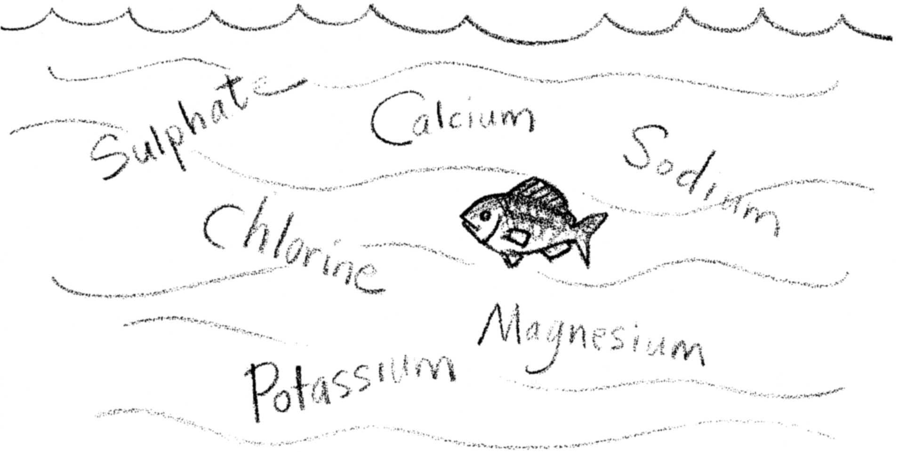
When you stand on the beach and look at the ocean, the water you see looks like the water in a lake or stream. As soon as you run into the water you can feel and taste the difference. How does sea water differ from other waters? We call sea water “salt water” and other waters “fresh water”. This gives us a clue to their differences. Salt water basically differs from fresh water by the salts dissolved in it.

The saltiness of the ocean, salinity, is measured in parts of salt per thousand parts of water. A salinity of 34 parts per thousand would have 34 parts of salt per thousand parts of water. Parts per thousand is written ‰ and abbreviated ppt. (The symbol “‰” looks very much like “%”, the “per cent” symbol. What does %, or “per cent” mean?)

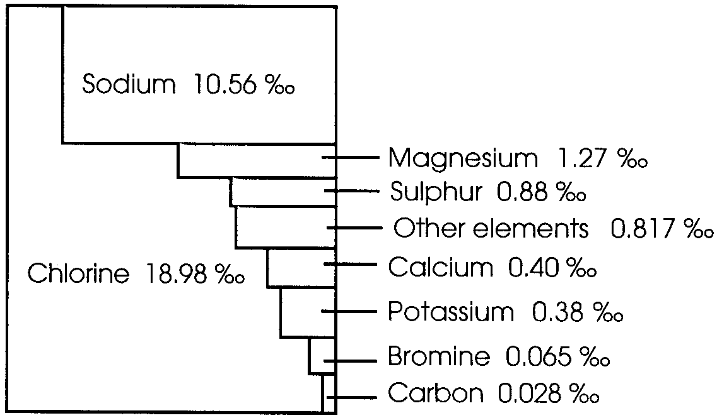
The graph to the right shows the most common materials dissolved in salt water.

Use the graph to answer the following questions:

1. Which element has the greatest abundance?

2. Which element has the second greatest abundance?

3. Which element shown on the chart is least abundant?

4. Sodium and chorine can combine to form table salt, sodium chloride. If all of the sodium and chlorine were to combine to form table salt, how much of which element would be left over? Please show your work.

5. For the eight most common elements in sea water, what is the total parts of salt per thousand parts of water? Please show your work.

6. How many pounds of bromine would there be in 1,500 pounds of water?

7. What percent of the saltiness of sea water is due to sodium and chlorine?

(HINT: to find percentage:

sodium + chlorine % x 100 = due to sodium & chlorine)
total parts per thousand

Please show your work.

8. This graph only shows the most abundant materials in sea water. All chemical elements are found in sea water. For example, gold is found in a concentration of .0000000004 parts per thousand parts of water. How many tons of gold would you be able to mine from 1 million (1,000,000) tons of sea water?

(HINT: multiply while keeping track of the decimal points)

