Connecting Marine Environments
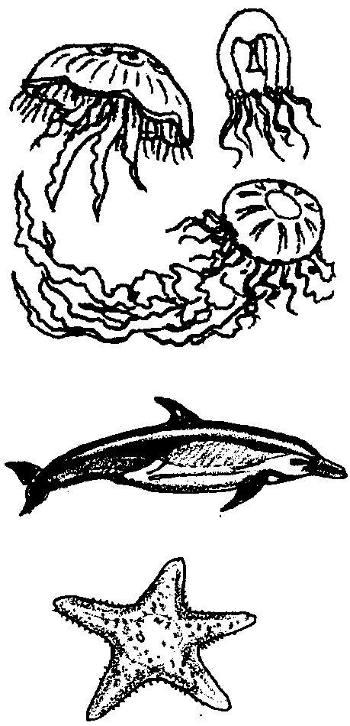

Key Concepts
1. An environment is all of the things that surround and affect a living creature.
2. Stable ecosystems are essential to the health of the aquatic environment.
3. The stability of ecosystems tends to be directly proportional to the diversity of their population.
4. Human choices affect the aquatic environment.

Background

Background information for “Connecting Marine Environments” is found in the preceding lesson “Marine Environments”.

Materials

For each student or pair of students:

• crossword puzzle and clue page

Teaching Hints

“Connecting Marine Environments” provides a crossword puzzle designed to build vocabulary skills by reinforcing the words introduced in the reading section “Marine Environments”.

Duplicate the crossword puzzle blank and clue pages.

You may elect to have students work on this puzzle individually, in pairs, or in small groups. Alternatively, you can have them work for a set period of time independently, then have them form groups to share answers and finish the puzzles. Each approach has its merits. The one chosen will depend upon your class. Regardless of the approach, you should plan to spend a few minutes at the end of the exercise in review. Give the correct answers (or better yet, have the students give the correct answers).

Some students seem to excel in making crossword puzzles. Think about providing graph paper and encouraging students who wish to do so to make crossword puzzles about any of the topics covered. These puzzles can be fun and you can use them to help other students reinforce areas in which they might be having difficulty.

Key Words

Key words are those found and defined in the crossword clues.

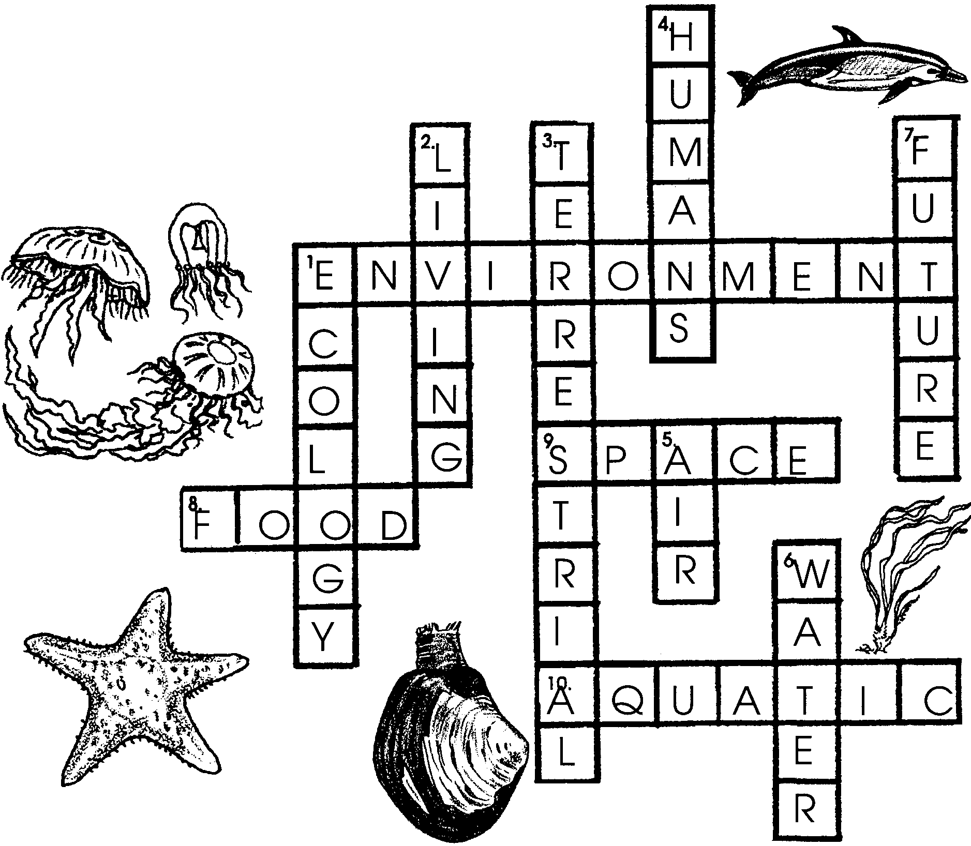
Answer Key

Connecting Marine Environments
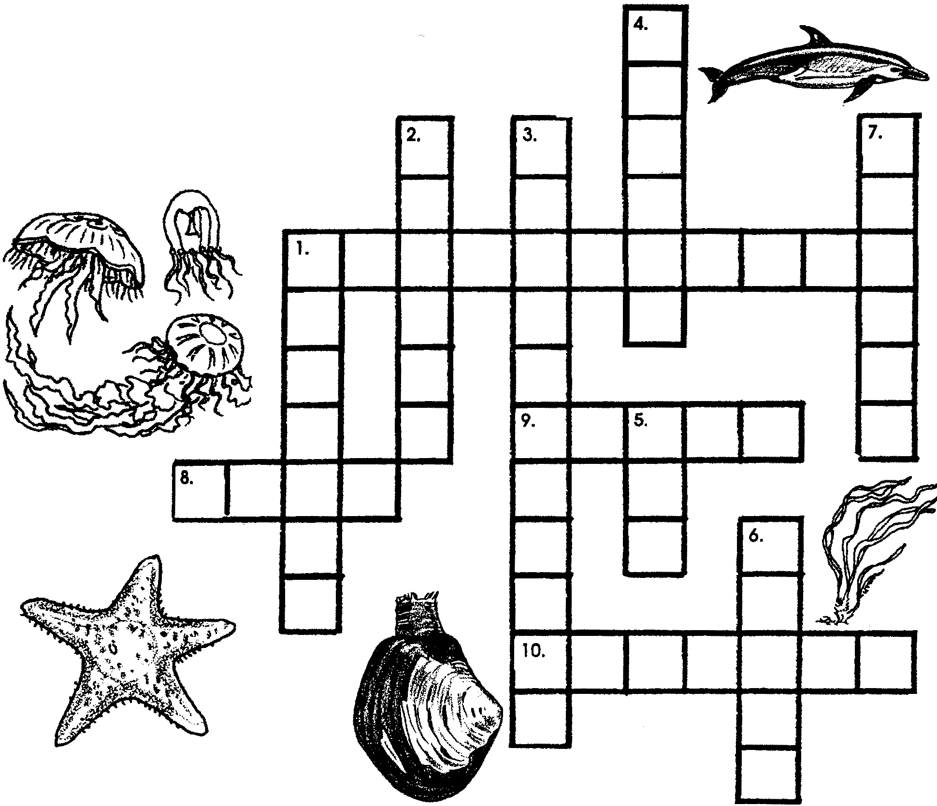
Down:
1. The study of environments.

2. An organism’s environment is composed of both the non-living and the
things that affect that organism.

3. Land environments are said to be .

4. An agent of change.

5. One of the qualities an environment must provide before life can exist.

6. One of the qualities an environment must provide before life can exist.

7. The oceans will play an important role in our .

Across:
1. All of the living things that surround and affect a living creature.

8. One of the qualities an environment must provide before life can exist.

9. One of the qualities an environment must provide before life can exist.

10. Water based environments are called .

