Marine Environments

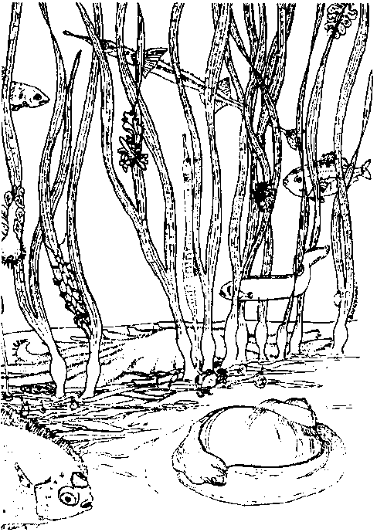
Key Concepts
1. An environment is all of the things that surround and affect a living creature.
2. Stable ecosystems are essential to the health of the aquatic environment.
3. The stability of ecosystems tends to be directly proportional to the diversity of their population.
4. Human choices affect the aquatic environment.

Background

The ecosystem concept is fundamental to any study of the marine environment. An ecosystem may be thought of as a basic functional unit of nature, comprising both organisms and their non-living environment. An ecosystem, or “ecological system”, includes all of the plants and animals in a local environment, as well as the soil, air, and water of that area. Ecology, a branch of biology, studies these ecological relationships between organisms in a local environment, and between the organisms and their non-living environment.

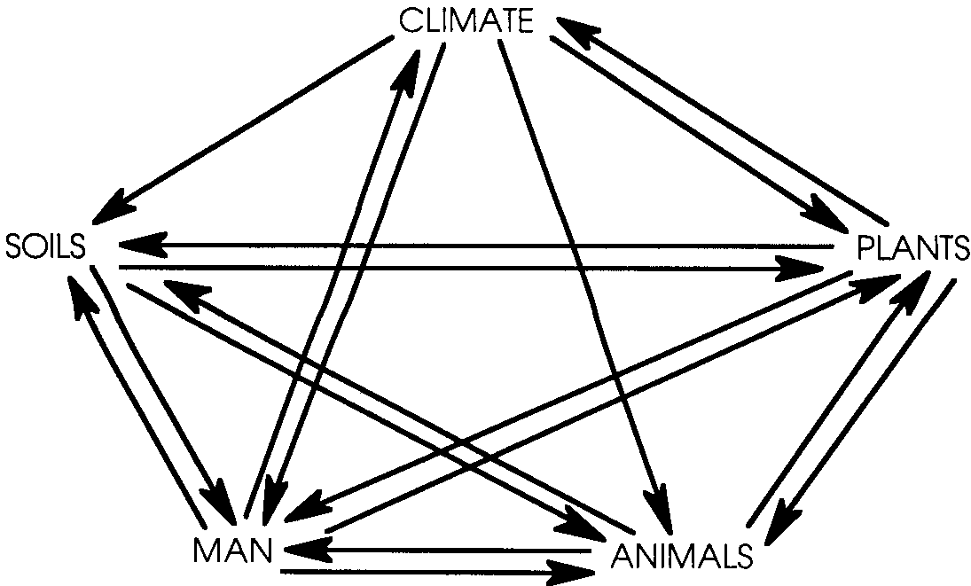
The complex network of abiotic (non-living) and biotic (living) factors of an ecosystem are intimately interrelated; each factor is affected by the others:

In many ways the entire surface of the earth makes up a huge ecosystem, often called the biosphere. Since studying and modeling the entire globe is difficult, scientists usually define smaller areas of study such as coral reefs, tropical rain forests, or Chesapeake Bay as “ecosystems”. While these subdivisions are very helpful, it is wise to remember that all of the smaller ecosystems are subunits of the global biosphere ecosystem.

Ecosystems require a constant input of energy, usually provided in the form of sunlight. In any ecosystem, energy enters and energy leaves. Between the entering and the leaving, the energy may be present in many forms (e.g., light, chemical, heat, etc.). Eventually, the energy used becomes heat which is lost to the system by being radiated away.

Ecosystems also require matter (e.g., carbon, nitrogen, etc.). Unlike energy, matter in an ecosystem is usually recycled; used over and over. The notion that matter cycles and energy flows and is lost is another of the basic principles of ecology.
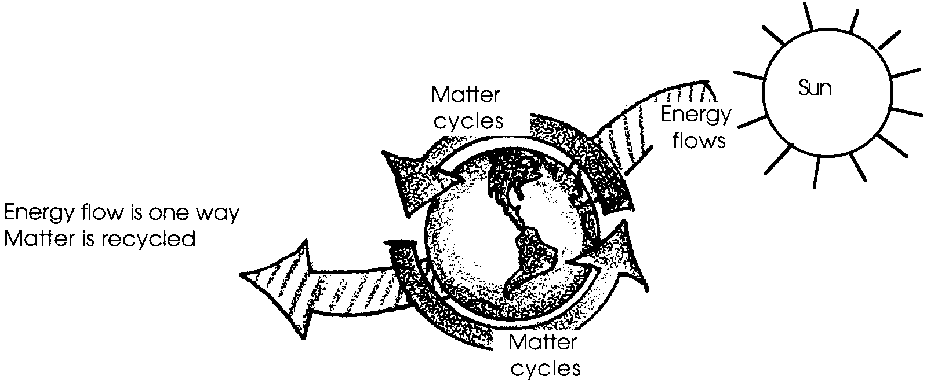

Ecosystems are often described by the food relationships that exist within. In most ecosystems, photosynthetic green plants are the “food makers” or producers, using light energy from the sun to form high-energy organic compounds such as glucose from carbon dioxide and water. Some animals in these ecosystems rely directly upon the plants as food (herbivores or first order consumers). Other animals rely indirectly upon the plants by eating animals that ate the plants directly (first order carnivores or second order consumers). Still other animals rely indirectly upon the plants by eating other carnivores (second or higher order carnivores or third or higher order consumers).

Through feeding, the energy and matter move from one organism to the next. This movement is often diagrammed as a food chain. Some energy is lost at each step in a food chain. Since most animals have several sources of food, food chains are not usually distinct but interconnect to form food webs. Decomposers are also found in all ecosystems. Decomposers are organisms which feed on dead organic matter, returning basic substances such as minerals and water to the soil. A typical set of these food relationships may be diagrammed as follows:
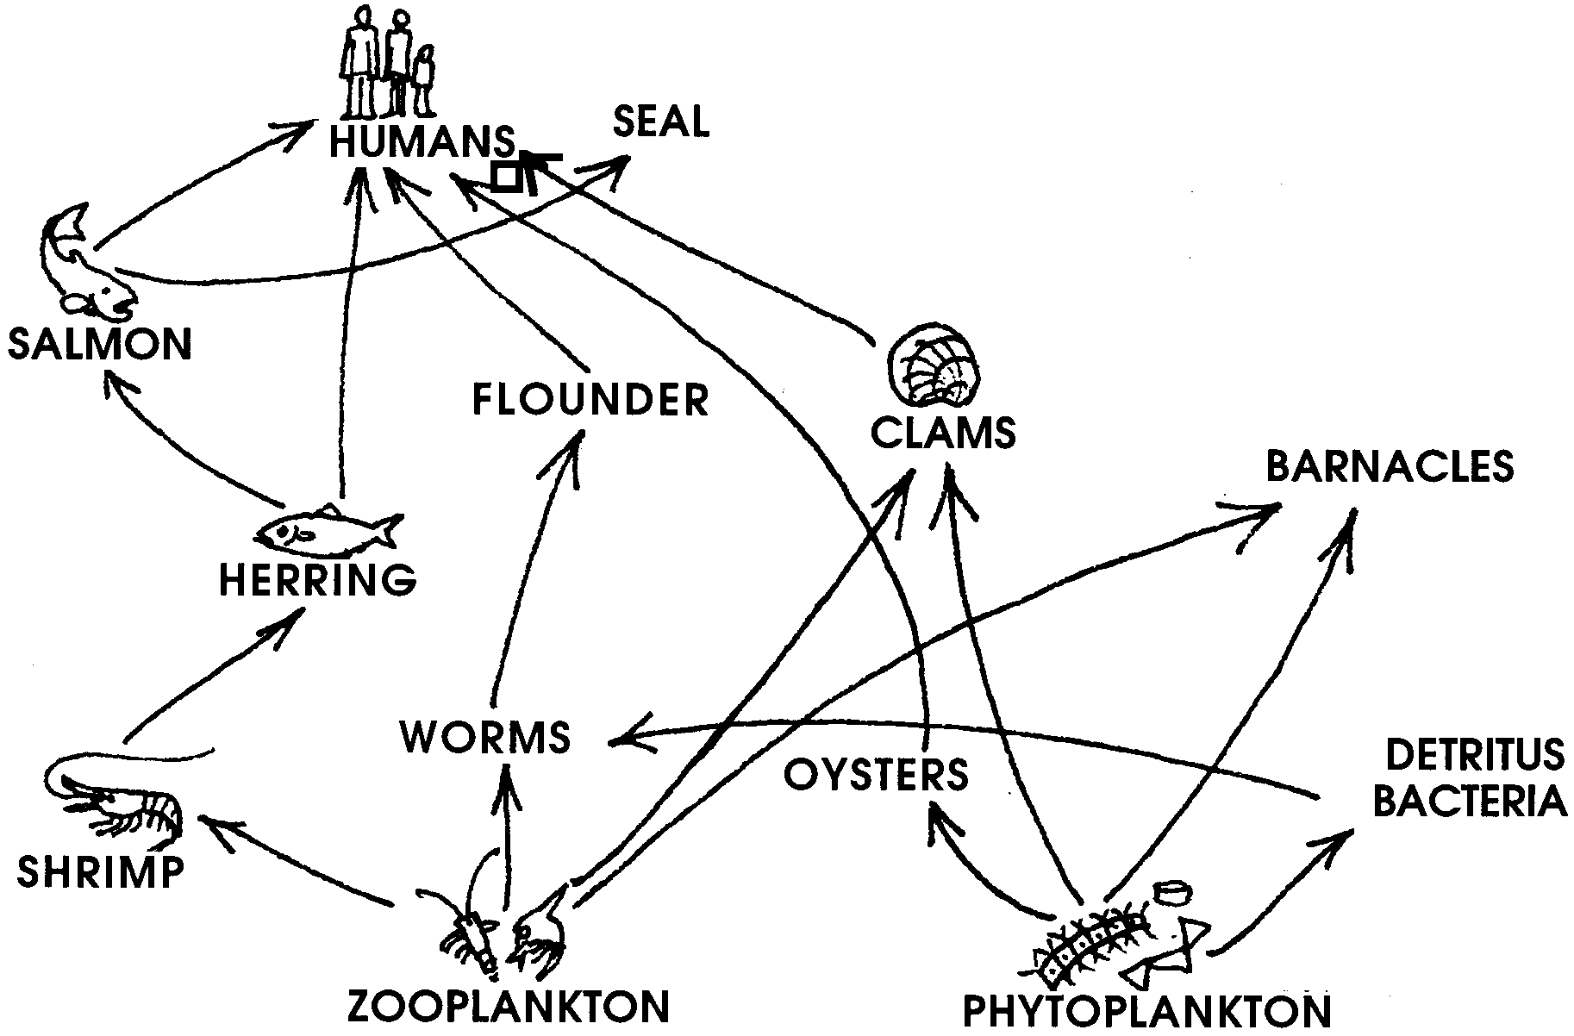

The above diagram hints at the highly integrated complex of interacting factors that constitute an ecosystem. It also reveals the potentially widespread changes that can be caused by removing a single component from the ecosystem. It follows that the stability of ecosystems tends to be directly proportional to the diversity of their population.

Stable ecosystems are essential to the health of the aquatic environment. As is becoming increasingly obvious, human choices affect the aquatic environment. Those choices which tend to simply these stable ecosystems may have serious, deleterious consequences for both the ecosystem and for human survival.

Author’s aside: In developing this curriculum, lessons were reviewed for accuracy by prominent ocean scientists. Dr. Jim Schumacher, an internationally known oceanographer, reviewed lessons covering this topic. His comments seem important to pass on.

“This (topic) is a good place to address the responsibility humans have for their Mother Earth. Note that ‘Man did not weave the web of life, he is merely a strand of it. Whatever he does to the web, he does to himself’, was said by Chief Seattle in 1854. Humans directly influence all (aspects of an ecosystem).

For example: Both strip mining and clear-cut logging result in loss of soil during rains. This creates turbid (muddy) waters which limit primary production (plant growth), and eliminate gravel substrate (bottom of creeks) where salmon eggs must be laid to survive. Thus consumers of young salmon heading to sea (many other fishes, birds and marine mammals) lose their food source, as do all those (including humans) who relish adult salmon.

It is crucial that ‘humans’ have a place in the web, and that our impact on the natural flow of energy through food webs be presented. We are the only animal which so drastically impacts the entire web of life on this planet.

It is a profound but simple truth that if humans do not come to know they are ‘but a strand’, then the web will be broken. How will our children’s children survive if we don’t begin to honor the web?”

An important point to keep in mind while teaching these lessons.

Materials

For each student:

• “Marine Environments” text pages

Teaching Hints

“Marine Environments” serves as an introduction to this course of study. It is important to use all of the assets at your command to generate and foster enthusiasm for the coming events. Emphasize that both living and non-living factors influence every living creature. It is not necessary to cite myriad examples at this stage. The activities and lessons that follow will provide material to show how the living and non-living combine to form an organism’s environment. Keep this central theme in mind as you go through the next several weeks of instruction.

Marine studies are inherently interesting to students. They can also be fun to teach. Enjoy this experience and your students will also.

Procedure

1. Duplicate the text pages.

2. Individually or in pairs, have students read “Marine Environments” and answer questions as they read.

3. In a class discussion, summarize the section and answer the six questions posed in the text.

This section provides ample opportunity for discussion. The challenge is to regard this as an introduction and not to get deeply involved, at this point, in the topics mentioned. You will have lots of chances to elaborate on these concepts.

Key Words

aquatic - living or growing in water

ecology - a branch of biology which studies the ecological relationships between organisms in a local environment, and between the organisms and their non-living environment

environment - the air, water, minerals, organisms, and all other external factors surrounding and affecting a given organism at any time

organism - a form of life considered as an entity; an animal, plant, fungus, protistan, or moneran

parasite - an organism that lives on or in an organism of another species, known as the host, from the body of which it obtains nutriment

terrestrial - growing or living on or in the ground; not aquatic

Answer Key

1. There are many possible answers. For example, the material of which the bottom is composed, pressure of water, pounding from the surf, etc.
Questions 1 and 2 are included to provide material for discussion.

2. Again, there are many possible answers. For example, sea gulls that might eat the sea star, people turning the sea star over and not returning it, etc.

3. The forest environment must provide the deer with space in which to live, food, water and air.

4. The answers will vary widely. Logic should prevail.

5. Same as question 4.

6. People tend to simplify environments.

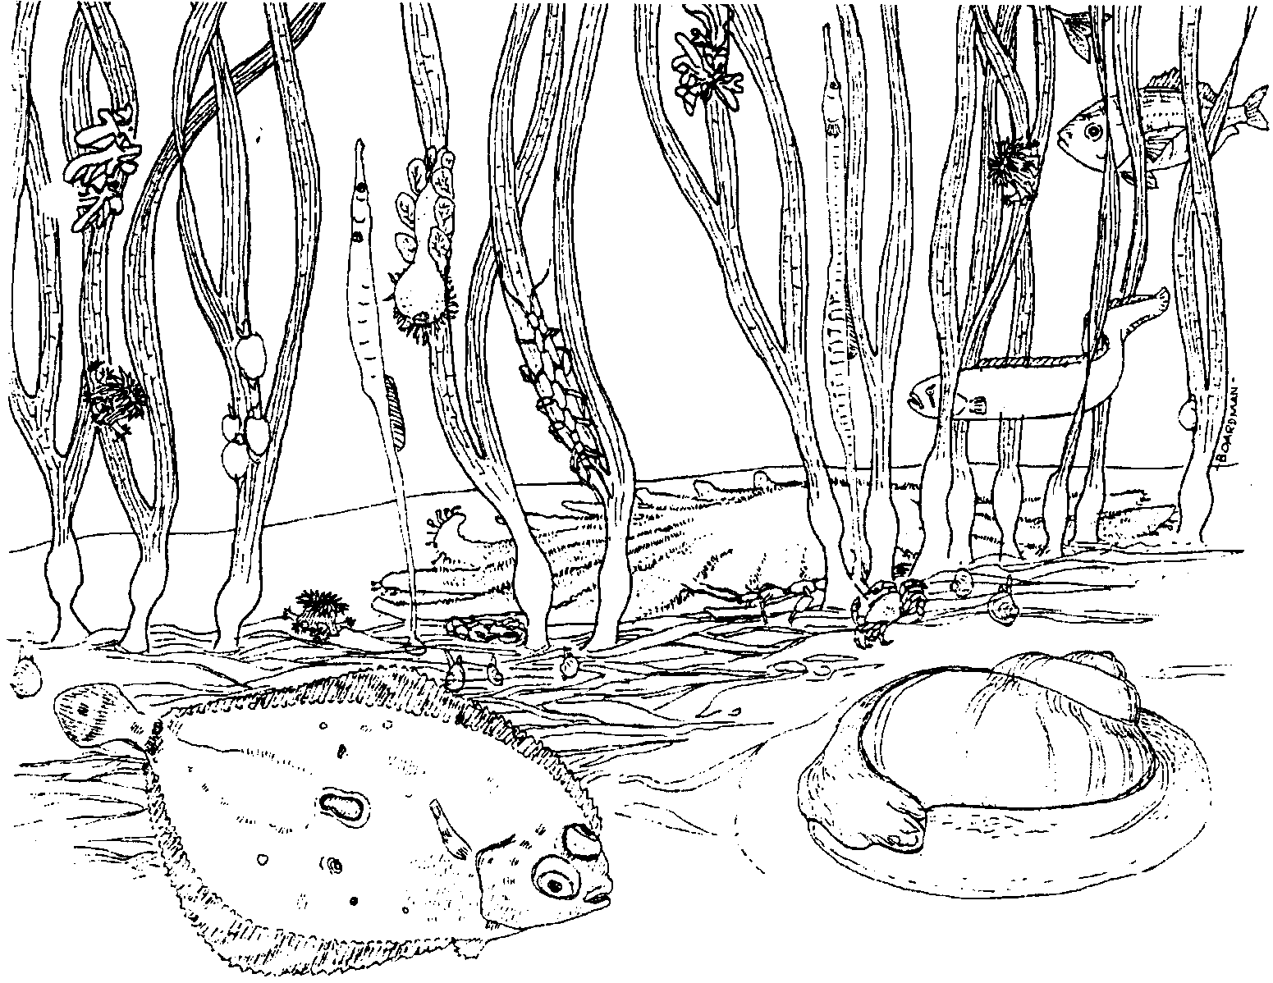
Marine Environments

What is an environment? An environment is all of the things that surround and affect a living creature. Ecology is the study of these environments. What kinds of things make up an organism’s environment? Let’s look at a seastar (starfish) and see. What kinds of non-living things affect the sea star? Temperature of the water and the air, movement of the water, and the chemicals present in the water, are all non-living things that affect the sea star.

1. Name one other non-living thing that might affect the sea star.

There are also many living things that affect the sea star and are therefore a part of its environment. The amount and kind of food present, and parasites that live on the sea star, are living things that affect our sea star.

2. Name one other living thing that might affect the sea star.

What are some of the qualities an environment must provide before life can exist? Animals require:
a. Space in which to live
b. Food
c. Water
d. Air

These factors must occur in an adequate amount and in the proper location for the animal. Plants also require these four items.

In addition, green plants require sunlight.

3. Deer live in the forest. What four items must the forest environment provide for the deer?
a.
b.
c.
d.

What kinds of environments exist? We can look first at the land or terrestrial environments. We might make the following list of terrestrial environments:
1. wooded
2. grass lands
3. tundra
4. mountainous
5. desert
6. city

Each of these environments has different animals and plants. The animals and plants find the things that they require for life within their environments.

4. For four of the terrestrial environments listed, name an animal or plant you would expect to find in that environment. Write the name next to the environments listed above.

Just as there are many kinds of land based environments, there are also many kinds of water based or aquatic environments. We could again make a list like the following:
1. swamp
2. lake
3. river and stream
4. estuary (fresh and salt)
5. seawater
6. aquariums

These environments each provide space, food, water and air for certain kinds of plants and animals.

5. For four of the aquatic environments listed, name an animal or plant that you would expect to find in that environment.
a.
b.
c.
d.

What is the effect of humans on these environments? People are agents of change. This means that, as humans, we tend to change the environments around us. We tend to make environments more simple. We eliminate certain animals and plants. We change the non-living factors by building dams, adding chemicals and heat to the water, and similar things. In the long run, simple environments may not be able to support life as we now know it. In your study of the marine environment look for the living and non-living factors that make up the marine environment. Look also for the impact of humans on the marine environment.

6. How do people tend to change environments?

The marine environment is one of our last frontiers. You will have a chance to discover some of the interesting things we now know about the seas. You will also see some of the things that are awaiting discovery. Perhaps you will be the person who will someday answer the questions we have about the marine environment. The marine environment will play an important role in the future of this country and of the world. Understand and enjoy the marine environment.

