Viewing the Ocean Planet From Space -

Plankton Patterns
Lesson by Linda Hagelin, Saratoga, CA

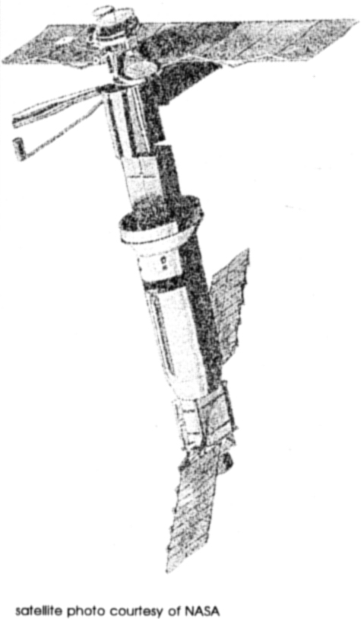
Key Concepts
1. Satellite measurements provide a global view of temperature, current and nutrient patterns in the sea.
2. Measurements taken from on board ships produce detailed, local information about temperature, current and nutrient patterns in the sea.
3. Scientists use both methods to get the most accurate information possible.
4. Changes in temperature, current and nutrient patterns are more easily monitored now with satellite technology.

Background

Technology has increased the ability of oceanographers to collect observations of the surface of the ocean. Satellites now pass over a particular location several times a day, collecting hundreds of pieces of data in a fraction of the time it would take aboard ship. Satellites can collect information in 10 minutes that would take weeks to collect on board ship at the surface. The speed and volume of data collection is important because sometimes ocean conditions can change before data can be gathered by ship. At sea measurements still remain important to link (and verify) the surface data, collected by satellites from a thin (less than a few centimeters thick) veneer of the ocean, with data taken at depth from ships. As a result of these efforts, large scale pictures of ocean conditions are possible now. These global images make tracking changes in natural patterns more feasible.

One important large scale picture is that of plankton patterns. Presence of plankton means the presence of fish that eat plankton and other animals higher in the food chain that eat these fish. This is valuable information for fishing fleets as well as biologists.

Living organisms are not distributed evenly over the earth. Plants and animals alike live where the conditions are best suited for their survival. The same holds true in the ocean. Plankton live where the temperature and nutrients in the water favor their growth. Most often the areas of greatest plankton are along the coastlines of continents, especially along the eastern boundaries of the oceans where nutrient-rich deep-ocean water upwells. Runoff of nutrients from the land and the comparatively shallow sunlit waters in these areas also favor plankton reproduction. By contrast, there are large areas of the open ocean that have a relatively low plankton population because of less favorable nutrient, temperature, or sunlight conditions. Today, satellites are able to map the phytoplankton (plant plankton) in the ocean through the use of special instruments which detect the chlorophyll they contain. Changing plankton patterns can be mapped by season in any area of the world.

Materials

For the class:

• NASA’s TOPEX-POSEIDON video (see source below)

• Nimbus-7 image of North America: plankton patterns on FOR SEA-CD ROM

For each student:

• graph paper (4 squares to the inch, marked with alternating bold lines)

• pencil

Teaching Hints

In “Viewing the Ocean Planet from Space - Plankton Patterns”, your students will have a chance to become oceanographers and find the plankton pattern from given data. They should be familiar with the points on a compass and how to plot coordinates on a graph before beginning. They should also be familiar enough with maps to know that north is always at the top of the chart.

Before beginning this activity, show the NASA video tape introducing the TOPEX-POSEIDON satellite used to study ocean surface topography. It is a short video and gives a good overview of satellite oceanography and its benefits. The video is available from:

NASA Jet Propulsion Laboratory Teacher Resource Center
JPL Education Outreach
4800 Oak Drive
Mail Code CS 530
Pasadena, California 91109
(818) 354-6916

In “Viewing the Ocean Planet from Space - Plankton Patterns”, students use coordinates to locate a plankton pattern along an imaginary coastline. The larger areas formed by the drawn lines are called SECTORS and are labeled as: A1, A2, B1, B2, etc. Within each sector are four smaller squares called QUADRANTS. Each quadrant is labeled according to the points of a compass. North on this chart is at the top. In each sector there are Northwest, Northeast, Southeast, Southwest quadrants. For example, in Sector A1, can the students find the NW quadrant? (Upper left corner of the sector.)

SECTORS represent the data that would be collected by SATELLITE. They are larger areas, more general information than can be pinpointed by shipboard measurements. QUADRANTS represent the data that would be collected on SHIPBOARD. You students will use both kinds of information to find the plankton pattern.

Procedure:

1. Before reproducing the grid worksheet, draw in a coastline or land masses on a copy of the blank graph master included here. For example, your finished grid might look like this:

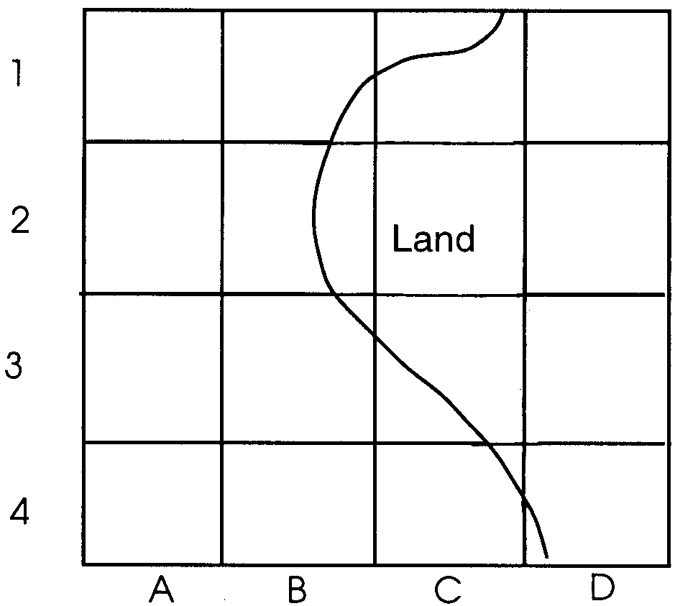

2. Duplicate the worksheets.

3. Decide before class what the plankton pattern will be for this activity. Be sure that you make a sketch of the plankton pattern on one of the labeled student sheets for your reference.

4. During the activity, the students will ask you questions to gather their data. “Is there plankton data in Sector B4?” Might be a typical question. You answer yes or no, depending on the pattern you have drawn, and the students mark the sector. It is suggested that students fill in only the sectors and quadrants that have plankton data . . . this will yield a readily discernible pattern when enough data is gathered. The first time you do this with the class you may want to keep a record of the requested data on the blackboard as the students ask for it:

Plankton Present Plankton Absent
A - 1; NW, NE B-4; NW,
B-1; NW, SW

5. To make the activity a little more challenging and realistic, tell the students that they are on a limited budget. They can request only 10 satellite data inputs and 20 shipboard inputs. The class can work together as a group to find the pattern the first time. While each class will develop its own strategy, usually the students will ask for satellite data first (sectors), then zero in on the sectors with plankton to ask more detailed shipboard data questions (quadrants).

6. When they have used up their question budget, ask the class to show the plankton pattern that they found. Lead a discussion on what features might be in the area to encourage plankton growth. (Most plankton is found along continental coastlines, especially along the eastern boundaries of the oceans where nutrient-rich deep-ocean water upwells. Runoff of nutrients from the land and shallower, sunlit water also helps make the conditions favorable for phytoplankton growth.)

7. Experiment with different patterns for the class to find. You might show a small circle in the middle of the chart as a pattern. This could be plankton blooming around the edges of an island such as Hawaii. Plankton might bloom at the edge of a sewer outfall or the mouth of a large river like the Mississippi.

8. On the FOR SEA- CD ROM, have small groups observe the image of the Nimbus-7 satellite picture of North America. The image shows patterns of phytoplankton (plant) productivity along the Atlantic coastline. The highest levels of phytoplankton are shown in reds and oranges, with green, blue, and pink showing gradually lower levels. Black means no data for that area. Have the groups answer the following questions as they look at the satellite image:
a. Where are the highest populations of phytoplankton (plant plankton)?

(The highest populations of phytoplankton are found near the continental margins.)

b. What do you think might explain the high phytoplankton populations in those areas?

(Answers will vary depending upon student experience. If students have completed the previous activities, some should suggest that upwelling over the continental shelf brings nutrient-rich water from the deep ocean to the surface where it becomes available to spur phytoplankton growth.)

Key Words

current - large scale movement of ocean waters

plankton - free floating plants and animals, usually (but not always) microscopic, that are at the mercy of currents in the ocean

phytoplankton - plant plankton

quadrant - in this activity, an area comprised of four equal, square sections each labeled according to the points of the compass

sector - in this activity, one of the four equal, square sections of a quadrant, the sectors are labeled NW, NE, SE, SW

zooplankton - animal plankton

Extensions

1. Colorful wall posters of satellite oceanography are available from:

U.S. Government Printing Office
Superintendent of Documents
Washington, D.C. 20402
STOP: SM

Ask for the “Oceanography from Space” posters.

2. When the students are familiar with the procedure in this activity, you might make it a competitive task. Divide the class into teams of scientists. They ask you for plankton data. You circulate among the teams. A team will ask for sector or quadrant information by pointing to one on their chart. You can nod yes or no without saying a word. Teams keep their information secret and try to be the first to come up with the correct plankton pattern.
Viewing the Ocean Planet From Space - Plankton Patterns

