The Ocean Planet
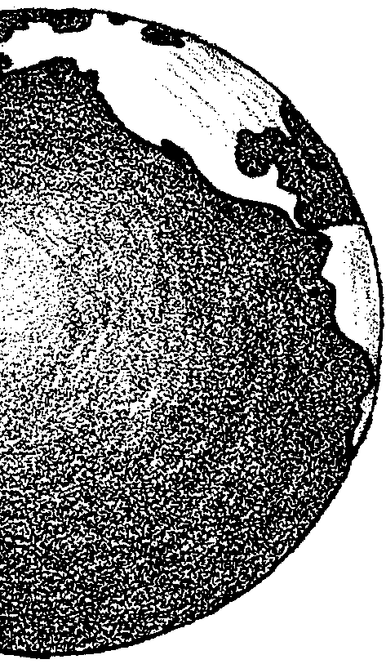

Key Concepts
1. What we usually call the “oceans” are really connected in one world ocean whose waters mingle because of global currents.
2. The sun warms the ocean differentially; this temperature differential plays a role in global currents and climate helping to keep our planet habitable.
3. Water and air are both “fluids” and behave in similar ways.

Background
Earth is the Ocean Planet: ocean waters, vital to all life, cover more than 70% of its surface. Stirred and mixed by mighty currents, the oceans distribute heat across the globe and, along with our atmosphere, help regulate our climate.

The sun warms the ocean (and the atmosphere) differentially: equatorial waters receive more sunlight and are warmer than water farther away from the equator. Likewise, the polar waters receive the least sunlight and are the coldest. This differential heating of the earth by the sun drives the global atmospheric and oceanic currents like a huge circulatory system and helps keeps our planet habitable.

Near the equator, these differences in temperature help cause the trade winds which push ocean water westward. The water warms as it travels at the surface. The earth’s rotation deflects this warm, westward flowing water out away from the equator toward the poles. As this surface water diverges north and south, deeper colder water rises (upwells) to replace it near the surface.

The equatorial water moves great distances north and south. As it nears the south pole, it cools and sinks to the bottom. The water becomes part of a bottom current of very cold, dense water which moves away from the poles back toward the equator. Arriving at the equator, this cold, dense water once again rises because of the upwelling driven by the trade winds. The cycle is completed, only to begin again.

The ocean has a much higher heat storage capacity than the atmosphere and acts as a huge heat distribution system for our planet. This global mixing insures a distribution of the sun’s heat that keeps our ocean planet habitable. Without this distribution of heat, the water at the equator would heat to boiling while the water at the poles would freeze to a much greater extent!

Materials

Part I - Heat Storage

For the class:

• jars, 2, quart-size with lids

• thermometers, 2

Part II - Global Vision

For each group of 3 or 4 students:

• globe (preferred - borrow from other classes!) or world map

• “Ocean Planet” activity sheet

Part III - Water In Motion

For each group of 3 or 4 students:

• clear drinking glass or jar to hold water

• water, tap water cool

• water, tap water hot with a couple of drops of red or orange food coloring

• colored ice cube (freeze colored water made with LOTS of blue or green food coloring)

• aquarium thermometer

Teaching Hints

“The Ocean Planet” introduces students to the interconnectedness of the oceans through three activities. Part I is a teacher-lead investigation which compares the relative heat storage capacities of water and air. In Part II, students examine a globe or world map to determine everything they can about the world ocean from such a source. Part III is a student experiment concerning cold water currents.

Part I - Heat Storage

In Part I, students demonstrate the heat storage ability of water in comparison with that of air through a simple experiment.

Procedure

1. Place a thermometer in a covered jar, and put the jar in a sunny window of the classroom, or in a sunny place outside. Say:

“This jar is full of atmosphere (air).”

2. Place a thermometer in the second jar, fill the jar with water and replace the lid. Place this jar next to the first jar. Say:

“This jar is full of ocean (water).”

3. Record the temperature of both the air and the water on the chalkboard. Ask the children to predict what will happen. After a bit of time for predictions, ask which thermometer will show a faster rise in temperature: the atmosphere (air) or the ocean (water)? Ask why they think so.

4. Allow the two containers to remain in the sun for 15 minutes to an hour (the amount of time depends on your latitude, time of year etc.; allow enough time for the water to feel warm). You may wish to go on to Part II while the containers are sunbathing.

5. Record the new temperatures of both atmosphere (air) and ocean (water) on the chalkboard next to starting temperatures. Ask:

“Which one is hotter?

Which one showed the most change?”

6. Say:
“We are now going to see which container, the “atmosphere” or the “ocean”, loses heat faster. What do you think will happen? Why do you think so?”

7. Place the containers in a shaded place in your room. After 15 minutes to an hour away from the sunlight, take the temperatures again. Find the difference between the new and the previous air temperature. How many degrees did the air cool? Find the difference between the new and the previous water temperature. How many degrees did the water cool? (Note: the important point here is the number of degrees of the change in each glass; the water may remain cooler than the air.)

8. Ask the students to make a general statement about the heating and cooling characteristics of the “atmosphere” (air) and the “ocean” (water).

(A general statement might be: Water heats up more slowly than air. Once it is warm, water releases heat (cools down) more slowly than air.)

9. Ask the class:

“In winter, do you think the average ocean would be warmer or cooler than the air temperature? Why?”

If students need a hint, remind them that they just found that the ocean does not cool off as fast as the air does. (In the winter, average ocean temperature is likely to be warmer than the average air temperature.)

“What do you think would happen in the summer?”

If students need a hint, remind them that they just found that the ocean does not heat up as fast as the air does. (In the summer, average ocean temperature is likely to be cooler than the average air temperature.)

This capacity to store heat makes the ocean a climate regulator for the Earth. Cities along a coastline have somewhat milder weather than cities far inland. Since the ocean does not heat up or cool down as fast as the air does, it tends to moderate the temperature.

Part II - Global Vision

In Part II, students examine a globe or world map to help them discern the relationship between the ocean and the land masses. (Many globes show warm and cold currents and/or sea floor topography).

Procedure

Distribute globes and activity sheets. Circulate through the room as students work in groups to answer the questions posed. Upon completion, be sure to provide time to discuss the results with your students.

Part III - Water In Motion

In Part III, students observe the interaction of waters of different temperatures using colored ice cubes and a thermometer, then draw a parallel with global ocean currents warmed differentially by the sun.

(Part III) Procedure

Well before class, freeze colored ice cubes. Be generous with the food coloring to assure students will be able to see the cold, colored water sink from the ice cube and form a colored layer on the bottom.

Duplicate and distribute the student activity pages.

Caution students to be very gentle when pouring the colored, warm tap water. You may wish to demonstrate the pouring. If done carefully, a red layer (a lens) will form over the clear water (actually, if all works well, your students will end up with a very patriotic red, white (clear) and blue model).

Plan to allow time for a discussion of the “Analysis and Interpretation” section. Emphasize the mixing of ocean waters and the concept that the oceans are really connected in one world ocean.

Key Word

atmosphere - the air surrounding the Earth

Answer Key

Part II - Global Vision

1. Answers will vary: some globes and maps show ocean currents and sea floor topography. “The Seven Seas” depends upon how you count the water areas on the globe. Do you include the Mediterranean? The Baltic? After struggling with this question, help students notice there is just ONE interconnected ocean on our planet.

2 a. Differences between ocean at North Pole and South Pole are quite striking. The North Pole is ocean surrounded by land; the South Pole is land (Antarctica) surrounded by ocean.

b. Because Antarctica is a huge area of ice (elevation at the South Pole is about 10,000 ft. . . . all ice!), the South Pole is much colder. Ocean water tends to moderate temperature, so you would expect the North Pole, covered by ocean, to be warmer.

3 a. A ship could sail all the way around the globe without running into land only in the Southern Ocean around Antarctica. The winds in this area are a sailor’s nightmare, and were called the “Roaring Forties” (the treacherous winds were found beginning at 40 degrees South Latitude). No land blocks or slows down the wind and waves. The fiercest storms in the world occur in this region.

b. There is also little shipping in this area because there is very little land area in the Southern Hemisphere. Most of the continental land areas are north of the equator.

4 a. You would expect to find the warmest ocean water at the equator.

b. You would expect to find the coldest water at the poles.

Part III - Water In Motion

Analysis and Interpretation

1. The colored water moving away from the ice cube was warmer/cooler than the tap water in the glass. (The correct answer is underlined.)

2. In the ocean, one would you expect to find floating ice and cold water near the poles (and in the deep ocean).

3 a. One would expect moving cold water to flow at the bottom.

b. Explanations will vary but should be based on the observed experimental results.

4. The warm, colored water you added was warmer/cooler than the tap water in the glass. The correct answer is underlined.

5. In the ocean, one you expect to find the warmest waters near the equator (and at the surface).

6 a. One would expect moving warm water to flow at the surface.

b. Explanations will vary but should be based on the observed experimental results.

7. Differences in temperature cause large scale versions of the movements observed by the students which help, over long periods of time to thoroughly mix ocean waters.

The Ocean Planet
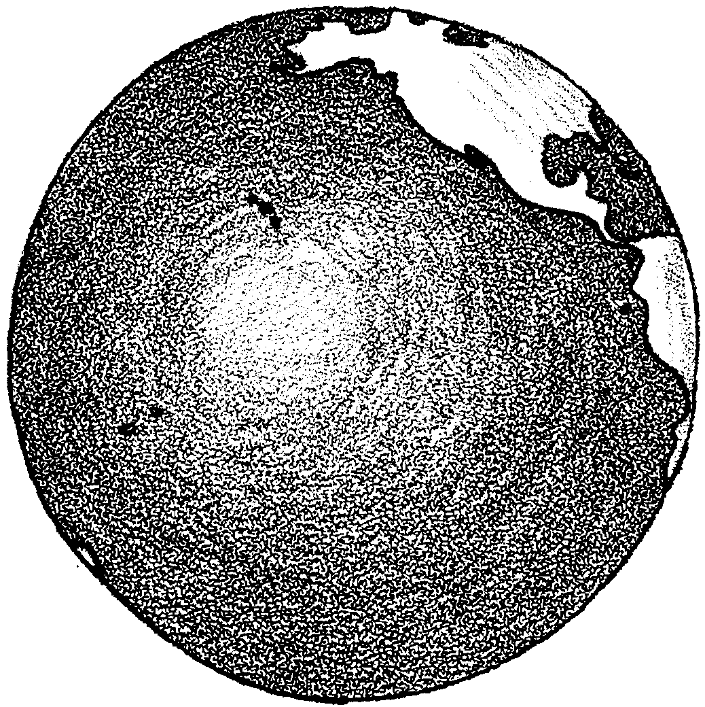
The Ocean Planet: Global Vision

You can learn a lot about our Ocean Planet by looking at a globe or world map. See what you can find out. Answer the following questions with your group while looking at a globe or map of the world.

1. Look at the oceans of the world. Is the old saying “The Seven Seas” correct? Why or why not?

2. Look at the globe from the North Pole and then from the South Pole.

a. What are the differences that you notice in the ocean?

b. Which do you think is the coldest area, North Pole or South Pole? Please explain your choice.

3 a. Where could a ship sail in a straight line all the way around the planet without running into land?

b. There is actually VERY LITTLE shipping traffic in that area. Why do you think this is so?

4. The sun warms the land masses of our planet. It warms the ocean waters and the atmosphere too.

a. Where would you expect to find the warmest ocean water? (Hint: Where are the warmest/coldest places on our planet?)

b. Where would you expect to find the coldest ocean water?

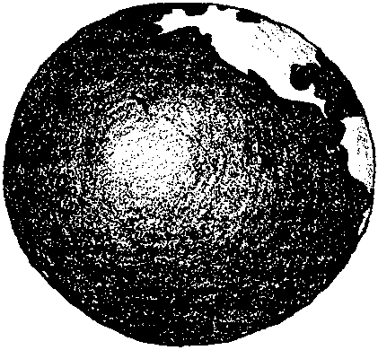
The Ocean Planet: Water In Motion

Ocean waters are always in motion. We know the wind blows across the ocean and moves ocean waters. What else causes ocean waters to move? To begin to answer that question, you’ll need a few things:

Materials

• clear drinking glass or jar to hold water
• water, tap water cool
• water, tap water hot with a couple of drops of red or orange food coloring
• colored ice cube (freeze colored water made with LOTS of blue or green food coloring)
• spoon
• aquarium thermometer

Here’s what to do.

Procedure:

1. Obtain a clear drinking glass or jar.

2. Fill the glass 3/4 full with cool tap water.

3. Gently place the aquarium thermometer in the glass. Wait two minutes. Take the temperature. Record the temperature here:


4. Obtain a colored ice cube. Use the spoon to gently place the ice cube in your glass.

5. Watch your glass. What happens?

Draw a picture of what happens. Use this picture of a glass.

6. After two minutes, take the temperature. Record the temperature here:

7. Obtain about 1/4 glass of warm, colored tap water.

8. Very gently pour the warm, colored tap water down the inside edge of your other glass. Try not to disturb the water.

9. Watch your glass. What happens?

Draw a picture of what happens. Use this picture of a glass.

10. After two minutes, take the temperature. Record the temperature here:

Analysis and Interpretation

1. The colored water moving away from the ice cube was warmer/cooler than the tap water in the glass. (Circle the correct answer.)

2. In the ocean, where would you expect to find floating ice and cold water?

3 a. Would you expect moving cold water to flow at the surface or at the bottom?

b. Please explain your answer.

4. The warm, colored water you added was warmer/cooler than the tap water in the glass. (Circle the correct answer.)

5. In the ocean, where would you expect to find the warmest waters?

6 a. Would you expect moving warm water to flow at the surface or at the bottom?

b. Please explain your answer.

7. Scientists have studied water from all areas of the ocean. They have found that waters are very much alike. They seem to be well mixed. How might differences in temperature help mix ocean waters?

