Papier-mâché Tidepools
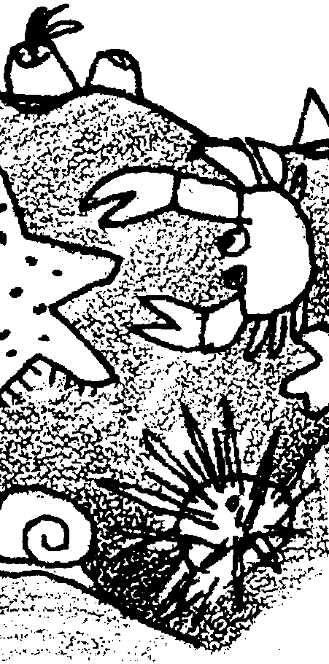
Lesson by Pat Williams, Eugene, OR

Key Concepts
1. A tidepool is formed when receding seawater is trapped in a hole or depression in the rocky shore.
2. Tidepools provide habitat for many plants and animals of the sea.
3. Plants and animals that live in the intertidal zone, including tidepools, have behavioral and structural adaptations which help them to survive in this harsh environment.
4. Tidepools are heavily populated communities, with a wide diversity of organisms.

Background

Background material for “Papier-mâché Tidepools” is found in “Intertidal Tales” and all other preceding activities.

Materials

Materials requirements vary depending on the number and size of tidepools constructed.

For constructing the tidepool:

• heavy cardboard or plywood for the base, approximately 4' X 4' ( one for each tidepool to be constructed); Cardboard bases are easier to move than plywood bases. The size of the base is not critical.

• newspaper

• masking tape (three rolls)

• papier-mâché adhesive (thin flour and water mixture)

• dish pans or buckets

• drop cloth or tarps for working area(s)

• tempera paints and brushes

For making tidepool animals:

• oil based clay

• reference materials for pictures of tidepool animals and plants

For seaweed:

• green cellophane

• brown and green tissue paper

Teaching Hints

In the activity “Papier-mâché Tidepools”, students create a life-sized replica of a coastal, rocky shore tidepool. This wonderful, “hands-on” activity is developmentally appropriate for primary grade children and is especially good for kinesthetic learners, but also good for visual and auditory learners. The activity brings abstract ideas into concrete form.

While “Papier-mâché Tidepools” is messy, it uses easily acquired materials and provides a great process and product. Children work together and learn from each other in cooperative learning groups. The project reinforces and demonstrates what children have learned about the tidepool habitat. It complements the previous lessons on tidepool creatures and tidepool etiquette, and can be used for evaluation of the unit. The tidepools also make excellent displays for “Parents’ Night” and similar events.

“Papier-mâché Tidepools” is suggested as a culmination activity for use after the children have acquired a general knowledge of tidepool organisms and habitat. It has been a consistent favorite.

This project will take from 4 to 10 days, depending on the length of each session.

Preparatory Activities

• Identification of Tidepool Organisms
Use posters or other large pictures of plants and animals in a tidepool for identification. Ask, “Can you find a . . . ” questions. The poster “Intertidal Organisms Zonation” (see Bibliography) is particularly helpful.

• Pantomime
Have children describe or act like tidepool creatures. For example, a child or group of children can pantomime a creature while the other children try to guess its identity.

• Books and stories
Read from books like Clancy and His Tidepool Friends, by Carol Batdorf and stories from“High Tide/Low Tide” from Project ORCA (see Bibliography).
Constructing the Papier-maché Tidepool

Phase 1: Building the Base (1-3 sessions)

1. Put the plywood or cardboard base on a horizontal stand or table. Allow walking room around the table. Place a tarp or drop cloth underneath.

2. To begin the forming of the tidepool, have students wad up single sheets of newspaper and tape down the wads with long pieces of masking tape. Shape the pool on the base using the wads of newspaper, making one side of the pool higher than the other. Wads can be stacked on each other to create the irregular shapes of natural, rocky tidepools. The result should not look like an inner tube. All of this is done with dry, wadded newspaper. The messy part comes next.

Phase 2: Papier-Mâché (1-2 sessions)

1. Before class, mix water and flour into a glue with a consistency of very thin pancake batter. Mix enough for two buckets per tidepool, and about two quarts of the mixture per bucket. (Parent helpers can make excellent mixers.)

2. Have students tear newspaper into six inch wide strips.

3. Proceed with the papier-mâché molding. (Here comes the mess - see hints below.)

Have students hold a newspaper strip by one end and dip it into a bucket of glue. To remove excess glue from the strip; hold up the strip with one hand; place the first and second fingers of the other hand around the strip, near the top; grip the paper gently with fingers and slide the fingers gently (to avoid tearing) down the strip. Students may need some guidance. One approach involves taking turns: have them form a circle around the table with one child dipping, one stripping, one applying; then, rotate to the next step.

4. Place the wet strips over the wadded newspaper. Create a natural look by leaving rock-like humps, holes, and crevices.

HINT: If the tidepool is too smooth and round, squish it and poke it with your hands to make it more irregular and natural looking, like rocks.

Hints for dealing with “THE MESS”:

This is a messy activity. Invite adults to join as helpers, one to a tidepool. If available, have students use smocks. Have rags available for wiping the soles of their shoes before they leave the tarp. Glue on fingers is an obvious problem for which we can only suggest that you remind students of the time-honored rule to keep their hands to themselves and out of their noses and hair!

5. Let the structure dry overnight.

6. Repeat steps 3 & 4, as needed.

Phase 3: Painting the Tidepool (1-2 sessions)

1. Have students paint the tidepool with tempera paints. Use rock-like colors (gray, brown, green-browns) and various shades of blue for water.

Phase 4: Making the Animals and Seaweed (1-3 sessions)

1. Provide pictures, posters, books, shells, etc. as visual references for use as students make tidepool organisms.

2. Have students construct animals from oil-based clay. While oil-based clay is available in limited colors, it is a great medium for shaping animals and for adhering to the tidepool. Children will usually have their own creative ideas for animals (e.g. toothpicks in a ball of clay make great urchins) and for where to place them in the tidepool. Other materials such as paper egg cartons and pipe cleaners are useful for creating tidepool denizens.

3. Cut green cellophane and brown and green tissue paper to represent seaweed. Place (tuck or scatter) in the tidepool .
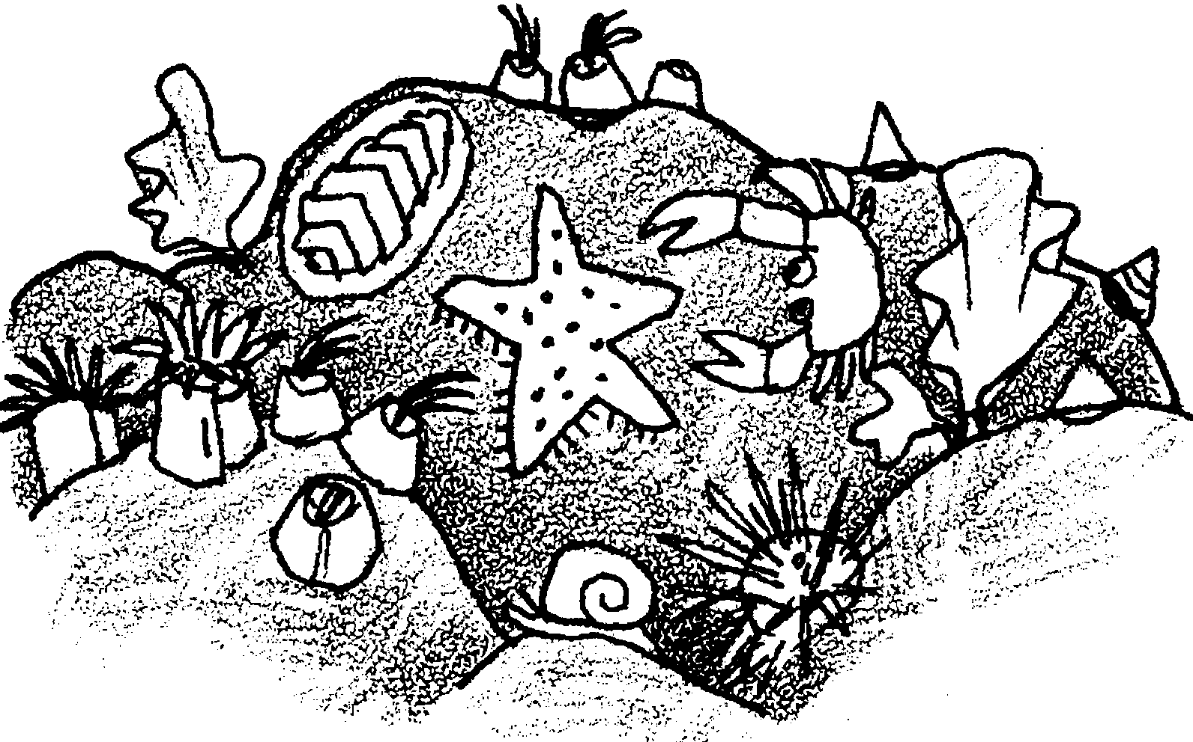

Phase 5: Reviewing Tidepool Organisms (1-4 sessions)

1. “Ways to Hold On”, “Ways to Catch Food”, “Ways to be Protected”, and “Hiding in the Tidepool” activity sheets are provided to help you use your need tidepools to review the concepts and information covered in previous lessons. These activities were adapted by Pat Williams of Eugene, Oregon from the “Marine Life Teaching Kit” by Julie Swartz, Queenscliff, Victoria, Australia.

Key Words

adaptation - an alteration or adjustment, often hereditary, by which a species or individual improves its condition in relationship to its environment

habitat - the area or type of environment in which an organism or biological population normally lives or occurs

tidepool - a depression which retains receding seawater as the tide ebbs, often providing a suitable habitat for many marine plants and animals

Answer Key

Completed activity sheets for the following are in the Resource Files for this lesson.

Ways to Hold On

Ways to Catch Food

Ways to be Protected

(Answer Key is continued on the following page.)

Answer Key -
Ways to Hold On

(The correct parts are circled.)
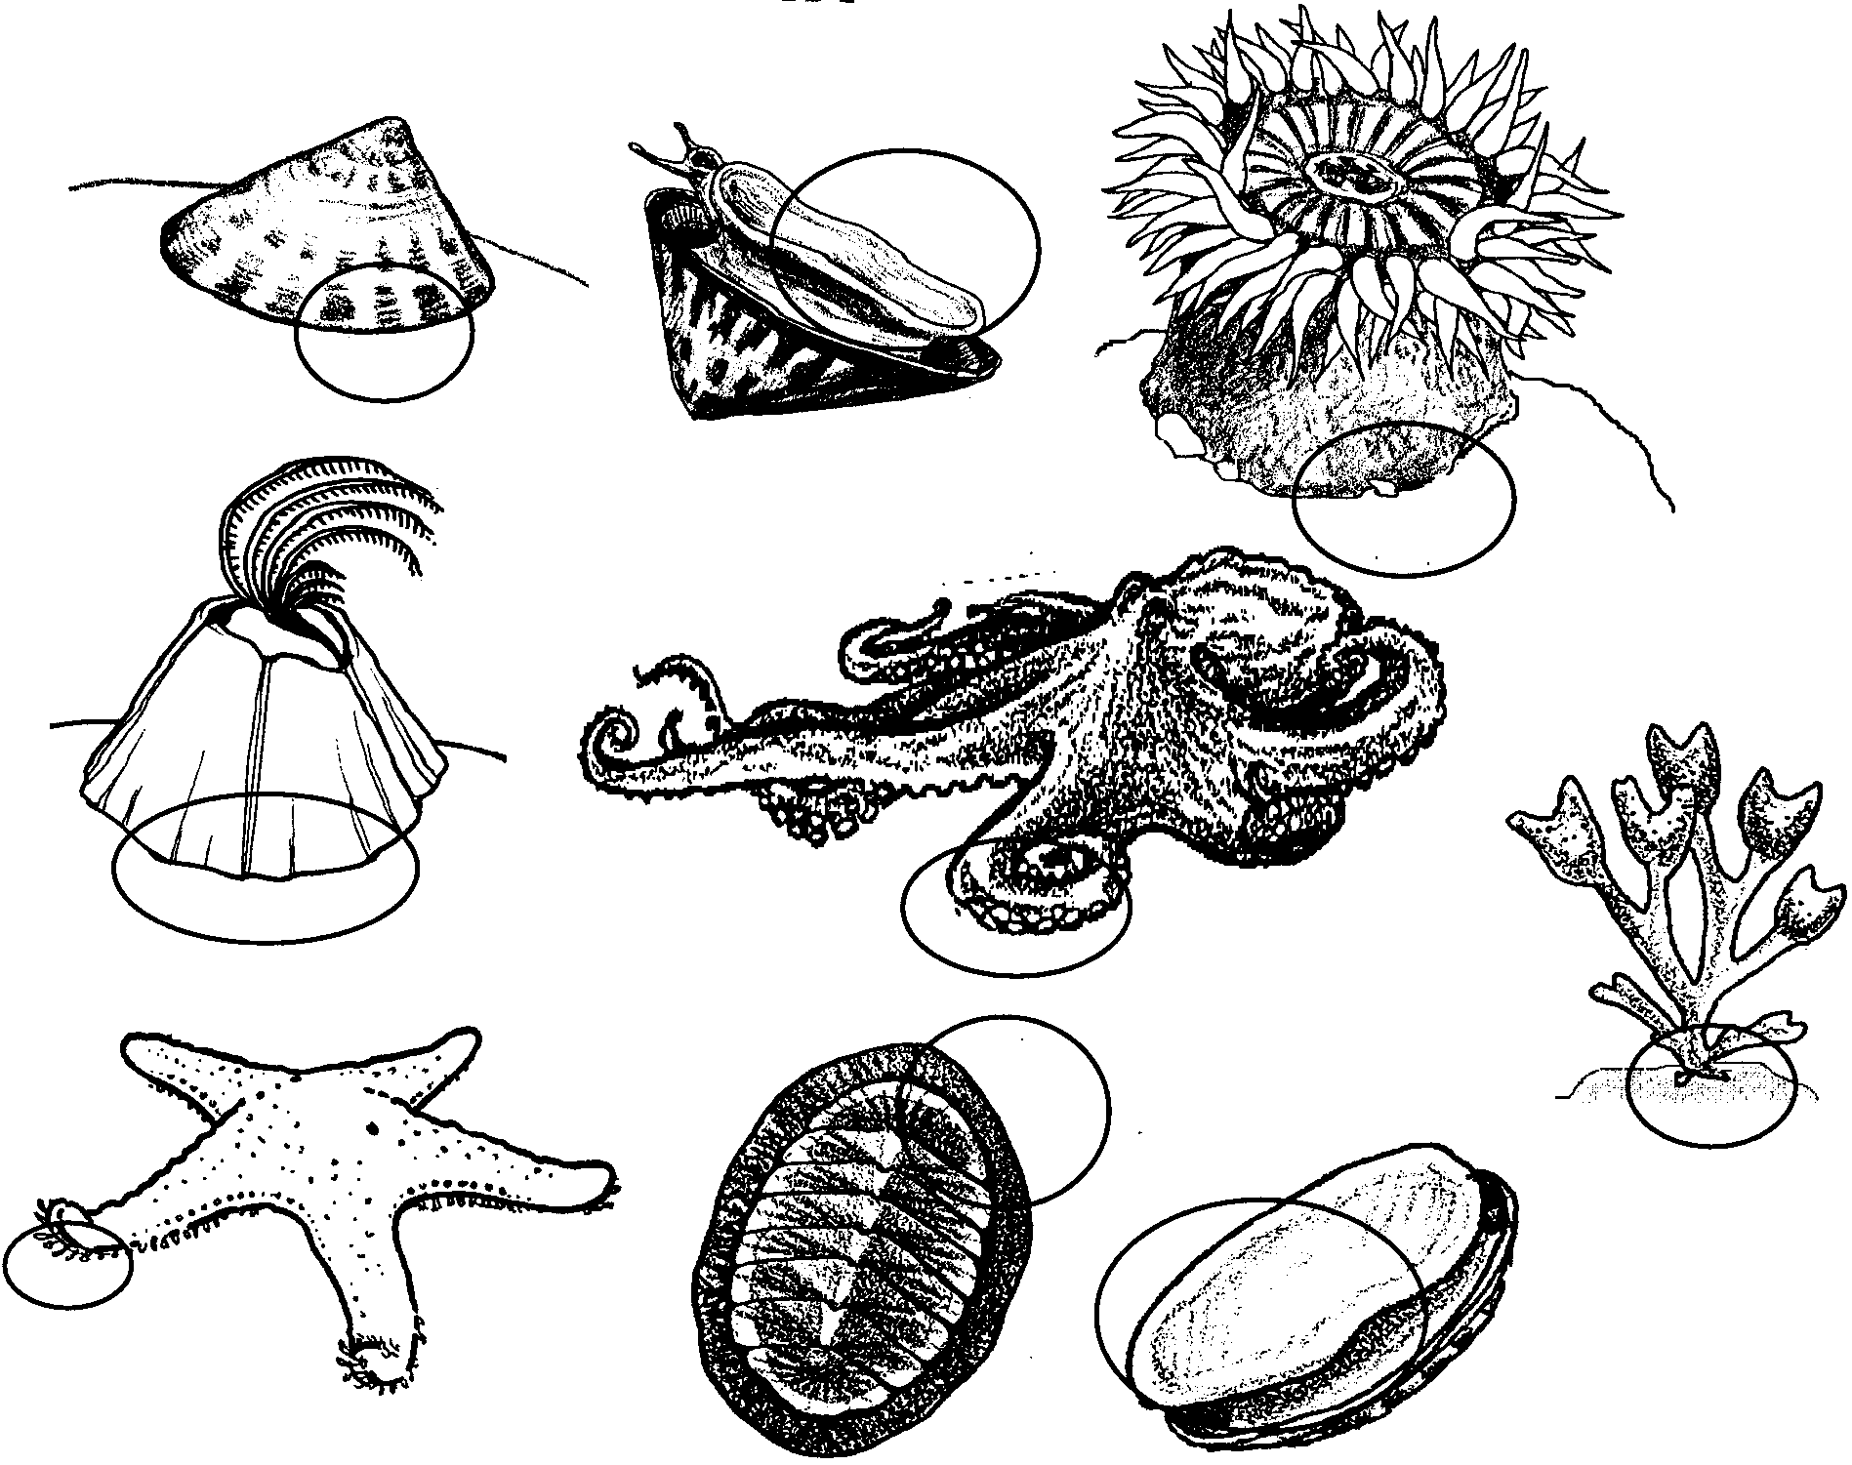

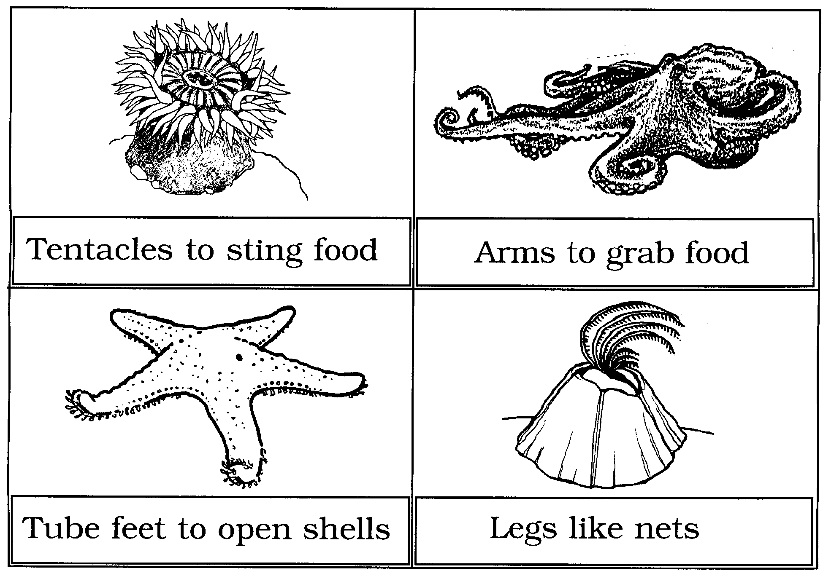
Answer Key -
Ways to Catch Food

Answer Key -
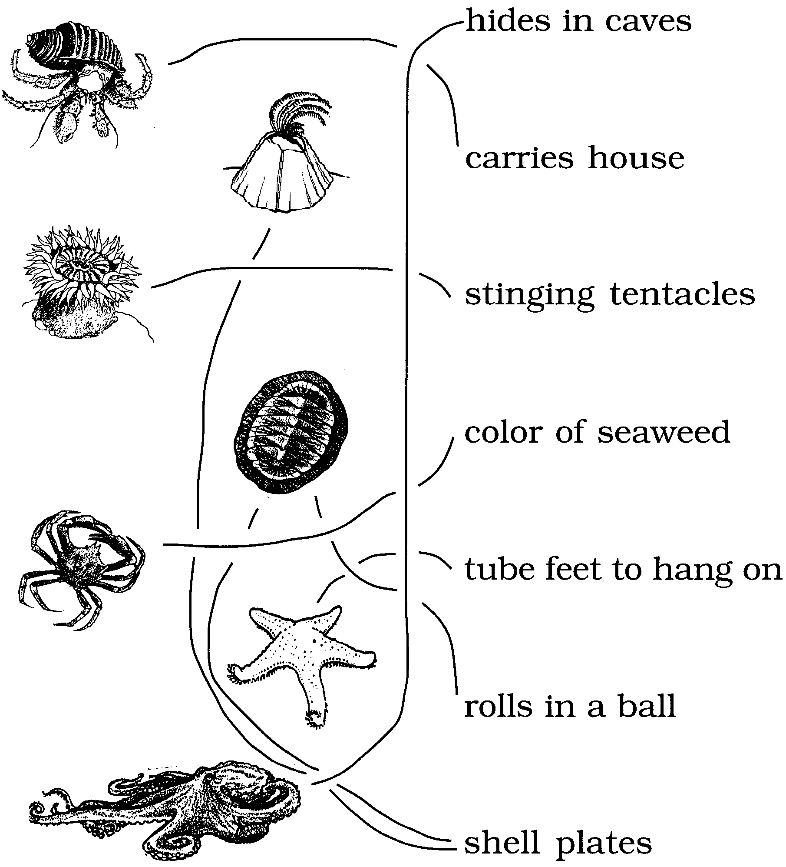
Keeping Safe

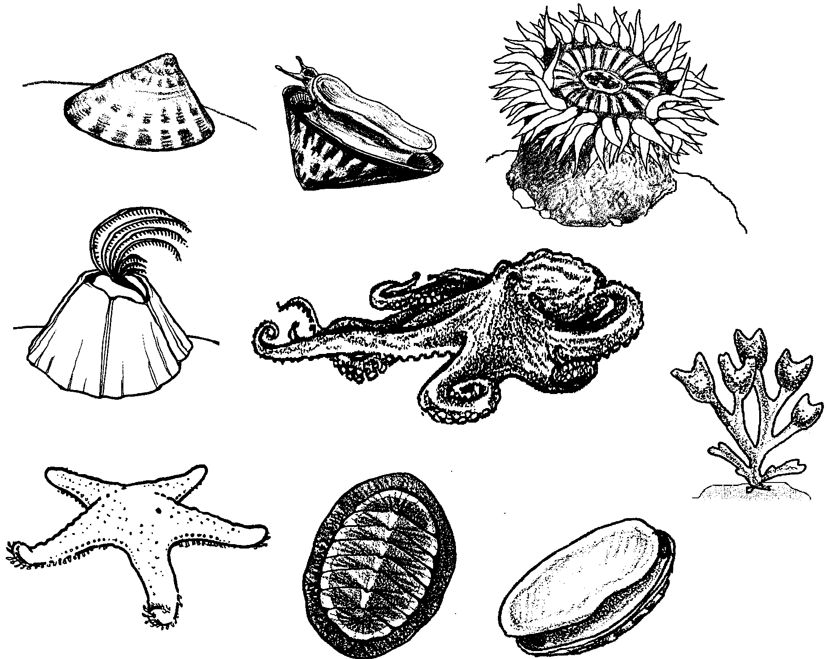
Ways to Hold On

Plants and animals live in tidepools. Waves crash onto the tidepools. They pound the plants and animals.

How do plants and animals hold on?

1. These are tidepool plants and animals. Circle the parts that hold on.
Ways to Catch Food

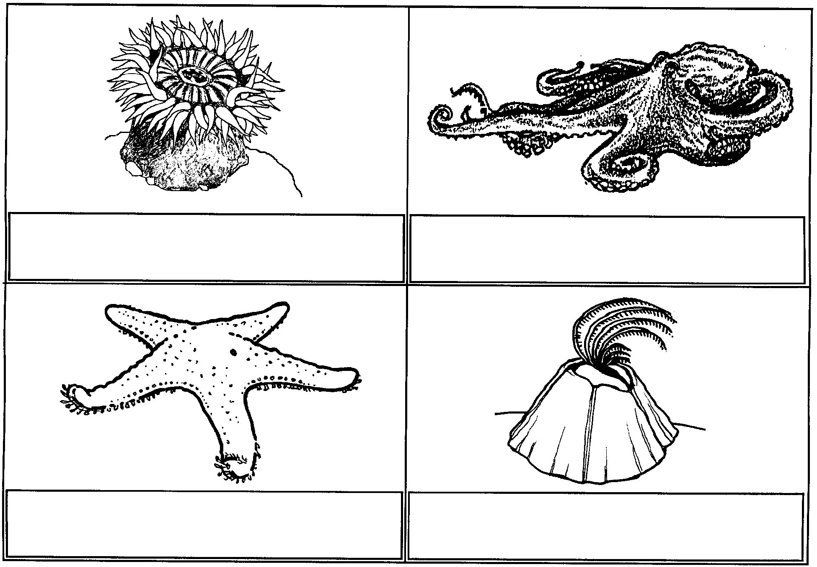
Here are four tidepool animals:

Tidepool animals have different ways of getting food. Here are four ways:

Tentacles to sting food Tube feet to open shells

Legs like nets Arms to grab food
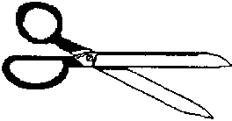
1. Cut out each way.

2. Match the way with the animal.

3. Glue the way under the animal.
Keeping Safe

Here are tidepool animals. How are they protected?

Match the animal and its words. Draw lines between them.

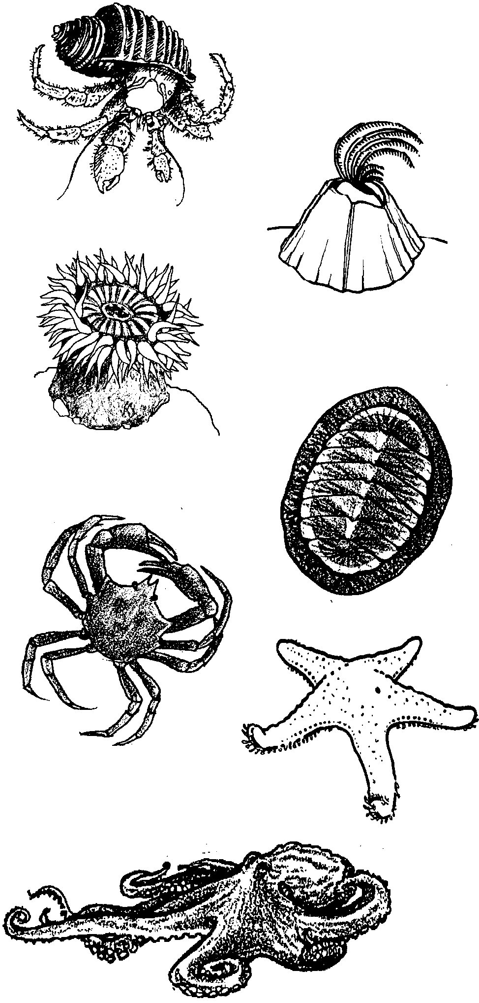
hides in caves

carries house

stinging tentacles

color of seaweed

tube feet to hang on

rolls in a ball

shell plates

Hiding in the Tidepool

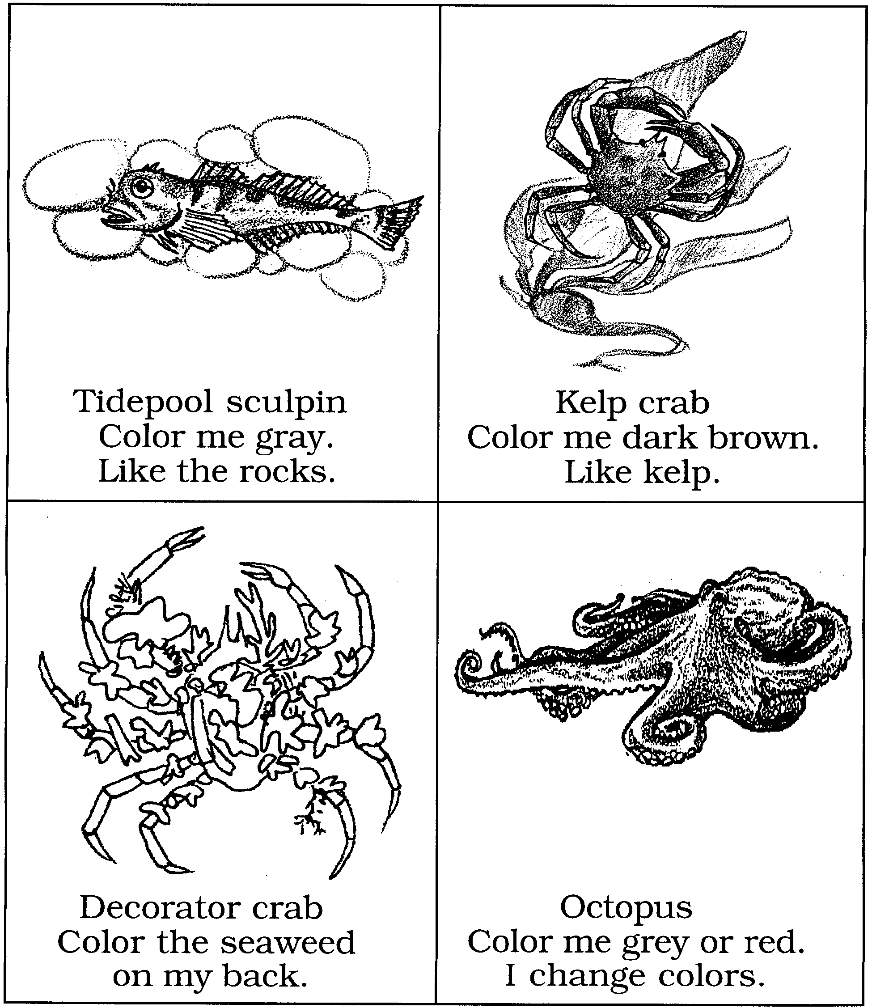
Tidepool animals try to hide. Help these hide.

