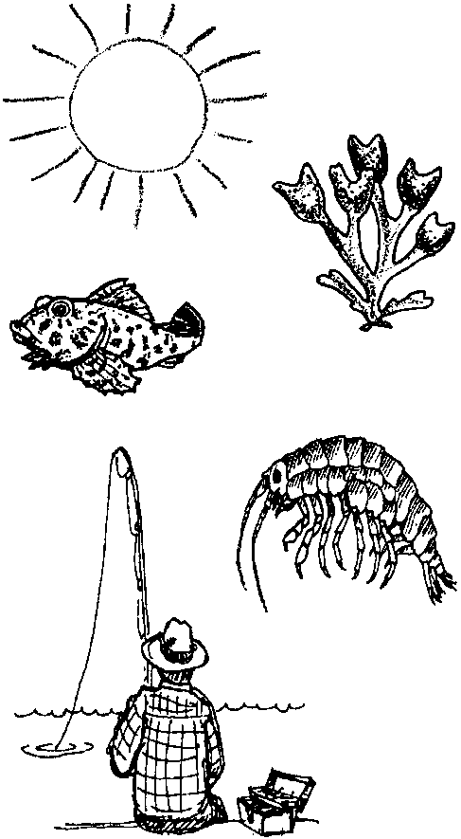
Interdependence
Lesson by Laura Erickson, Poulsbo, WA

Key Concepts
l. Animals and plants depend on each other for the things they need to survive.
2. Plants and animals are sources of food for other plants and animals. These interrelationships are described in diagrams called food chains or food webs.
3. Aquatic plants convert solar energy to food energy.

Background

All life in the sea is interrelated, every organism is dependent upon other organisms. In a balanced environment, plants and animals interact and depend on each other in a stable, predictable fashion. The plants provide food and oxygen for the animals, and the animals provide nutrients and carbon dioxide for the plants. Dead and decayed tissue provide some of the nutrients for the plants. Energy from the sun drives all of these interactions.

In the sea, seaweeds and microscopic plant plankton use the sun’s energy and nutrients in the water to produce their own food. These seaweeds and plant plankton (phytoplankton) form the basis of food for almost all of the animals in the sea. In the intertidal zone, some animals, like turban snails, graze directly on seaweeds. Others, like abalones and urchins, feed on fronds that have detached (drift kelp) and have drifted to the bottom. Drift kelp that is not eaten is decomposed by bacteria. The resulting material is eaten by filter-feeders, like sponges, which take the food particles from the water, or by deposit-feeders, like sea cucumbers, which eat the food particles which have settled on the sea floor. Many of these animals are eaten by larger predators like crabs, rock fish, or seastars. Seaweed that piles up on the beach is eaten by shrimp-like creatures called beach hoppers which, in turn, provide food for shore birds. These relationships may be represented in diagrams called “food chains”.

In a food chain, plants are called the producers. Producers make, or produce“ food using the sun’s energy. The animals that eat the plants are called first consumers. First consumers are “first” to eat the producers. Animals that eat the first consumers are called second consumers and so on
up the chain. An example of a simple food chain is:
kelp → sea urchin → sea otter
(producer) (first consumer) (second consumer)

Other food chains are:

drift kelp → abalone → people

decomposed seaweed → beach hoppers → shore birds

decomposed drift kelp → filter feeders → rock fish → people

Arrows in a food chain show the direction of the movement of the food energy and matter.

Although many food chains in the intertidal zone and the near shore areas of the sea are based on seaweeds, most food chains in the ocean are based on plant plankton rather than on the larger seaweeds.

Materials

Part One: Making Food Chains

For the class:

• pictures of members of a land food chain and of members of a sea food chain, including humans (land and sea)

For each student:

• “Making Food Chains” activity sheet

• scissors

• paste or glue

Part Two: Constructing Food Webs

For the class:

• ball of yarn or string

• 3 x 5 cards for names/sketches

• scissors

Teaching Hints

Part One: Making Food Chains

In part one, students make a variety of food chains to see how sea creatures transfer energy in the form of food from one organism to another.

1. Use pictures to show examples of land and sea food chains. Emphasize the interrelationship between plants and animals. Note how green plants are the basis of most food chains on land and in the ocean.

2. Distribute the student activity sheet, “Making Food Chains”. Have students cut the strips apart for Food Chain #1.

3. Have students glue the strips together to show the proper feeding relationships. Begin by saying:

“Look at the strips. Where does the energy to start our food chain come from?”
(The food chain starts with energy from the sun.)

“Who uses the energy from the sun?”
(The seaweed uses the energy from the sun to produce its food.)

“Glue the left end of the seaweed strip to the right end of the sun strip.”
(Demonstrate how this is done.)

“What gets its energy from eating the seaweed?”
(The turban snail gets its energy from eating the seaweed.)

“Glue the left end of the turban snail strip to the right end of the seaweed strip.”
(Again, demonstrate how this is done.)

“What gets its energy from eating the turban snail?”
(The sea star gets its energy from eating the turban snail.)

“Glue the left end of the sea star strip to the right end of the turban snail strip.”
(Again, demonstrate how this is done.)
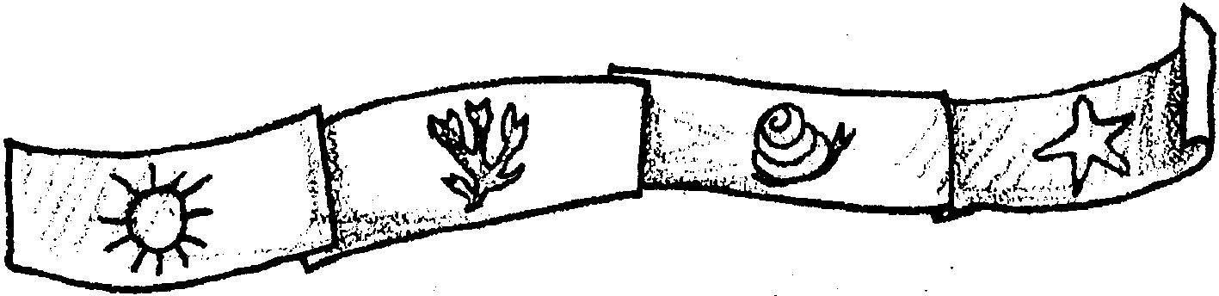

“This is one of the food chains we could see in a tidepool. Let’s look at some others.”
4. Repeat the same procedure for Food Chain #2 (sun - seaweed - abalone - sea otter) and #3 (sun - seaweed - beach hoppers - rockfish - people) or have students complete the construction on their own.

5. When all three food chains are complete, ask:

“What would happen if a middle member of a food chain were removed?”
(The animals up the chain would have to find other food or starve. Demonstrate this by cutting the beach hopper link in food chain #3)

“What do you think people mean when they say that animals and plants depend on each other to survive?”

Part Two: Constructing Food Webs

In Part Two, the class models two food webs, one land-based and the second intertidal zone-based.

1. Have students sit in a circle on the floor. Start the food web by using land animals with which the children are familiar.

Example: “I am the sun. What needs the sun to grow? Grass! Good I will roll the ball of yarn to Fred and he will be our grass. Here is the word grass for Fred to hold. (On a 3 x 5 card or slip of paper, write the word “Grass” and make a quick sketch of grass)

Now, what needs grass to grow? A cow! Great, Susie can be our cow. Fred will roll the ball of yarn to Susie and we will give her a card with the word “Cow” on it.

What else eats grass? Horses! Right, we now need to cut the string that went from our grass to cow, and start the string at the grass again and lead it to Jake, our horse.

Does anything eat a cow or a horse? People eat cows. Let’s give Sally the word “people” and put a string between the cow and our people. Now we are starting to make a web, etc.”

2. Once students understand how to make this food web model, begin all over with intertidal zone creatures. Start, once again, with the sun. Remind students that the plants in the sea also obtain their energy from the sun. Then go on to animals that need seaweed to grow. Then to what eats those animals. To help eliminate confusion on what has already been said, remember to give a card with the name and a quick sketch of the animal or plant to each person.

You may find several animals that will eat the same thing. Be sure that the separate pieces of yarn go to each animal before the yarn goes to the next food source.

You should end up with a spider-like web on the floor. Tell the students that a food web is many food chains that are interconnected. (Show what this means by pulling up on part of the web and having students notice that the other parts of the web move also.)

3. Choose one of the animals in the food web. Say:

“Let’s see what will happen to (name of the animal) if the food web changes.”

Observe the links to the chosen animal and discuss with students the problems that animal would face if one, or all, of its food sources were to die off. Ask questions like: What would happen if the animal only ate one type of food and that food was all destroyed? What would happen, then, to the animals that eat this animal?

4. Move the web to a bulletin board so that students can continue to add links as you study more animals and plants. Have students decide on the animals to include and where the strings will need to go. Students may want to make pictures or 3-D models of the plants and animals to place on the bulletin board.

Key Words

food chain - a diagram showing relationships among plants and animals based on who eats whom

food web - a diagram showing interconnected food chains

intertidal zone - the area of the beach exposed by the tides

Extensions

1. Sing a salty song!

Salty, Salty Sea (tune: Yellow Submarine)

We all live in the salty, salty sea,

Such variety,

Creatures of the sea.

We all live in the salty, salty sea,

We’re in-ver-te-brates! Yes!

by Sherry Matson
Kenai Peninsula Borough School District
Answer Key

Completed food chains are shown below:

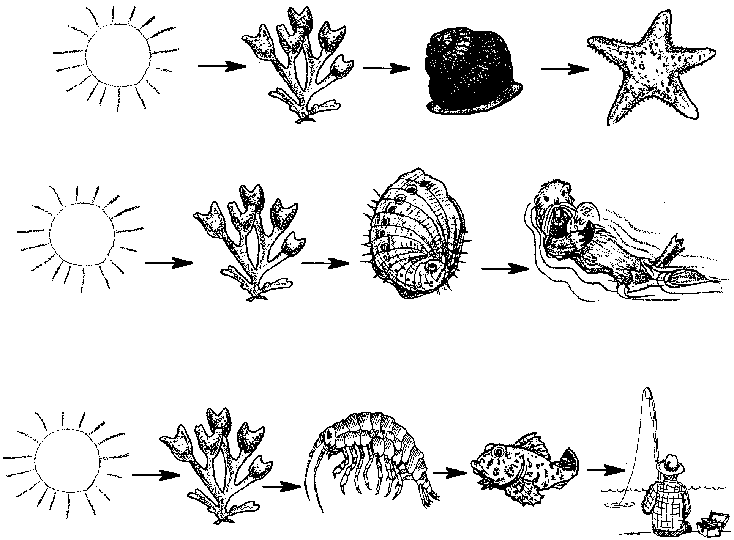

Making Food Chains

Here are sea plants and animals. Some eat each other. Make them into food chains. Your teacher will tell you how.

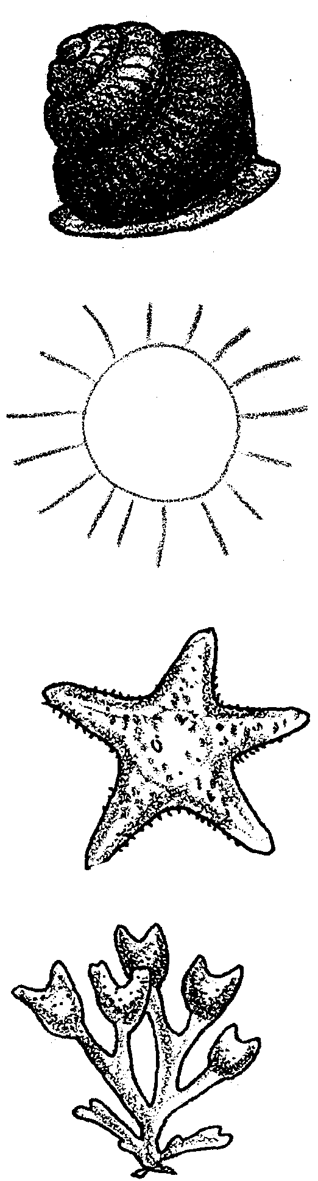
Food chain #1

Food chain #1

Food chain #1

Food chain #1

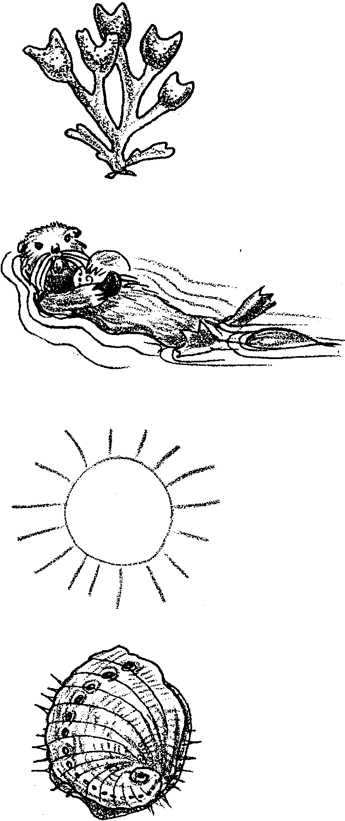
Food chain #2

Food chain #2

Food chain #2

Food chain #2

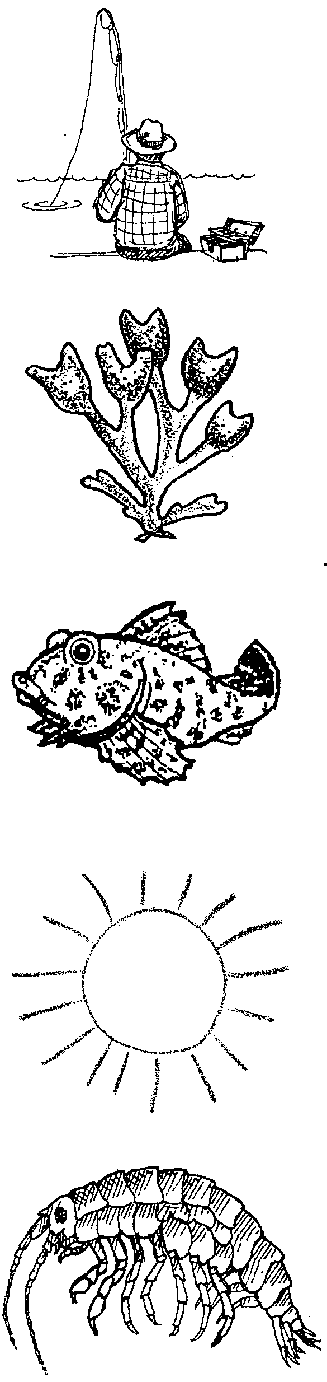
Food chain #3

Food chain #3

Food chain #3

Food chain #3

Food chain #3

