Seaweed Anyone?
Edited by Wendy Naruo, Felton, CA and
Laurie Dumdie and Laura Erickson, Poulsbo, WA

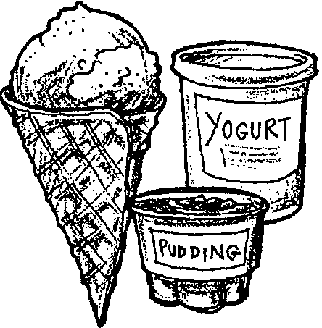
Key Concepts
1. Seaweeds are a source of food for many animals including humans.
2. Many common food and non-food products contain algae.

Background

Marine plants are known as seaweeds or algae. Most seaweeds are found in intertidal and near shore areas. Numerous items we eat or use everyday contain algae. Throughout history, seaweeds have been harvested and used for a variety of products. As a food source, reference to its use in China goes back to 600 BC. Algae is used in milk puddings by the Irish, as salads and aspics in the Far East and in medicines in South America. Today, carrageenan (extracted from various red algae) is used in hundreds of products ranging from foods and toothpastes to air fresheners and industrial suspensions. This extract stabilizes and gels foods, cosmetics and industrial products; it’s the “smoothness” in ice cream, the “consistency” in toothpaste, and the “body” in latex paint.

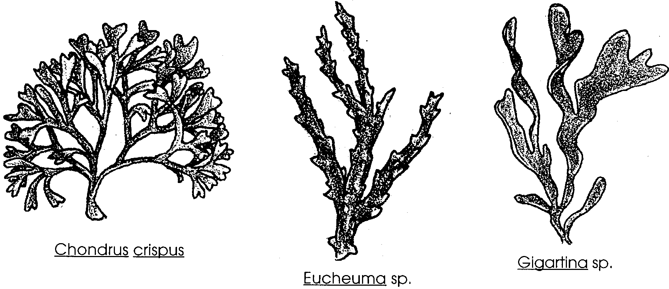
There are three main carrageenan producing seaweed sources; Chondrus crispus (also known as Irish Moss), Eucheuma species, and Gigartina species.

These seaweeds are harvested using floating “seaweed mowers.” The cut seaweeds are stored in bales from which carrageenan is extracted. The seaweed is tested and warehoused close to the manufacturing plant. To assure a standardized product, various lots of seaweed are selected and co-processed. The selected seaweed is put into extraction tanks where it is treated under varying alkaline conditions for several hours to obtain the optimum gelling or viscosity characteristics. The extracted dried carrageenan is ground and stored.

Another group of algaes also plays an important role in modern society. Kelp (a brown algae) contains iodine, minerals, vitamins, and carbohydrates and is used in many countries as a food supplement for people and animals. Kelp also contains algin, a substance which has the unique property of absorbing large quantities of water. A tablespoon of algin added to a gallon of ice cream prevents the water from forming ice crystals.

Algin also has ability to suspend, stabilize, and emulsify chemicals. It is used to suspend drugs in antibiotics and to suspend the abrasive in auto polish and the pigments in paint. Algin is used as a creaming, thickening, and stabilizing agent in rubber and textile manufacturing. Algin prevents the dyes in printed fabrics from running.

Materials

Part One: Seaweed Anyone?

For the class:

• products that contain algae

• Japanese rice crackers with seaweed

• jar or can of ajitsuke nori (flavored seaweed)

For each student:

• “Seaweed Anyone?” activity sheet

Part Two: Seaweed Pudding

• products that contain algae

• milk, 1 pint, cold

• Lactarin 406 powder

• mixing bowl

• wire whisk

• container

• refrigerator
Teaching Hints

Many students tend to ignore seaweeds and find them uninteresting. This behavior really stems from the fact that they have not taken the time to look closely at the marine plants. Marine plants are diverse and well adapted to life in the sea. To create interest, supply ample visual aids. Dried, pressed seaweed specimens can be easily made and will last for years. These specimens can help create interest in marine plants.

Seaweed is not often thought of as a foodstuff. In reality, large amounts of seaweed are harvested each year for the food markets of the world. Recognizing this fact, recipes are included so that you might share this taste experience with your students. All of the ingredients may be purchased in most large grocery stores or in health food stores. While it is possible to prepare the food as a demonstration or to bring the prepared food from home for sharing, the most instructive approach involves student participation. Most of these items may be prepared in the classroom. This is a golden opportunity to expand vocabulary skills and measurement skills. The recipes can be readily metricized. The activity also provides a good experience in following directions. HAVE FUN!

Part One: Seaweed Anyone?

We use seaweed in many ways in our daily lives. In Part One, students learn about some of the products made from seaweed and have an opportunity to eat some of the foods made from seaweed.

Procedure

1. Collect products or packaging of products that contain algae, as well as Japanese rice crackers and/or a jar or can of ajitsuke nori (flavored seaweed). You may even want to collect and dry some of your own seaweed for eating. Try sea ribbon (Palmaria palmats), black seaweed (Porohyra perforata), or giant kelp (Macrocystis integrifolia).

2. Display the collected products or packaging on a table and ask if anyone can guess how these products are alike.

3. Ask students:

“Have any of you have eaten or used algae in some way in the last week?”

Most students will answer “no.” Say,

“I think I may have. Let’s see if we can find out for sure.”

4. Distribute the student worksheet, “Algae, Anyone?” and help students complete it.
5. When students have completed the worksheet, say:

“Now that you know more about algae, have any of you have eaten or used algae in some way in the last week?”

6. To keep anyone from feeling left out, distribute the Japanese rice crackers and flavored seaweed for taste tests. Explain that often seaweed is eaten with rice.

7. Ask students if they know any other groups of people who eat or did eat seaweed as a basic food.

Part Two: Seaweed Pudding

In Part Two, students make a simple pudding which uses algae extracts as a thickener.

Have students write a class letter to Marine Colloids asking for product information. In the letter, ask for information regarding where to purchase Lactarin 406 and/or whether a sample might be available free to your class. Lactarin 406 is an ingredient in making Dry Mix Cold Process Pudding. Write to:
FMC
Marine Colloids Division
2000 Market Street
Philadelphia, Pennsylvania 19903
Phone: 800-526-3649

Dry Mix Cold Process Pudding

Ingredients:
milk, 1 pint, cold
Lactarin 406 powder

1. Pour 1 pint of cold (10°C) whole milk into a mixing bowl.

2. Add dry powder mix to milk while stirring with wire whisk for 1/2 minute.

3. Pour into container and refrigerate for 10-15 minutes.

4. Pudding is ready to serve.

Key Word

algae - (singular = alga) aquatic non-vascular plants, as seaweeds. The following words pertain to algae: agar, agarophytes, algin, alginates, carrageen, carrageenan, dulse, furcellaran, laver

Extensions

1. Have students who bring their lunch, examine their contents for items that contain algae.

2. Have students take the worksheet home and collect containers of products containing seaweed to add to the classroom display. Have them circle the words for algae in the list of ingredients on the containers.

3. Have students select and prepare one of the following recipes, using algae:

Blanc Mange Pudding

Blanc Mange Pudding is a tasty way to use Irish Moss or
Eucheuma sps.:

1 cup washed Irish Moss or Eucheuma

1 quart milk

vanilla, sugar, honey to taste

1. Add one cup of washed Irish Moss or Eucheuma to one quart of milk.

2. Cook in a double boiler for half an hour.

3. Strain the milk to remove the seaweed.

4. Add vanilla, sugar, and honey to taste.

5. Refrigerate until firm.

Honey Kelp Cookies

1/2 cup butter

1/4 cup brown sugar

1 egg, beaten

3/4 cup honey

1 cup raisins

1 cup whole wheat flour

1 1/4 cups all purpose flour

2 teaspoons baking powder

1/8 teaspoon baking soda

1 teaspoon dried kelp

1. Grease cookie sheets.

2. Preheat oven to 375 degrees F.

3. Blend butter and brown sugar until smooth.

4. Mix egg and honey together, then add to the butter/sugar mixture.

5. Sift the dry ingredients and slowly add them to the blended butter/sugar/honey/egg mixture.

6. Keep blending as you add the dry ingredients until smooth. Add raisins.

7. Drop teaspoonfuls onto the greased cookie sheets and bake for 7-12 minutes at 375 degrees F.

Kelp Candy

2 cups kelp

distilled vinegar

water

2 1/4 cups sugar

2 teaspoons cinnamon

2 teaspoons flavoring of choice

1. Wash and cut kelp into bite-size pieces (not too small as the kelp shrinks somewhat in the cooking process).

2. In a large pan, cover kelp with distilled vinegar and bring to a boil. Boil gently for 45 minutes.

3. Drain and rinse. Let stand in fresh water for four hours, changing the water every hour until vinegar taste is gone.

4. In a pan, place 2 cups of kelp. Cover with 2 cups of sugar in which 2 teaspoons of cinnamon have been mixed. Stir until sugar has melted. Add flavoring (2 teaspoons - cherry, maple, etc.). Bring mixture to a boil. Reduce heat and let cook for one hour.

5. Remove kelp from syrup and drain. Syrup can be re-used (with additions of sugar, flavoring, and if desired, coloring) for next batch - or poured over ice cream, etc.

6. Place cooked pieces in loaf pan with granulated sugar and coat well. Put coated pieces on waxed paper to dry. Pieces of kelp candy should be stored loosely covered in refrigerator.

Seaweed Breads

Thoroughly rinse and dry about two pounds of seaweed or use dried kelp. Using your favorite, simple, bread recipe, substitute water for milk, add an extra tablespoon of butter to recipe, and omit salt. Grind or powder dry seaweed into a flour and substitute seaweed flour for half the amount of flour called for. Follow the rest of the recipe, experimenting with different seasonings.

Traditional “laver bread” is made from Porphyra sps., a red algae, used by the Welsh. The finished product is like a pudding. Porphyra is called “nori” by the Japanese. West Coast species can be used to make sushi and Chinese seaweed soup, in addition to bread.

Answer Key

1.-3. Answers will depend on the experiences of your students.
Seaweed Anyone?
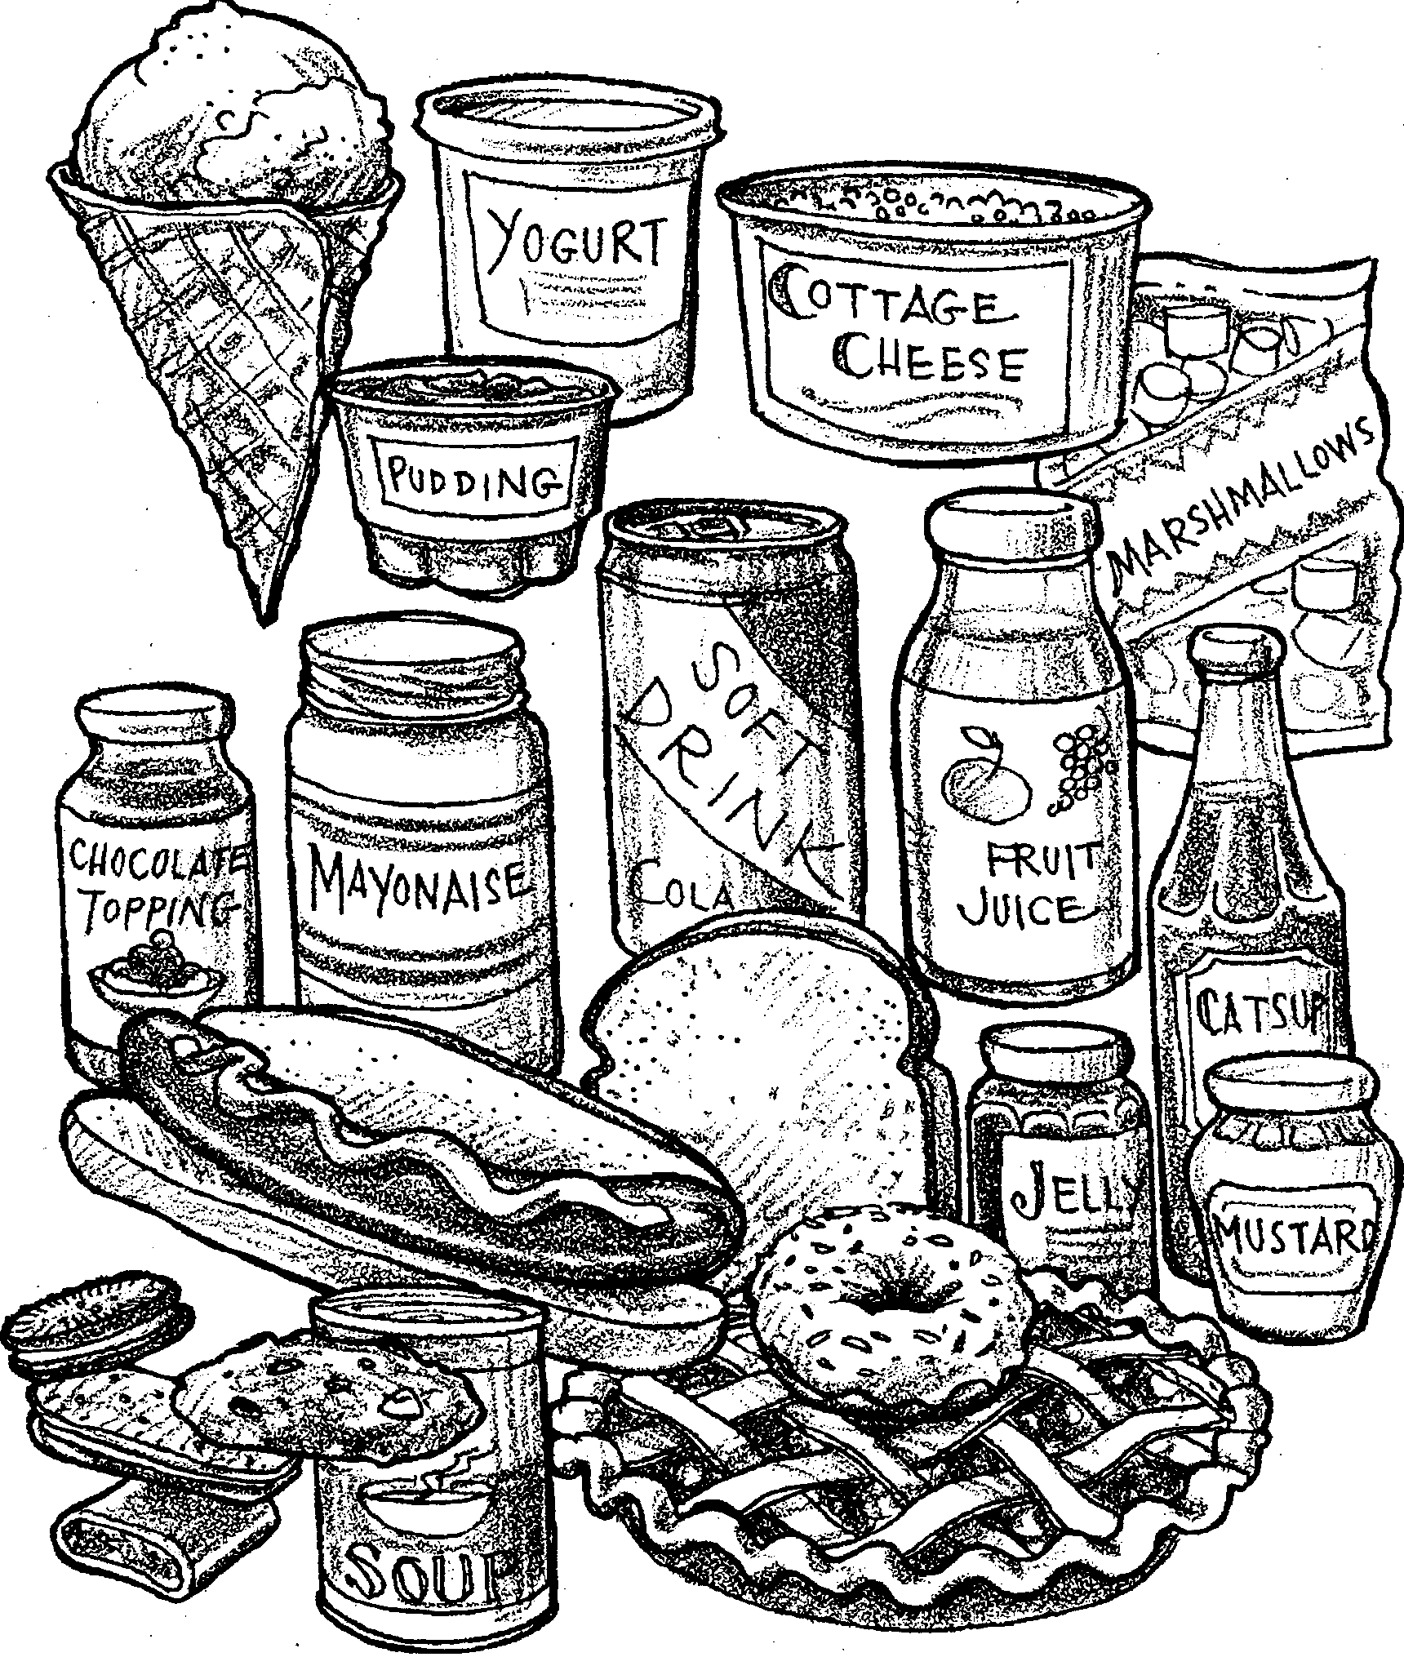

1. These foods are made with seaweed. Which have you eaten this week? Circle each of them.

2. How many did you circle?
3. These are all words for seaweed:
agar carrageenan
agarophytes dulse
algin furcellaran
alginate slaver
carrageen

Look for these words on labels. Check at home. Draw 2 of the foods. Use the back of this page.

