Seaweeds Are Plants of the Sea
Edited by Wendy Naruo, Felton, CA
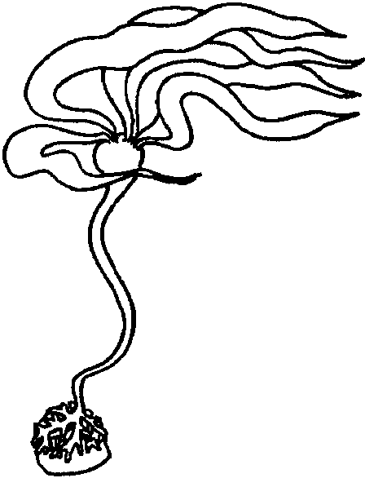

Key Concepts
1. Seaweeds are plants of the sea.
2. Seaweeds have three basic parts: holdfast, stipe, and blades.
3. Seaweeds photosynthesize, creating their own food from sunlight.

Background

Seaweeds or algae are marine plants. Some seaweeds are large, over 15 feet in length. Other marine plants are microscopic and drift freely with the currents. They are called plant plankton or phytoplankton. These plants of the sea photosynthesize to create their own food. As land plants do in the terrestrial world, seaweeds and plant plankton form the basis of food for animals in the sea.

In the process of photosynthesis, seaweeds use carbon dioxide and minerals from the water. Seaweeds are usually grouped into four categories: greens, browns, reds, and blue-greens. Because all algae need sunlight for photosynthesis, they are restricted to relatively shallow depths with green algae in shallow water, brown algae in the middle zone, and red algae in deeper waters. In Puget Sound, for example, algae rarely exist below a 75-85 foot depth.

Seaweeds are made up of three basic parts: the holdfast, stipe and blades. These compare to the roots, stems, and leaves of land plants. The main function of the holdfast is to anchor the seaweed to the bottom, usually to a rock. However the holdfast does not take minerals from the soil as do the roots of land plant. Similar in appearance to a stem, the stipe is tough and elastic so that it can bend easily in the water. Like leaves, the blades are the major photosynthetic site. Some seaweeds, such as kelp, have floats or bladders (air sacks) which help hold the blades up to the sunlight for photosynthesis. A stipe and its attached blades is called a frond.

The top layer of a kelp forest, where the fronds float on the surface is called the canopy. Some juvenile kelp plants, at first visible only through a microscope, will grow as much as 10-15 feet in six months! Kelp, a brown seaweed, is the fastest growing plant in the world.

Materials

For each group of 3 or 4 students:

• seaweed (Can be collected at beach fresh or collected and frozen for use later. Pressed seaweed samples will also work. If neither of these are possible, obtain dried seaweed samples from the grocery store and collect pictures of seaweed.)

• land plants (weeds from the school yard are fine)

• “Seaweeds Are Plants of the Sea” activity sheet

Teaching Hints

Part One: Comparing Marine Plants to Land Plants

In this activity, students observe and compare land and marine plants.

1. Form students into groups of three or four and distribute at least one seaweed and one land plant to each group.

2. Ask students to observe similarities and differences. Record their observations.

3. Have students sort all the seaweeds according to different characteristics and record their groupings (i.e. red seaweed/not red seaweed, segmented seaweed/not segmented seaweed, long and red seaweed/not long and red seaweed). Have students create a name for each group of seaweeds.

4. In a similar fashion, have students sort all the land plants according to different characteristics and record their groupings. Have students create a name for each group of land plants.

5. Explain to students that they have just done what scientists do. It is called classifying. Discuss the word.

6. Distribute two or more samples (seaweeds and land plants) to each group, and have students place them in a seaweed or land plant group, describing characteristics observed.

7. Use the overhead transparency, “Bull Kelp”, to introduce the parts of seaweeds and their functions, comparing them to land plants. Have students identify the parts on the seaweeds distributed.

8. To help reinforce the concepts explored, distribute and have students complete the “Seaweeds Are Plants of the Sea” student worksheet.
Key Words

algae - (singular = alga) aquatic non-vascular plants, as seaweeds

blade - in this case, the part of seaweed resembling the blade of a leaf

canopy - in this case, uppermost, spreading, branchy layer of a kelp forest

frond - in seaweeds, a stipe and its attached blades

holdfast - the part of a seaweed which clings to a surface

seaweed - a marine alga

stipe - joins the holdfast and blade of a seaweed

Extensions

1. Make “Sun Prints”, “Seaweed Prints”, or “Pressed Seaweed”, with your students.

Sun Prints

Materials:
• dry pieces of seaweed

• flat tray or cookie sheet

• water

• sun print kit* (sun sensitive paper and transparent covering found in toy or educational stores)

* Sun print paper can usually be found in toy or educational stores. It is also available from:

Solar graphics
P.O. Box 7091 P
Berkeley, CA 94707
(415) 548-5230

Procedure:

1. Place sun sensitive paper, blue side up, on cookie sheet in the shade.

2. Arrange seaweed specimen on paper.

3. Cover with a transparent cover (to hold the seaweeds on the paper).

4. Place in direct sunlight for 3-7 minutes, until the paper turns almost white.

5. Develop by placing the exposed paper in a tray of water, in the shade, for at least two minutes.

6. Dry prints on a flat, clean surface.
Seaweed Prints

Materials:
• newspaper

• ink or paint

• brushes

• plain newsprint or other absorbent paper

• seaweed specimens

Procedure

1. Lay flat pieces of dry seaweed, or freshly collected seaweed washed in water and blotted dry, on newspaper.

2. Paint seaweed with ink or paint.

3. Lay plain paper on seaweed and rub lightly.

4. Lift print off carefully and dry.

Pressed Seaweed

Materials:
• shallow pan or tray of water

• newspaper

• waxed paper

• heavy white paper (large index cards work well)

• various specimens of seaweed

Procedure

1. Place seaweed in tray with just enough saltwater to cover it.

2. Slip heavy, white paper under the seaweed, leaving just enough water to arrange seaweed easily.

3. Carefully remove the seaweed and paper, and place between two sheets of waxed paper.

4. Place the mounted seaweed on top of a stack of newspapers and cover with several more layers of newspaper.

5. Place a heavy weight on top of the stack. Dry in a warm place, replacing newspapers daily for faster drying.

6. When dry (drying generally takes a few days), the pressed specimen will usually adhere to the white paper. If not, it may be glued to another piece of paper.
Answer Key

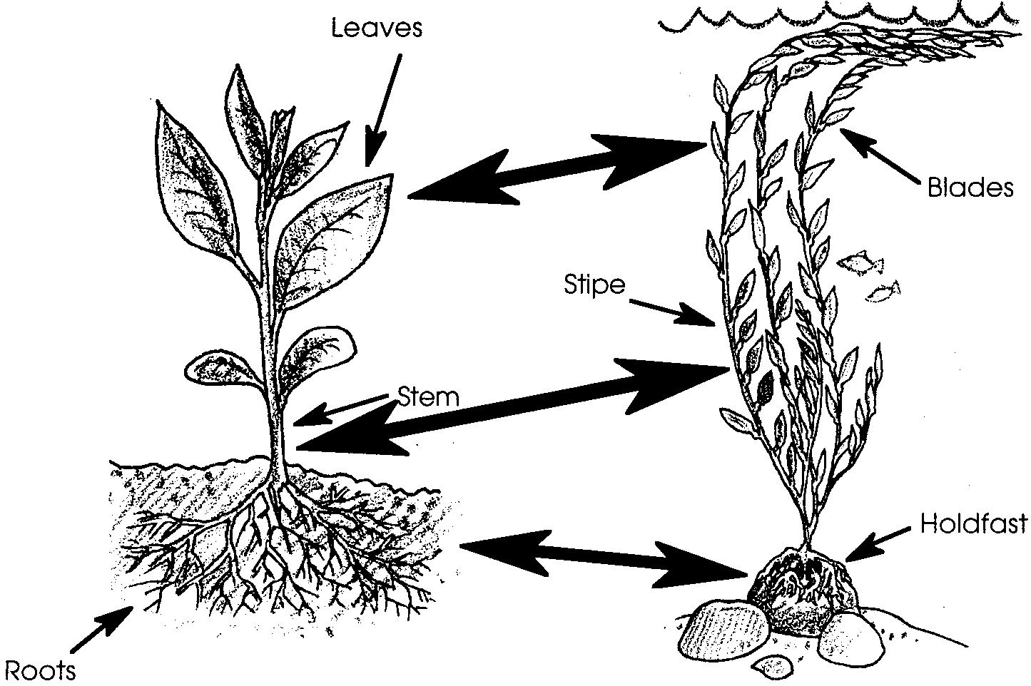
1.

2. The blades are like leaves.

The stipe is like a stem.

The holdfast is like roots.

This question emphasizes the similar structures of seaweeds and land plants. The structures are similar in shape and, to a degree, in function. Internally they are vastly different and some of their physiological functions are also quite different. Even so, the parts look similar and the comparison is valid.

3. Pictures will vary. Help students to think about times and places they may have seen living seaweed. Seaweeds attach to: rocks, shells, crabs, pilings, docks, the bottom of boats, floats, etc. As an aside, attached seaweeds, especially those growing in clusters such as found in kelp beds, create habitats for other animals just as a forest might for land creatures.

4. When the seaweed in a tidepool disappears from collection or damage, most of the seaweed-eating tidepool animals either leave or die. Those that also eat animals, will turn to animals for food - this is a short term solution, of course. In real life, complete disappearance of seaweed would be unlikely. Since tidepools are submerged during high tide, emigration is relatively easy. Plants or plant parts are also often washed into the pools. This question is included to provide a springboard for discussion of the interdependencies between plants and animals.
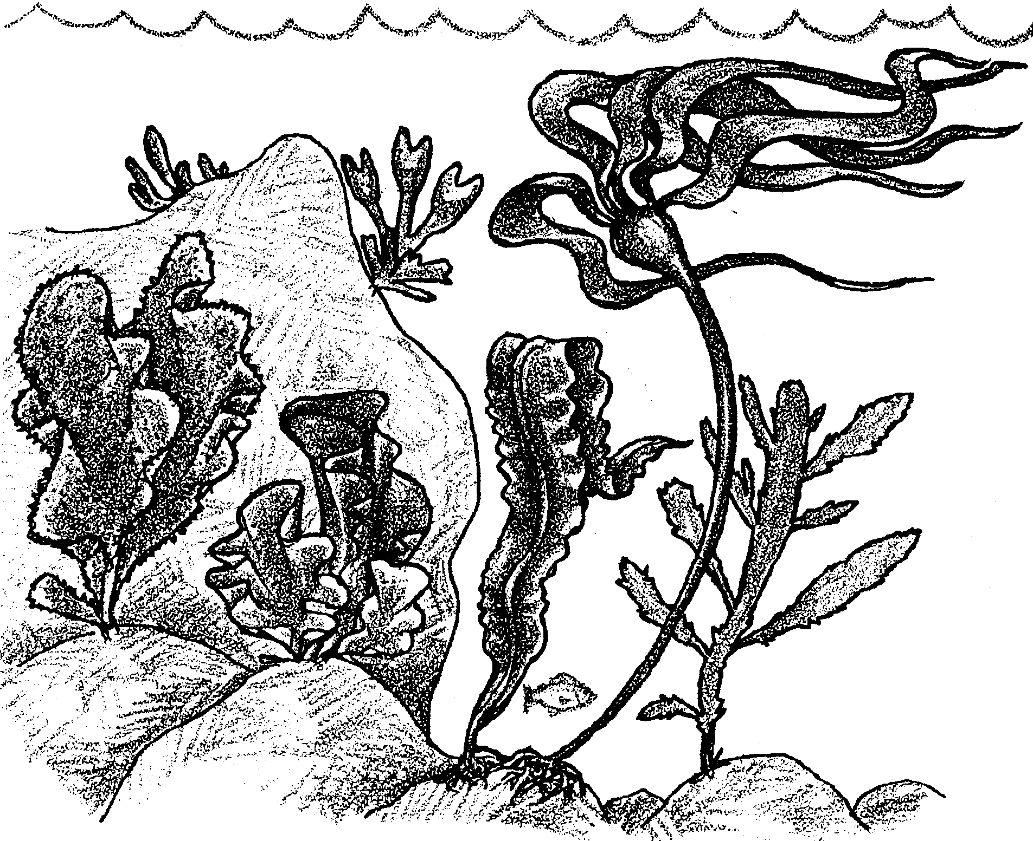
Seaweeds Are Plants of the Sea

Seaweeds are plants of the sea. Some grow in tidepools. Some grow in the ocean.
Some look like land plants.

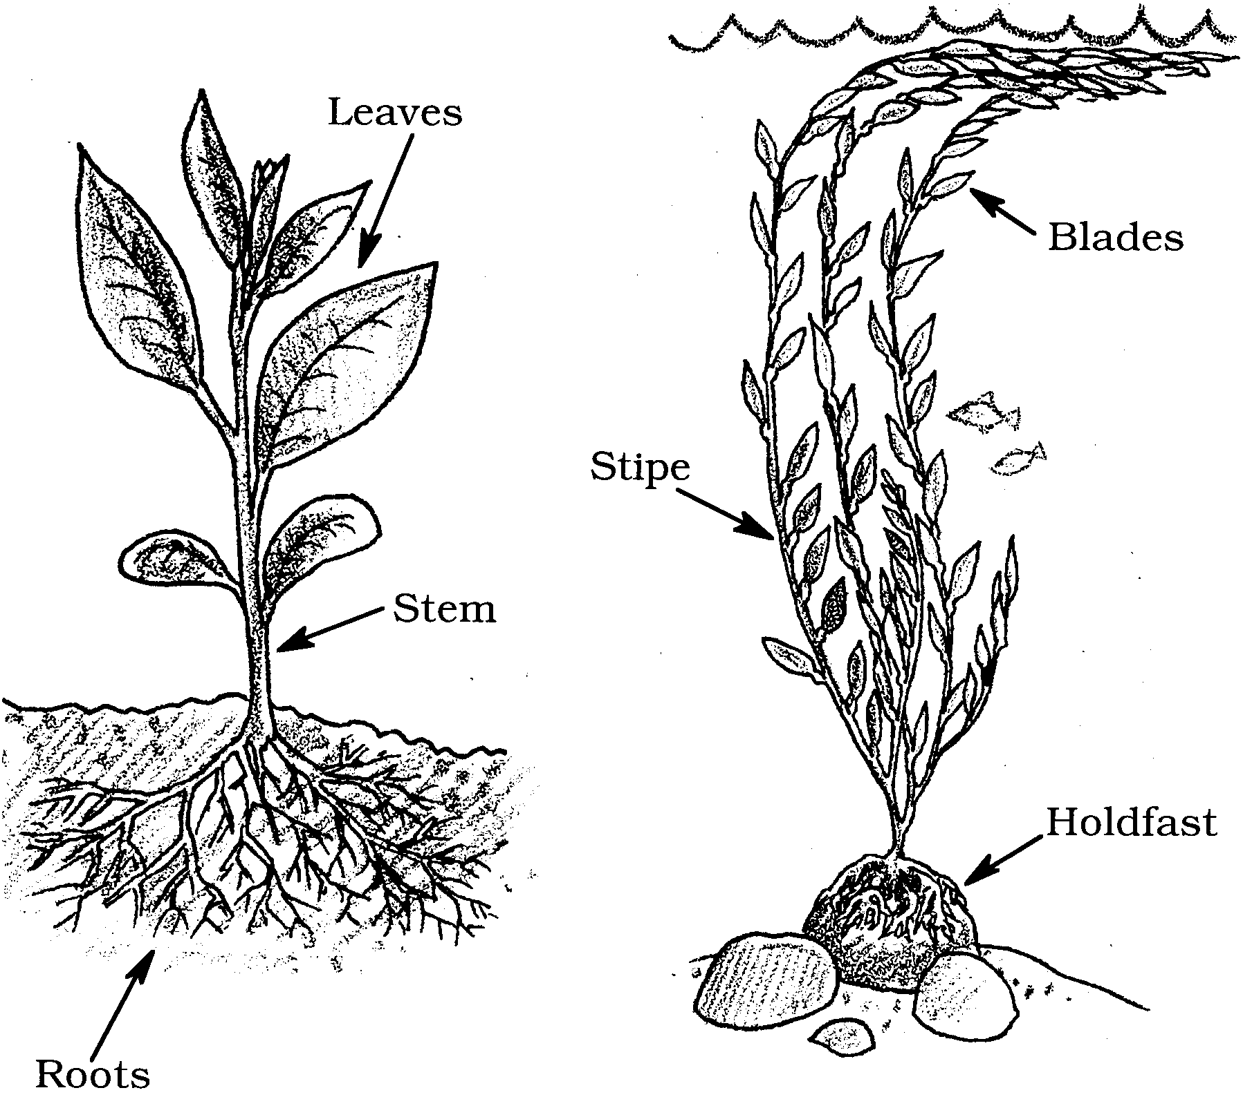

1. Which parts are alike? Connect them with lines.

2. Fill in the blanks. Use these words: stipe, blades, holdfast.

The are like leaves.

The is like a stem.

The is like roots.

3. Many seaweeds attach to rocks. Some attach to shells. Others attach to docks. Draw a picture of seaweeds. Show how they are attached.

Tidepool animals eat seaweed. So do people. Name these seaweed eaters.
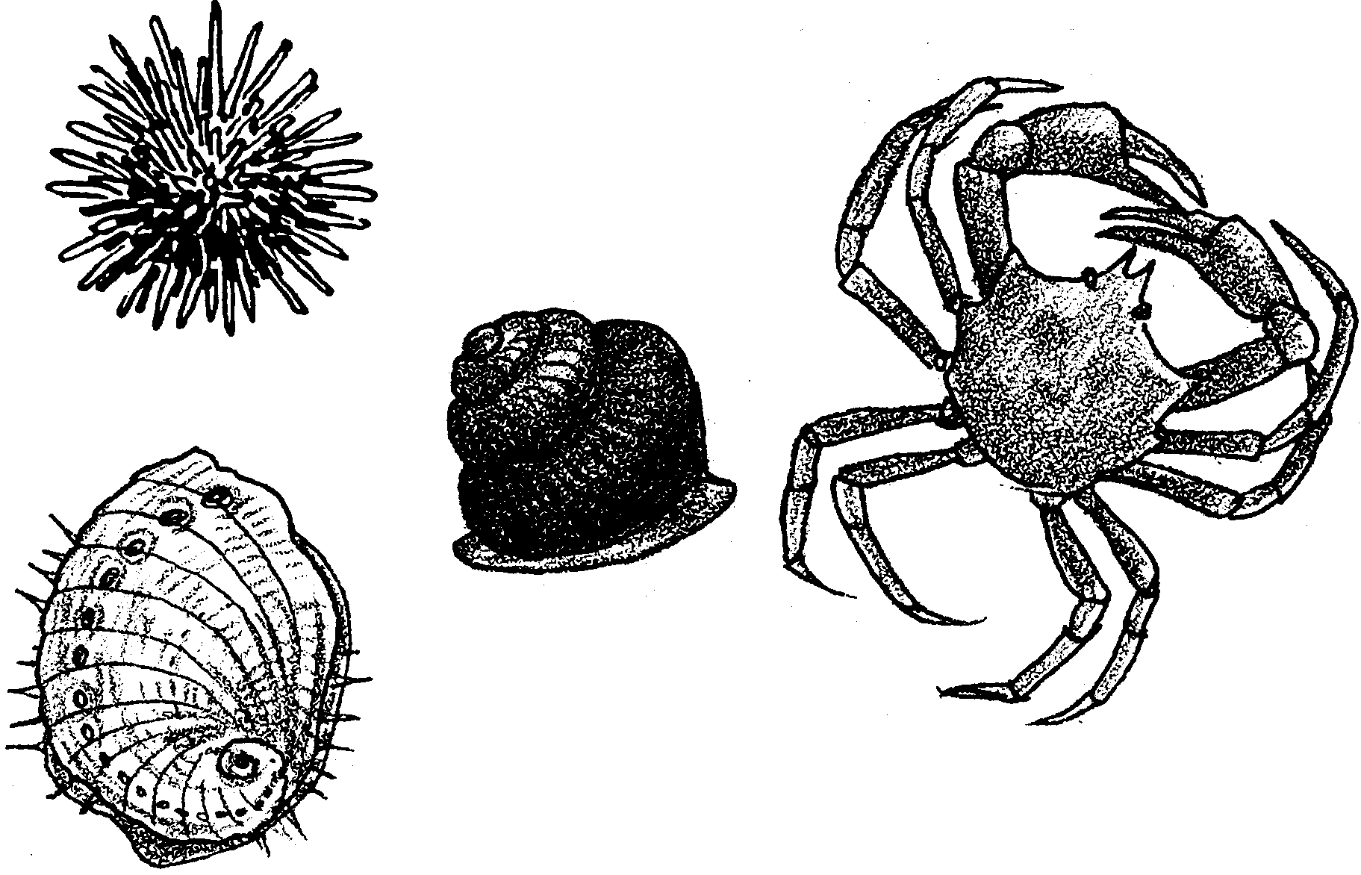

4. People collect seaweeds. Oops! The seaweeds are all gone. What can the tidepool animals do?

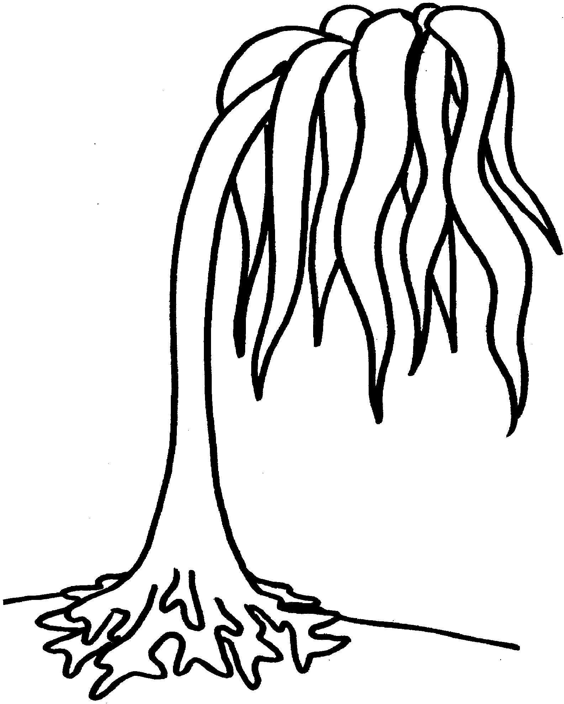
This is a sea palm.

1. Can you find its stipe? Color it brown.

2. Color the holdfast darker brown.

3. Color the blades green.
