Octopus Changes
Lesson by Laura Erickson, Poulsbo, WA

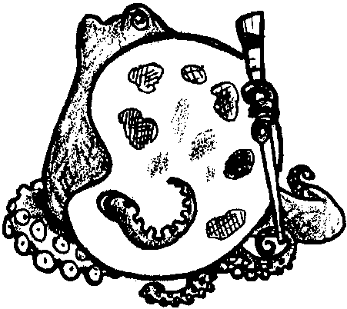
Key Concept
1. Octopus can change their color and texture to match their surroundings.

Background

The octopus has an extraordinary ability to change color. When an octopus is trying to hide from its enemies it can take on the color and texture of the surroundings. Scientists say that an angry octopus will turn dark red. An octopus that is frightened will turn white or grey. Others say that a grey octopus is the sign of a relaxed octopus.

For extensive octopus information, see the preceding activity, “Octopus”.

Materials

Part One: Color Changing

For each student:

• 3" X 5" piece of paper

• black ball-point pens

• Q-tip

• lemon juice

Part Two: An Octopus’ Garden

For each student:

• lunch size paper bag

• multi-colored strips of paper

• crayons

• scissors

• stapler or glue

• string

Teaching Hints

Part One: Color Changing

Part One provides students with an opportunity to make an octopus “disappear”. This activity serves as a springboard for a discussion of protective coloration.

Hint: Try this activity before you do it with students. Not all ink will disappear of fade when treated with lemon juice. Try a different types of pens to assure success.

Procedure:

1. Distribute paper and have students draw just the outline of an octopus using a pen. The drawing need not be detailed.

2. Say:

“Sea lions, seals, sea otters, and wolf-eels all like to eat octopi. What are some ways an octopus can protect itself?”

“What color is the octopus you’ve drawn?”

“Let’s see what an octopus can do when it is threatened.”

3. Give each child a Q-tip and some lemon juice. Have them dip the Q-tip into the lemon juice and paint over the ink. As the octopus starts to disappear ask:

“What is happening to the octopus?”

Explain to students that the octopi can “disappear” by changing color and blending into the background. Ask:

“How could changing color help an octopus survive?”

Part Two: An Octopus’ Garden

This is a fun, self-esteem building lesson.

1. Read students one of these books:

Octopus by Carol Carrick

My Very Own Octopus by Bernard Most

I Was All Thumbs by Bernard Waber

“The Octopus and Raven” a Native American story in:

Keepers of the Animals by Michael J. Caduto and Joseph Bruchac

2. After reading one of the books listed above, distribute a paper bag to each student. Explain this bag will represent the body of an octopus. Have students fill the bags with scraps of paper from your recycling box.

3. When the bag is stuffed, have students tie the end of the bag closed with a piece of string.

4. Distribute eight strips of paper and have them write one thing they can do to help others, on each strip of paper. If writing is difficult for your students, encourage them to draw pictures.

5. Explain that these eight strips represent the tentacles of an octopus. Have students glue or staple the end of each tentacle to the paper bag. If students work carefully they can curl the legs by rolling them on a pencil.

6. Be sure to add eyes to the octopus. Hang the paper bag octopus from the ceiling. The legs will dance in the air over the children’s heads.

Extensions

1. Cooking: The octopus is used as a food source in many places around the world. It may be possible for you to obtain an octopus from you local grocer. If you have an adventuresome class you might try cooking it. Following, you will find two recipes, one for real octopus and another for those who like to pretend.

Fried Octopus

octopus

lemon juice

1 egg beaten

1 cup cracker crumbs

Slice one to two-inch rounds from the raw tentacles. Pound very well. Dip in lemon juice, beaten egg, and roll in fine cracker crumbs. Brown quickly on both sides in hot oil and serve with tartar sauce.

“Octopus Soup”

1 hot dog per person

1 large can tomato soup

2 regular cans chili beef soup

water to mix with soup

water to boil hot dogs

Mix soups and water together and heat. Leaving approximately an inch of hot dog unsliced for the head, slice the rest of the hot dog in half lengthwise. Turn the hot dog and slice it again making four sections. Be sure to not slice through the head section. Place the hot dog in boiling water and watch each end of the hot dog curl. In a bowl, ladle out a serving of the soup mix and then place an “octopus” on top.

It is possible to microwave the hot dogs and get the same curling of the legs. Your students can cut the hot dog using a table knife. They will enjoy doing part of the cooking.

This is a good story starter. As the kids are eating you can be writing their story ideas on the board for use later.

2. Creative Writing: For centuries, the octopus has figured prominently in stories. Using the following as points of departure, have your students continue this tradition.

According to legend, the kraken, which looked like a giant octopus or squid, would sleep on the sea floor for many years, then rise to the surface. Sailors told of hair-raising tales of the kraken destroying passing ships with its hundred-foot-long tentacles. Have students write or tell an “eco-myth” about an octopus or kraken that comes up from the deep to protest the way humans are treating the watery world.

An exciting story about going for a swim with an octopus may interest your students. The story could be written from the perspective of the octopus. Have students include things that they have learned about the octopus but allow for an adventure tale.

Read The Important Book by Wise. Have students write “facts” or observations about an octopus following the pattern presented in the book. Next, have students illustrate their writing.

3. Octopus Math: The prefix octo- or octa means eight. An octopus is an animal with eight arms. What other words can your students think of that have this beginning prefix? Here are a few:

Octagon - eight sided figure, like a stop sign

October - which used to be the eighth month

Octave - an interval of musical notes

Octane - molecules containing eight carbon atoms; found in gasoline

Have your students use the dictionary to see if they can find any others.

