Creating Graphs
Lesson by Laura Erickson, Poulsbo, WA
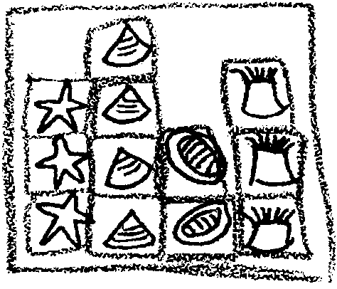

Key Concept
1. Graphs are pictorial devices used to display relationships.

Background

When teaching marine science you will find that students have varied experiences of visiting the sea. Many students will bring in collections of shells, stuffed animals, books, and treasures. This is a good time to take all the materials that have been gathering and do some graphing activities with them. If you have been lucky enough to go on a trip to the sea, you could also do graphing activities on what you found at the beach.

Materials

Activity 1 - Classroom graph

For the class:

• large sheet of butcher paper

For each student:

• 3" x 5" sheet of paper

• pencils and crayons

Teaching Hints

If this is your students’ first experience with graphing, start out by using real objects, such as shells. Then move to the representational graph by having students draw pictures. You may also wish to start with a floor graph by laying the objects in columns and discussing which category has more or less and asking questions that fit the graph you make. Then move to a
representational graph that is up on the wall. Comparisons of the two graphs can then be made.

Procedure:

1. From the materials brought in by you and the students have the children pick an animal about which they enjoyed learning.
2. With the class sitting in a circle, on the floor, decide as a group the categories into which you could group these materials.

Examples: Crabs, sea stars, limpets, etc.Tide pool critters, mammals, plants, etc.

3. Arrange all materials that fit in the first agreed upon category in a row on the floor. Do the same for the next category and so on.

4. Discuss which row has the most materials and which has the least. Are there any two categories with the same amount? Why do you think one category had more than another? Continue to ask questions that relate to your graph.

5. Pass out the small sheets of paper and ask the students to draw the items laying on the floor; one item per sheet.

6. While students are drawing, copy the categories you used on the floor on to a sheet of butcher paper. Hang the butcher paper at a height which students can reach.

7. Have students come forward to tape or glue their pictures on the wall graph to make a representational graph of what was on the floor. Compare the two graphs.

Key Word

graph - a pictorial device used to display relationships

Extension

1. Use this activity as a review.

