Sea Star Math
Lesson by Laura Erickson, Poulsbo, WA

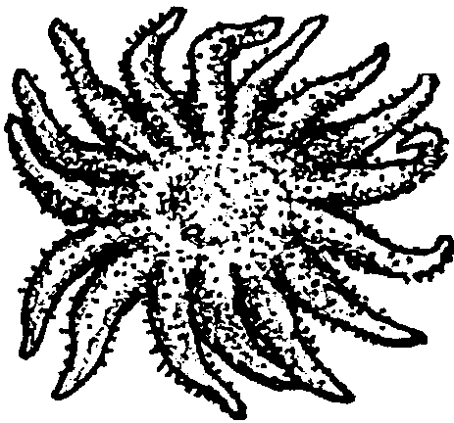
Key Concept
1.Different species of sea stars may have different numbers of rays.

Background

Not all sea stars have five rays. There are many types of sea stars with five, six, ten or even twenty rays.

Additional background information may be found in the preceding activity “Sea Stars”.

Materials

For the class:
• paper and pencils

• star rubber stamp and ink pad or self sticking stars (optional)

Teaching Hints

“Sea Star Math” uses five rayed sea stars to provide practice in counting by fives, as well as using ‘more than’ and ‘less than’ symbols.

Procedure

1. Demonstrate “Sea Star Math” by drawing three five-rayed sea stars on the board. Have the class count by five as you write the total number of rays under each successive sea star (i.e. 5, 10, 15)

2. Have the students make a row of five rayed sea stars. The row can be made by drawing, using a rubber stamp, or by using self-sticking stars. If you are using a star stamp, let each child stamp a given number of stars. If students are using self sticking stars, give each student a set number of stars. The number of stars will depend upon the math skills of the group.

3. Have the students count by five and write the total number of arms under each successive sea star.

Example: one star = 5 rays, two stars = 10 rays, etc.

4. Have the students create math problems using the stars.

Examples: one star + one star = two stars
five rays + five rays = ten rays
two stars - one star = one star
ten rays - five rays = five rays

5. Have the students draw or stamp groups of stars and place a box around each set of stars.

6. Next, have the students place “more than” or “less than” symbols between the boxes according to the number of sea stars in each box.

Example:
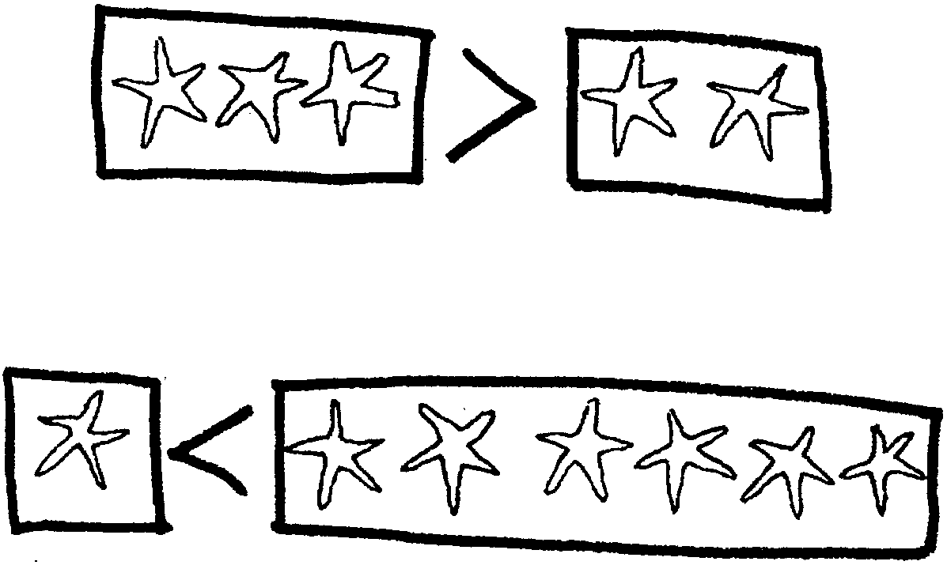

Extension

1. Have students continue the activity with sea stars with a different number of rays.

