Sea Stars

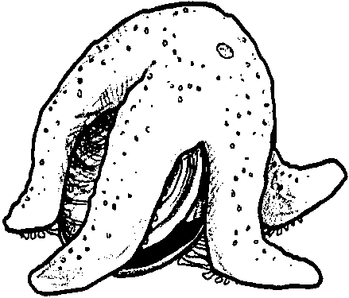
Key Concepts
1. Sea stars are adapted developmentally, structurally, functionally, and behaviorally to their environments.
2. Sea stars are spiny-skinned animals that have an internal hydraulic system which operates hundreds of flexible, elastic tubes on the underside, called tube feet.
3. The tube feet of a sea star are used for moving, eating, and holding on.
4. When a star eats a bivalve (two shells) animal, the sea star pries the shells open, inserts its inside-out stomach between the shells, and digests the animal’s soft tissues.

Background

As common intertidal zone animals, sea stars (starfish) may be more familiar to students than many of the other marine organisms.

Sea stars are interesting creatures with several unusual characteristics. With their hundreds of tiny tube feet they can move in any direction, crawling along the bottom of the sea or up a piling. Each foot is tipped with a tiny suction cup, which help sea stars hang on tight against wave hits.

The tube feet are so strong and powerful that when they all work together they can literally pull a mussel or clam apart. Once the shell is open the sea star inserts its inside-out stomach into the shell and digests the food. When finished, the stomach is retracted and the sea star moves on.

Because oysters, mussels and clams are the bulk of the sea star’s diet, they are very unpopular with shellfish growers, and at one time were cut up into many pieces in an attempt to eliminate them. Much to the surprise of the oyster growers, this only made the matter worse because each part with a portion of the central disc became a whole new sea star through the process of regeneration.

Sea stars can usually regenerate lost arms. Regeneration is, however, a slow process and often times an animal missing one of its appendages will succumb to predation or starvation before regeneration is complete.
A sea star has gills, however its gills are not used for breathing. Instead, sea stars breathe through the soft, fuzzy clumps of oxygen-absorbing tissue on the spiny skin covering. Tiny pinchers on the skin prevent suffocation by routinely pinching off organisms and other debris that settles on the skin. If you have access to a living sea star, try holding it gently against your arm. When you remove it, feel the pinchers tugging at the hair on your arm.

If students have an opportunity to observe a sea star, challenge them to determine if the sea star has a front or back by observing which side or ray (arm) of the sea star is most often in front when traveling.

Materials

For each student:

• “Sea Stars” activity pages

Teaching Hints

“Sea Stars” investigates a common inhabitant of the intertidal zone. Although sea stars (starfish) are more familiar to students than many of the other marine organisms, be sure to provide pictures and visual aids to help your students visualize the animals.

Duplicate the text pages. One set is recommended per student. Recognizing that the reading ability of first grade students varies dramatically over the course of the school year, give thought to the best way to complete the activity with your particular group of students. In the fall, you may wish to read the selections to your students, having them complete the requested actions on the activity sheet and answer the questions out loud. In the spring, you may wish to have them work in small groups or independently to complete the activity. Regardless of the approach you select, allow a few minutes to discuss the basic concepts covered in the reading.

Key Words

ray - arm of a sea star

sea star - a spiny-skinned animal that is star-shaped with a central body and five or more arms (rays)

tube feet - special, fluid-filled organs used for locomotion and attachment in sea stars, sea cucumbers and sea urchins; each foot is tipped with a tiny suction cup

Extensions

1. Reinforce concepts taught using the matching activity, “Sea Star Matching” or the coloring pages that follow.

2. (To the tune of “If You’re Happy and You Know It”)

If you’re a seastar and you know it, stretch your rays.
If you’re a seastar and you know it, stretch your rays.
If you’re a seastar and you know it, then your rays will surely show it.
If you’re a seastar and you know it, stretch your rays.

If you’re a barnacle and you know it, wave your legs.
If you’re a barnacle and you know it, wave your legs
If you’re a barnacle and you know it, the your legs will surely show it.
If you’re a barnacle and you know it, wave your legs.

If you’re an anemone and you know it, sting your food.
If you’re an anemone and you know it, sting your food.
If you’re an anemone and you know it, then your sting will surely show it.
If you’re an anemone and you know it, sting your food.

If you’re a limpet and you know it, find your spot. (on the rock)
If you’re a limpet and you know it, find your spot.
If you’re a limpet and you know it, then your spot will surely show it.
If you’re a limpet and you know it, find your spot.

If you’re a chiton and you know it, count your shells.
If you’re a chiton and you know it, count your shells.
If you’re a chiton and you know it, then your eight shells will surely show it.
If you’re a chiton and you know it, count your shells.

Answer Key

“Sea Stars” Text Questions
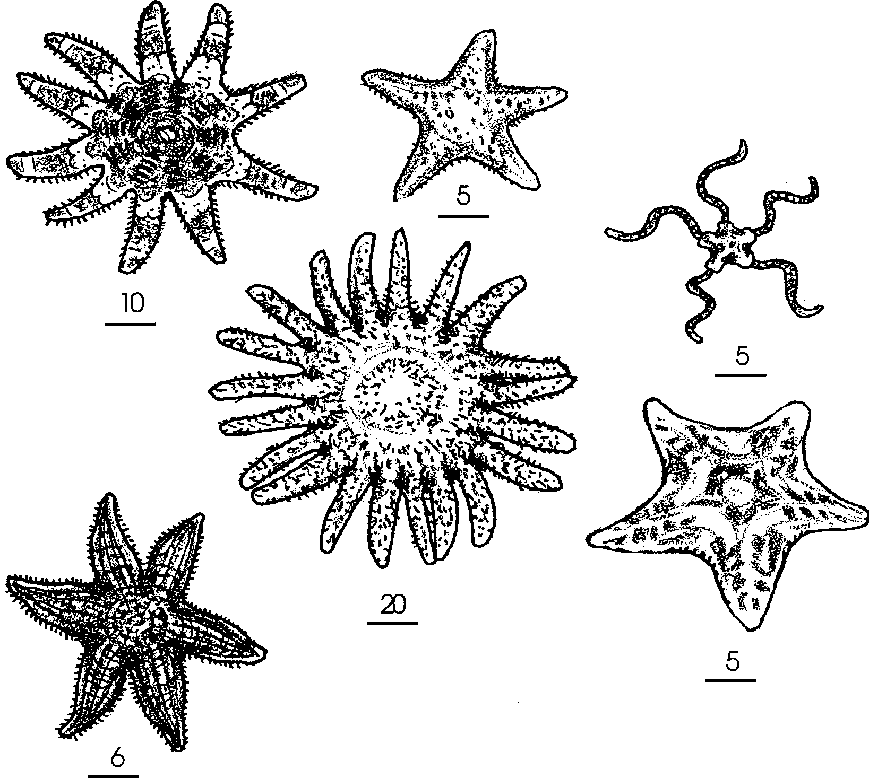
1.

2. Tube feet help a sea star move and hang on. A sea star must hang on tight when a wave hits, when a predator tries to pry it off, or when opening shellfish to eat.

3. Tube feet help a sea star eat. A sea star uses its tube feet to open shells. Its tube feet pull the clam shells apart. The sea star turns its stomach inside out and inserts it into the shell and digests the food. When finished, the stomach is retracted and the sea star moves on.

Key for “Sea Star Matching”

1. Sea stars eat clams.

2. Sea star arms are called rays

3. Sea stars use tube feet to move.

4. Sea stars come in many colors.

5. The brittle star is on the right.
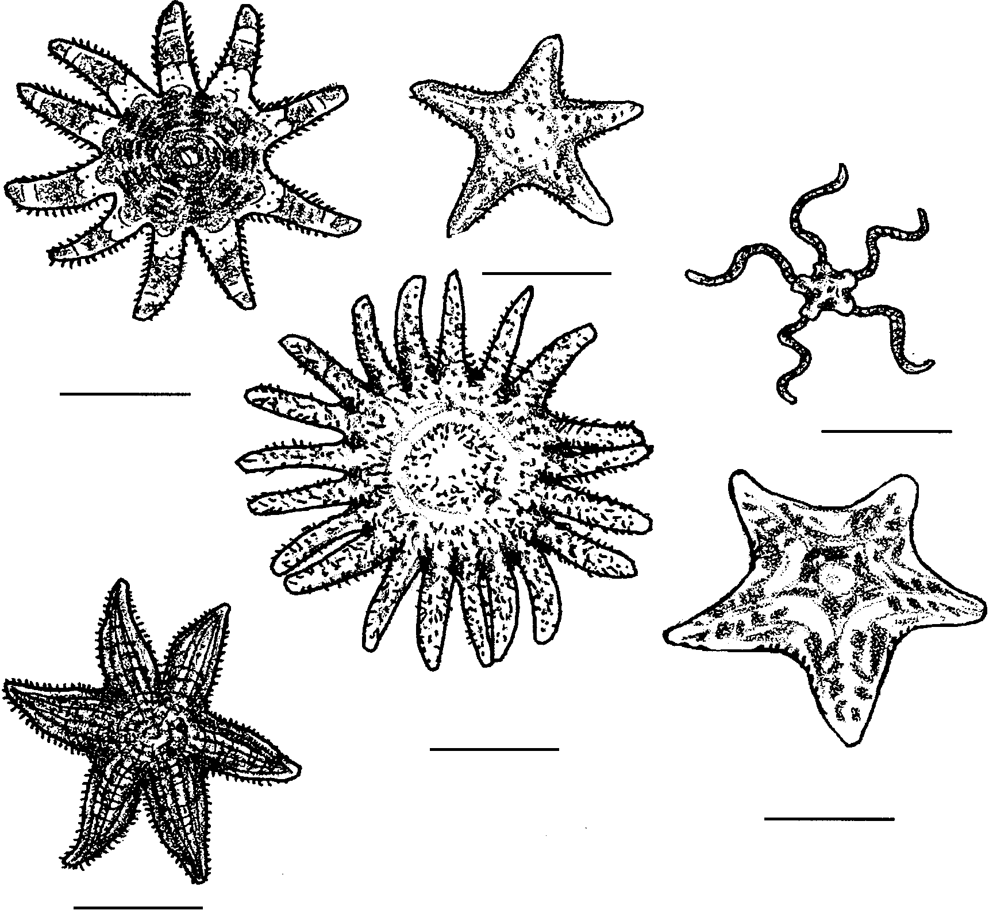
Sea Stars

Some sea stars look like stars. Some are red. Some are orange. They come in many colors. They have arms. The arms are called rays.

1. Count the rays. How many rays does each have? Put the number under each sea star.
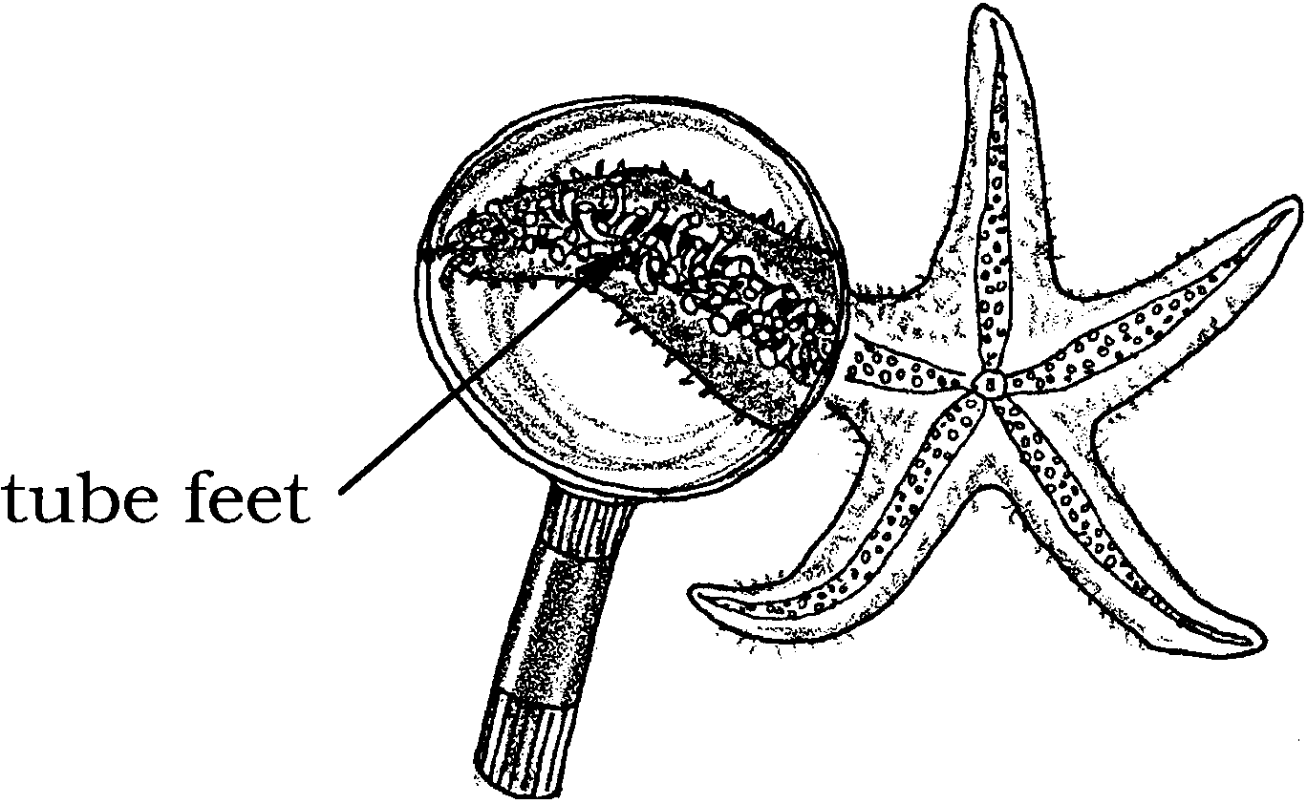
A sea star’s top side is hard. The bottom has many tube feet.

1. They help the sea star move. They also help it hang on.

2. Tube feet help a sea star and .

A sea star eats clams. It uses its tube feet. They pull the shells open. Then it eats the clam.

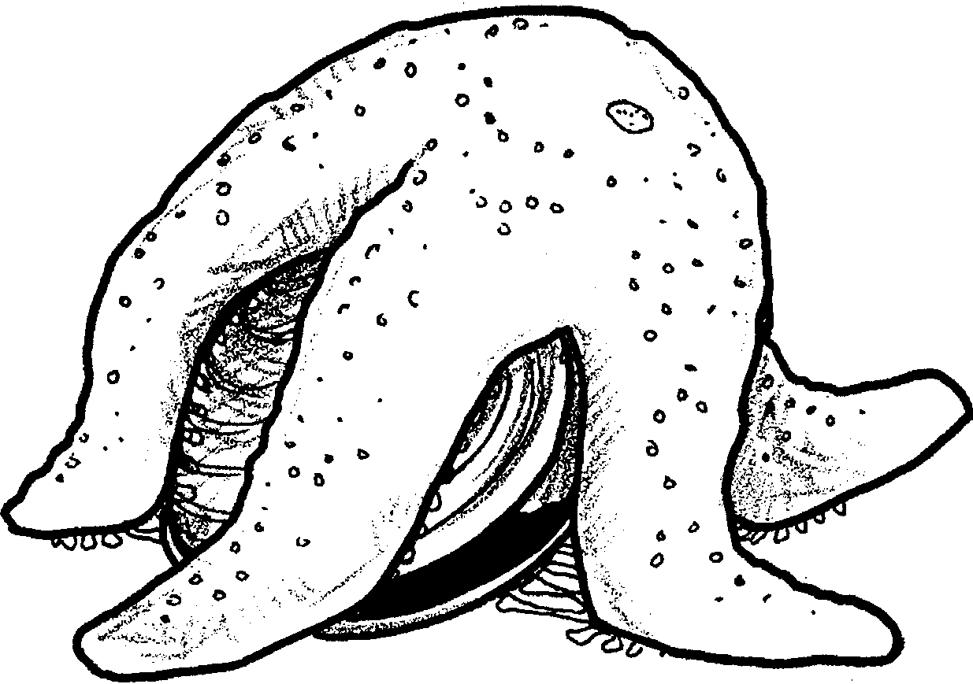

3. Tube feet help a sea star to .

4. There are many kinds of sea stars. Draw:

A sea star with 5 rays.

A sea star with 20 rays!

A sea star with fat rays.

A sea star with thin rays.

A red sea star.

A purple sea star.
A sea star may lose a ray. A new one grows back slowly.

5. Tell a story about this picture.
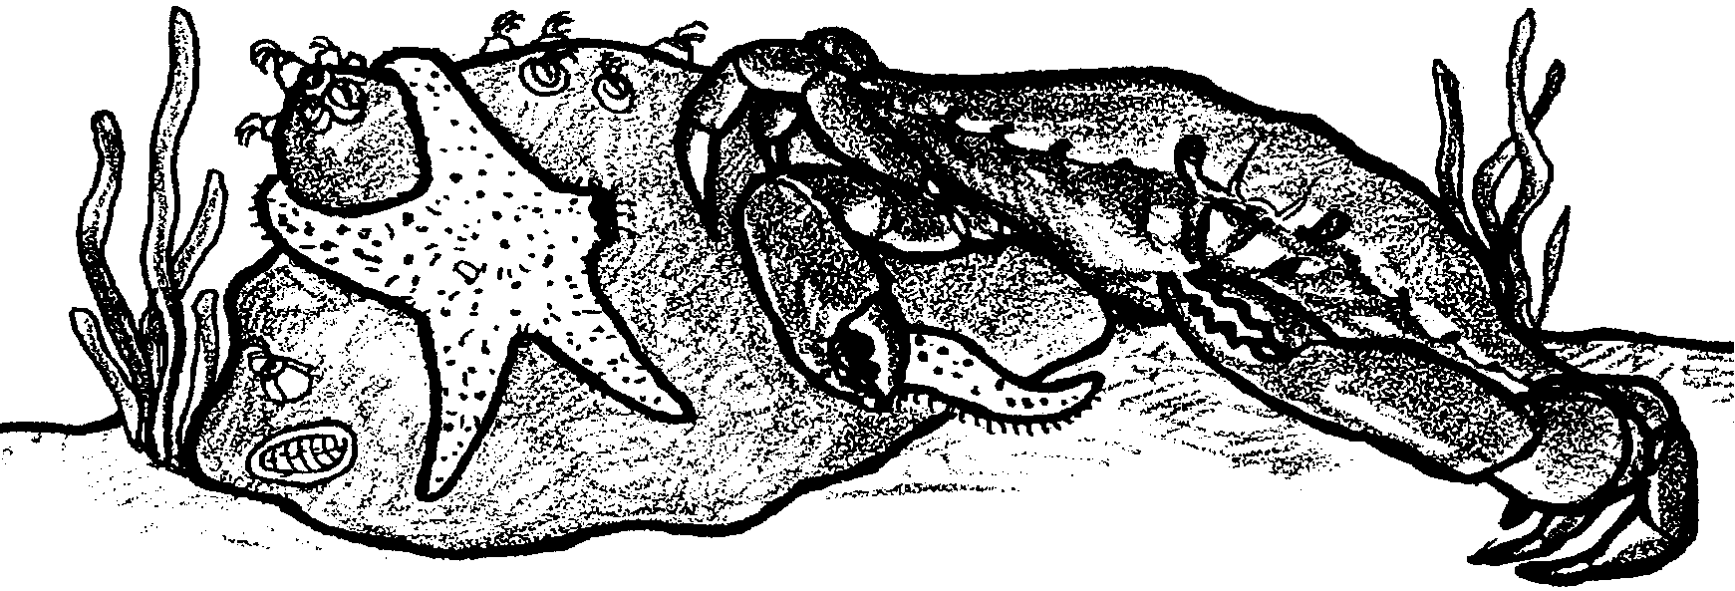

Sea Star Matching

Cut the words out. Glue the correct word in the box.

1. Sea stars eat

2. Sea star arms are called

3. Sea stars use to move.

4. Sea stars come in many

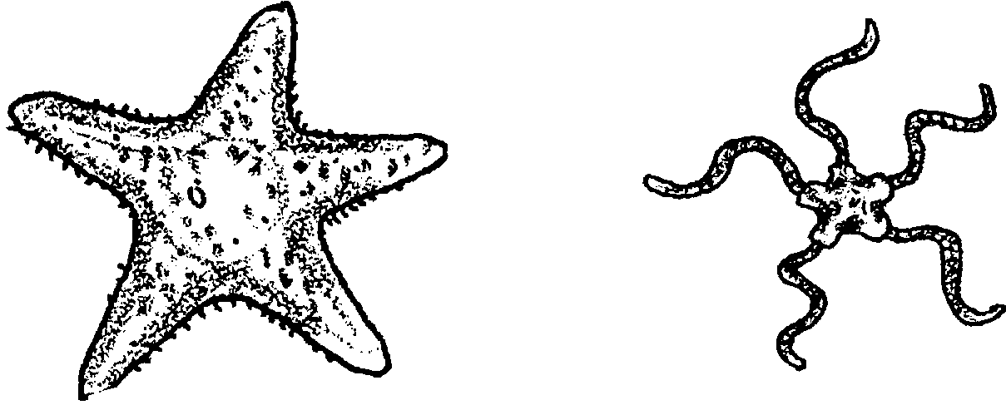
5. Brittle stars have very thin arms. Circle the brittle star.

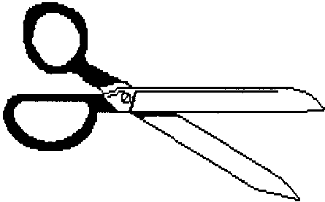tube feet rays

clams colors

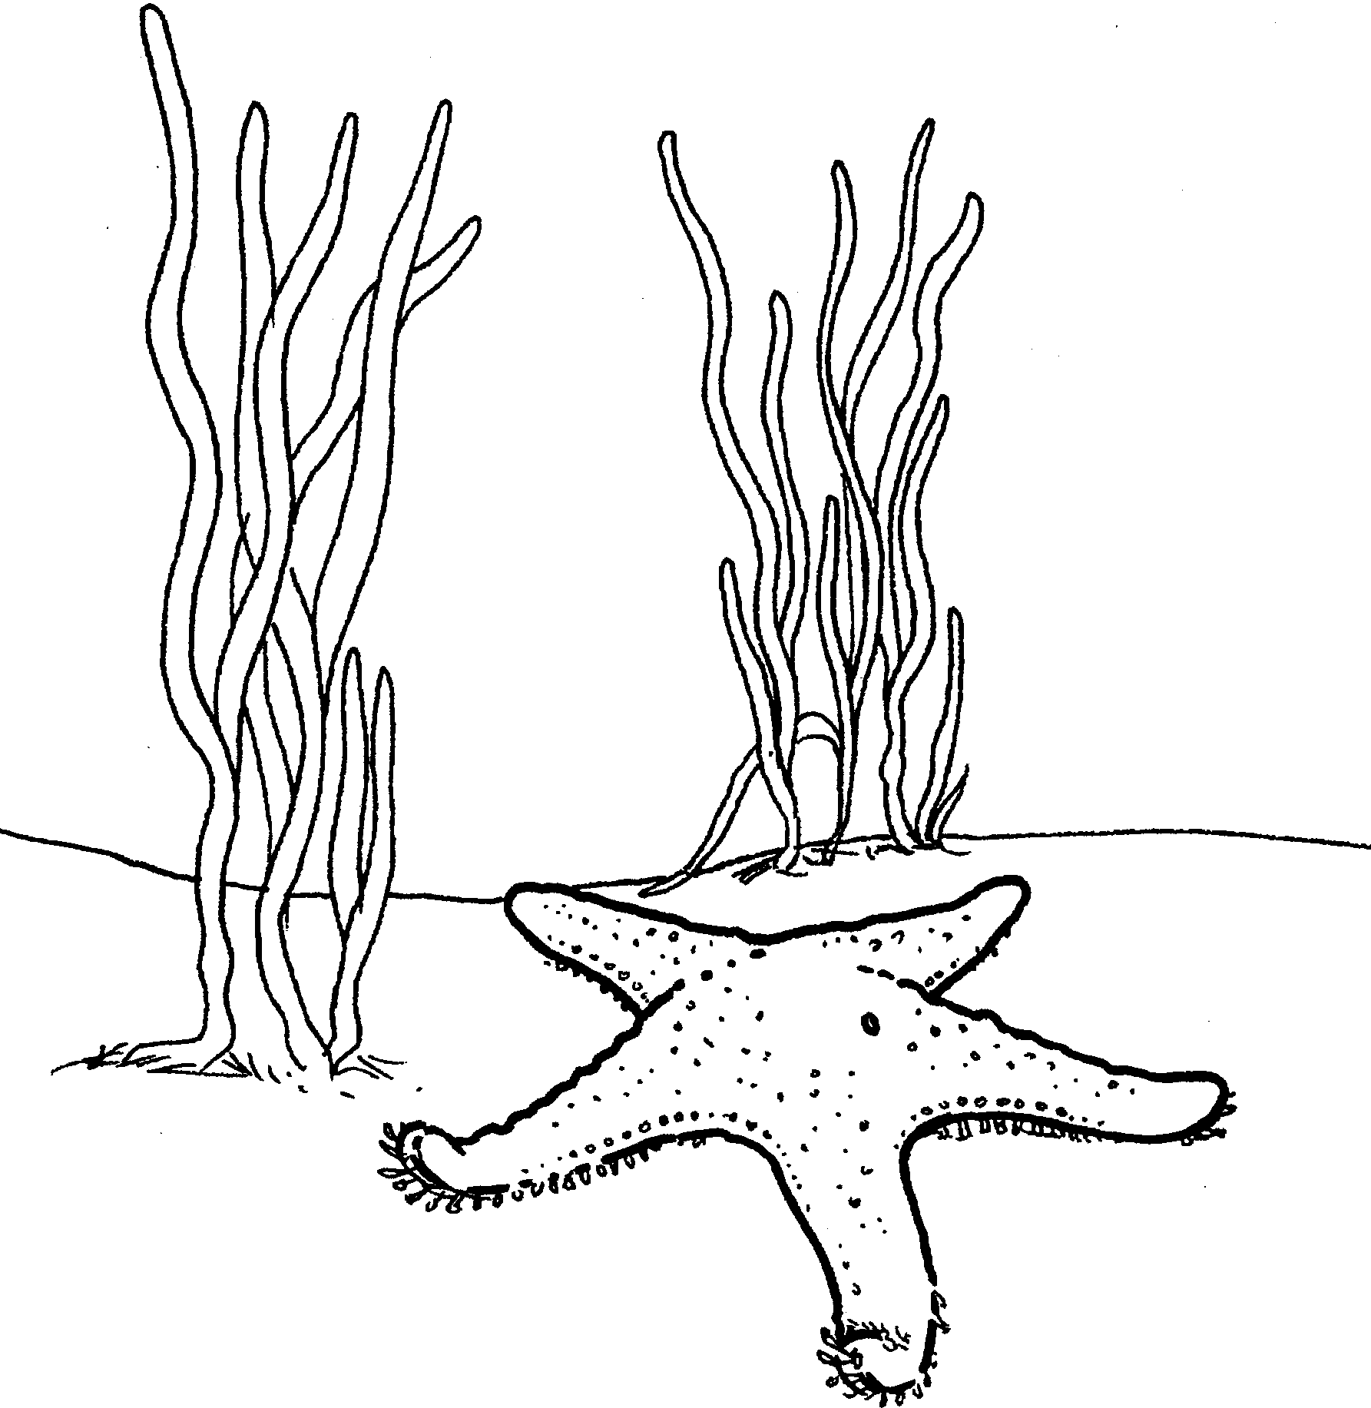
1. I'm a .

2. How do I move?

3. Color me.

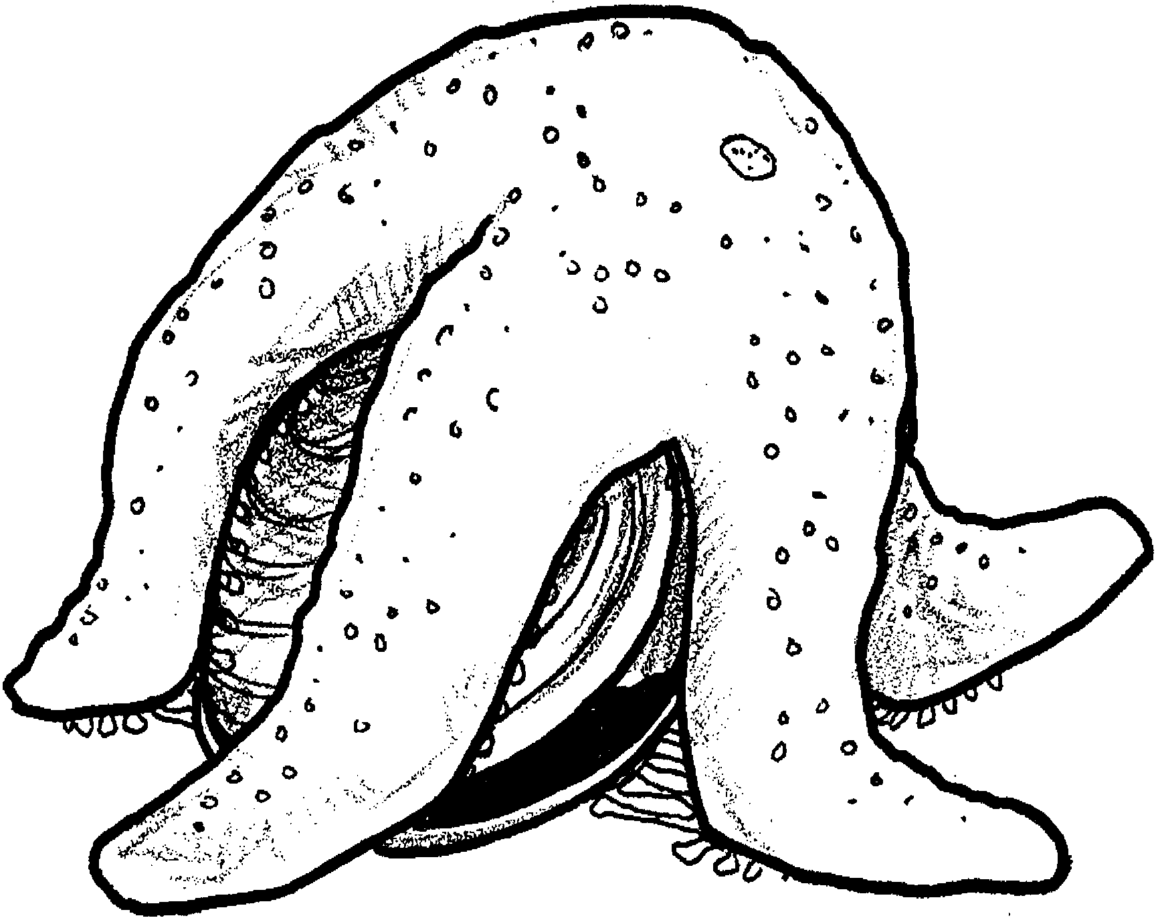

Clams for dinner!

1. I am a .

2. What am I doing?

3. Color us.

