Creating Chitons
Lesson by Laaaura Erickson, Poulsbo, WA

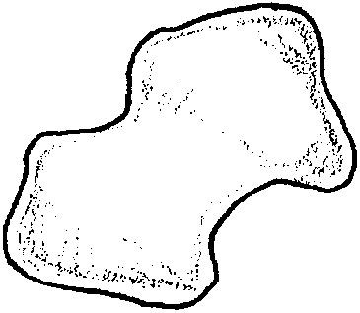
Key Concept
1. Chitons have eight overlapping, shell plates for protection.

Background

The chiton is a very intriguing character. Each of the eight individual shell plates of the chiton looks like a pair of butterfly wings. If you are a very lucky beachcomber, you may be able to find all eight shell plates of a chiton and see how they fit together so smoothly, one on top of the other.

Additional background information is found in the preceding activity “Limpets and Chitons”.

Materials

For each student:

• paper plate

• copy of large chiton picture

• clay

• scissors

• markers or crayons

Teaching Hints

In “Creating Chitons” your students will form and assemble the eight shell plates of a chiton.

Procedure:

1. Distribute a paper plate to each student. Have students color the paper plate to look like a rock upon which a chiton would live.

2. Have students cut out the large drawing of the chiton and glue it to the paper plate.

3. Give each student a chiton shell plate pattern sheet and clay to form the eight individual shell plates. Have them form one shell plate at a time starting with the smallest one. After the first shell plate is made it is placed on the paper plate. Then make the second shell plate. Carefully overlap the second shell plate on the first, continuing in this manner until all eight plates have been made.

Key Word

shell plate - one of eight, butterfly-shaped shells that make up the hard, outer covering of a chiton

Extension

1. Encourage students to identify and locate pictures of other animals that have “suits of armor”, like the chiton, for a protective covering.

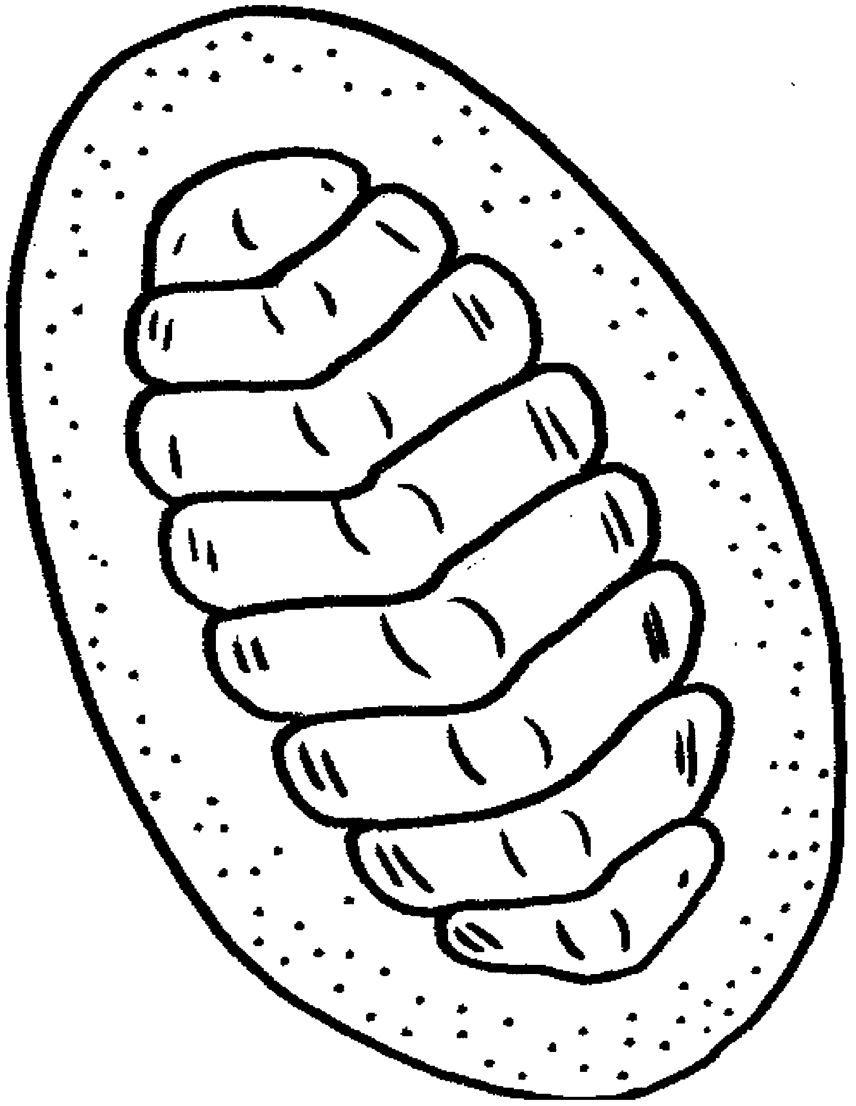
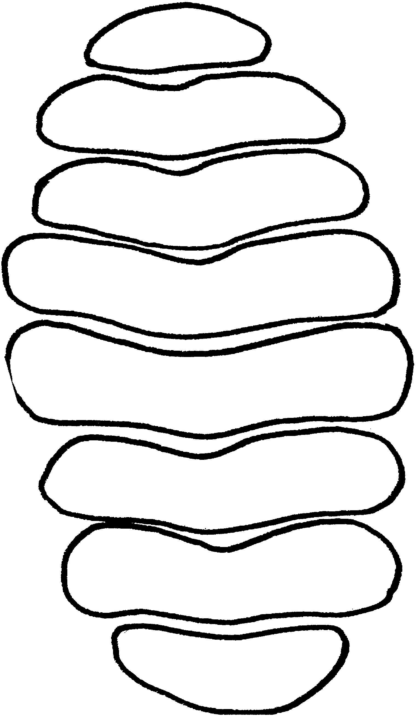
Chiton Shell Plate Pattern

