Life on the Rocks
Lesson by Laaaura Erickson, Poulsbo, WA

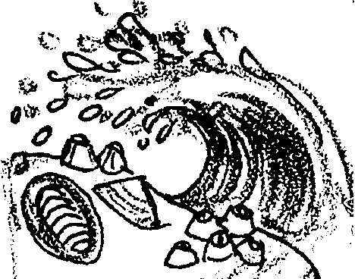
Key Concepts
1. Animals living in the intertidal zone must be adapted to withstand the pounding surf.
2. Limpets and chitons have a flat, muscular foot for attachment.

Background

Limpets and chitons have special adaptations to withstand the conditions of life on the rocks of a tidepool. They must be able to withstand the pounding of the surf, as well as the drying of the sun, and changes in the water’s salinity and temperature.

Additional background information is found in the preceding activities, “Intertidal Tales” and “Hold On.”

Materials

For the class:

• school yard fence, trees, or buildings

• buckets of water

For each pair of students

• 2" by 2" piece of sponge

• miscellaneous materials (paper clips, string, pipe cleaners, etc.)

Teaching Hints

The purpose of this activity is to show the difficulties an organism faces in trying to hold on to a rock in the pounding surf. Pairs of students use their creativity to adapt a “sponge” limpet to hold onto a fence, tree, or even a school building.

1. Divide the class into groups of two. Challenge them to adapt their sponge piece “limpet” so that it will stay attached to a fence (or whatever you have selected) when a “wave” (a bucket of water) washes over it. You might demonstrate fastening the limpet using paper clips that have been reshaped, tying the limpet on with string, etc. Encourage creativity.
2. Have each pair draw a picture of their plan, including materials needed. Have them gather the necessary materials and move outside to attach their “limpet”.

3. When all “limpets” are attached, simulate a wave by tossing a bucket of water on them. The sponges that stay attached are considered successful “limpets”. Those that fall off from the force of the water need to try again to be successful.

Extension

1. Limpets use a flat, muscular foot to stay attached in the intertidal surf. Investigate other forms of attachment for intertidal creatures.

