Hold On
Lesson by Pat Williams, Eugene, OR
Adapted from Marine Life Teaching Kit by Julie Swartz
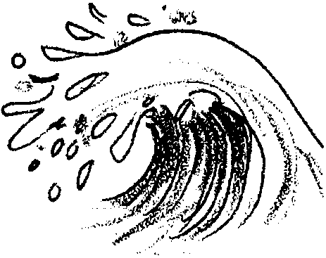

Key Concepts
1. Waves have force that can wash away plants and animals.
2. Tidepool plants and animals have many adaptations that help them hold onto rocks or wedge into small crevices.

Background

Waves

Waves are disturbances in the surface of the ocean. Waves are most commonly caused by winds blowing over the surface of the water. The size of waves is determined by the wind force, the length of time the wind blows, and the distance the wind can move over the ocean. Storms that are strong, last a long time, and travel many miles create the biggest waves. The highest wind-created wave ever recorded was 112 feet high.

Waves can also be caused by earthquakes and volcanic eruptions. These types of waves are called tsunamis and can cause great damage when they hit land.

The normal wave action of the ocean is especially important in mixing oxygen from the air into the water. Oxygen is needed by marine plants and animals.

Adaptations of Intertidal Organisms to “Hold On”

Plants and animals that live in the exposed intertidal zone must adapt to the pounding force of waves so they will not be dislodged and destroyed. Tidepool creatures adapt by anchoring themselves to the rocks. They must hold on for “dear life”. Barnacles have thick shells and, as adults, permanently glue themselves to rocks. Sea stars and sea urchins use suction cup-like tube feet to hang on to rocks. Limpets, chitons, and snails use a heavy muscular foot to create suction. Mussels attach themselves with tough, fibrous, byssal threads.

Materials

Part One: The Force of Water

For the class:

For outside:

• Hose (ask the custodian to set one up for your use)

• Nozzle, if available

• Variety of objects (e.g. milk carton, plastic containers, egg carton sections, leaves, grass)

For inside:

• Spray bottle with an adjustable nozzle

• Turkey baster with a strong “blast”

• Variety of objects as above, but smaller and lighter

For activity center:

• Collection of “stuff” including:
egg carton sections to represent barnacles, paper plates folded to represent bivalves, suction devices (from a craft store), cut up rubber bathmats with suction on the back, construction paper, tagboard scraps, glue, heavy thread or yarn, tapestry needles, burlap cloth, paper clips

Teaching Hints

This activity is open-ended, allowing for exploration and problem solving. There are no wrong ideas, just interesting ones. Allow two or more days for this activity, depending on the time spent on each session.

“The Force of Water” activity can be done with a whole class, but it is preferable to do it in small groups, with additional adult helpers for supervision. It is most fun to do outside, but can be done inside.

Part One: The Force of Water

Part One allows your students to directly experience the force of water upon a variety of items. You may choose to supply the items listed under “Materials” above or have your students bring items from home. Tell your students that they are going to experiment to see how items are affected by moving water. Ask the group to predict the items which will be least affected. Write those on the board or on a tablet for later discussion.

To do this activity outside:

If you are working with the whole class: Have students place the items they have collected on a firm surface. Spray them with the strongest spray to move them. Discuss results (see questions below).

If you are working in small groups with adult supervision: Have the children place the items they have collected on a firm surface. Allow them to use the hose to spray and move the objects.

Discuss results by asking:

“What happened to the objects?”

“How did what happen match your predictions?”

“What do you think happens when a wave pounds tidepool creatures?”

“What adaptations might they have to avoid being swept away?”

To do this activity inside: Use the modified materials to do the same experiment.

Part Two: Resisting the Water’s Force

Visualization activity - imagining “holding on”

Lead the class through a visualization of what it is like to be in the waves. Say:

“Yes, you may have “adapted” by running away.”

“Can a mussel or sea star run away?”

“If you were standing in front of a big rock and could not run away, what might you do? (Expected answer: hang on tight).”

“Do you think a sea star or a mussel can hang on? How?”

Activity center

1. Divide the “collection of stuff” you have gathered (see “Materials” section above) among enough work tables to allow the children to work in groups of about 4 students.
2. Gather each group around a work table set up with materials. Direct the children to think of ways tidepool creatures can “hold on” to rocks.

3. Have children use the materials to create a “hold on” adaptation for a creature they already know about, or an imaginary creature that has an adaptation for holding on to its spot. Allow plenty of time for them to experiment and explore.

4. Allow projects to dry overnight if they have been glued.

5. After projects have thoroughly dried, have the children share their creature and its “holding on” adaptation.

Key Words

adaptation - modification of an organism or its parts that makes it more fit for existence under the conditions of its environment

byssal thread - a strong, elastic fiber used by mussels to attach themselves to a solid substrate

force - strength or energy exerted or brought to bear

holdfast - a structure that attaches seaweeds to rocks or to other substrates

tube feet - special, fluid filled attachment organs for movement and for collecting food: as in sea stars, sea cucumbers, and sea urchins.

Extension

1. Test the children’s adaptations. Use a spray bottle or turkey baster to simulate waves to see which creatures can hold on. (Since the spraying can be messy, you may wish to go outside or use a tarp.)

