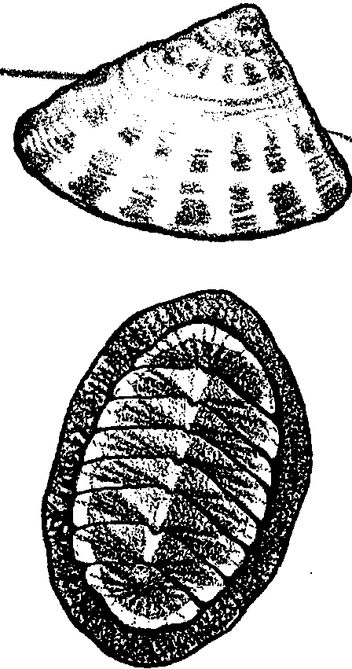
Limpets and Chitons (Ki tons)

Key Concepts
1. Limpets are single shelled marine animals that use a flat, muscular foot to remain attached to rocks.
2. Chitons are marine animals which have eight shell plates for protection and use a flat, muscular foot to remain attached to rocks.
3. Both limpets and chitons use their rasping tongue or radula to graze on tiny algae which covers the rocks in tidepools.

Background

Limpets and chitons are common and commonly overlooked tidepool animals. We tend to think of free swimming fish and scurrying crabs when we think of marine animals. However, a great many marine animals, such as limpets and chitons, lead a sedentary existence, firmly affixed to the bottom or some other feature. Both limpets and chitons possess a large, muscular foot which they use for attachment.

During low tides, most limpets and chitons stay in one spot. When submerged during high tides, they glide slowly over the rocks. As the tide falls, they return to precisely the same spot. For limpets that spot is a neat “scar” the exact size and shape of the limpet.

Limpets and chitons eat very small but nevertheless visible (macroscopic) plants (algae). Using a rasping tongue, called a radula, a limpet or chiton grazes the surface scraping off the microscopic plants as it travels. This feeding action underscores the interrelationships that exist between plants and animals. The existence of any species of animal is directly or indirectly related to the existence of some species of plant.

Although both molluscs, the shells of limpets and chitons are quite different. The single-shelled limpets vary in size. Some are tiny, others fit on the end of a finger, others are larger than a silver dollar and some can grow to the size of an adult’s hand. Some limpet shells are plain others look like fancy painted buttons with stripes and spots. Chitons have eight shell plates that run across the back of their body. Tidepoolers delight in finding chiton plates; butterfly shaped, blue or white arches of shell.

Materials

For each student:
• “Limpets and Chitons” activity pages

Teaching Hints

In discussing this section, draw the students’ attention toward the differences between free swimming and fixed animals. If students have an opportunity to observe live chitons and limpets, encourage them to distinguish the difference in the feeding patterns or habits of the two animals. On occasion, chitons and limpets can be pried loose from their foothold if proper pressure is quickly exerted before the limpet or chiton has the chance to clamp down firmly.

Recognizing that the reading ability of first grade students varies dramatically over the course of the school year, give thought to the best way to complete the activity with your particular group of students. In the fall, you may wish to read the selections to your students, having them complete the requested actions on the activity sheet and answer the questions out loud. In the spring, you may wish to have them work in small groups or independently to complete the activity.

Duplicate the text pages. One set per student is recommended. The following format may be helpful in guiding your discussion.

Limpets and Chitons

Limpets look like .

Chitons look like .

They (action)

Limpets are not like chitons because

.

Limpets are like because

.

Chitons are like because

.

These are limpets and chitons.
Key Words

chiton - a molluscan marine animal with eight separate shell plates and one large, muscular foot with which the animal adheres tightly to rocks and other hard surfaces

limpet - a molluscan marine animal with one hard shell and a large, flat muscular foot with which the animal adheres tightly to rocks and other hard surfaces

mollusc - any of a large group of invertebrate animals having a soft, unsegmented body, usually covered with a hard shell; such as snails, clams, oysters, and octopuses

radula - a rasping, tongue-like structure used by limpets, chitons, and other molluscs for scraping food from rocks

Extension

Concepts presented in this activity can be reinforced by completing the activity “Hanging On” or the coloring sheets that follow this lesson.

Answer Key

Limpets

1. Answers will vary depending upon experience.

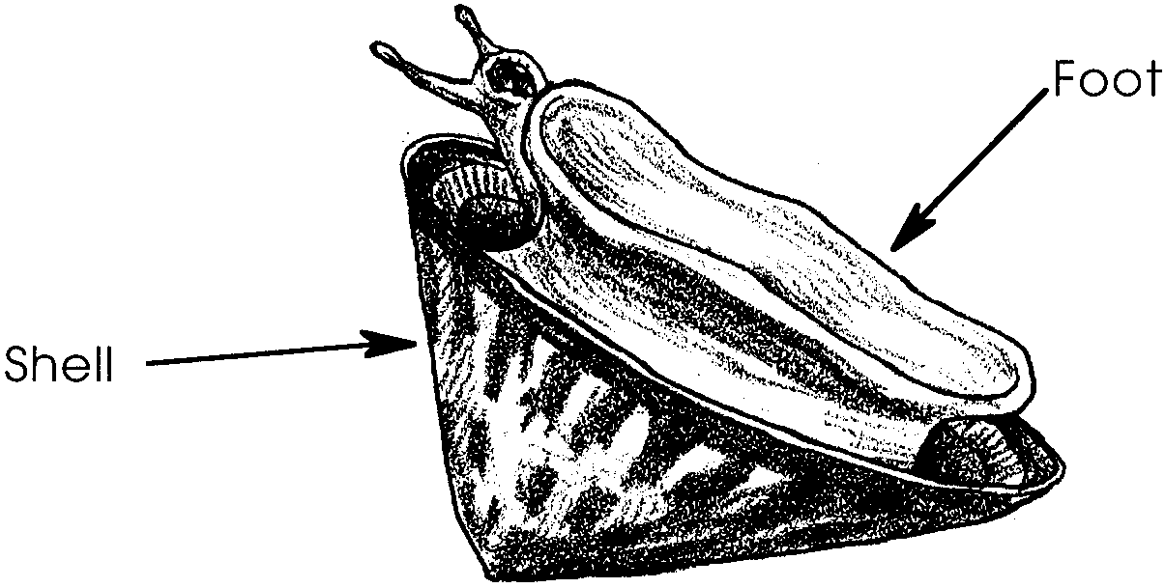
2. and 3. A correctly labeled limpet follows:

Chitons

1. Chitons have eight shell plates.

2. Answers will vary depending upon experience.

3. Answers will vary. Chitons protect themselves by rolling into a ball. It is worth noting that the rolling is relatively slow which seems to indicate that this behavior only offers protection from very slow predators.
Limpets
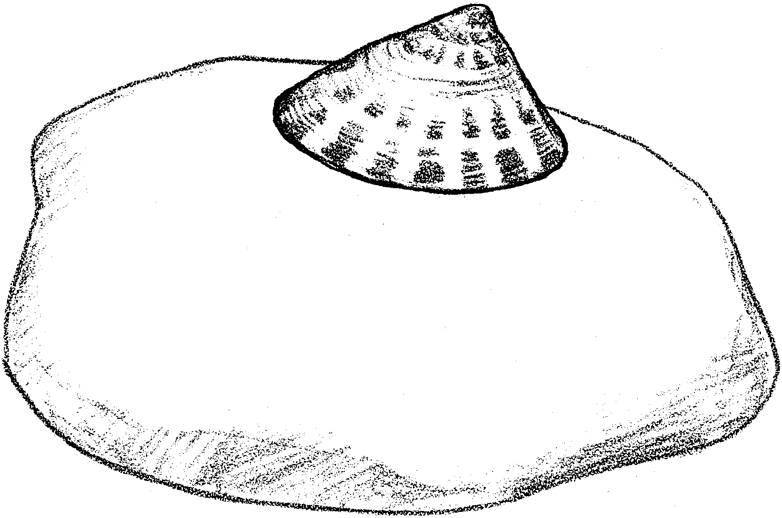
This is a limpet.
1. What does it look like?

Draw 3 more limpets on the rock.

Limpets live on rocks. Each limpet has its own spot. This spot just fits their shell. They hang on with one, large foot.
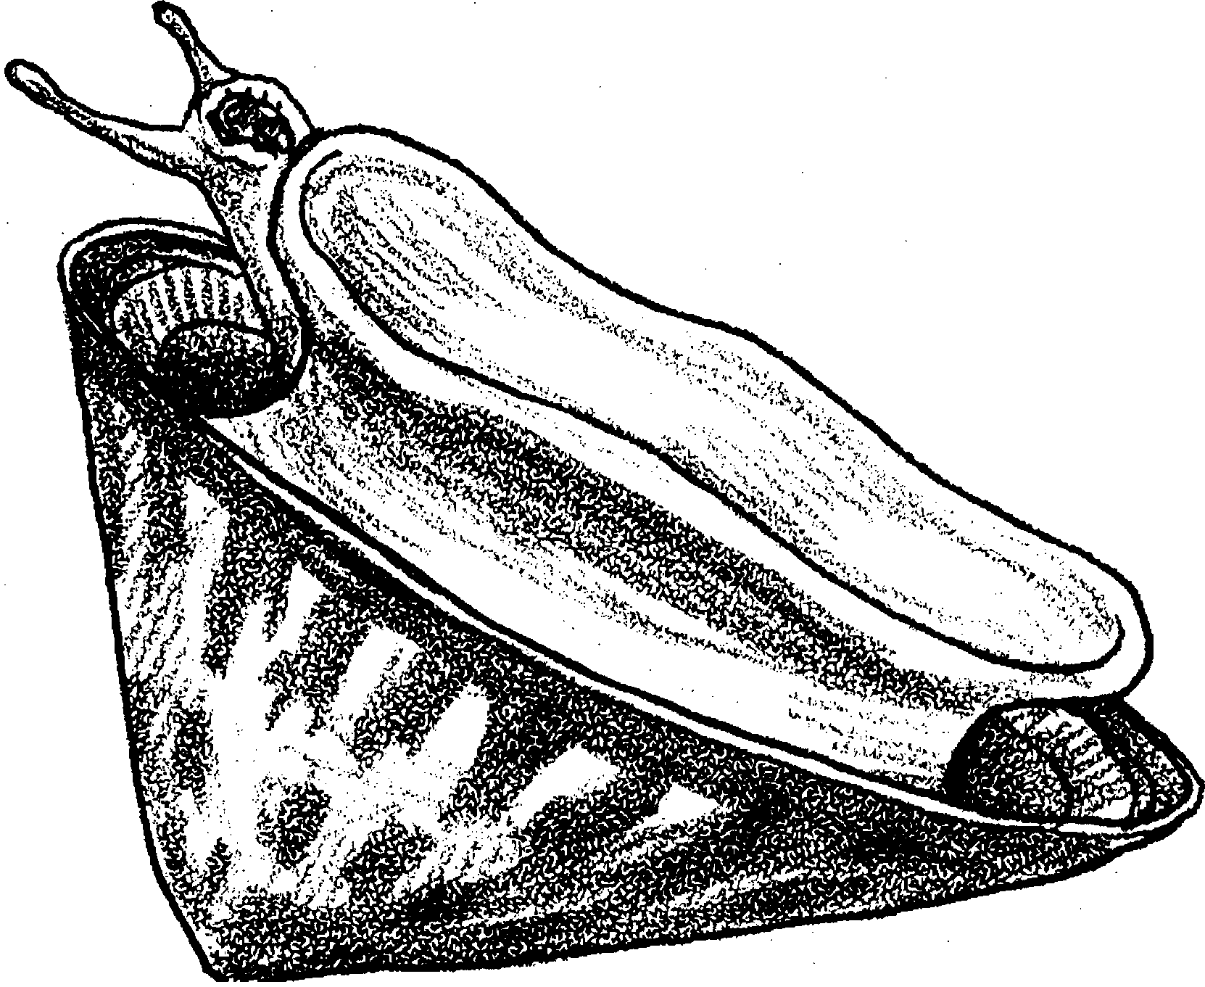
This limpet is turned over.

2. Label the limpet’s foot.

3. Label the limpet’s shell.

Limpets eat seaweed. They scrape it off the rocks.
Chitons

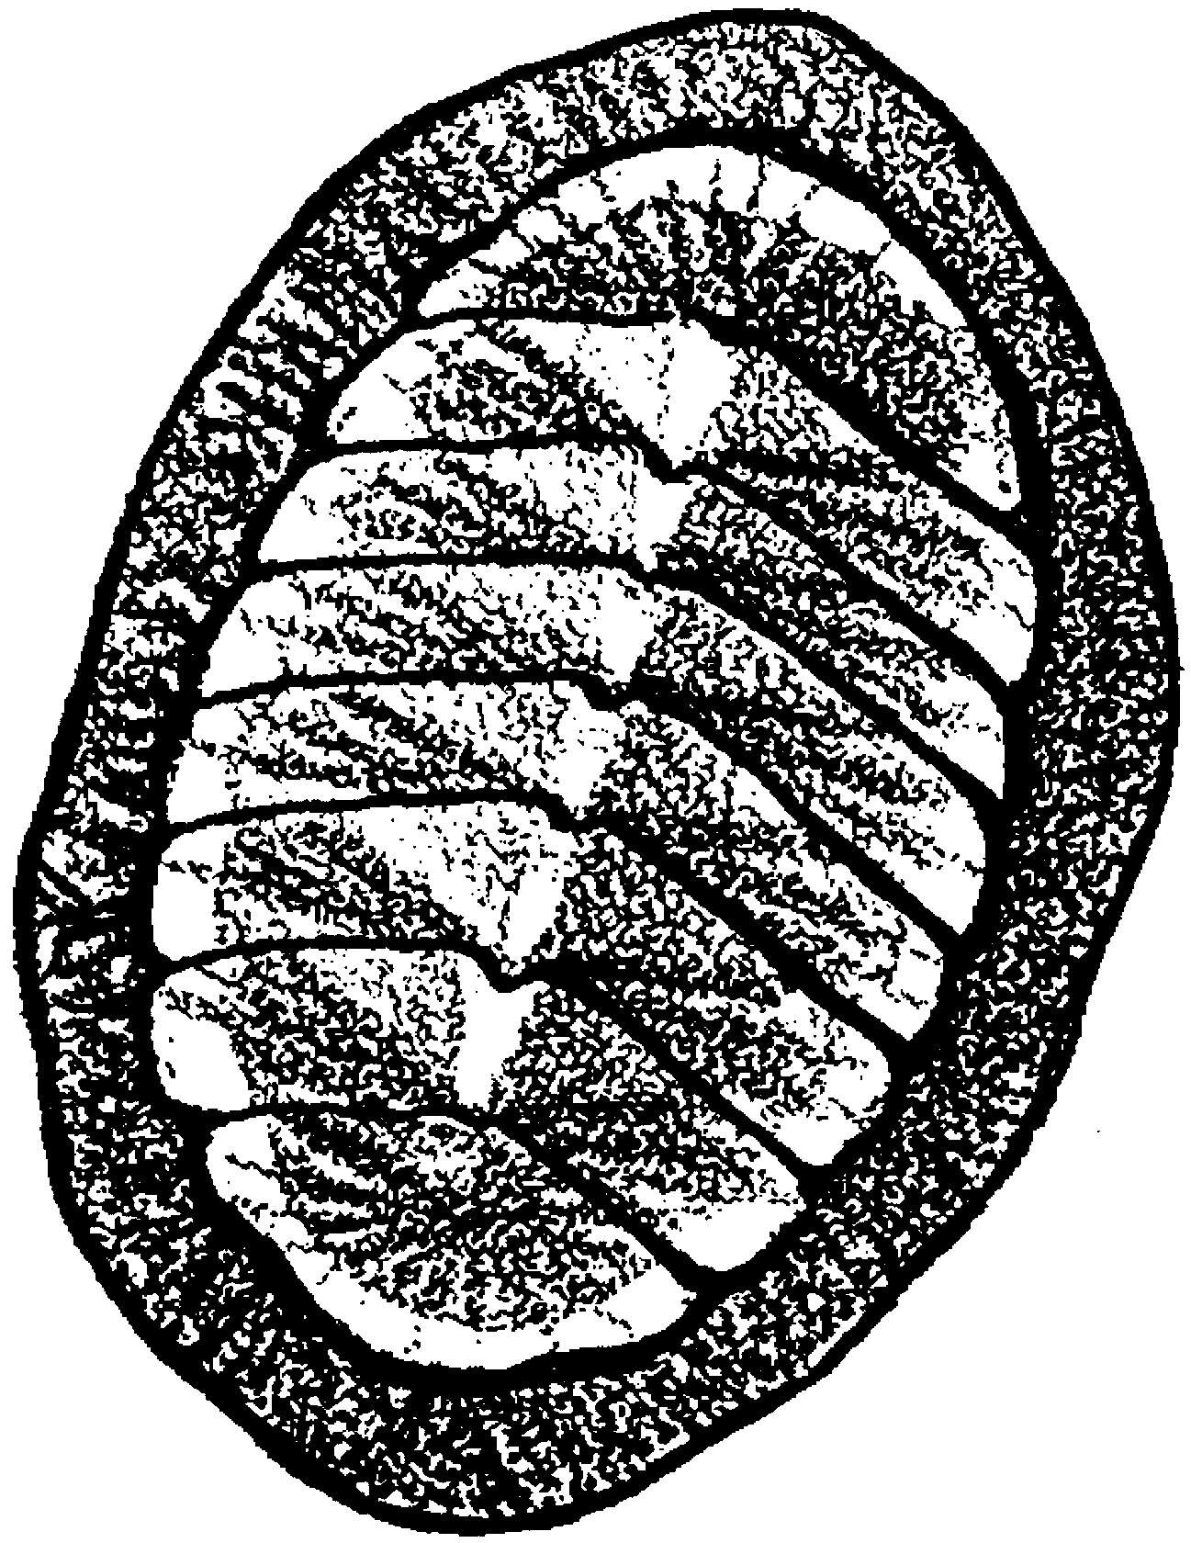

This is a chiton (ki ton). Look at the shell parts. They are called shell plates.

1. There are shell plates.

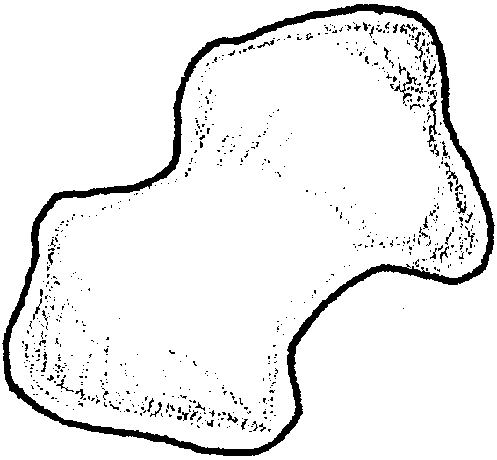
Here is a shell plate.
It is white.

2. What does this shell plate look like?

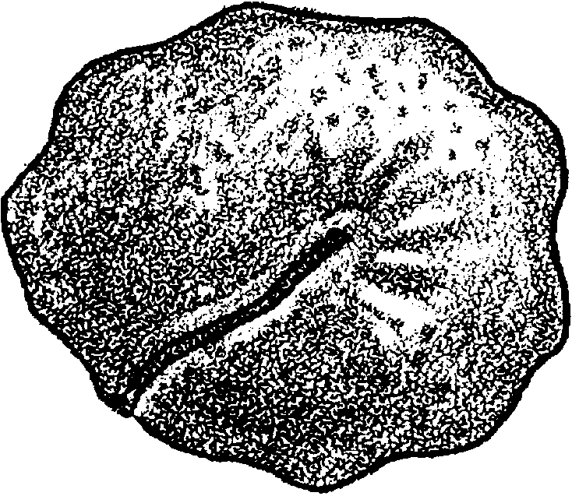
A chiton has a large foot. The foot holds it on its rock. This chiton was taken off its rock.

3. How is this shape helpful?

Hanging On

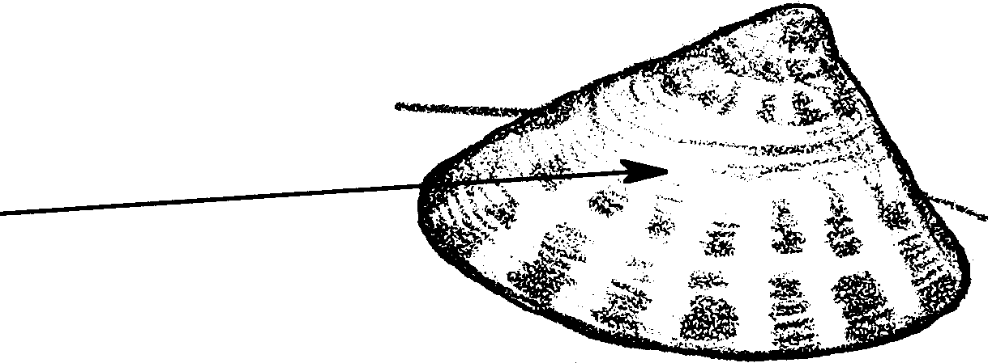
Match the words to the animal or animals. The first one is done.

1. One shell
2. Eight shell plates
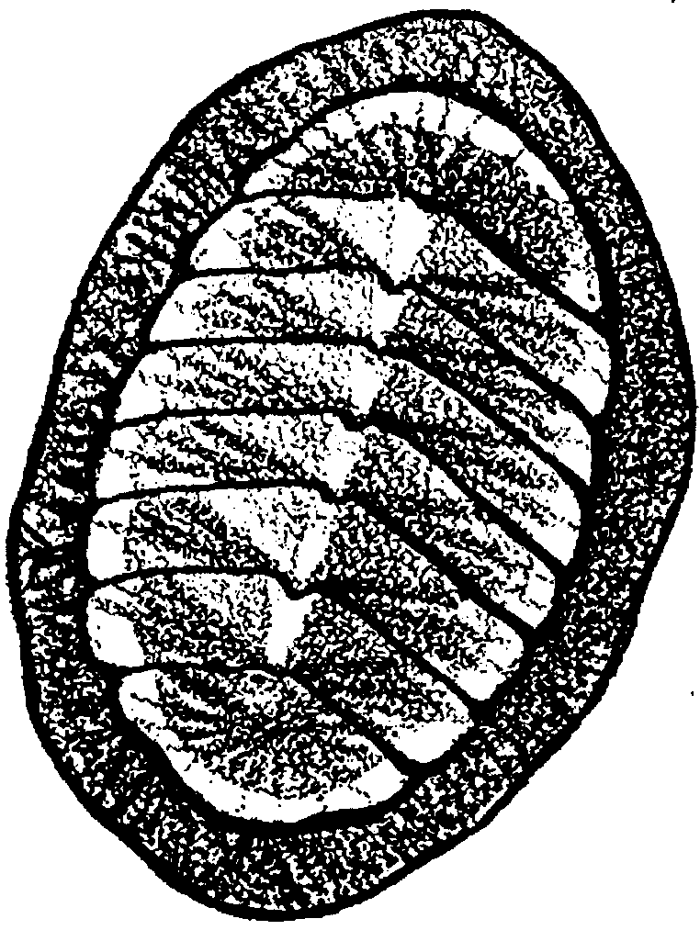
3. Lives on rocks
4. Eats seaweed
5. Has a foot
6. Rolls into a ball

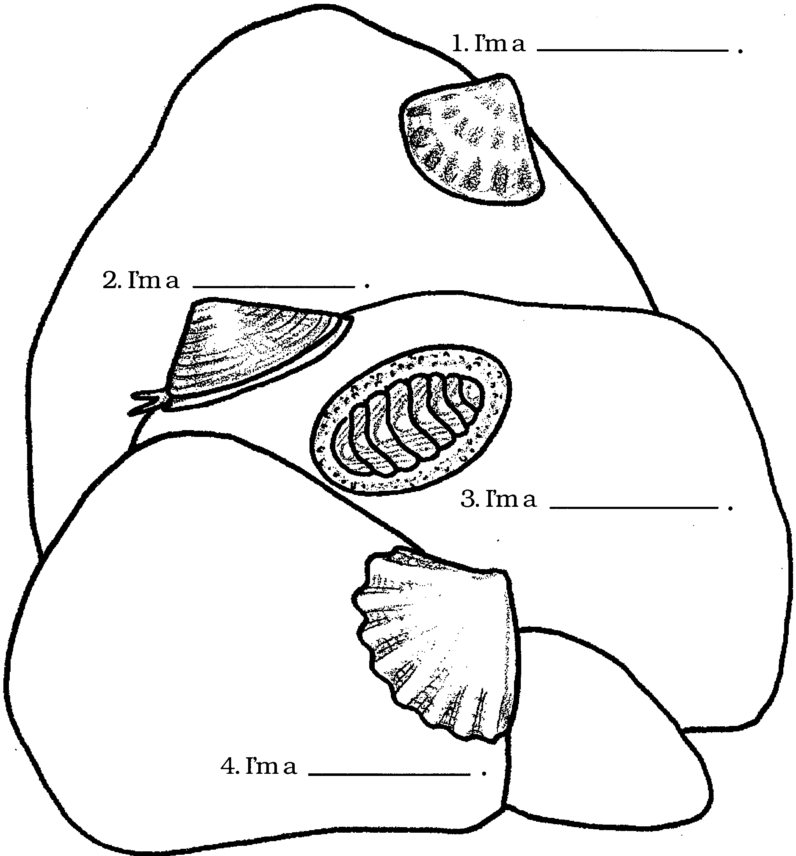
Neighbors. . . . . . Who's who?

Color the animals.

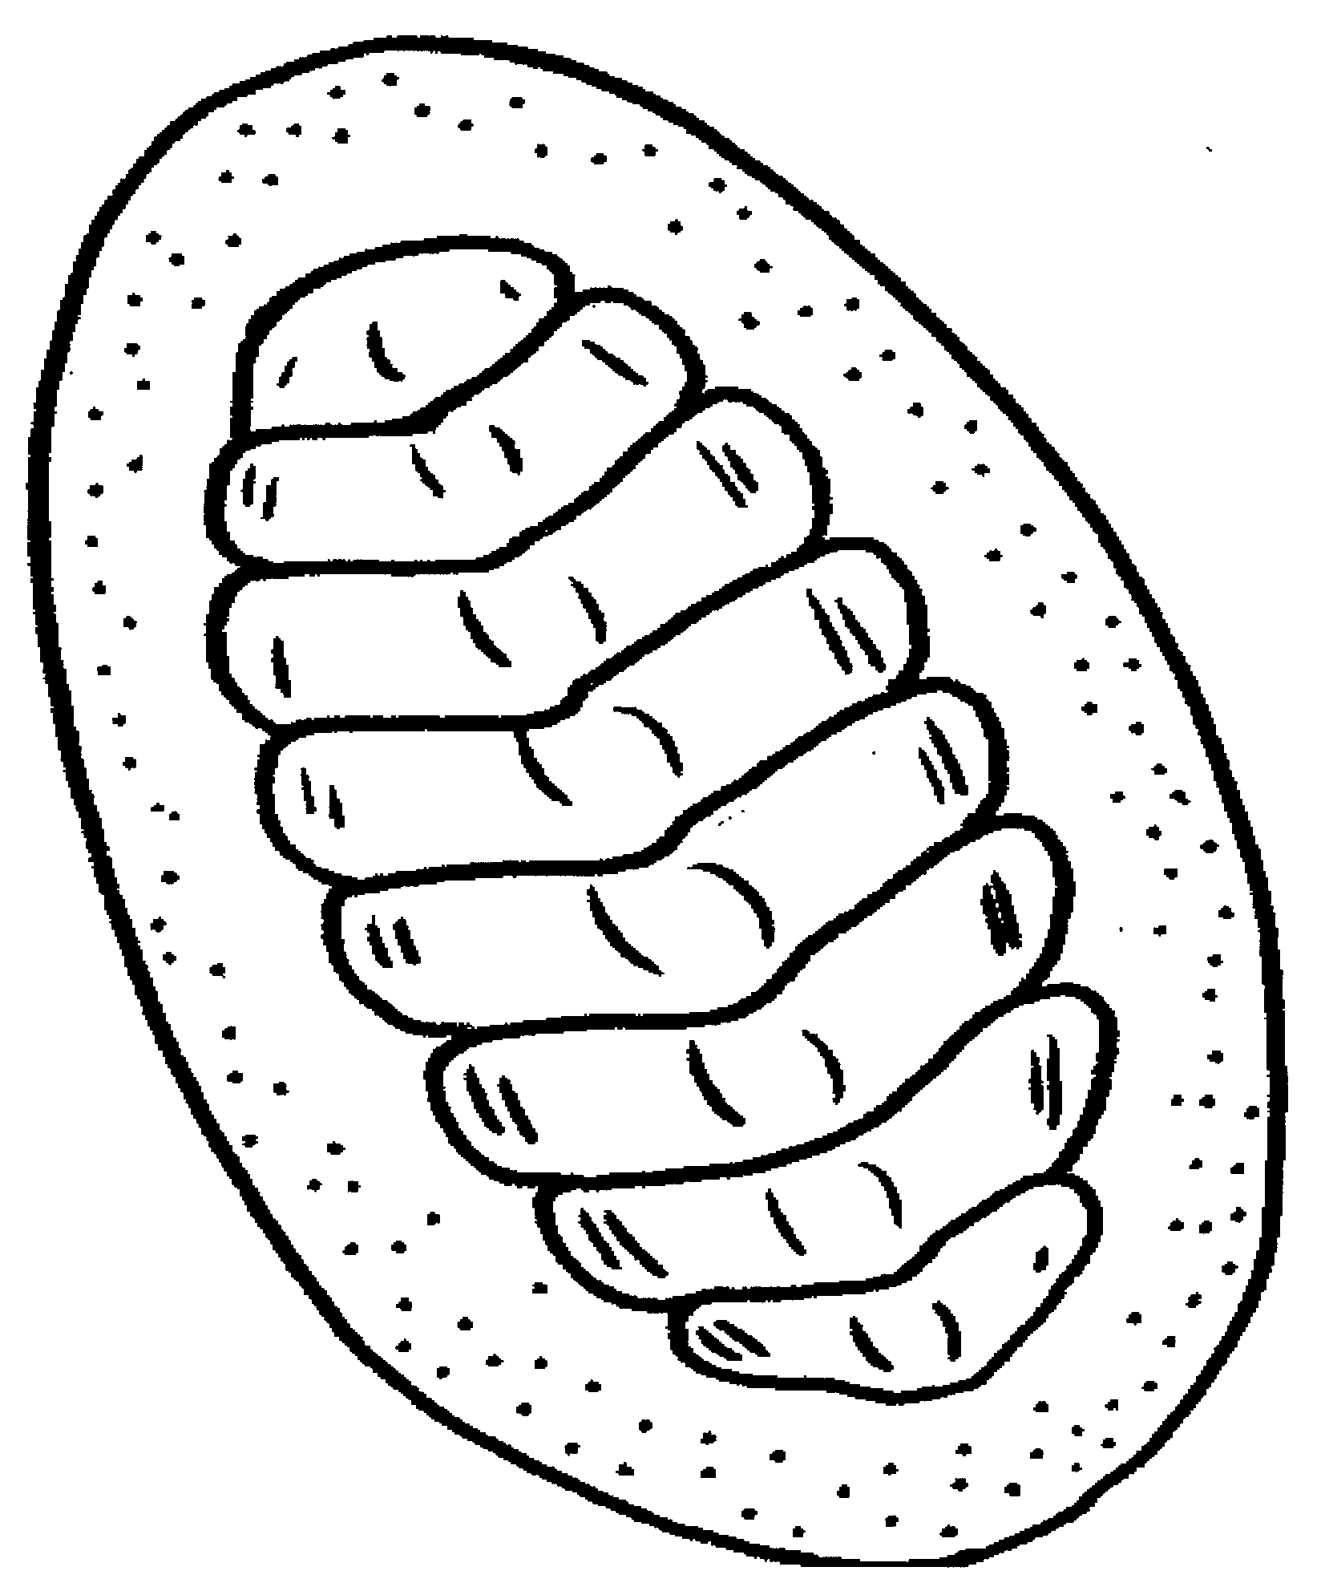
1. I'm a .
2. Count my shell plates. How many do I have?
3. I live on .
4. Color me.

