Barnacles: Drying on the Line

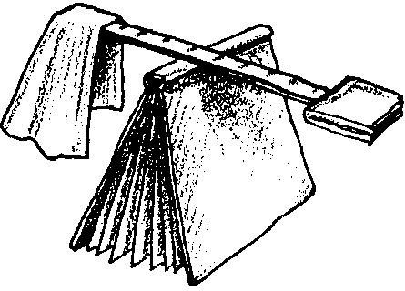
Key Concepts
1. Animals and plants that live in the intertidal zone face periods of immersion followed by periods of drying.
2. Marine animals have adaptations that help them avoid drying during periods of exposure. For example, a barnacle closes its moveable shell plates to keep its body from drying out during periods of exposure.
3. The rate of drying out in aquatic organisms is influenced by their shape. For example, the compact shape of a barnacle’s body keeps it from drying out when exposed.

Background

Animals and plants that live in the intertidal zone face periods of immersion followed by periods of drying. Avoiding desiccation is a major challenge for many of these organisms. Many adaptations exist to reduce drying during periods of exposure. Some animals trap water inside their shell, others close up shop and reduce the surface area exposed. Still others move or hide under rocks.

Additional background information can be found in the preceding activities “Intertidal Tales” and “High and Dry”.

Materials

For each student or team of two:

• 2 paper napkins or paper towels

• 12 inch ruler

• a book

Teaching Hints

“Barnacles: Drying On the Line” is a look at the effect of surface area on the rate of drying. Students will infer that marine animals can reduce their rate of drying simply by changing shape.

1. Review with students how a barnacle looks when it is out of water (low tide) and how it looks when it is submerged (high tide). Ask:

“What are some problems faced by barnacles during low tide?”

(They warm up, may become food for birds, can be stepped on, etc. Try and elicit drying as a problem.)

“What is something barnacles do to keep from drying out?”

(Answers will vary depending on experience of class.)

2. Explain that this experiment may provide additional ideas. Distribute two paper napkins (the same size) to each student or pair of students.

3. Demonstrate how to fold one of the napkins in half four times. Have students do this with one of the napkins.

4. Do not fold the other napkin.

5. Have students wet both napkins with water, let them drip for a minute or so.

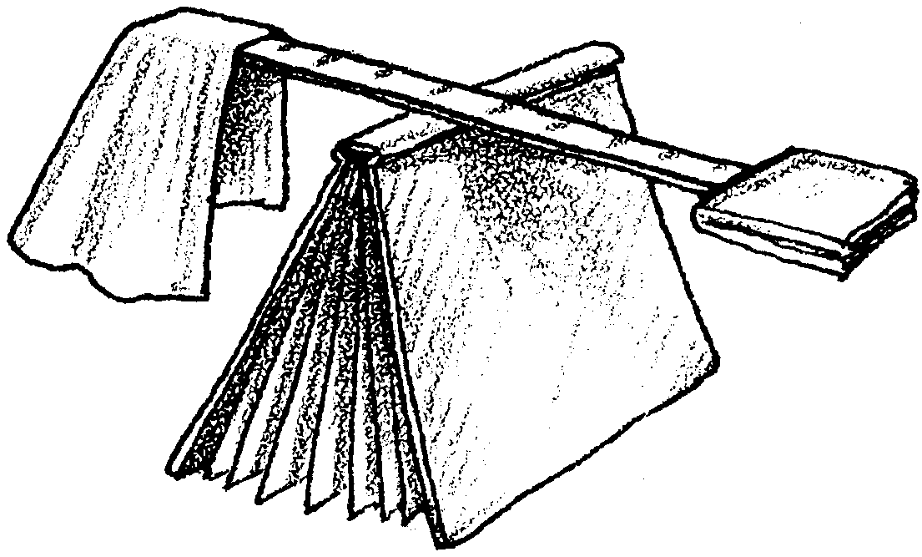
6. Have students place the folded napkin on one end of a ruler and the unfolded napkin on the other end. Then have them balance the ruler on the spine of a book. Caution students to avoid getting the books used as fulcrums wet.

7. Have students predict what they think will happen. Write the prediction on the board.

8. Wait one hour and have students return to their experiment. Discuss results by asking questions like:

“What has happened to your set up?”

(Most likely, the ruler will have tilted or fallen on the wet side.)

“How does what happened compare to your prediction?”

(Read the prediction. Answers will vary.)

“Which napkin dried faster? How do you know?”

(The unfolded napkin dries faster. If students have some idea of how a simple balance works, they can explain the “how” part of this question by describing the change in the balance position; they could also touch the napkin.)

“Why do you think this napkin dried faster?”

(Answers will vary. This question sets the stage for the next questions.)

9. Discuss the results of the experiment, relating it to barnacles and other animals of the intertidal zone. Flat napkins and flat animals dry out faster. The water evaporates into the air. The flat napkins and flat animals have more air around them. They lose more water into the air because they have more air around them.

Ask students to think about the napkins and compare them to a barnacle’s body. Ask questions such as:

“Which napkin had a shape most like a barnacle’s body?”

(The tightly folded napkin is more like a barnacle)

“What do barnacles do to stay wet?”

(They have a compact shape and close tightly)

