High and Dry
Lesson by Pat Williams, Eugene, OR

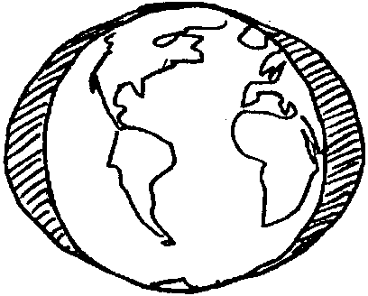
Key Concepts
1. Tides alternately submerge and expose areas of the beach and the animals and plants living there. At high tide, water covers more of the beach than at low tide. The tide is said to be “in” or “up” on the shore. At low tide, the tide is said to be “out” or “down” on the shore.
2. During low tide periods, organisms of the intertidal zone are exposed to air, sun, and wind which can cause desiccation.

Background

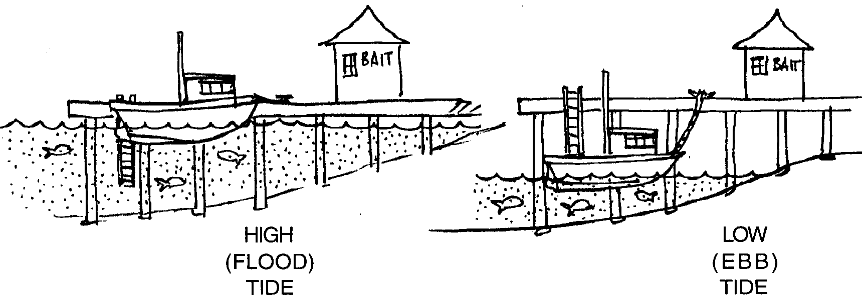
Tides are the twice-daily rise and fall of the sea level along the shore. If you live near the saltwater, you may have seen the motion. Sometimes rocks and parts of the beach are covered with water. Other times these same areas are not covered. What you are seeing are the tides. When the water level is high, more of the beach is covered with water. The beach may appear to be a very small or narrow beach. This is called high tide. When the water level is low, less of the beach is covered with water. The beach appears to be larger or wider. This is called low tide.

In most coastal areas of the U.S., the tidal rises and falls occur twice each 24 hours and 50 minutes (referred to as a lunar day). In some places both high tides reach about the same height and both low tides drop to about the same level in a tidal cycle. In other areas, the two high tides are not the same height, nor are the low tides equal.

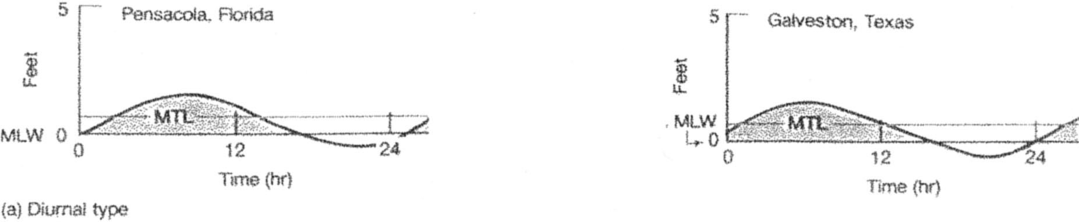
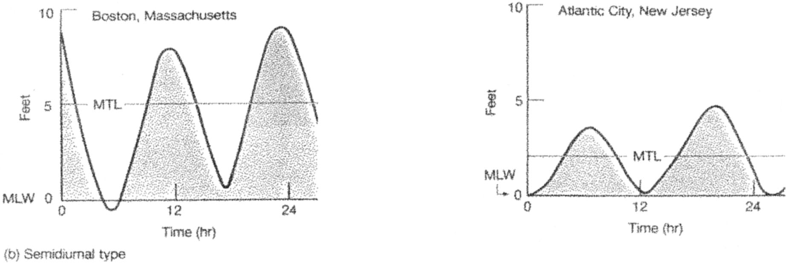

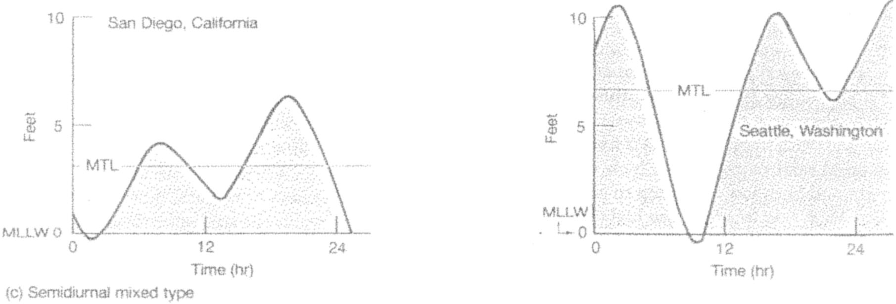
In some coastal areas, like the Gulf of Mexico, there is a pattern of only one high tide and one low tide each lunar day. The difference between the high tides and the low tides may be only a few inches. However, it may be as much as 40 feet. Tide types and ranges vary from one coastal area to another.

What Causes the Tides?

The background information that follows is intended for your use and reference. Causality of the tides is very difficult for most primary students (adults, too!) to grasp due to the abstract concepts involved. Observation of beaches at high and low tide and understanding how tidal action affects inhabitants of the intertidal are more appropriate concepts for primary students.

The tides we see are largely a result of gravity. The moon and the sun exert attractions on the waters of the earth. Even though the moon is much smaller, the moon, because it is so close to the earth, exerts the major pulling force on the water causing a great bulge in the ocean directly under it. This tidal bulge tends to follow the moon as it orbits around the earth. The centrifugal force from the earth’s rotation creates a second bulge in the ocean on the opposite side of the world.
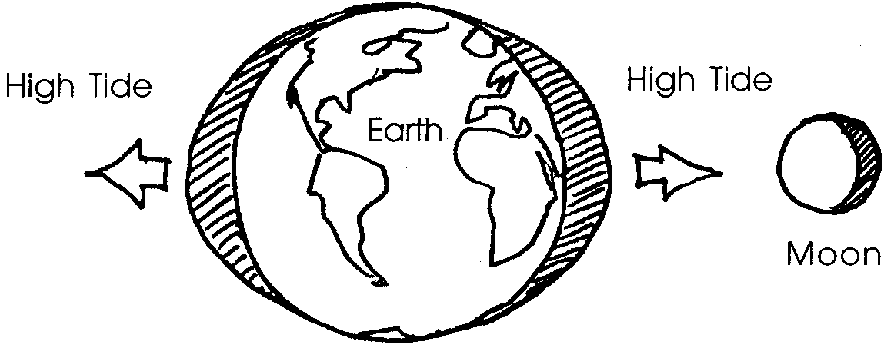

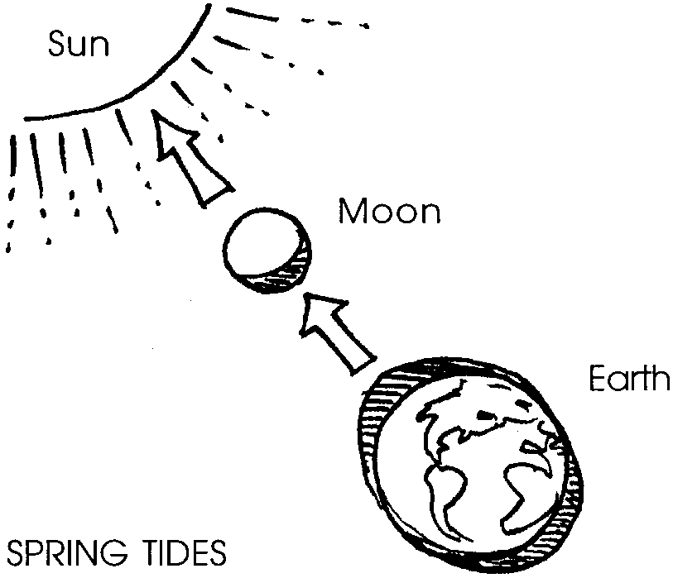
The effect of the sun is to increase or decrease the size of the bulge created by the moon. Twice every 28 days the sun and the moon are “in line” with each other. At full moon, the sun and moon are on opposite sites of the earth, but in line. At the new (dark) moon phase, the sun and moon are on the same side of the earth and in line. At these times, the combined, additive pulling forces of both the sun and the moon on the earth produce the highest rise in water levels along our coasts. These tides are called spring tides. Spring tides occur all year long. The term “spring” comes not from the season but rather from the “springiness” of the water movement.

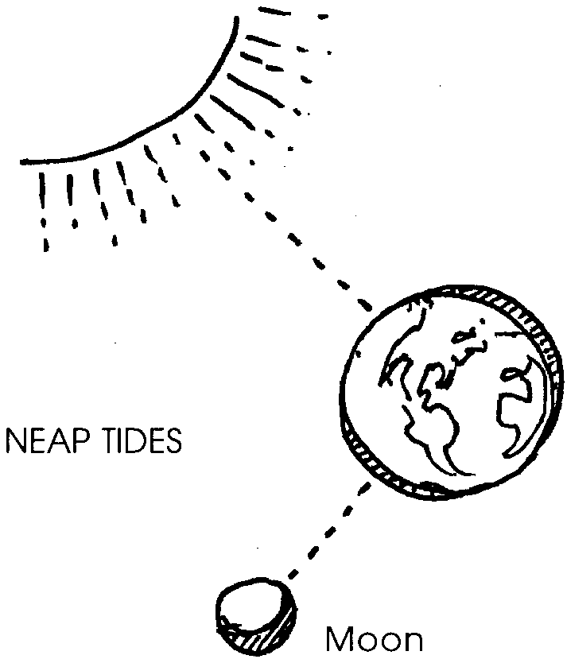
Twice every 28 days the moon is at right angles to the sun. The attraction of the moon for the earth cancels out the sun’s attraction for the earth. At these times, there is the smallest rise in water levels. We call these tides “neap tides”.

Plants and animals in the intertidal zone must endure variations in many environmental factors. As aquatic organisms, these plants and animals must deal with the drying which occurs during the time they are exposed to the air during low tides. Plants and animals have developed a host of ways to deal with this problem. Shore crabs, some snails, and other animals spend the low tide beneath rocks which tend to hold moisture and moderate temperature changes. Some plants and animals like the sea anemone store enough water that they can tolerate some drying. Animals like the barnacle tightly close themselves so that their moisture cannot escape.

Additional background information can be found in the preceding activity “Intertidal Tales ”.

Materials

For the class:
• a variety of items such as thin slices of vegetables (cucumber, carrots, potato, pieces of cloth, pieces of paper towel, etc. (no water soluble items)

• two shallow dishes

Teaching Hints

“High and Dry” introduces tides and their effect on the plants and animals living in the intertidal zone through a simple, two part teacher demonstration which shows how things dry out when not covered with water. Since you will need to allow time between the two parts for desiccation to occur, plan to either do Part I early in the morning and observe at the end of the day, or do Part I late in the day and observe the following morning.

Part One: Preparing the materials
1. Ask students if they have ever visited the ocean or seashore. Discuss what the beach was like. Did they notice the water move up or down the beach? Display any pictures or video footage available of shorelines at low and high tide. Have students identify differences as they observe the pictures. (The BioSciII laser disk is one source for such pictures.)

2. Explain that the movement of the saltwater up and down the beach is called the tide. In most areas, twice every day saltwater moves far up the beach. The water covers animals and plants living at the ocean’s edge. When this happens, we say, “The tide is in”. When the water is the furthest in, we call it “high tide”. Also twice each day, the level of the saltwater goes down. Organisms that live along the edge of the ocean are exposed. When this happens, we say, “The tide is out”. When the water is at its lowest point on the beach, we call it “low tide”.

3. Ask students to think about what could happen to the plants and animals no longer covered by saltwater at low tide. Discuss and list their ideas on the board.

4. Tell your students that barnacles are one of the intertidal animals uncovered when the tide goes out. Say

“Let’s see what happens to some things when the ‘tide goes out’.”

5. Cut 2 thin slices of each vegetable. Cut two small pieces of other materials to test.

6. Place one slice or item in a shallow dish of water. Place the other in a similar dish without water.

7. Place both dishes in the sun or near a warm place.

8. Have students predict what will happen. Record their predictions on the board. You may wish to have students write or draw pictures of their predictions.

Part Two: Observing the Effects of Desiccation

1. Later in the day or the next day, observe the two dishes as a class.

2. Discuss what happened. Ask students to infer:

“What do you think might happen to plants and animals that are not covered by saltwater at low tide?”
(Answers may include: they dry out, warm up, are eaten or stepped on, etc.)

“What do you think might happen to the plants and animals that remain covered by water in the tidepools?”
(Answers may include: they continue to feed and don't dry out, warm up, or get eaten or stepped on, etc.)

Key Words

desiccate - to dry out

evaporate - to convert into vapor, to draw moisture from

high tide - the tide at its full, when water reaches its highest level; the point at which the saltwater is furthest up on the beach

intertidal zone - alternately submerged and exposed area of the beach above the low tide mark

low tide - the tide at its lowest, when water reaches its lowest level; the point at which the saltwater is furthest down on the beach

tide - the periodic variation in the surface level of the seas caused by the gravitational attraction of the sun and moon

Extensions

1. Direct observation of a saltwater beach over time: The most concrete way to teach students about the variation in the tide level is to have them observe the beach over time. Wooden stakes or markers calibrated in centimeters can be used as monitoring instruments to help students collect data on tidal movement. Drive the stake into the sand at the edge of the water and note the time. Return to the stake at regular intervals and note the changes. An activity of this nature helps students develop the skills of quantifying an observation.

2. Tell the story of Raven and Tide Woman. Raven is a central character in many folk tales and myths from the Indian tribes of the Northwest coast. Raven makes things happen. Raven is sometimes good, sometimes bad. Raven can be kind, mean, funny, and/or sad. Raven sometimes plays tricks on others and sometimes gets caught! In folk tales and myth, Raven’s adventures often explain why things are the way they are. See the bibliography for Keepers of the Earth: Native American Stories and Environmental Activities for Children by Caduto and Bruchac; Raven: A Collection of Woodcuts adapted by David Williams from D. DeArmond, and other references.

