Have or Do?

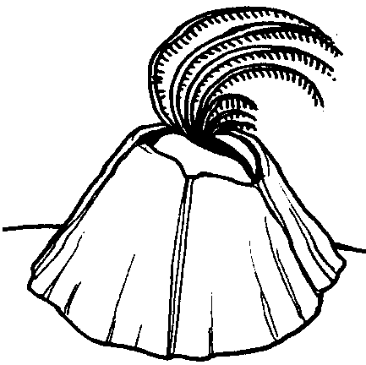
Key Concepts
1. Barnacles are sea animals which glue themselves to hard objects. Once attached, hard shell plates protect their soft body.
2. Barnacles submerged in seawater sweep their feather-like legs through the water to gather food.

Background

Background information can be found in the preceding activity, “Barnacles”.

Materials

For each student:
• “Have or Do?” activity sheet
• scissors
• glue

Teaching Hints

“Have or Do?” is an activity designed to help students learn to classify related facts. The ability to classify items is basic to science and to reading. You may need to provide some examples of the difference between “Have” and “Do”.

This activity requires students to discriminate between some examples of “Things Barnacles Have” and “Things Barnacles Do”. You may choose to have students complete the “Have or Do” activity sheet individually or in small groups. Alternatively, if the reading level of the instructions is difficult for your students, you may choose to complete this activity in a more directed fashion as follows:

1. On the chalkboard, copy the clip-out list of “Haves” and “Do’s” from the bottom of the student page.

2. Near the top of the chalkboard place the two headings “Things Barnacles Have” and “Things Barnacles Do”.

3. Read (or have students read) each of the items on list.
4. Poll class for opinions on whether the item is a “Have” or a “Do”.

5. Record and discuss each choice.

Regardless of the approach selected, provide the assistance necessary to get your class started on this activity. As a conclusion, devote a few minutes to discussion of the basic concepts covered.

Key Word

feathery - resembling or suggesting a feather

Answer Key

Things barnacles have Things barnacles do
hard shells eat small animals
feathery legs grow in groups
glue on hard things catch food with legs
live on other animals
stick on with glue
Have or Do?

Look at the end of this page. Find the boxes. Some are things barnacles have. Some are things barnacles do. Cut out each box. Put the “have” boxes together. Then put the “do” boxes together. Glue the boxes in the right list below.

Things Barnacles "Have" Things Barnacles "Do"
(body parts) (behaviors)

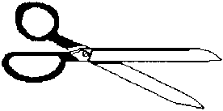
live on other animals stick with glue

eat small animals feathery legs

hard shells catch food with legs

grow in clusters grow on boats

