Barnacles

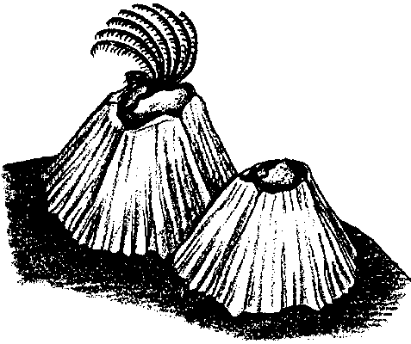
Key Concepts
1. Barnacles are sea animals which glue themselves to hard objects. Once attached, hard shell plates protect their soft body.
2. Barnacles submerged in seawater sweep their feather-like legs through the water to gather food.

Background

Most people who have visited the seashore are familiar with barnacles, the inhabits of those volcano-shaped shells so abundantly attached to rocks and other hard objects in the intertidal.

A barnacle has sharp pointed, shell plates covering its body. An unusually strong glue holds these plates to the surface of a rock. The glue is so strong that once a barnacle is attached to something, it is almost impossible to remove. In fact, if pulled off a rock, the glue does not release, but instead the barnacles often leave behind the bottom shell plate. Dentists are very interested in this glue because it is so strong and works when wet!

Compared to its relatives, the crab and shrimp, the adult barnacle is unusual because its body orientation seems upside down. With its feathery legs it sweeps the water to gather plankton (microscopic plants and animals) into its mouth and, at the same time, uses the gills attached to its legs to absorb oxygen from the water. Barnacles have their heads glued to a hard object and their legs up in the water.

When the tide is out, a barnacle is able to retain enough moisture in its body to enable it to survive until the next high tide by sealing closed the moveable shell plates on top of its shell.

Materials

Part One: Observing Barnacles
For each group of 4 or 5 students:
• living barnacles, cluster in a clear container
• seawater to pour on the barnacles
• magnifying lens

Part Two: Drawing Inferences from Observations
For the class:
• living barnacles (or student drawings)

For each student:
• copies of student worksheet, “Barnacles”
• crayons

Teaching Hints

Part One: Observing Barnacles

Preparation:

Observation of living barnacles is a real experience; enjoyed by adults and children alike. Barnacles are most often found attached to rocks in the upper tidal zone and are quite accessible during low tides. If you can not take students to the beach to observe barnacles, consider collecting some for use in the classroom. Before collecting, make certain it is legal for you to collect them. (Call your State Department of Fisheries or Fish and Game Department). Usually they are collected in clumps attached to rocks or pieces of shell. Do not try to remove the barnacles from their substrate, take the barnacles and the rock or shell.

Remember, to keep barnacles alive, you must reproduce the conditions found in the environment from which they were collected. Although barnacles are hardy intertidal animals, they will need to be kept in saltwater, and refrigerated if the water they live in is cold. An aquarium air pump provides plenty of dissolved oxygen. When finished, return the barnacles to the place they were collected. Please model a caring ethic by doing your best to return the barnacles to the beach ALIVE!

If you cannot collect barnacles, show a film or video of living barnacles. The Education Department at the Monterey Bay Aquarium has produced an excellent video tape, “Monterey Bay Aquarium Video Collection”, which includes footage of barnacles feeding. You can order the tape by calling the Aquarium Bookstore at (408) 649-6466.

Procedure:

1. Have students observe the barnacles without any water in the container. This simulates barnacle observation at low tide.

2. Distribute magnifying lenses to students and discuss their use if necessary.

3. Discuss student observations of the barnacles at “low tide”.

4. Pour seawater on the barnacles and encourage students to keep the container perfectly still while watching what happens. This simulates barnacle observation at “high tide”.

5. Have students record their observations by drawing a large picture of the barnacles as they observe.

6. Discuss student observations of the barnacle at “high tide”. During the discussion, you may choose to have students share observations of barnacles through movement of their own bodies. For example, they may use creative dramatics to show the actions of the barnacle’s legs sweeping for food.

Part Two: Drawing Inferences from Observations

“Drawing Inferences from Observations” is intended to sharpen your students’ powers of observation (what they can physically “see”) and to help them make inferences (“logical guesses”) about how the barnacle lives based on their observations.

1. Discuss student observations of the barnacles using questions like:

What color are the barnacles?

What are they attached to?

What are they doing?

Does anything move?

Help students draw inferences from their observations using questions like:

How do you think a barnacle protects itself?

How might barnacles keep from drying out at low tide?

What do you think the moving part is doing?

What do you think the moving part is called?

What does the moving part look like?

2. Distribute the student worksheets for students to record their observations and reinforce the learning from this experience. Recognizing that the reading ability of first grade students varies dramatically over the course of the school year, give thought to the best way to complete the activity with your particular group of students. In the fall, you may wish to read the selections to your students, having them complete the requested actions on the activity sheet and answer the questions out loud. In the spring, you may wish to have them work in small groups or independently to complete the activity. The following pattern may be helpful in shaping the discussion:

Barnacles (action)

Barnacles look like

Barnacles are like a because

Barnacles are not like a because

In addition, a coloring sheet is included for your use in reinforcing the key concepts.

Key Words

barnacle - various relatives of crabs and shrimp that in the adult stage form a hard shell and remain attached to submerged surfaces

plankton - the mostly microscopic plants and animals that drift or swim weakly in the sea; they cannot swim against the current.

tide - the periodic variation in the surface level of the oceans and of bays, gulfs, inlets and tidal regions of rivers, caused by the gravitational attraction of the sun and moon

Extensions

1. “Missing Barnacles” is a word search game which helps build sight vocabulary and visual discrimination skills. The activity sheet for the game is included as a student page. Some of your students may not be familiar with this type of puzzle. Provide the assistance necessary to assure success for all of your students.

Answer Key

1. Answers will vary. Encourage a lively use of the imagination.
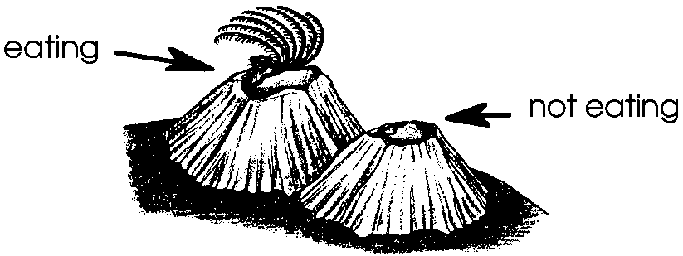
2. & 3.

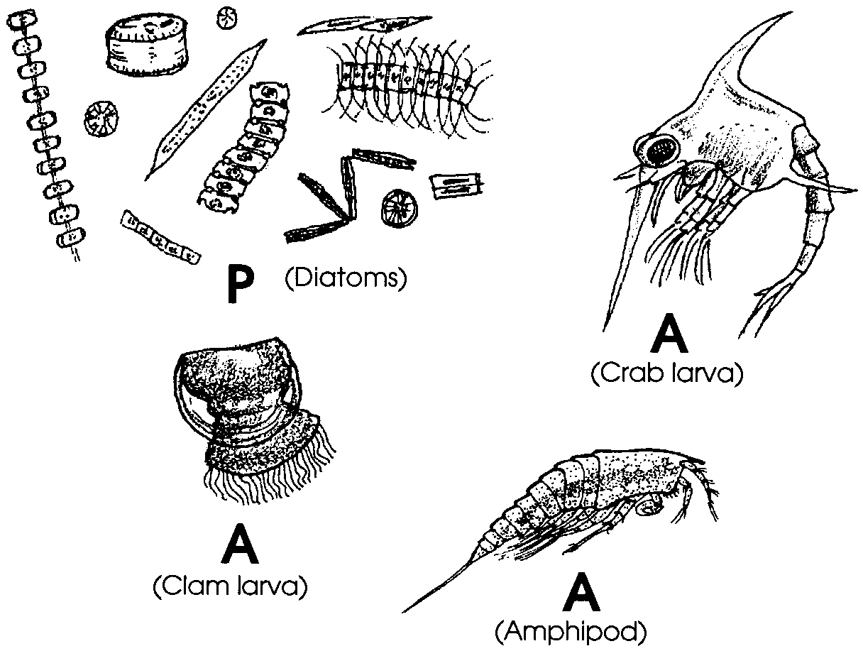
4. & 5.

6. Seastars and some sea snails eat barnacles.

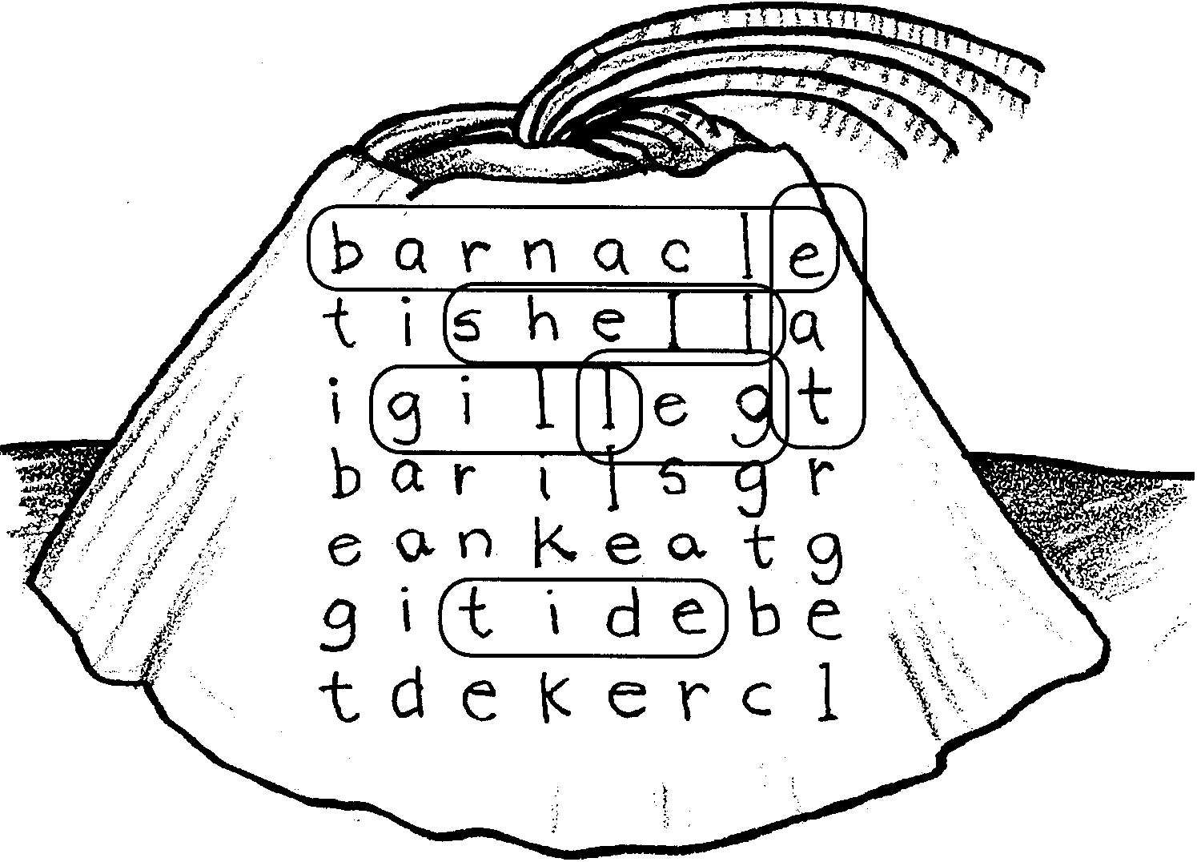
7. Display student drawings of barnacles.

Barnacles
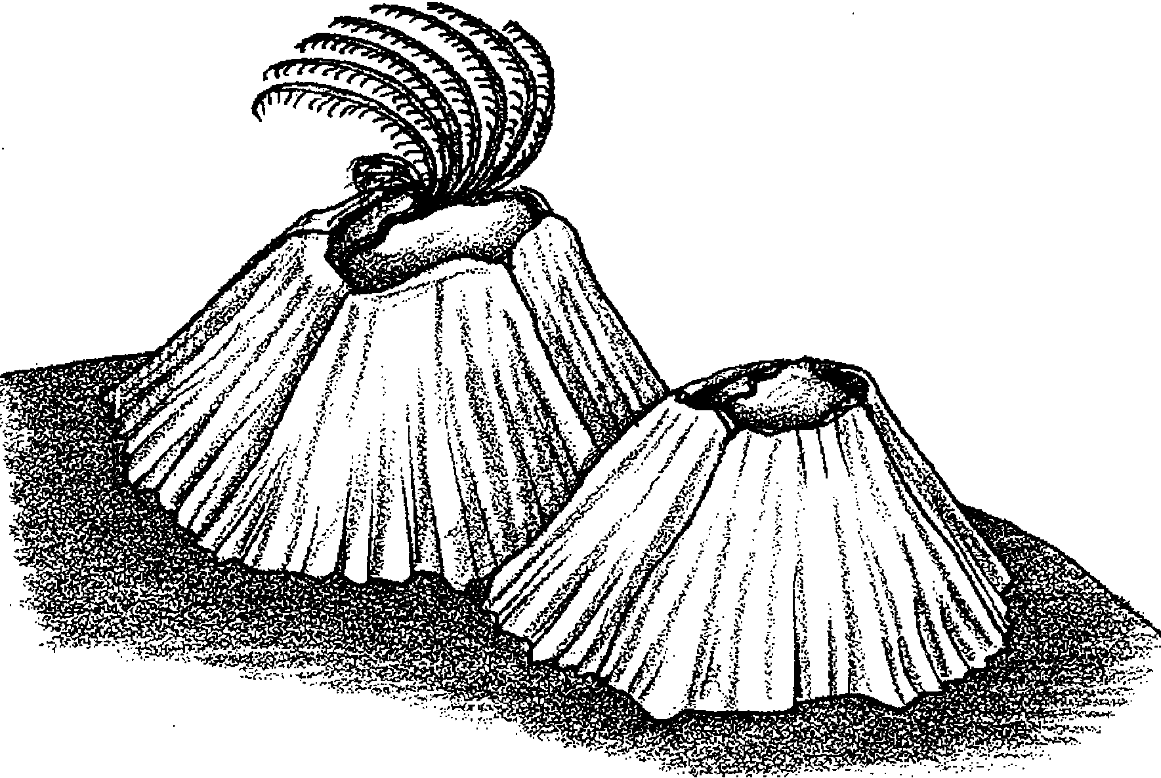

These are barnacles. Barnacles are sea animals. They live on almost anything. They stick on with glue. After that, they do not move. Many live on rocks. Some live on boats.

1. What does a barnacle look like?

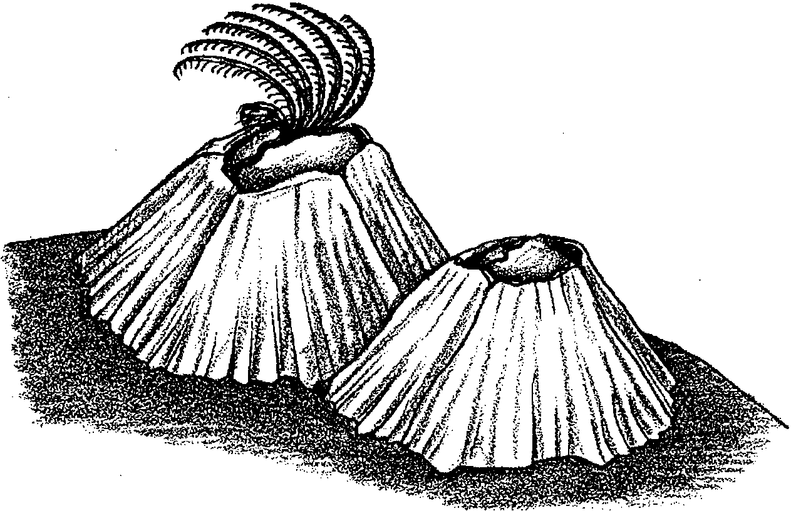
Barnacle legs look like feathers. The legs help catch food. Look at these barnacles.

2. Which barnacle is eating? Write “eating” under it.

3. Which barnacle is not eating? Write “not eating” under it.

Barnacles eat very small plants and animals. These are some of them. In real life, each one is about this big ° .

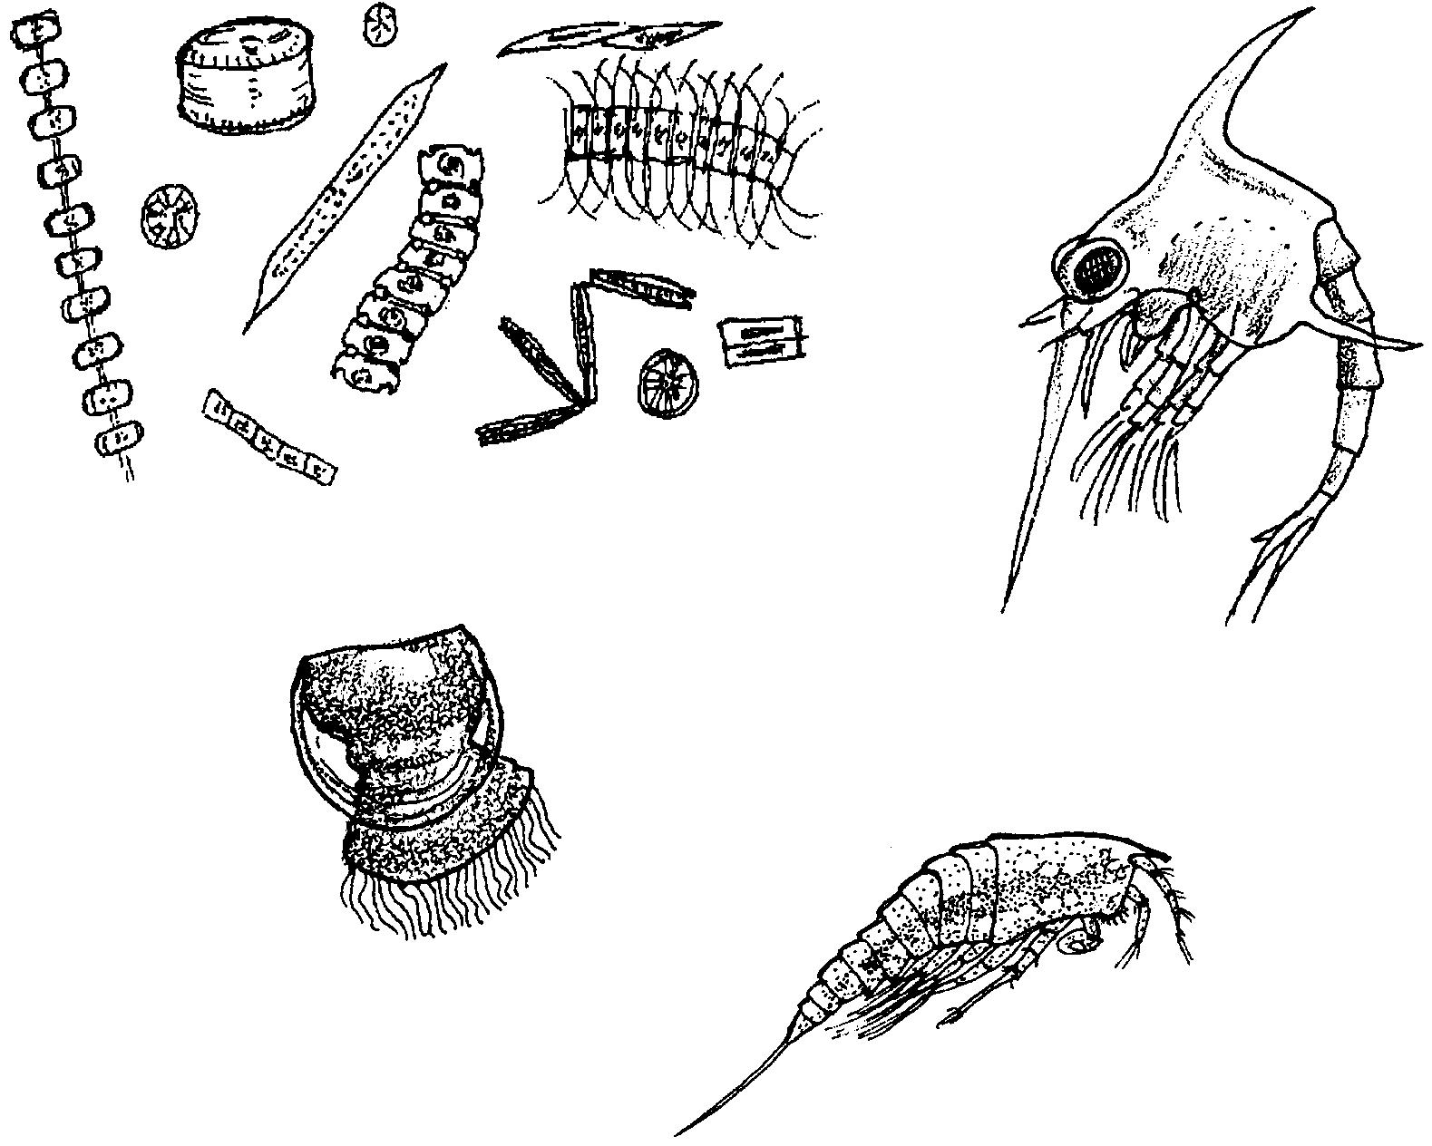

Some of these are plants. Some are animals. Which is which?

Try guessing.

4. Put a P under the plants.

5. Put an A under the animals.

Barnacles live where the tide goes out. They can close their shells. Some water stays inside. They do not dry out.

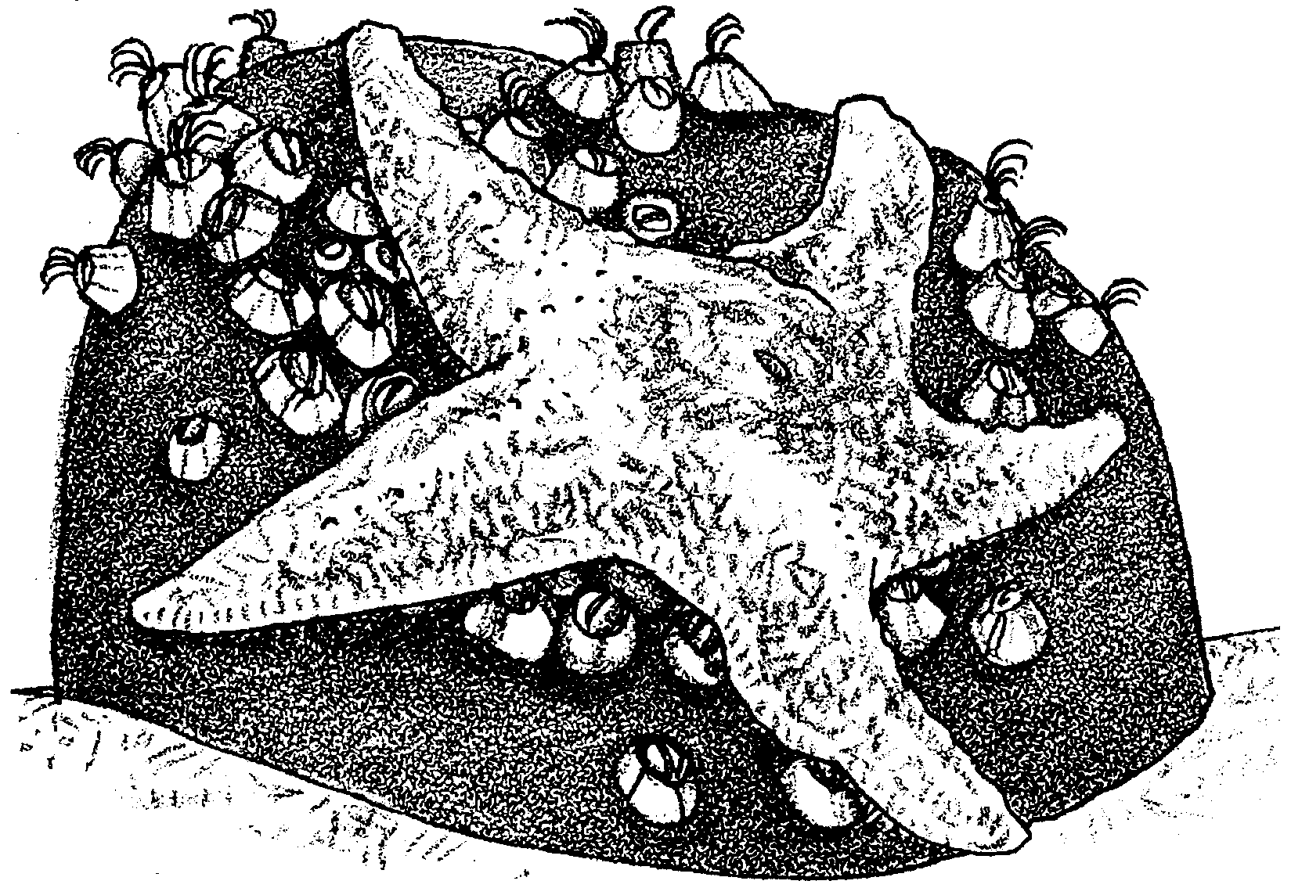
Sea stars eat barnacles. The sea star opens the barnacle’s shell. Then it eats the barnacle.

Some sea snails also eat barnacles.
7. What eats barnacles?

8. Draw a barnacle.

Missing Barnacles?

Find the missing words. Some words are spelled left to right. Some are spelled up and down. Circle as many as you can.

Words to look for:
barnacle
gill
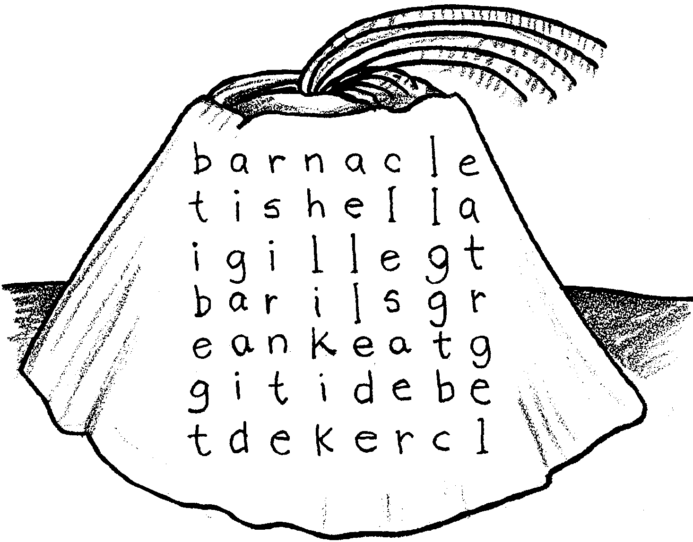
eat
leg
plankton
tide
shell

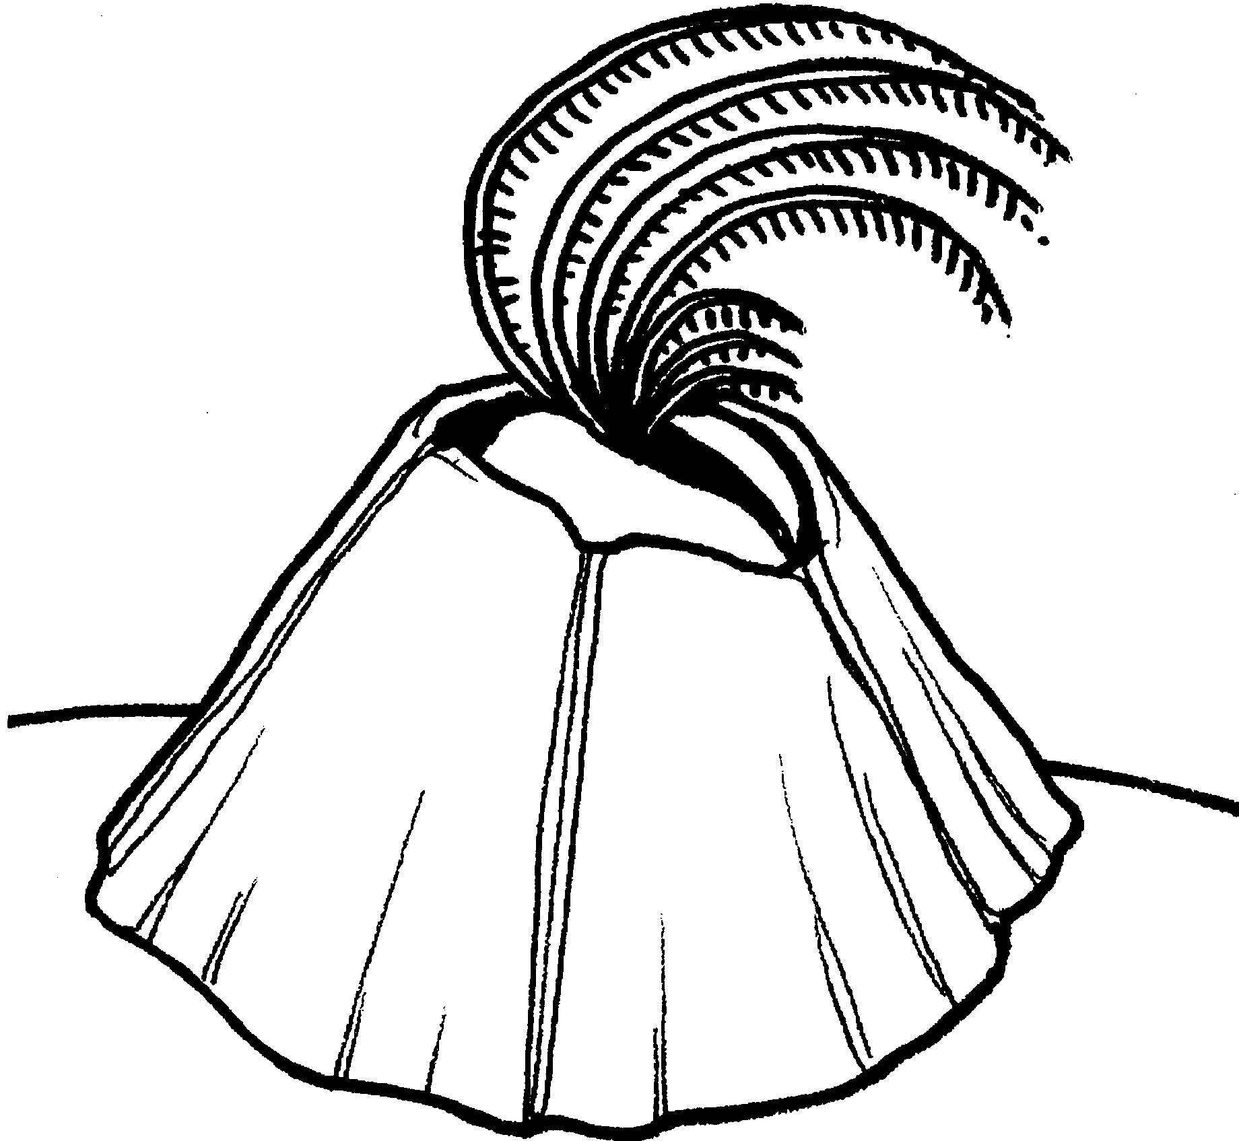
Fishing for food.

1. I am a .

2. Color my legs brown.

3. Color my shell plates yellow.

4. Draw in my food.

