Clothespin Claws
Lesson by Laura Erickson, Poulsbo, WA

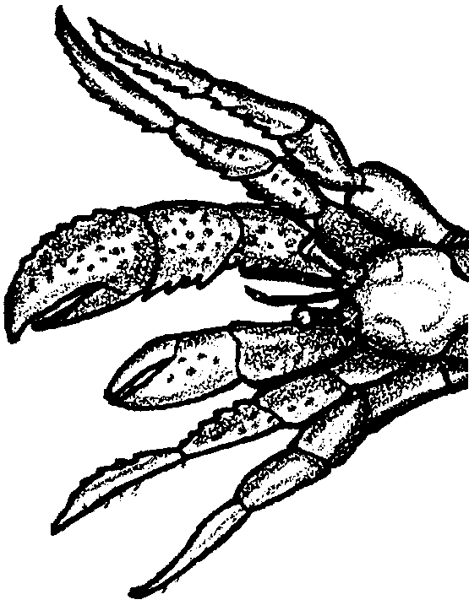
Key Concepts
1. Hermit crabs use their claws for eating and protection.
2. All crabs can break off a part of their legs or claws at a “breaking plane”.
3. Crabs can regenerate appendages.

Background

Hermit crabs have five pairs of jointed legs. Two pairs are modified for holding the hermit crab in its shell; two pairs are used for walking; and one pair ends in claws. Hermit crabs use their claws for two main reasons: to eat and to protect themselves.

Crab legs are vulnerable to damage and a hermit crab may lose an appendage for many reasons. It could lose a claw in a fight with another hermit crab, a sea gull or other predator; the claw could get caught under a rock; or a human footstep may crush an appendage. Loss of limbs usually poses a serious threat to the survival of an animal. In response to this threat, crabs have evolved a unique type of protection. When a crab is in danger of losing a limb from attack or injury, it can break off that body part at a “breaking plane”. This action allows the crab to escape. The wound quickly seals over so very little blood is lost. All crabs have “breaking planes” on their legs and claws.

Hermit crabs can regenerate appendages including their eyes. Regeneration is a slow process, with changes becoming noticeable when the crab molts. Beginning as a rather formless lump, or “bud”, the missing limbs are replaced with limbs smaller than the ones that were lost. With each molting, the limb grows larger until it is the appropriate size. During the period of regeneration, crabs are more vulnerable to predation.

Materials

For each group of two students:

• clothespins (2 per student)

• containers of misc. objects

• “Clothespin Claws" student activity sheet
Teaching Hints

In this activity, students use clothespin “claws” to simulate the action of crab claws. Students make predictions and then complete a simple test using the clothespin “claws”.

Part One: Investigating with Clothespin Claws

1. Introduce this activity by asking questions like:

“How does a hermit crab use its claws?”

“What do you think it would be like to have claws like a crab instead of hands with fingers?”

2. Explain that each person will receive two clothespins to represent crab claws.

3. Distribute to each two students a plastic container with assorted objects. Have students dump out and examine the contents of the container.

4. Have students make a prediction as to how many objects they think they can pick up and put in the container in one minute using only the clothespins as claws. Have students record this number.

5. Distribute the clothespins and have students test their predictions.

6. After one minute, have students count the number of objects they were able to collect and record this number next to their prediction.

Discuss the results of the experiment:

“Which objects were the easiest to pick up and put in the container using the clothespin claws?”

“Which objects were the most difficult to pick up and put in the container using the clothespin claws?”

“Do you think everyone in the class got the same number of objects in the container using the clothespin claws? Why or why not?”

7. Have students make predictions of the number of objects they could pick up in one minute using their fingers. Repeat the experiment again, this time using fingers, and record the results.

8. Compare the results of using clothespins and fingers. Ask:

“Which method proved most efficient for getting the objects into the container?”

9. Have students analyze the data further by making a bar graph using strips of graph paper to show how many objects they picked up using clothespins and how many using fingers. Students should color in one square for each object they picked up. Have students place these two strips side by side for comparison and discussion of results.

Part Two: Regeneration

1. Discuss with students the importance of a hermit crab’s claws and legs. Ask questions like:

“Have you ever seen a crab without a leg or claw?”

“What are some of the ways the crab could have lost its appendage?”

“What do you think happens when a crab loses a claw or leg?”

2. Remind students that in the last activity they used clothespins as claws to pick up the objects. Explain that they are to imagine they are a crab that has lost one claw.

3. Distribute one clothespin to each student, and the plastic container with an assortment of objects to each group of two students.

4. Challenge students to try picking up the objects using only one clothespin claw. Discuss results:

“Did you pick up the same number of objects as a one-clawed crab?”

“How did it feel to be a one-clawed crab?”

“What do you think happens to a hermit crab living in the tide pool with only one claw?”

5. Explain the process of regeneration of body parts to the students (see “Background” section above). Ask:

“Do you know of other animals that regenerate lost body parts?”

(Sea stars and octopus can regenerate arms; earthworms can regenerate body parts when cut; some lizards can regenerate their tails.)

“Do humans regenerate body parts?”

(While nothing as dramatic as regenerating a leg is possible, skin disappears. When a bone is broken, the broken ends form new bone tissue to repair the damage.)

6. Discuss the disadvantage to a crab of only having one claw. Say:

“Some people think that since crabs can regenerate legs, it is all right to break off their legs. What would you tell these people?”

Even though crabs can regenerate claws, leg, and eyes, be sure to emphasize that proper beach manners dictate that no living things are harmed.

7. Have students analyze the data further by making a bar graph on the bottom of the student sheet.

Key Word

regenerate - to replace a body part by new growth of tissue
Clothespin Claws

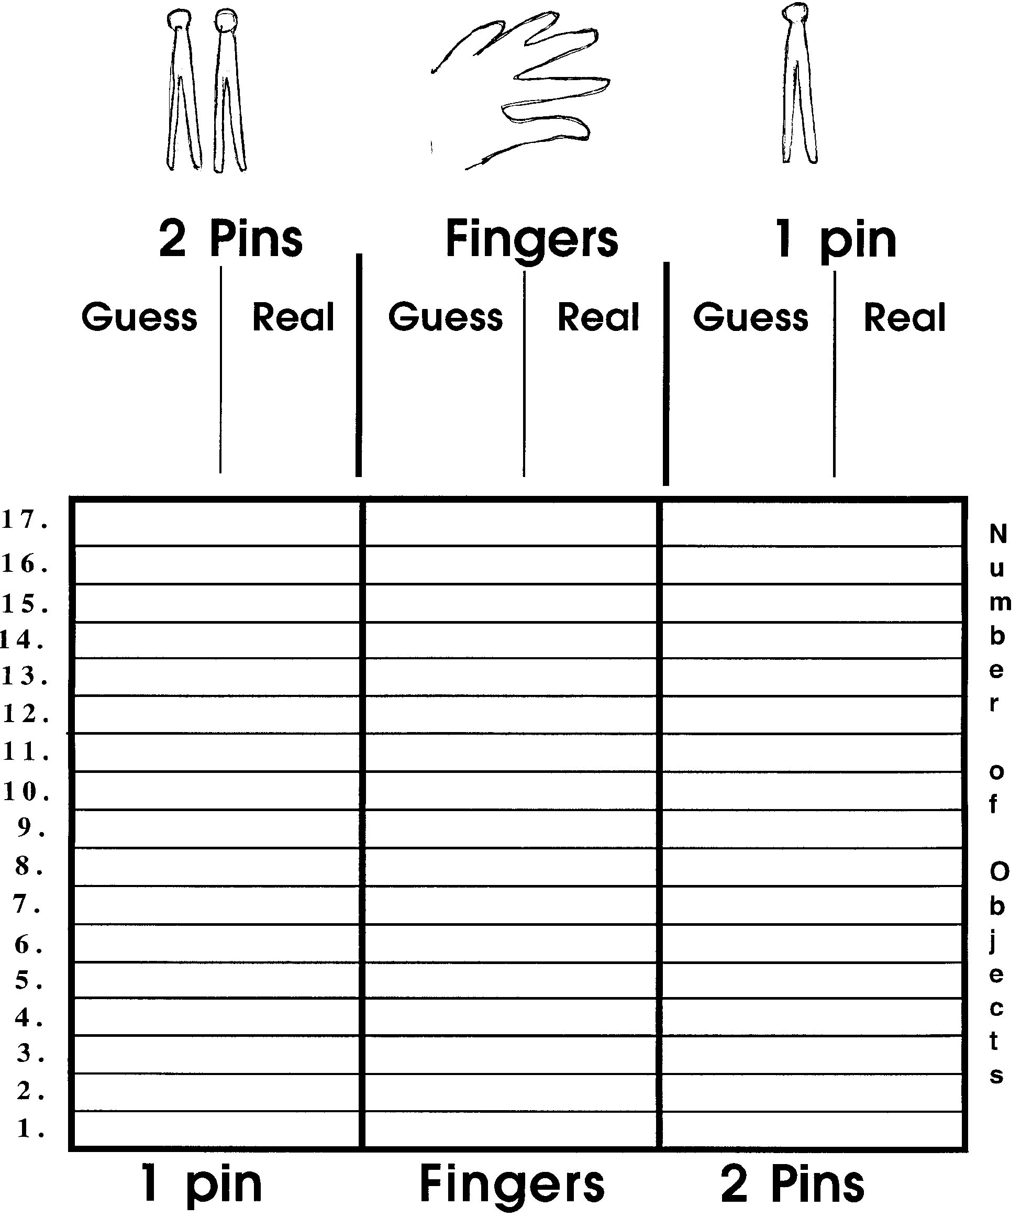
Write your guess in the first column. Write the number you picked up in the second column.

