Borrowed Shells
Lesson by Pat Williams, Eugene, OR

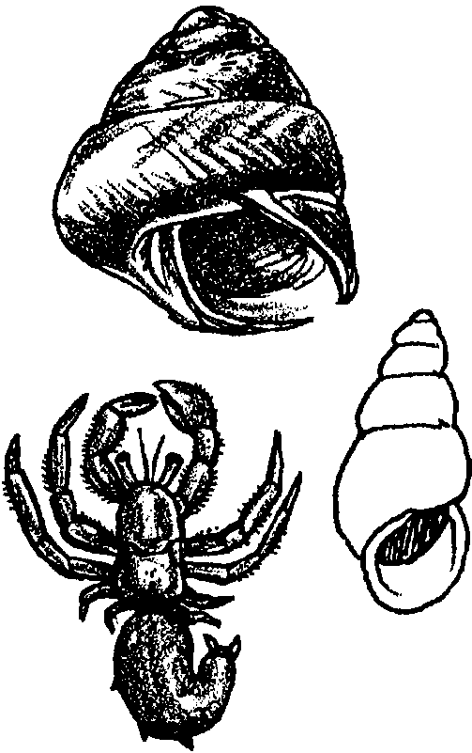
Key Concepts
1. Shells are a form of protection for many sea animals.
2. Some animals grow their own shells, but hermit crabs borrow the empty shells of other animals to protect their bodies.
3. The hermit crabs’ lower abdomen is soft and curled. As hermit crabs grow, they must periodically find larger shells to protect their bodies.

Background

As soft-bodied members of the crab family, hermit crabs need protection from predators. They have adapted by borrowing and living in empty shells from other animals. Borrowing shells is a rather clever way for hermit crabs to conserve energy. By recycling or reusing shells left by others, they do not have to expend the energy necessary to grow their own shells.

The hermit crab’s body is twisted and easily fits in the coils of the empty shell. The crab’s back legs hold the shell on tightly. Their front legs sport uneven claws; the right one is larger and acts as a “door” to the shell. Although hermit crabs threaten and protect themselves with their large front claws, they are not hunters. They eat seaweeds and dead animals.

As they grow, they leave one shell and find another that is just the right size. Some species of hermit crabs seem to encourage sea anemones to grow on their shells. This arrangement appears to work well. The hermit crab gains a little protection from the anemone’s stinging cells, as well as a contribution toward its camouflage. The sea anemone gathers left over food morsels as the hermit crab feeds.

Materials

Part 1
For the class:
• Does Anyone Know Where a Hermit Crab Goes? by Michael Glaser

• live hermit crabs

• music and words for “You Can’t Make a Turtle Come Out” and “Down by the Bay” and an accompanying instrument

• several empty snail shells

Part 2
• “Finding A Home for Hermy” activity sheet

Teaching Hints

“Borrowed Shells” is a two part activity that teaches to the visual and linguistic intelligences. It integrates music with science.

Part One: Hermit Crabs and Shells

1. Read the book Does Anyone Know Where a Hermit Crab Goes? Discuss:

What kind of shells do hermit crabs have?

Why do they need a shell?

Where do they get their shells?

What happens when a hermit crab grows?

2. Have students observe live hermit crabs, if possible. A video, film, or pictures will substitute. Encourage observations of the hermit crabs’ shells.

3. Show students how to pick up a hermit crabs by grasping the shell in one hand while supporting the crab and shell from beneath with your other hand. Have students observe behavior of their crabs when picked up. Discuss students’ observations. Ask:

“Why might the crabs respond this way?”

4. Display assorted, empty snail shells. Pick up one of the hermit crabs. Ask:

“Are any of the shells the right size for the hermit crab’s next home?”

“Which are too big for the crab?”

“Which are too small for the crab?”
5. Sing “You Can’t Make a Turtle Come Out.”* Change the words and sing the song again singing “You can’t make a hermit crab come out.”

* “You Can’t Make a Turtle Come Out” by Malvina Reynolds, in The Music Centennial Edition, Grade 3, Silver Burdett, 1985.

6. Sing “Down by the Bay” and add a new verse about a hermit crab with a name like “Purmitt Drab.”

Part Two: Finding A Home for Hermy

Reinforce concepts presented by distributing copies of the student
worksheet, “Finding A Home for Hermy” for completion. Recognizing that the reading ability of first grade students varies dramatically over the course of the school year, give thought to the best way to complete the activity with your particular group of students. In the fall, you may wish to read the questions to your students, having them complete the requested actions on the activity sheet and answer the questions out loud. In the spring, you may wish to have them work in small groups or independently to complete the activity. Regardless of the approach you select, allow a few minutes upon completion of the exercise for discussion of the basic concepts and the answers. Emphasize the protection afforded the hermit crab through this behavior, as well as the danger involved every time the crab out-grows its shell.

In addition, two coloring sheets are included for your use in reinforcing the key concepts.

Extensions
1. Pagoo by Holling Clancy Holling tells an interesting life story of a hermit crab. While the vocabulary is not be appropriate for many primary students, the book provides excellent pictures for your students to study as you paraphrase the story. An excellent film, with the same name, portrays this story and shows the hermit crab in action. “Story of a Book”, a sound film by Churchill Films, tells how the book Pagoo was made. Its purpose is to teach children the steps followed in making a book; from the idea for a book to its printing. The film includes activities.

Other children’s literature that supports hermit crab studies include: Kermit The Hermit; by Bill Peet, The Hermit Crab; by Brian and Jillian Cutting and Is This a House for Hermit Crab? by Megan McDonald.

2. Read aloud the book, A House for Hermit Crab by Eric Carle which tells of a crab’s adventure through the months as it grows and adds one more animal to its shell each month. Be aware, this is not scientifically accurate, but it is fun. Brainstorm with students other animals to put on a hermit crab’s shell (this does not need to be scientifically correct). Explain to students they will create their own big book, modelled after, A House for Hermit Crab. Have students choose partners and decide which animal they will add to the hermit crab’s shell.

Have students make rough drafts of a “big book” page showing their animal and the month. Remind students they will need to include in their picture all the animals added for each month that precedes their month (since there is a different animal ADDED each month). Have students draw the hermit crab and the appropriate animals on its shell on posterboard. Help the class formulate a few sentences for each page which you can add to their artwork.

Original idea for this whole language activity from Ronna Knowles, Silverdale, WA

Key Word

abdomen - the major posterior (end away from the head) part of an arthropod’s body; the other parts are the head and thorax (which bears the legs)

Answer Key

1. Shell number 1 would probably fit Hermy the best. Discuss the differences in shape and size of the shells shown.

2. Hermy puts his tail end into the shell. He actually “tries the shell on” by placing a claw inside to examine the size and inhabitants. He then taps the shell with his claw and if all suits his taste, he backs in and settles down.

3. Hermy will have a problem if he chooses #3 since the shell is already occupied! Hermit crabs can close off the opening of the shell with one of their claws after they pull their body inside. This makes the shell look unoccupied. Hermy would not choose this shell since he would be at an obvious disadvantage in a dispute.

4. Hermy needs to find a new shell quickly to avoid being eaten.
Finding a Home For Hermy
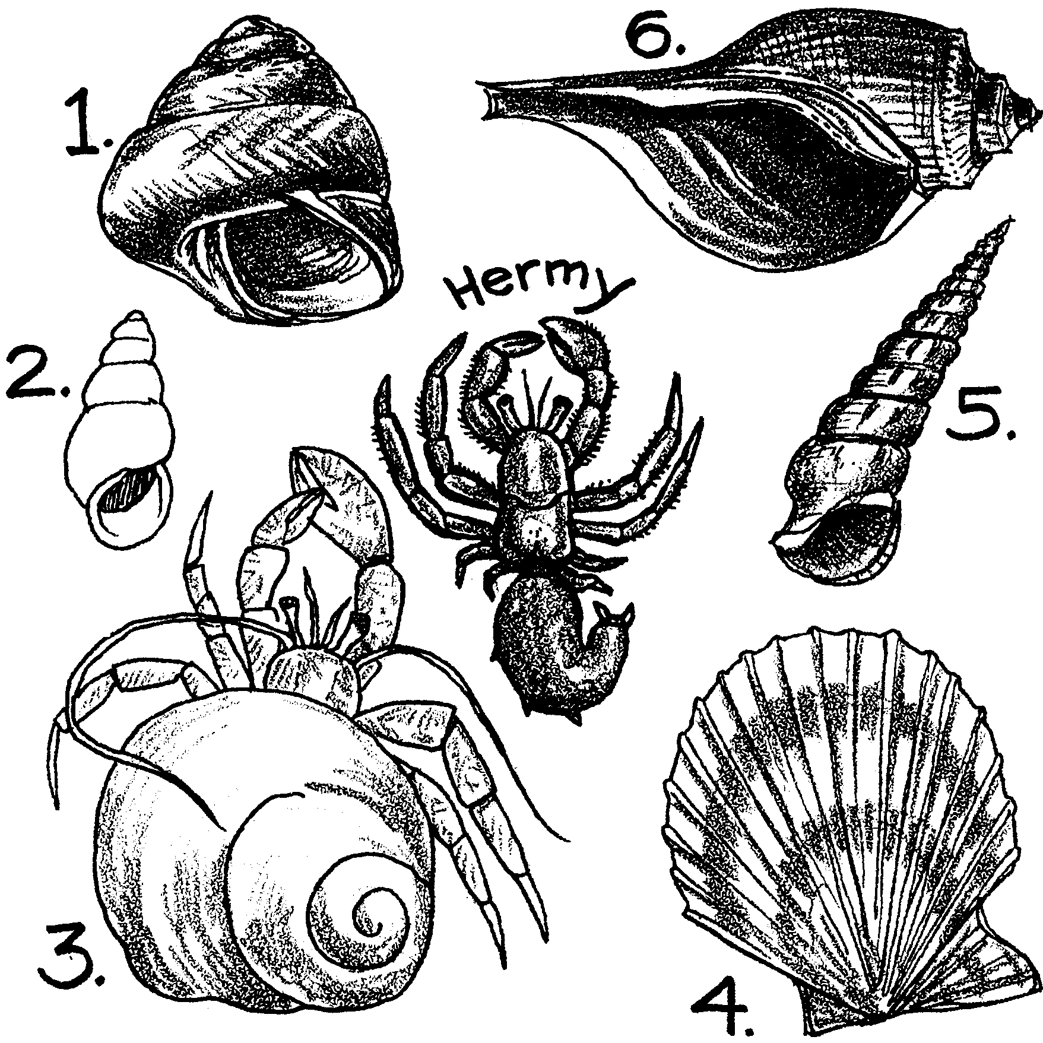

Hermy is too big for his shell. Help Hermy find a new shell.

1. Circle the shell that will fit Hermy the best.
2. How does Hermy put on the shell?

3. Hermy likes shell #3. What can you tell Hermy about #3?

4. Hermy needs to find a new shell quickly. Why?

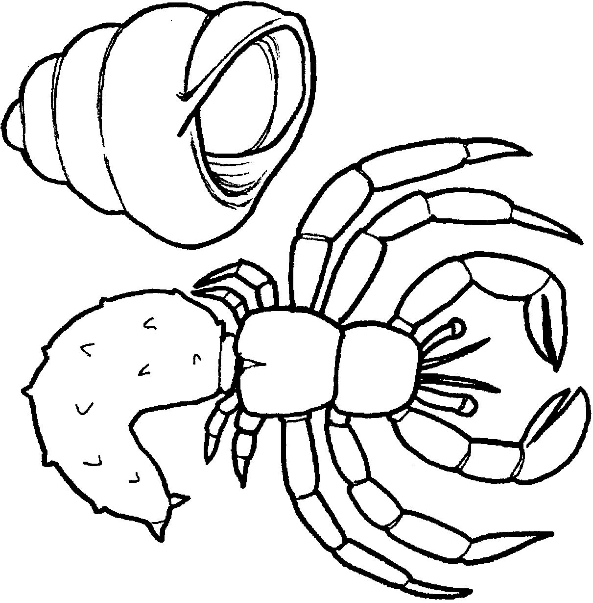

1. I'm looking for a new .

2. I had to move. My old shell was

.

3. Draw me a new home.

4. Color me.

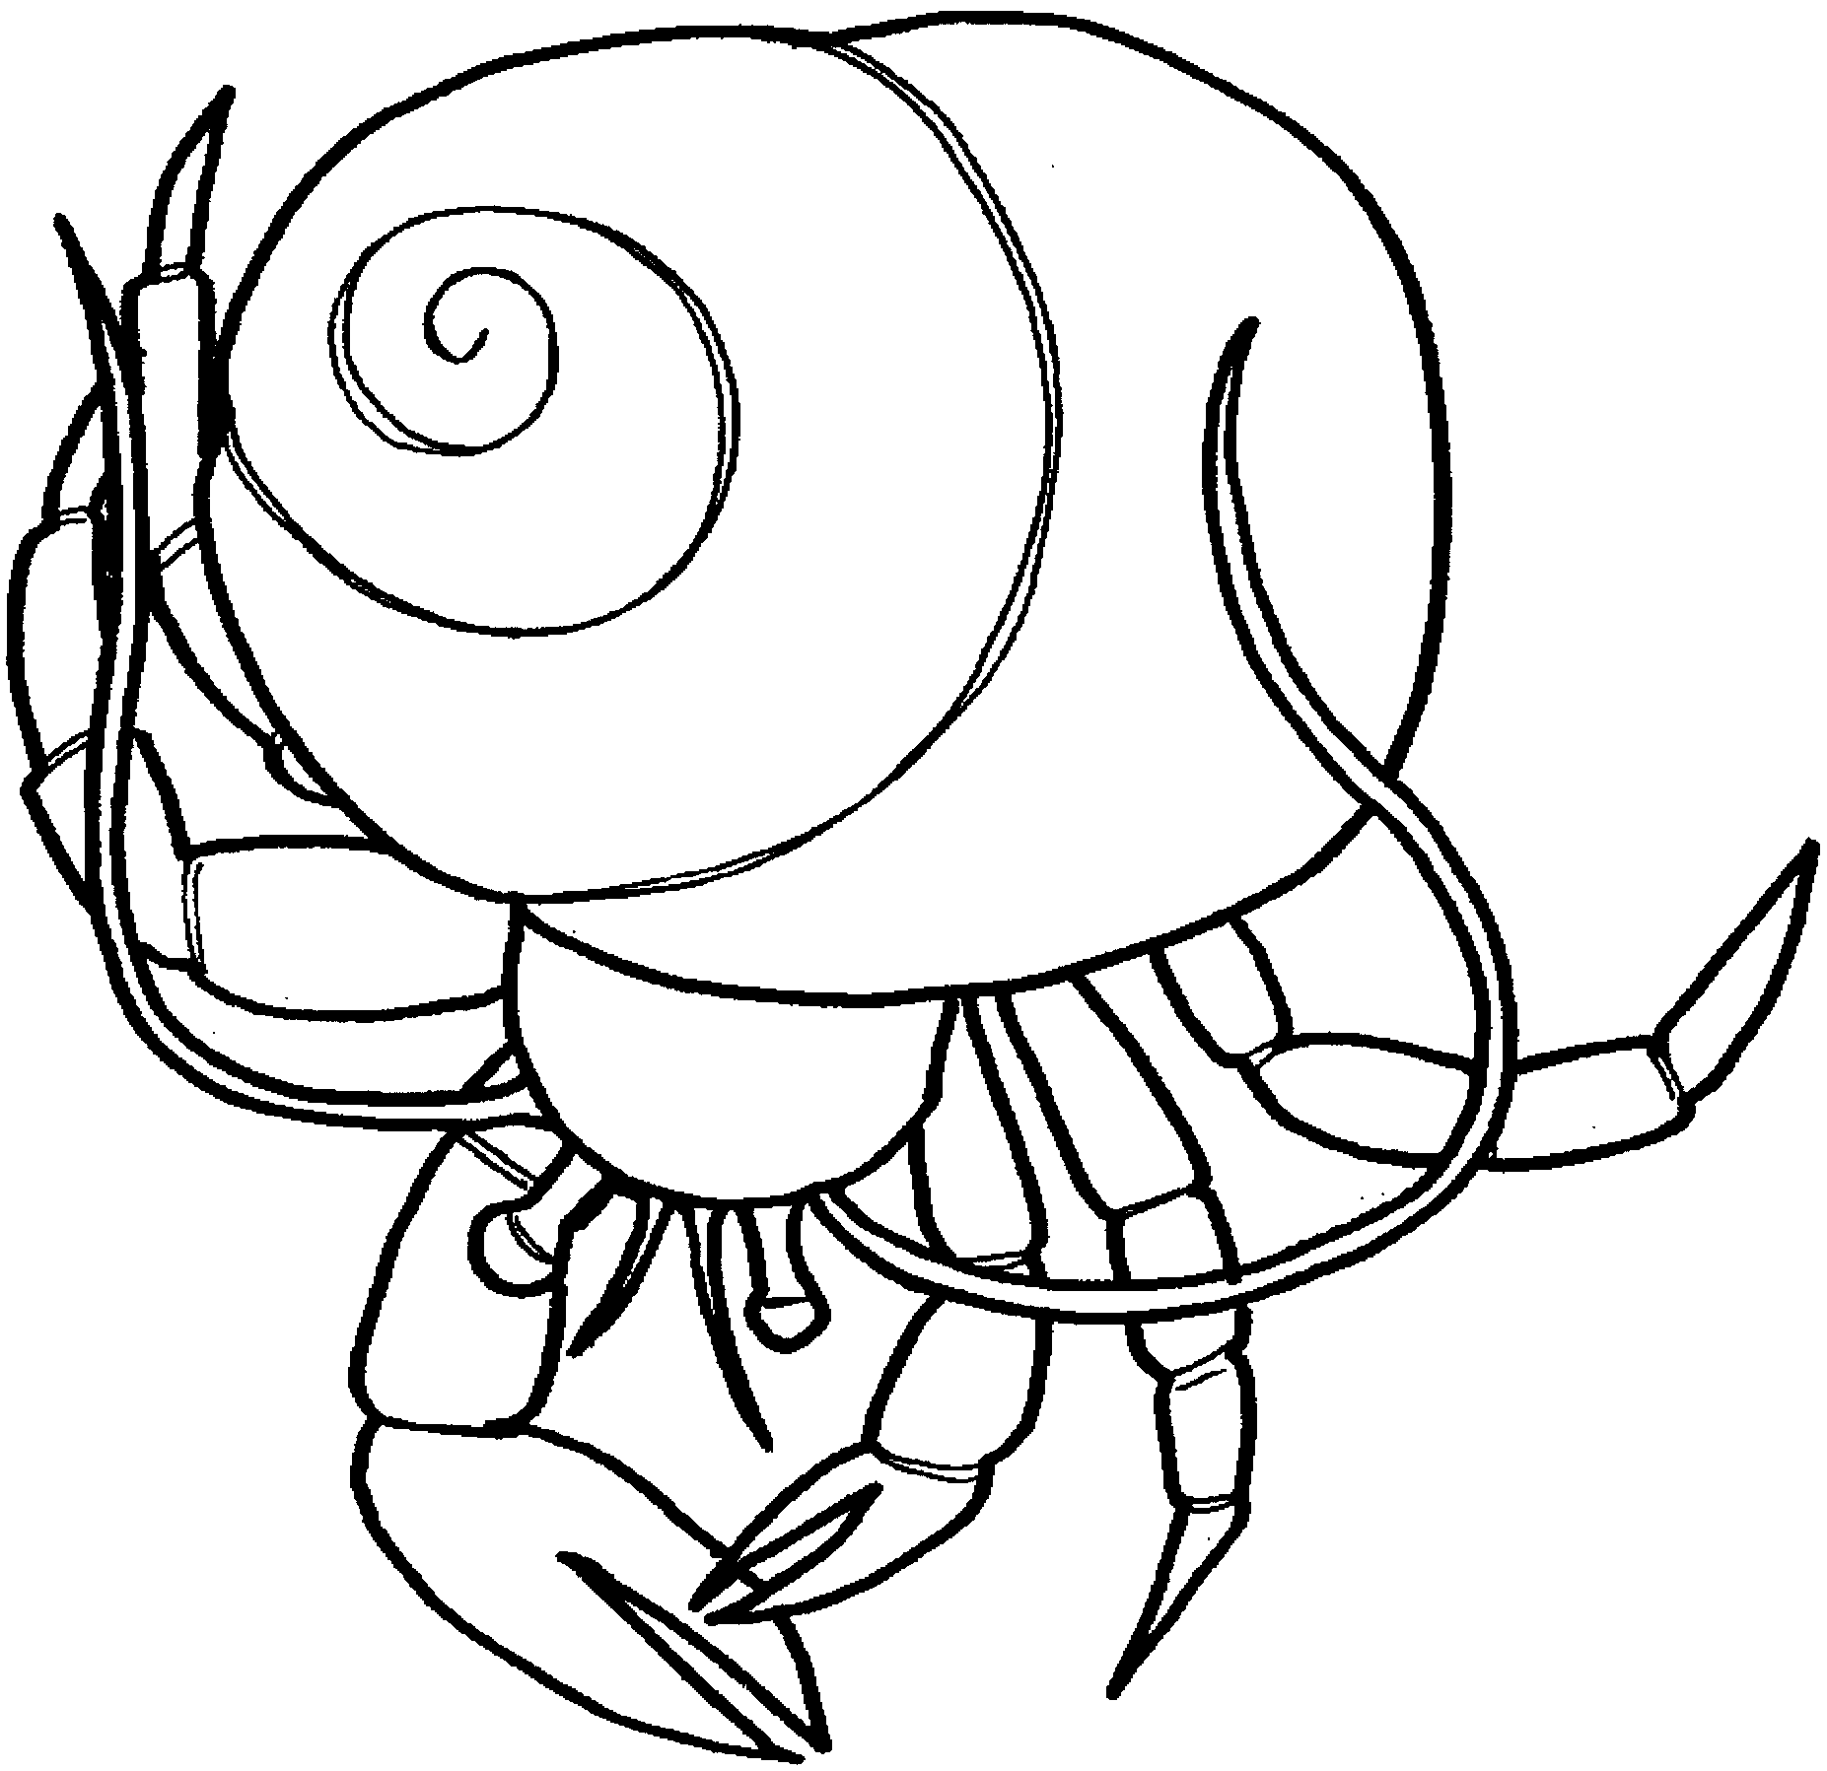
Out for a walk...

1. I'm a .

2. Color my new home.

3. Color me.

