Intertidal Tales
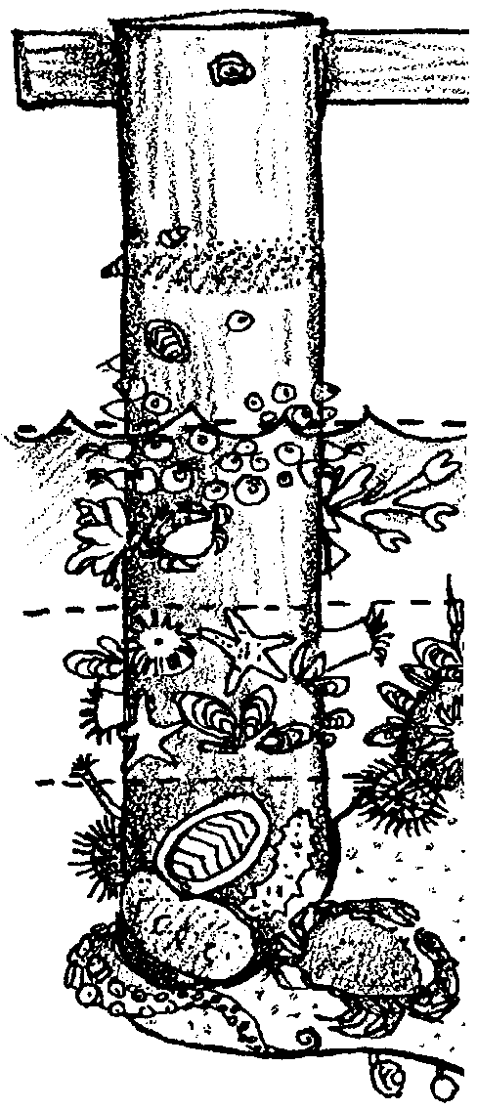
Lesson by Laura Erickson, Poulsbo, WA
and Pat Williams, Eugene, OR

Key Concepts
1. The periodic rise and fall of saltwater up and down the beach (or shore) is called the tide. The area of the beach affected by these changes in water level is called the intertidal zone.
2. A tidepool is formed when receding seawater is trapped in a hole or depression in the rocky shore.
3. Tidepools provide habitat for many plants and animals of the sea.
4. Plants and animals that live in the intertidal zone, including tidepools, have behavioral and structural adaptations which help them to survive in this harsh environment.

Background

Life in the intertidal zone, the area affected by the periodic rise and fall of sea level that we call the tides, is difficult. The rise and fall of the tides alternately expose the intertidal rocky shore and its tidepools to varying amounts of sun, air, and water. Plants and animals are exposed to great variations in temperature, available oxygen, sunlight, and drying. These conditions can vary from place to place on the shore.

Areas within the intertidal region can be divided into four zones which reflect their different exposures to the elements:

The Spray Zone. Occasionally exposed to spray and water carried in by the highest tides and storms, the spray zone is basically a dry, terrestrial area. Animals and plants in the spray zone must adapt to both fresh water from the rain and salt water from the ocean. They must withstand extremes in heat and retain moisture during long dry periods.

High Tide Zone. This zone is usually uncovered except during high tides. Plants and animals in the high tide zone must also adapt to elements and forces outside the marine environment, as well as to the marine conditions which exist when they are submerged. They need to tolerate wave action, and changes in temperature, salinity, exposure to air and water. Many organisms in this zone cling to rocks and rely on the tides to bring food to them. More species are found in this zone than in the spray zone.

Mid Tide Zone. Alternately covered and uncovered during most tide cycles, conditions in the mid tide zone are more moderate with fewer changes in temperature and salinity. More food and oxygen is available than the high tide zone and, as a result, this zone has more species. Animals and plants living here must anchor themselves against wave action.

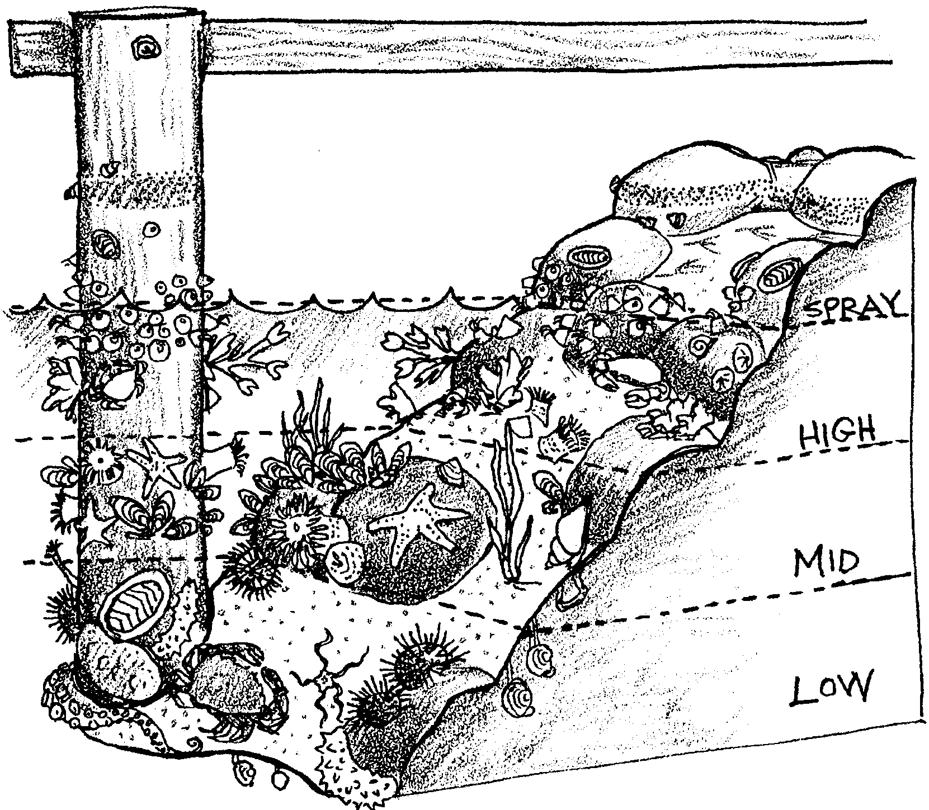
Low Tide Zone. The low tide zone is covered by seawater except during the lowest of low tides. Here, conditions are more constant in terms of salinity, temperature, and exposure to air and water. Most organisms found in the low tide zone are not able to survive in the upper zones. It is a crowded area that contains more species than any of the other intertidal zones. Abundant seaweed creates a layer of protection for the inhabitants of this zone when the tide is low. Stresses are lower from environmental change, but greater from predators and competitors.

Adaptations for Life in the Intertidal Zone

The plants and animals of the intertidal zone face harsh and continuously changing conditions. These organisms have developed special behaviors and structures to assure their survival in the tidepools of the intertidal zones. Organisms must adapt to wave force and desiccation (drying out). When the tide is out, water remaining in the pools is not refreshed, so inhabitants must adapt to changing water temperatures (warming in summer, cooling in winter) and depleted oxygen levels. Evaporation and rain may also change the salinity of the water. Organisms must also adapt to predation and competition for space and food.

Waves — “The need to hold on.” To withstand the constant push and pull of waves and tides, animals and plants in the intertidal zones must be able to anchor themselves in some manner. A variety of mechanisms are employed to keep from being washed away. Sea stars and urchins use suction; mussels attach themselves to rocks using sticky threads called byssal threads. Barnacles glue themselves to rocks and surround themselves with shelled plates. Snails, chitons and limpets hold tight with muscular feet. Seaweeds hold their ground with structures called holdfasts, which look like roots, but serve as anchoring devices, not means of getting nourishment. Seaweeds are also flexible so that they can flow with the motion of the tides and waves.

Desiccation — “The need to keep wet.” Plants and animals also possess a wide variety of structures and behaviors to avoid drying. For example, some animals such as snails, limpets and barnacles adapt to the drying effects of sun, air and wind by clamping down tightly on a marine surface (e.g., rock, another animal) and trapping moisture inside their shells. Bivalves such as clams and mussels shut their shells. Sea anemones close up and spread sand over themselves to conserve water. More mobile animals retreat to dark, cool hiding places in the rocks or under wet, moist seaweed. Their color also affects the absorption and drying effects of sunlight. Some seaweeds have leathery skins to prevent moisture loss and some can become quite dry without dying.

Predators — “The need to avoid being eaten.” Other adaptations offer protection from predators. Many animals like limpets and barnacles have hard shells. Others, like sculpins, use color as camouflage. Still others, like crabs, can scamper away and hide.

Food — “The need to eat.” In addition to avoiding damage from waves, drying, and predators, intertidal animals have to eat. A large number of eating styles is seen in the intertidal zone. Filter feeding organisms, such as the barnacle, filter food from the water. The barnacle uses feathery feet that reach out to grab onto plankton. Scrapers, such as chitons and snails, have raspy tongues that scrape algae from rocks. Scavengers, like crabs, feed off the remains of dead plants and animals. Predators, use a variety of means to capture their prey; sea anemones sting their prey, while sculpins catch small prey in their mouths. Seaweeds make their own food through photosynthesis but “feed” by absorption of nutrients from the sea through all surfaces of the plant.

Additional background information on tides is found in the activity “High Tide, Low Tide” in Unit 6.

Seashore Etiquette

If possible, teach this lesson before or after a visit to the intertidal beach. There is nothing that can replace the experience of taking your students to the intertidal zone to investigate the organisms in their natural habitat. Whether you intend to go on a fieldtrip or not, it is vital that your students learn to respect the beach and the organisms that live there. Students need to be taught to respect all living things and the beach is a great place to begin. Unthinking visitors can cause great damage. Modelling the proper behavior and concern is the best example. “Do as I do”, is a very effective teaching strategy.

When visiting the beach, investigate the plants and animals but respect their habitats. Follow these rules:

Fill in any holes. When digging for burrowing animals be sure to fill in any holes. The burrowing animals may float away or be vulnerable to predation and other animals are killed by the piles of mud or sand which prevent them from reaching the surface.

Turn rocks back over. Many animals live on, under, or beside rocks found on the beach. When investigating the underside of rocks, be very careful to return rocks to their original position trying not to crush any animals as you do so. With an animal like a shore crab, it is often a good idea to turn the rock back over, then place the crab just beside it, allowing the animal to move under the rock on its own.

Avoid walking on animals. Choose bare rocks or patches of sand and mud for your footsteps. Watch out for the animals that live on the surface.

Leave it at the beach. The best rule of thumb is to take only memories and leave only footprints. It is very tempting to take those little critters home with you, but few can survive in buckets or aquaria. Letting animals die in containers or suffocate out of water is cruel and models unacceptable behavior. Be sure to leave the animals in the area in which you find them. Taking animals from one tidal zone to another can cause stress or death to the animals.

Cover unprotected animals. Some animals dry out very quickly when left unprotected in the sun. Cover them with moist seaweed. This gives them protection from the sun and other animals looking for a meal.

Materials

Activity 2
For the class:
• posterboard

• felt pens, etc. for making posters

Activity 4
For the class:
• paper for rubbings

• crayons

• bags

Teaching Hints

Activity #1 - A Day at the Beach

Divide the class into groups. Have the students role play the correct and incorrect way to visit a beach. While students love to demonstrate the improper use of the beach, it is important that correct beach manners also be demonstrated. Suggest students show constructive ways of dealing with people who are not taking care of the beach.

Activity #2 - We Care Posters

Have students design posters that show how to care for the beach and which illustrate good beach manners.

Activity #3 - “Who’s Been Messing Up My House”

Students often have a hard time remembering to return rocks at the beach to their original positions. Here’s an activity that reinforces the importance of this behavior. Demonstrate how it would feel if someone came along and “messed up” your house. While the class is out at recess, or before school, move things around in the room. Turn over some chairs, desks, and centers.

When the class returns, ask how they felt when someone came and disrupted their environment. Compare this to what happens to animals at the beach and to their habitats. Then have the class put the room back in order.
Ask:

“Does it take time and energy to put our ‘house’ back in order?”

“What else could beach animals be doing with their time and energy?”

“Do you think beach animals enjoy rebuilding their homes?”

Activity #4 - So What Can We Take?

If you are able to travel to the beach, learn the rules for collecting before the trip. In some places absolutely nothing, including empty shells, may be taken. Help the students find alternatives to taking things from the beach. Here are some possibilities:

1. Beach rubbings. Take paper and crayons to the beach. Find shells, drift wood, and other hard, dry objects. Lay the hard object down with the paper on top of it. Hold the crayon flat down on the paper over the object and rub back and forth. This is usually enough to make a good impression. Suggest that students try using different colors and making patterns and designs. Have the students label each rubbing. Have a contest to see how many of the rubbings (besides their own) students can identify.

2. Write stories or poems about what you see at the beach. Write a fiction tale about one of the critters that lives on the beach and its adventures. Pagoo, by Holling C. Holling, is a good example of a hermit crab’s adventures.

3. Make a list of all the animals that you find. Take the time to do some sketching of the plants and animals. When you get back home make a collage of those animals using pictures from magazines, etc.

4. Act out what you see happening on the beach. Watch a tidepool closely and see what is happening. Then get in a group and act out what you saw. This is guaranteed to provide memories to take back home.

5. Before going home, have each person tell about one new thing they saw, felt, smelled, or heard on the trip to the beach.

6. Take bags to collect things that should not be on the beach. Be sure to tell students to exercise caution in choosing what to pick up. If they are unsure about picking up something, tell them to ask an adult.

Key Words

adaptation - an alteration or adjustment, often hereditary, by which a species or individual improves its condition in relationship to its environment

habitat - the area or type of environment in which an organism or biological population normally lives or occurs

intertidal zone - the area of the beach exposed by the tides

observation - the act of paying attention or noticing; the act of noting a phenomenon often with instruments and recording it for scientific or other purposes

tide - the periodic variation in the surface level of the oceans and of bays, gulfs, inlets and tidal regions of rivers, caused by the gravitational attraction of the sun and moon

tidepool - a depression which retains receding seawater as the tide ebbs, often providing a suitable habitat for many marine plants and animals

