ISLAND
ROCK
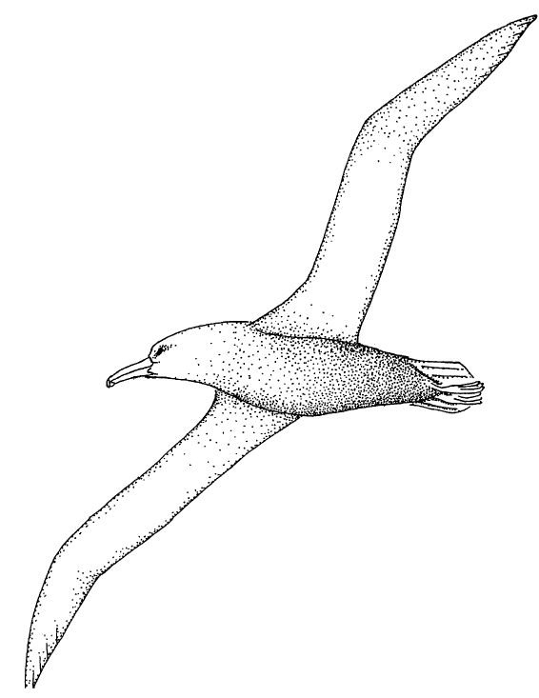
FOR THE TEACHER

Discipline
Biological Science

Theme
Patterns of Change, Systems and Interactions

Key Concept
Most seabirds breed on their own special island habitat and migrate to the open sea for the winter. A successful breeding habitat has nest sites, nesting materials, food, and an absence of predators.

Synopsis
Students listen to, discuss, and write new lyrics to the Banana Slug String Band song “Island Rock” based on information they teach each other through a small group jigsaw activity.

Science Process Skills
communication
comparing
organizing
relating

Social Skills
share ideas and information
check for agreement

Vocabulary
rookery
pelagic
seabird
migration
refuge
fledgling

MATERIALS

INTO the activities
• Slugs At Sea audio cassette and a tape player, or piano or guitar to play “Island Rock”
• lyrics and musical score to “Island Rock”
• one sheet of letter-size drawing paper (for each pair of students)
• one pencil (for each pair of students)
• 1 sheet of scratch paper (for each pair of students)
• 1–2 sheets of chart paper (each about 2 X 3 feet)
• 4–6 colored marking pens, wide-tip, several colors for the teacher
• masking tape

THROUGH the activities
• Key Concept written in large letters on butcher or chart paper

Quick Writes or Journal Entries
• 2 sheets of chart paper (each about 2 X 3 feet)
• 4–6 colored marking pens, wide-tip, several colors for the teacher
• masking tape
• journal or 2-3 sheets of writing paper (for each student)
• 1 pen per student

Island Rock Advance Organizer
• 1 sheet of chart paper (about 2 X 3 feet)
• 4-6 colored marking pens, wide-tip, several colors for the teacher
• masking tape
• “Island Rock Advance Organizer” copied onto chart paper (The Advance Organizer can be duplicated for each student or made into a transparency to use with an overhead projector).
• 1 sheet of letter-size paper per student
• 1 pencil per student

Seabird Jigsaw
For each group of students:
- one of the following “Seabird Fact Card” sets copied, cut out, and glued onto 4 X 6 cards:
Sooty Shearwater (New Zealand)
Red Tailed Tropicbird (Hawaii)
Waved Albatross (Galapagos)
Pigeon Guillemot (Farallones)
Great Black-backed Gull (Long Island)
Brown Pelican (Channel Islands, Bahamas, Galapagos)
- one seabird illustration corresponding to the seabird fact cards
- one labeled diagram of the parts of a seabird
- 1-2 sheets of chart paper (each about 2 X 3 feet)
- 4-6 colored marking pens, wide-tip, several colors
- colored pencils including pink, red, pale blue, black, yellow, buff, white, brown, gray, silver
For the class
- masking tape
- world map
Optional
Bird and seabird field guides are helpful as references. Three excellent reference books on seabirds are Seabirds of Eastern North Pacific and Arctic Waters, edited by Delphine Haley, Pacific Search Press, Seattle, WA., 1984; Seabirds: An Identification Guide, by Peter Harrison, Houghton Mifflin, Boston, 1983; and the National Geographic Society Field Guide to the Birds of North America

Island Pro/Con
• 1-2 sheets of chart paper (each about 2 X 3 feet)
• 4-6 colored marking pens, wide-tip, several colors for the teacher
• masking tape for the class to share
• world map
For each group:
• 1 or more copies of one of the six Island Fact Sheets
• 6 Island Selling Points worksheets
• 1-2 sheets of chart paper (each about 2 X 3 feet)
• 4-6 colored marking pens, wide-tip, several colors
Optional
construction paper or paper mache and chicken wire
Optional
encyclopedias and/or an atlas of the world would be helpful

Writing New Lyrics
For each of six cooperative groups of five students each:
• 2-3 sheets of letter-size scratch paper
• pencil or pen for each student
• 2-3 sheets of chart paper (each about 2 X 3 feet)
• 4-6 colored marking pens, wide-tip, several colors

BEYOND the activities
Migration Journals
• one journal or several sheets of letter-size writing paper per student
• one pen per student

Library Research
• reference books on seabirds
• atlas and/or encyclopedia
• world map

“Flybys”
• 5-10 various seabird pictures copied from reference books

Field Guide to Seabirds
For each student
• 2-3 sheets of letter-size drawing paper
• 2-3 sheets of letter-size writing paper
• pen and pencil
For the class
• colored pencils, several colors
• 3 brads
• hole punch

Oil Spills
• videotapes about oil spills such as “When the Spill Hit Homer,” from The Video Project, 5332 College Ave., Suite 101, Oakland, CA 94618 at (800) 4-Planet. This and other oil spill videos are also available for loan from the MARE library.

INTRODUCTION
Seabirds were familiar and welcome sights to the very first seafaring people. They brought hints of landfall to explorers and Christopher Columbus is said to have set his course for land by following the seabirds. Early Polynesians paid close attention to the flights of birds as they sailed across the Pacific and sailors lost in foggy seas have found their way to land following the cries of puffins and murres returning to their rookeries. Great writers such as Chaucer, Chekhov, Dante, Milton, Coleridge, and Shakespeare include seabirds in their writings as various symbols of freedom, goodness, cleverness, and even greed.

Seabirds divide their lives between the land, where breeding takes place, and the sea, where they find their food. They nest on the islands of the world, situated in most cases near productive waters where they can find their prey.
Islands are very important to these birds of the sea. They are havens of isolation where they can find a place to rest, perform courtship displays, lay their eggs, and fledge their young. Nesting islands are chosen for various reasons: freedom from terrestrial predators such as bears, wolves, foxes, and people; access to nesting materials; proximity of food to feed the young; and a moderate climate.

Most seabirds breed in colonies. This provides some stability in the seabirds otherwise unpredictable world. Strength in numbers helps protect the birds from predators and also is a place where a bird can replace a lost mate without missing a breeding season. (Throughout most of the year, most seabirds look rather dull in color as they search for food on the high seas. During the breeding season however, some become very brightly colored. The descriptions of plumage in this activity are taken from breeding birds.)
Unlike most land birds, most seabirds lay only one egg and if they do lay two, often only the first one survives. This is probably an adaptation given the rigors involved in raising young in an environment where feeding may require many miles of travel to find food and bring it back. More coastal species tend to lay more eggs. Gulls lay three eggs and cormorants lay five or more, but these are still small when compared to land birds, which may lay as many as fifteen. Because there is usually only one egg, it is very important for seabirds to protect their egg and young from predators.

There are three large orders of seabirds that occur worldwide. The fourth order, Sphenisciformes, is made up of penguins and is limited to the Southern Hemisphere. The most pelagic, or thoroughly adapted to life at sea, are families of the order Procellariiformes. When not on their breeding grounds, these birds usually fly far and wide on the open sea. They are the albatrosses, having the longest wingspan of any bird of up to 11 feet; the fulmars, shearwaters, and gadfly petrels, many of them great migrators that travel thousands of miles between hemispheres each year; and the storm-petrels, which seem to walk on the water.

Less oceanic, but still very well adapted to marine life, are members of the order Pelecaniformes. These birds are mainly adapted to inshore waters, although some are seen far out at sea. They are the tropicbirds, snowy white birds that streak through the sky with their courtship aerobatics; the boobies with their comic behavior and bright feet; the familiar pelicans, which patrol the coasts in orderly lines, diving to catch fish in their pouches; and the dark cormorants spreading out their wet wings to dry in the sun.

The third order, Charadriiformes, includes the greatest number of species, among them the shorebirds that are mostly adapted to fresh and brackish water. Marine members of this group are largely coastal, although some are highly pelagic. Among them are the gulls, those hardy survivors that have adapted to people and the marine world alike; the terns including the greatest traveler of them all—the Arctic Tern—which makes a round trip of 22,000 miles between polar regions each year. The alcids are also in this group and include the murres, guillemots, and puffins. They are the Northern Hemisphere’s version of the penguins since they “fly” under water much like penguins. Puffins even look similar to penguins.

Specialized adaptations of anatomy, physiology and behavior help seabirds survive in the marine environment. For example, the eyes of diving birds have changeable lenses for focusing on underwater prey, and salt glands near the eye extract excess salt from the blood. Their bills, often serrated, are adapted for capturing fish and other marine organisms. They have air sacs beneath the skin to cushion the impact of dives. Some have long, narrow wings for soaring on sea breezes and others have shorter wings for swimming underwater. Their legs are positioned towards the back of the body and the feet are webbed, both attributes increase their swimming ability.

Many seabirds migrate great distances between the North and South hemispheres each year, or between where they breed and where they spend the rest of the year. These birds appear to have some sort of innate navigational system combined with external clues, such as the stars, which helps even first time migrators be successful.

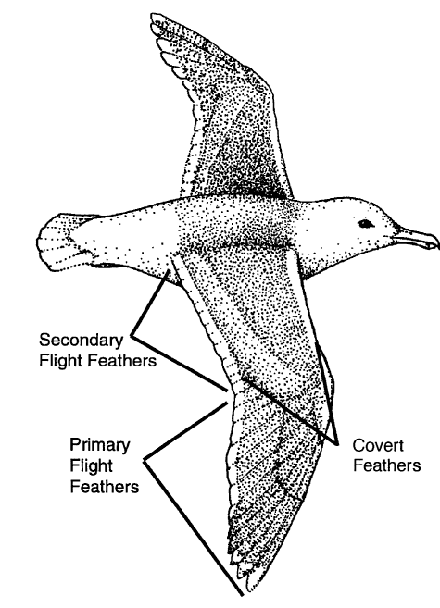

In the past, egg collecting reduced some populations of seabirds, and at the turn of the century they were slaughtered by the millions for their feathers and plumes. For hats, the millinery trade took huge numbers of egrets, and millions of terns and albatrosses, causing the near extinction of some populations. Today all marine birds are protected under national law and international treaty. Except for a few northern species that are still taken for Native American and Eskimo subsistence, such as the murres, seabirds exist in what appear to be great numbers.

Though they are now protected from direct exploitation, marine birds are increasingly susceptible to the effects of people and our activities. Mammals introduced onto islands—rats, cats, foxes, dogs, and mice—are predators against which seabirds have very few defenses. People visiting remote islands may inadvertently disturb the nesting birds, sometimes causing a whole colony to desert their eggs and young. Commercial fishing takes its toll: An estimated 150,000 to 200,000 marine birds drown yearly in gill nets. The results of oil spills are also devastating, especially to the millions of birds that visit and breed in the North Pacific and Arctic each year.

INTO

THE ACTIVITIES

The Music
Have the class listen to “Island Rock” on tape, or play it for them on guitar or piano. Have the students sing along and add hand motions to the song if you wish.
• “wind” hands held high, tossing motion with wrists; wave arms and hands in the air above the head
• “waves” rolling motion with hands held high; wavy motion with arms and hands
• “wild” hands held high above shoulders; palms pointing outward; shake hands back and forth.

Two on a Crayon
Have two students share a sheet of paper and a crayon. They both hold the crayon and together draw an image on the paper.
Have them draw a seabird or an image that comes to mind as the song “Island Rock” is playing.

Think-Pair-Share and Anticipatory Chart
1. Have students think about the following questions, jotting down some ideas in words or pictures:
If you were trying to find out everything you could about a particular seabird species including its migration routes and natural history, what questions would you ask?
• What is the name of the species?
• What is its flying speed, direction and length of migration?
• Where does breed?
• What does it eat?
• What type of nest does it make?
• How many eggs does it lay?
• How many chicks are fledged?
2. Now have each student pair up with another student and compare/ discuss their ideas. They can add to their notes after discussion with their partner if they like.
3. Finally, have each pair share their ideas with another pair of students.
4. Lead a class discussion and record the group's responses on a class chart.

Have each sharing group add their questions to a class Anticipatory Chart at the front of the room and label it: Things We Want To Know About Seabirds

THROUGH
THE ACTIVITIES

Quick Writes or Journal Entries
Use the topic of each of the song as a writing prompt by suggesting a few leading questions to the students. Write the following verses and questions on the chalkboard or chart paper. Read the song aloud, revealing each question in turn as the associated verse is read. Give students a few minutes to write about the verse and then lead a class discussion. This is a good opportunity to explain the topics and concepts mentioned in the song.
Here are some pertinent verses of “Island Rock” with associated sample questions to post.

• “My parents flew from the north for twenty days and nights”
If a bird flies between_________and __________miles/hour, how many miles did it fly?
Note: The measurement of a bird's flying speed is a very uncertain and tricky thing. The wind, the angle of the bird's flight, whether it is being pressed to fly faster and many other factors affect its speed. Birds vary greatly in how fast they can fly and also how fast they need to fly. Sixty miles an hour is fast for a bird and the fastest known species, the duck hawk doesn't exceed 175–180 miles per hour. A Canada goose in easy flight goes 20 miles per hour, but when pressed by a plane it can go 45–60 miles per hour.

• “They had to fight for space for a nesting site”
How might birds fight for space. What else might they fight about? What do they need to make their nests?

• “They had to lay an egg not once but twice”
Most seabirds only lay one egg, why would these birds have to lay an egg twice? Why do seabirds lay so few eggs compared to land birds which may lay as many as 15 eggs?

• “We dive and catch a fish with one or two tries”
What are different ways birds could chase and catch fish? Some dive from high—how else might they catch their prey?

• “And nothing could hurt on us on this paradise”
What could hurt a bird on an island?

• “But one day I migrated to northern skies”
Why go to northern skies? What’s there? Why leave the island?

• “An oil spill ruined my paradise”
How common are oil spills? How do they hurt seabirds? How can we prevent oil spills?

• “It is a refuge, they say, may it always stay nice”
What does the word “refuge” mean to you? What might it mean to a bird?

Island Rock Advance Organizer
1. Display the lyrics of the song “Island Rock” on chart paper using wide-tipped markers in various colors.

2. Copy the Island Rock Advance Organizer onto a sheet of chart paper, leaving the label off the third column (Characteristics and Natural History of “Your Seabird”) for now. Tape the chart to a wall where everyone can see it. Have each student copy the Advance Organizer onto their own sheet of paper. Pairs of students can work together to take notes on their charts as you call for volunteers to read each verse of the song.
Note: the Advance Organizer can be duplicated for each student or made into a transparency to use with an overhead projector. We have found however, that students seem to get the most out of the activity when they copy down the chart themselves.

3. After all the verses have been read and the students’ notes recorded on their Advance Organizer, call on the students to fill in the class chart posted on the wall. Ask them if any important information was left out of the song? Which of the questions recorded on the class brainstorm chart Things We Want To Know About Seabirds were left unanswered? [Name of seabird, description of seabird, flying speed, number of chicks fledged, name or location of the island (i.e. northern or southern hemisphere), how catch food] Have the students add these questions to their Advance Organizer.

4. Have the students make predictions about the unknown characteristics of the bird in the song: what it looks like, what kind of bird it is, and where in the world it breeds.
Note: If you have access to bird and seabird books, distribute them around the room and allow the students to browse through them before making their predictions.

Tell the students that in the next part of the activity, they are going to learn about six different seabirds. This information will be used to help figure out which, if any, seabird the song is about. Remind them to keep their Advance Organizers with them because they will be used in the next part of this activity.

Seabird Jigsaw
1. Divide the class into six groups of five students each. Have each student label the third column on their Advance Organizer Characteristics and Natural History of “Your” Seabird. Each of the six groups will become the experts on a different seabird. As each group gets more and more clues about their seabird they will be able to fill in the third column on their charts. No one student in a group will have all the information to complete the chart. They will need to work together and everyone will have some clues to contribute.

2. Distribute the six sets of seabird fact cards, one set to each group of five students. Each student within the group receives one of the cards to read and learn their piece of information. Tell them that as they read their card, they should use their advance organizer and try to fill in as many of the blanks as possible.

Tell them that they will need to really learn their card because they are the only one in their group with that piece of information and they will need to teach it to the rest of their group.

Distribute the corresponding seabird illustration and colored pencils or markers to the student with “Description/Characteristics” jigsaw card.

3. After the students learn their own card, they can now teach it to the rest of their group. The group can work together to color the illustration appropriately and to fill in the column labeled Characteristics and Natural History of “Your” Seabird on the Island Rock Advance Organizer. Each student should be able to contribute information to fill in at least one row of the table.

Have each student fill in their own chart with all the information gleaned by the group so that there are five completed charts from each group. Each student will need to have a complete chart for the next part of this activity.
Note: For assessment purposes, you might want to have the students put their initials next to the information they contributed to the chart.

- Have each group circle the clues on their chart that seem to apply to both their seabird and the seabird from “Island Rock.” Have them put an “X” next to those clues that do not apply.

5. After each group has completed their Advance Organizer, distribute large sheets of paper and colored markers to each group. Have them make one or several posters of their seabird showing its characteristics, migration routes, and where it usually breeds. Bird and seabird field guides would be helpful at this point, but are not necessary. Have each group present their posters to the rest of the class and then display them around the room.
Note: For assessment purposes, you may want to have each student in the group use a different color of marker so you can document what they contributed.

- Ask the class if they know which bird the song is about? They will probably determine that none of the birds they learned about match the song completely. In fact, it appears that no one bird was used as the model for “Island Rock.”

Tell the class that since they’ve learned about six different seabirds, they are going to learn about the six islands where these birds nest—the five islands in the song plus one more.

There will be a contest to determine which group makes the best presentation about their island. The island group that wins will determine which of the seabirds will be the centerpiece of a new song written by the class and sent to the Banana Slug String Band.

Island Pro/Con
1. If you were a seabird, what would you want in an island home and rookery? Do a class brainstorm and record on butcher/chart paper or the chalkboard. [abundant food nearby? isolated or protected from predators? human impact at a minimum? space and available materials for a rookery? within migratory range?]

2. Divide students into six expert groups, one for each of the islands in the song: Channel Islands, Galapagos Islands, Hawaiian Islands, Farallones, Long Island, and one new group for New Zealand. Be sure to include one student from each of the seabird groups in these new groups so that every bird is represented within each of the island expert groups. Have each student take their copy of the Advance Organizer to share with their new group. Distribute one or more copies of one of the Island Fact Sheets to each group. Have one member of the group read the island information aloud to their group or, if there are multiple copies, everyone can read their own sheet.

3. Have each group discuss the information about their island and then make pro/con lists for determining if the seabirds could successfully breed and build nests on their island. Distribute an Island Selling Points worksheet to each group and have them determine how they would make a case to convince the seabird to return to their island for nesting. What are the selling points of their island?

4. Have each of the groups make posters illustrating and extolling the virtues of their island or, optionally, make them in 3-D using construction paper or paper mache and chicken wire.

5. Have each group use their graphics to make presentations to the rest of the class as if they were trying to convince a seabird to nest on their island. Give each group five more Island Selling Points sheets to share and to keep track of the points that were covered for each of the other islands. Finally, have the class vote for the island that seems the most appealing from a seabird’s point of view.

6. Ask the class:
• If they voted for the Galapagos Islands, which bird would they write new lyrics about? [waved albatross]
• If they voted for the Hawaiian Islands, which bird would they choose? [red-tailed tropicbird]

After the island and associated seabird are determined, look at the posters about that seabird. Have the one student in each group that studied that specific bird review its characteristics for their group using their Advance Organizer and the posters displayed on the wall.

Writing New Lyrics
1. Play the song “Island Rock” again. How could the lyrics of the song be changed to reflect all the natural history characteristics of the actual seabird and its island rookery? Have each small group use the characteristics of the seabird chosen by the class and write new lyrics to the song. They can write all new lines or use some of the original words, but the new verse needs to fit in with the beat and tempo of the original song. Additionally, each group must include as much natural history information in the song as possible.

2. Distribute chart paper and colored markers to each group and have them write their new lyrics in large bold letters. Post the new lyrics where everyone can see them and then have the class vote on the verses they like the best. Finally, write out the new verses or make a tape of the class singing the new verses and send them to the Banana Slug String Band for their comments.

Key Concept
Hold up the key concept and have one or two students read it aloud. Post it near other work from this activity.

BEYOND
THE ACTIVITIES

Migration Journals
Have the students write individual or group first-person stories or keep journals as if they were actually one of the migrating birds. What dangers did they encounter on their journey? Where did they stop to rest and what did they find to eat? How long did the trip take? Did they feel tired? Did they get lost? How did they know when and where to go?

Library Research
The song says that the seabird is not nesting on any of the islands mentioned in the song except maybe Long Island. What other islands on earth may be suitable for seabirds to nest on? What island do you think the seabird of the song was born on? Birds must be able to breed there, so keep in mind: habitat, weather, food availability, migration routes, and absence of predators.
• Do further research on the island groups in the song.

Point Reyes Bird Observatory
Call this research facility for information on seabirds, outreach speakers, and field trip possibilities. (415) 868-1221 main office or 868-1434 for the Palomarin Field Station.

“Flybys”
Have the students help make a list of attributes or characteristics of birds that are used by birders to distinguish between different species. [color, shape, size, habitat, and jizz—the overall outline or aspect]
Have students imagine they are on a ship bouncing up and down on huge ocean waves. Briefly hold up a picture of a bird as if it were flying by very quickly. What attributes of the bird were the students able to distinguish with such a brief glimpse? Show the picture two to three more times, slowing down each time. After each “flyby,” elicit from the students what attributes they were able to distinguish. This is an excellent activity to do before going birding in the field. It is a good reminder for the students that they need to have a sharp eye to note all the characteristics of the birds before they fly away.

Field Guide to Seabirds
Have individuals or cooperative groups pick different seabirds to research. Students can draw pictures of their chosen species as they would look in the water and in flight, describe their preferred food items, breeding habits, and include other natural history information such as maps of their distribution. Once everyone has completed their reports, compile the information and drawings into one field guide. The class guide can then be paper punched and put together with brads or Velo Bound at the local copy shop.

Oil Spills
Watch videotapes of oil spills and their aftermath such as the Exxon Valdez oil spill that occurred on March 24, 1989, in Prince William Sound in Alaska, or the Shetland Island spill in 1994. How do oil spills affect seabirds? Why are birds so vulnerable? Visit a bird rescue center or volunteer to help clean birds during an oil spill.
SEABIRD FACT CARDS

Sooty shearwater
Puffinus griseus

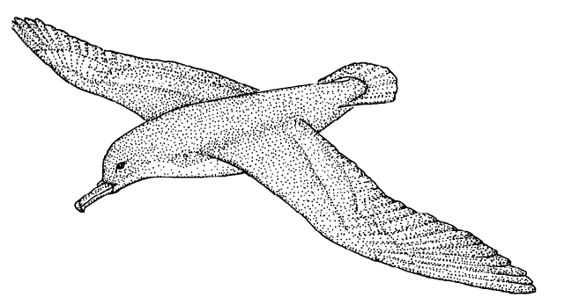

Sooty shearwater
Description/Characteristics
These oceanic birds resemble sooty-brown, slender gulls. Shearwaters are so named because of their habit of tipping from side to side as they follow currents of air at the sea surface, thus appearing to “shear” the water. Their wings are long and narrow with a wingspan of three feet. The birds weigh about one pound and are about one and a half feet in length. They have dark gray, long, slim-hooked bills, short tails, and dark gray legs and feet. These birds are independent of land for feeding or resting and come ashore only to reproduce. Although they are graceful at sea, their movement on land is clumsy and difficult because their feet are placed so far back on their body. These birds have tube-shaped nostrils placed side-by-side on top of their bill. They have a long life expectancy of 20–30 years.

Sooty shearwater
Distribution
Sooty shearwaters migrate thousands of miles yearly between the Southern Hemisphere, where they breed on the islands of New Zealand and South America, to the Northern Hemisphere where they spend their winter in the North Pacific and Gulf of Alaska. (Remember, when it is summer in the Northern Hemisphere, it is winter in the Southern Hemisphere.) They are by far the most common shearwater in Monterey Bay, California, from July through November when flocks of several million can often be seen from shore. They leave the North Pacific in early September as the cooling air and the freezing of shallow waters makes it more difficult to find food. In Alaska, these birds move through narrow passes in numbers greater than a thousand per minute for several hours at a time. Hawaiian fisherman call these shearwaters “crazy bird” because they seem to be in too much of a hurry to feed as they pass through the Hawaiian islands on their yearly migration.

Sooty shearwater
Courtship displays/Nest building/Breeding
Sooty shearwaters arrive at their nesting colonies in New Zealand in late September and by late November their eggs are laid. Each pair lays one large white egg in a burrow they have dug. They take turns incubating the egg. The burrows provide some protection from predators and from harsh cold or severe heat. The adults also try to protect and hide their eggs and young from predators such as gulls, ravens, and skuas by returning to the colony at dusk and then leaving before dawn. It doesn't appear they can lay a second egg if something happens to the first. The baby birds spend a long time as a nestling (more than one hundred days) in close physical contact with their parents. Sooty shearwaters don't breed until they are 2–3 years old, but several years before breeding, they return to their birthplace to learn the ropes and find a permanent mate. During this time they also learn the fishing skills crucial for their own survival and for feeding their future young.

Sooty shearwater
Food eaten/Capture of prey/Feeding chicks
Sooty shearwaters are called pursuit divers or pursuit plungers, because they capture their food by diving from the surface or plunging head first from about one yard above the water. They enter the water with open wings and then use them underwater to help chase and capture their prey—squid, shrimp, and schooling fish. These birds depend on widely scattered and unreliable sources of food at sea and seem to locate their food by smell. Parents must sometimes fly several hundred miles to find food for their chicks. After capturing their food, they swallow it and it is turned into a stomach oil to be used as food for the chicks. It is a concentrated energy source and can be carried easily by the birds as they search for food over many days before returning to the nest to feed the chicks. The stomach oil can also be spit out in defense against any threatening intruder! Chicks beg for food by touching their parent’s bills. They are then fed regurgitated food by both parents.

Sooty shearwater
Predators/Conservation/Interesting facts
Natural predators of the sooty shearwater eggs and young include skuas, tiger snakes, and hawks; also rats, mongooses and cats introduced by people also take their toll. People still eat “sooties” for food every year in Australia and New Zealand. Even though many migratory bird treaties have made it illegal to kill seabirds, even indirectly, an estimated 250,000 to 750,000 birds are drowned in gill nets each year. Commercial fishing for salmon in the North Pacific, using gill nets, kills a large number. Sooties are also vulnerable to expanding anchovy and squid fishing because they depend on those fish for food. Commercial development and transportation of oil resources world wide present very real threats to all seabirds if there is an oil spill, especially those species like the sooty shearwater that feed or breed in large groups at the same time in the same place.

Waved albatross

Diomedea irrorata

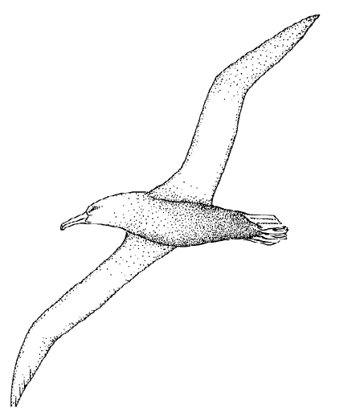

Waved albatross
Description/Characteristics
Albatrosses have long, strong, dull-yellow bills with a hook at the tip to hold onto their favorite food—slippery squid. Their bodies are about three feet long, with a wingspan of about eight feet. They have pale blue legs and feet, a mostly white head and neck, with just the top of the head and back of the neck buff-yellow. The underside of the wings are white with slight brown bars and the tail and back of the wings are brown. The waved albatross appears mostly dark in color with slight wavy white lines on its breast that give the bird its name. Albatrosses have extremely long, narrow wings and fly almost effortlessly. They are called tube-nose birds because they have nostrils shaped like tubes opening onto the top of the bill through which they shoot out excess salt. They are long-lived birds with a life span of 40–50 years.

Waved albatross
Distribution
These birds are independent of land for feeding or resting and rarely even come in sight of land except while they are breeding. Their breeding colonies are deserted much of the year while the birds roam alone over the productive waters of the tropical East Pacific off Ecuador and Peru, mainly between 4 degrees N and 12 degrees S. The entire world pop of some 12,000 pairs nests on Española Island in the Galapagos Island chain. It is the only albatross species (there are 13 species of albatrosses in all) to occur entirely within the tropics; most of the others occur in the southern oceans.

Waved albatross
Courtship displays/Nest building/Breeding
Waved albatross mate for life and return to the same area to breed year after year. They perform a spectacular courtship display toward the end of the previous breeding season so that when they return to the breeding colony, they can start straight away with the business of raising a chick. As birds come in from their ocean wanderings, the mates reunite and after a brief display begin mating. They build no nest, but just lay their one enormous white egg on the reddish clay among the lava stones. They may end up moving their egg as much as 40 meters in just a few days. Each pair lays their egg by the beginning of May and both parents take turns incubating it for two months. When the chicks hatch they are brooded for a few weeks, but then left unguarded as the parents return only to feed it. Parents and chicks find each other by a mutual calling back and forth until they locate each other. Young birds spend the next few years at sea and then late in the season of their 4th or 5th year, return to Española Island to breed.

Waved albatross
Food eaten/Capture of prey/Feeding chicks
Waved albatross eat squid, flying and other fish, and crustacea, which they capture by grabbing them from the surface of the water. Parents feed their chick large amounts of an oily liquid made up of digested fish and squid from the parent's stomach. This means the parents can cover large distances over a week or two and feed until they have accumulated a great quantity of food rather than having to return to the nest each time it finds and captures its prey. Another advantage to this type of food for the chicks is that the oily liquid is probably richer than the raw fish, squid, and crustacean from which it is made. The chick can receive as much as two kilograms of oil in just one feeding, after which it can barely move.

Waved albatross
Predators/Conservation/Interesting facts
So many tourists visit the Galapagos Islands that the Ecuadoran National Park system has set up rules and boundaries to keep people from trampling and disturbing the nesting birds. Fortunate for the albatross, Española Island is one of the only islands in the Galapagos that is free of feral animals such as goats, pigs, dogs, and rats that could eat its eggs and young.
“The Rime of the Ancient Mariner” by Samuel Coleridge is a poem about a sailor who thoughtlessly, and without motive, killed a friendly albatross. He is then pursued relentlessly by supernatural powers until he repents. Ever afterward he must do penance by teaching others the lesson he has learned—to love and revere all living things. To this day sailors consider it very bad luck to harm an albatross. The scientific name for the albatross, Diomedea, comes from the Greek warrior Diomedes, who was exiled to an island in the Adriatic Sea after the Trojan War. When he died, the gods turned his followers into birds with exceptional powers of flight.

Red-tailed tropicbird
Phaethon rubricauda

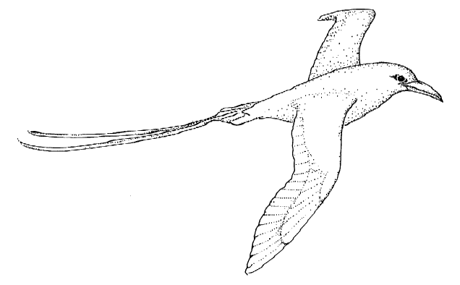

Red-tailed tropicbird
Description/Characteristics
The red-tailed tropicbird is a medium-sized bird about 18 inches long, not counting the 30–35 centimeter long, bright red, wispy tail streamers. It has blue-gray legs and feet, a white head with a black stripe through the eye, and a mostly white body. It has a wingspan of 41 inches with black lines on the tips of the wings and where the wings meet the body. The red-tailed tropicbird has a red dagger-like bill with serrated edges to hold slippery fish or squid. Their hind limbs are so small and weak that these birds can walk for only a few feet and if their nest is under a bush, crash landings are common as the hovering bird drops into the bush and then proceeds to fall down through the branches. However, they are excellent at hovering—an ability very important in their aerial displays for breeding, choosing a nesting site, and foraging for food.

Red-tailed tropicbird
Distribution
These are true oceanic birds and are seldom seen from continental shores. You almost always need to go to sea or to the islands where they breed to find them. They wander far and wide in the tropical Pacific and Indian oceans, and can be encountered in mid-ocean hundreds of miles from the nearest land. They breed on many islands in the Pacific Ocean including Hawaii, Bonin, Volcanin, New Caledonia, Pitcairn, Easter Island ,and in the Indian Ocean on Comoro and Seychelles, Christmas and Cocos Islands. Some range north of Hawaii to within 160 kilometers of Southern California, and stragglers have reached Japan and Bay of Bengal in India. Red-tailed tropicbirds seem to be adapted to warmer parts of the ocean, and their migratory movements seem to follow favorable warm surface currents rather than specific compass directions. They are mostly solitary, but may join large flocks of feeding terns and shearwaters.

Red-tailed tropicbird
Courtship displays/Nest building/Breeding
During courtship, the birds hover, glide, and swoop through the air in unison. Their courtship aerobatics are among the most dramatic in the world of birds. They nest is the flat, sandy atolls of the northwestern Hawaiian Islands. The nest is a shallow scrape in the ground or other flat surface with no materials added. The bird digs it with the feet, using the bill to loosen the ground. They nest in loose groups, where they lay a single egg ranging in color from pure white to speckled to heavily blotched with dark purple. Both sexes take turns incubating the egg for a total of 43 days. One parent sits an average of eight days until the mate returns; fasting the entire time they are on the nest. Tropicbirds breeding near the northern and southern limits of their range have nesting seasons that correspond to the spring and summer months. Closer to the equator, the breeding seasons are usually less well defined. The young bird will reach adult weight at 40 days, but is fed at the nest for another 30–40 days. Fledging takes place at about 85 days.

Red-tailed tropicbird
Food eaten/Capture of prey/Feeding chicks
A tropicbird locates its prey while gliding or hovering above the sea. It then partly folds its wings and plummets into the water from heights of up to 100 feet, steering with the wings on the rapid descent. Usually it stays below the surface for only a few seconds—it doesn't dive deeply or swim very far. The usual prey is squid or fish, especially flying fish, but they don't catch them above the surface. The catch is swallowed at once and is later fed to the young bird by regurgitation. They feed during daylight hours, especially in early morning when squid may still be found near the surface.

Red-tailed tropicbird
Predators/Conservation/Interesting facts
A parent will fiercely defend its nest against any potential predator, threatening it with loud, piercing screams or snarls, followed by swift biting jabs of the bill—a very effective methods against rats. They only nest on islands free from terrestrial predators or on steep cliffs with nests that are also relatively safe from predation from rats, pigs, dogs, and man. Its scientific name has mythical origins. Phaethon, the generic name, refers to the ill-fated son of Apollo who hurtled across the sky in the chariot of the sun and plunged into the sea, which perhaps refers to the aerobatics and plunging dives of the tropicbird.

Pigeon Guillimot
Cepphus columba

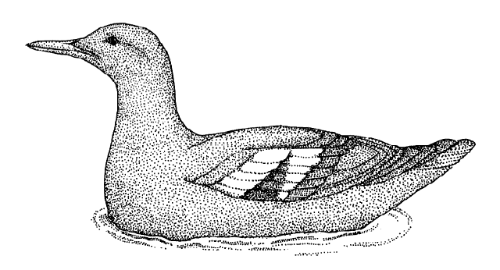

Pigeon Guillimot
Description/Characteristics
Pigeon guillimots are so named because of their pigeon-like color and size; they are 12–14 inches long, with a black bill, and bright red mouth lining, legs, and feet. As breeding adults, their body color is mostly a dull sooty black with just the upperwings showing a white patch with blackish bars. Because it does not normally nest in colonies, population estimates are difficult; it is estimated that there are about 224,000 in North America. Their ability to dive and “fly” under water has resulted in a highly successful group. They have been called the Northern Hemisphere’s ecological counterparts of penguins. In many ways they do resemble penguins being predominantly black and white, with legs set far back on the body and having an upright posture. They have webbed feet, short tails, and small wings for swimming.

Pigeon Guillimot
Distribution
They range from the Bering Sea, throughout coastal Alaska, south to British Columbia and the Channel Islands of Southern California. Where they go during the winter is something of a mystery and they don't return to their breeding areas until about March. They are a commonly seen bird, and yet are sparsely distributed in any one area—you will never see many in any single spot.

Pigeon Guillimot
Courtship displays/Nest building/Breeding
These birds are loosely gregarious, but they nest singly or in small groups, not in large colonies. They perform a water-dance in spring when several pairs may gather, forming lines, submerging and chasing each other, calling and presenting red mouths to each other and performing spectacular aerial displays. They return to their nesting areas from mid-March onwards; eggs are laid in May-July; fledging and dispersal begins in August. Pigeon guillimots are known for the diversity of the nesting sites they choose. They often nest in or under man-made structures such as wharves, and during the breeding season are commonly seen close to shore in kelp beds, and harbors. Usually they choose natural crevices on rocky slopes or even under driftwood, but sometimes it will dig a hole in soil on a steep slope or cliff. They lay two eggs with three days elapsing between laying the first and second egg. The first egg hatches in about 31 days and the second egg in 30 days. About 35 days after hatching, the chicks will fledge, usually one by one, under cover of darkness, and walk or flutter to the sea.

Pigeon Guillimot
Food eaten/Capture of prey/Feeding chicks
The chicks remain at the nest for about 35 days during which time the adults feed them fish—blennies, sculpins and flatfish—which the adults bring to them whole, one at a time. This means that the prey needs to be caught in water close to the breeding sites. The number of fish fed to the young increases from six per day at three days of age to 13 per day at 31 days of age. They feed on fish captured by diving and pursuit under water. The alcids are unusual in their ability to fly above and below the water. In the air they move with whirring wingbeats; under the water, they half-open their short, narrow wings, which become powerful paddles, and allows them to pursue prey to depths of 20 fathoms.

Pigeon Guillimot
Predators/Conservation/Interesting facts
These birds have few natural enemies—ravens, bald eagles, peregrine falcons, gulls, and river otters. They warn intruders away with high pitched whistles and displays of its scarlet-colored mouth lining. However, because pigeon guillimots, like other alcids, dive under water for food, they are especially vulnerable to the effects of oil pollution. Once their feathers become oil soaked, the feathers are no longer waterproof and the birds become hypothermic and die from the cold. Also, gill net fishery takes many birds each year as an indirect result of fishing; as the birds dive beneath the surface they swim into the nets and drown.

Great black-backed gull
Larus marinus

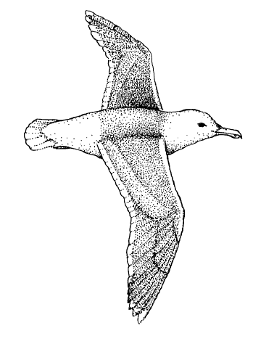

Great black-backed gull
Description/Characteristics
This gull is 28–31 inches in length with a wingspan of 60–66 inches. Its eye has a pale yellow iris with a red ring around the inner edge of the eyelid. It has a yellow bill with red spot near the tip of the lower bill. Its legs and feet are pale pink. The head, tail, rump, and under parts of the body and wings are all white; the upper wing and back are brownish-black. This is the largest gull of the region, and at all ages it is feisty, predatory, and domineering. The combination of its overall size, bulk, heavy bill, fierce expression, and barrel-chest imparts it with a more menacing look than other gulls. Gulls have a shrill voice that sounds like the wailing of a human voice. One interpretation of the gulls name comes from an old French Breton verb, gwel-a, meaning to “weep.”

Great black-backed gull
Distribution
The great black-backed gull breeds in North America from Labrador and Quebec south along the coast to Long Island (almost to New York). It also breeds in Greenland, Iceland, Faeroes Islands, Western Europe from the coast of Murmansk in Russia, south along the shores of Finland, Norway, and Sweden to the Baltic Sea, British Isles, and France. The American and Greenland populations winter as far south as Florida; the Russian and Scandinavian populations move south as far as the Mediterranean Sea. Gulls and people tend to converge wherever the edges between land and water provide a living. These are areas of high productivity, where shallow waters and changing tides expose fish and shellfish and where currents bring in dead organisms at high tide. Gulls have the ability to compensate for change to a greater extent than any other seabird, and its widespread distribution shows the gull's tolerance for a wide range of environmental differences. They are strong fliers, and prefer coasts and offshore waters as far out as the continental shelves.

Great black-backed gull
Courtship displays/Nest building/Breeding
Soon after arriving on the breeding grounds, mated pairs start their courtship, and then for the next few weeks, they walk their territory together, looking for a suitable nest site. Eventually the female makes the final selection of a nest site and the pairs settle down. They seem to prefer nest sites among large driftwood or 2–4 foot boulders; their nests are made of grass, feathers, sticks, and seaweed. Most females lay three eggs. If the eggs are lost early in the season, the female is likely to lay more. Distance to reliable food at fish factories or garbage dumps seems to influence breeding; the birds who nest closer to such food supplies lay eggs earlier with higher breeding success. Incubation is about 27 days. Pairs that have been together for several years nest earlier, lay larger clutches with heavier eggs, hatch the eggs more successfully and raise more young than less experienced or younger birds. It seems that gulls that hold a larger territory gain an advantage that insulates the chicks from the attacks of their predatory neighbors and they are able to raise more chicks. In late August and through September, when the young birds are about 50 days old, loose flocks move along the New England shore By their 4th year they have acquired the adult plumage and many begin breeding in their 4th summer.

Great black-backed gull
Food eaten/Capture of prey/Feeding chicks
Gulls eat almost anything: shrimp, mussels, cockles, crabs, sea stars, sea urchins, worms, small fish, carcasses, beetles, young rabbits, leftovers from cleaned fish, picnic lunches, and scraps from the dump. These large gulls go out onto the ocean to look for scraps floating on the currents, or wade in deeper water for shellfish, fish, and crustaceans. They use many techniques for finding food—flying close over the water, hovering and dipping on the surface, diving until the wing tips disappear, swimming among floating seaweed, floating in shallow water ,or running over the mudflats. Chicks are covered in brown spotted downy feathers and peck at the parent's bill to get attention and food. Parents recognize their chicks by the pattern of brown spots on their head. Both parents feed the young by depositing pieces either whole or regurgitated on the ground. Even at seven weeks, the young birds are very inefficient at finding food and they continue to beg from their parents as well as other adults. They have to tread a fine line between survival and being too competitive with their parents and other adults because they may get hurt.

Great black-backed gull
Predators/Conservation/Interesting facts
Once the gulls reach adulthood, they can expect to live about 10 years. Some live to be 35 or 40. Weather, predators, disturbance, and parental neglect all take a great toll on their numbers as well as attacks from other adult gulls. Mortality is high, by the time the chicks are three weeks old, a 60% will have died. Most of the chicks which die in the first few days of hatching are never found. When the chicks stray from their parent's territory, they are viciously attacked by other adult gulls. These attacks and cannibalism are major causes of death in the gull's early life. At three weeks they are no longer brooded and may die of exposure if there is heavy rain for several days; they may also drown in the sea or small pools.

Brown Pelican
Pelecanus occidentalis

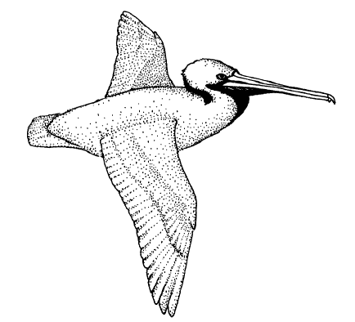

Brown Pelican
Description/Characteristics
These very large birds can weigh 8–10 pounds, with a 7–8 foot wingspan. They have large feet, short, stout legs, and a very long bill with a flexible, bowlike lower mandible (bill) from which a pouch is suspended. The eye is pale yellow with a pink ring around the inner edge of the eyelid and blue-gray skin on the face. The bill is yellow with scarlet coloring near the end and a yellow tip. The head is white with a yellow cast, the front and back of the neck are chestnut, the sides of the neck are white, and the base at the front of the neck is black and yellow. The pouch varies in color from red to black. The feet and legs are blue-gray to black and the tail is dark gray. The upper parts of the body are silvery brown; the under parts blackish brown. The upper wing coverts are silvery-gray to brownish, primaries black with white shafts, secondaries black; underwings dark with irregular white bands across coverts. The brown pelican is the only species in the genus that is entirely marine and plunge-dives to get food. Juveniles, however, may just dip their bill in the water while floating on the surface to catch food.

Brown Pelican
Courtship displays/Nest Building/Breeding
Brown pelicans nest on offshore islands from southern California to southern Mexico where they make a nest of sticks, feathers, seaweed, and even old bones, on the ground or in bushes and trees. Pelicans use their pouches during courtship. The pouches as well as the other non-feathered parts of the head intensify in color during breeding, apparently due to increased hormones. The bright red pouch fades in color as the last egg is laid and incubation begins. Some breeding colonies are very large and may have 15,000 breeding pairs. It takes about five months to raise a young pelican. The female usually lay three eggs over a period of a few days so that one chick hatches two or three days before the next. The parent incubates the eggs under its feet, which has many blood vessels that warm the egg. Chicks are completely featherless when they hatch, so they need to stay in the nest with a parent to keep them warm. The parents take turns brooding and fishing. Eggs take 30 days to hatch. By the time the chicks are 25–30 days old, the parents return only to feed them. Around the time the young begin to fly, the parents stop feeding them and they are on their own. The young birds fledge at about 10 weeks

Brown Pelican
Distribution
Pelicans are mainly coastal, and are rarely seen inland or far out at sea. They inhabit temperate and tropical regions of both hemispheres. In North America, the brown pelican ranges along the west coast from southern British Columbia to southern Chile and along the east coast from North Carolina and the Gulf Coast south to Guyana and Central America. The California Brown Pelican subspecies can be found from southern British Columbia as far south as Central America. It nests on offshore islands, such as the Channel Islands, from southern California to southern Mexico. A different subspecies breeds in the West Indies. Most birds that migrate travel to warmer climates at the end of their breeding season. However, brown pelicans travel from the south to the north after their breeding season. The brown pelicans that breed in Mexico actually travel north to California to spend the winter. This migration accounts for the large numbers of brown pelicans seen from August through November along the west coast.

Brown Pelican
Food eaten/Capture of prey/Feeding the chicks
The brown pelican hunts from the air, flying over the water until it spots a fish. It then pulls its head and neck close to its body, points its beak downward and plunges rapidly into the water. Sometimes they dive from as high as 60–70 feet, but a height of 30 feet is more usual. When the pelican plunges its bill into the water, the lower mandible expands the pouch into an oval scoop that captures the fish. This elastic and expandable pouch is about six inches deep when full of water and can hold as much as two gallons. After a successful dive, the bird quickly bobs to the surface and drains the excess water out of its beak before swallowing its prey. The bird hits the water so hard that fish two yards beneath the surface are stunned from the impact, which makes them much easier to trap within the pouch. The fish is swallowed whole, but can be carried long distances in the bird's gullet without being fully digested. When a parent returns from fishing, it regurgitates fish to feed the young. Older chicks feed directly from the parent's bill, sticking their head and neck up to their shoulders into the adult pouch to gobble down the fish being regurgitated from the stomach. Groups of birds hunting together are more successful than birds hunting alone because of cooperation.

Brown Pelican
Predators/Conservation/Interesting facts
Parents cover the chicks to protect them from hot sun and cold nights and from gulls and crows that steal eggs and eat abandoned chicks. Adults and older chicks from nearby nests may also attack them. If food is scarce, only the first hatched chick my survive. Since the younger chicks are not as big or strong, the older one may attack it. Pelicans feed near the top of the food chain and are therefore especially vulnerable to poisons in the environment that build up in the tissues of organisms at each higher level. This almost led to their extinction in California. In 1970 only one chick was raised on the Channel Islands due to the chemical DDT, which contaminated the fish they ate. The use of DDT was banned and pelicans were able to recover because there were enough older adult birds left to breed. The brown pelican is now doing well but is still considered to be endangered. The nesting islands of the Channel Islands are protected as a Marine Sanctuary and the Mexican government has set aside many islands in the Gulf of California as refuges. Enforcement is almost nonexistent however, and people may still become a major threat as they visit these refuges. Fishhooks, especially ripping their pouch, and entanglement in fishing line usually means starvation and death. As a result, pelicans living as long as 35–40 years are rare.

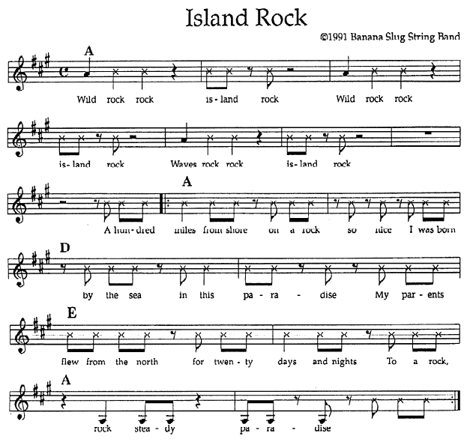

Island Rock

(Chorus) Wild rock rock island rock
Wind rock rock island rock
Waves rock rock island rock

100 miles from shore on a rock so nice
I was born by the sea on this paradise
My parents flew from the north for twenty days and nights
To a rock, rock steady, paradise

My parents flew from the north for twenty days and nights
To raise a family on this paradise
They had to fight for space for a nesting site
On a rock, rock steady, paradise

They found a space that would suffice
In this rookery on this paradise
They had to lay an egg not once but twice
On their rock, rock steady paradise

They lay once and they lay twice
Hatched my sister and me on this paradise
We dive and catch a fish with one or two tries
Rock home, rock steady paradise

Now we could dive and catch a fish with one or two tries
And nothing could hurt us on this paradise
But one day I migrated to northern skies
I left my rock, rock steady paradise

(Spoken)Honey, pack your bags we're going to the Galapagos
Aay aay I don't feel like it.
How 'bout the Farallones?
No, too desolate.
The Channel Islands?
Forget it, man, it's ugly.
How 'bout Hawaii?
Na, too many people.
How 'bout Long Island? HA!

I thought that I'd return, but to my surprise
An oil spill ruined my paradise
Keep the oceans clean, please hear my cries
I loved my rock

Now I've heard of a place that's just as nice
Where pelagic birds share a paradise
It's a refuge they say may it always stay nice Rock on

