BLUE PLANET

FOR THE TEACHER

Discipline
Biological Science

Theme
Systems and Interactions

Key Concept
The ocean covers most of the earth's surface and makes life possible on our planet; it needs to be handled with care and respect.

Synopsis
Students hear and then brainstorm about the song “Blue Planet.” They write original verses and murals symbolizing our ocean planet and environmental conservation issues.

Science Process Skills
communicating
comparing
organizing

Social Skills
share ideas and information
checking for agreement

Vocabulary
plankton
conservation
dependence
interaction
interconnectedness

MATERIALS

INTO the activities
• “Slugs At Sea” audio cassette and a tape player, or “Dancing With The Earth” video and a VCR (both by Banana Slug String Band), or piano or guitar to play “Blue Planet”
• lyrics and score to “Blue Planet”
• globe
• 9 sheets of poster/chart paper
• colored marking pens
• tape

THROUGH the activities
• 5 sheets of poster/chart paper
• writing paper
• colored marking pens
• pens or pencils
• sheets of butcher/mural paper (one per group)
• construction paper (various colors)
• glue
• scissors
• other art materials for mural-making
• key concept written in large bold letters on a strip of butcher/poster paper

BEYOND the activities
• whale and seal field guides and reference books for research
• poster paper and colored markers for migration route maps
• paper quilt squares (one per student)
• drawing/painting materials for Whale's Perspective Quilt
• hairdryers, plastic tubs, and food coloring or confetti (see the “Current Trends” listing in this grade level for a complete materials list for this activity)

INTRODUCTION
With more than 70 per cent of our planet’s surface covered by the ocean, the Earth could more accurately be called “Planet Ocean” or the “Blue Planet.” The one interconnecting world ocean makes our watery home unique among the planets in our solar system. Because the temperature of water fluctuates more slowly than that of land, the ocean plays the vital role of moderating the climate. Without an ocean our planet would burn up during the day and freeze at night. Also, the ocean provides food, water, and over half the oxygen that humans and other creatures need to survive. Many other planets, such as Venus, have no ocean but have atmospheres that are mostly composed of carbon dioxide, preventing life as we know it to survive. The ocean makes our planet unique, and is truly, as in the lyrics to the “Blue Planet” song “the reason all life can be.”

Within the ocean there is constant motion. Currents are the result of complex chains of events initiated by differences in temperature at the ocean's surface. Currents are also driven by winds produced when ocean and land surface temperatures differ. We are able to see how wind affects water movement when we “watch the waves With their windy whirls at the ocean.”
The movement of water is essential to the ocean's ability to support life. Currents and upwelling bring nutrients and oxygen, which are dissolved in ocean water, to phytoplankton, organisms that form the base of the ocean food chain: “little plankton plants are floating in the ocean . . . breathing out and in life's oxygen.” As phytoplankton, and then zooplankton, bloom, fish populations increase, attracting larger predators. Creatures high on the food chain will migrate to where currents carry food or cause food to be in abundance. This is the case along the west coast of the North America continent where we “See the surfing seals in the salty spray curls,” playing and feeding on fish. Humpback whales “breach and spout” as they migrate thousands of miles in the North Pacific every year to reach feeding grounds near Alaska, where annual cycles of ocean currents provide conditions that allow krill and fish to thrive. Thus, our “watery home moving, moving” influences the migration and feeding patterns of animals that live in the ocean.
Despite the crucial, life-sustaining role the ocean has on the Earth, we understand relatively little about it. Because of its immense size, and because humans must use specialized equipment to temporarily adapt to a water habitat in order to enter it, we are only beginning to learn about the ocean or the “mystery beneath the sea.” It is clear, however, that some human activities, such as ocean dumping and harvesting of ocean foods, have a significant impact on the ocean. As our knowledge of the ocean continues to expand, it is appropriate to work to conserve the ocean and to say “Thank you, mother sea.”

The ocean has been a source of inspiration and wonder throughout history for scientists, fisher people, and poets alike. This curiosity and sense of awe is captured by the line in the song “I wonder what the whales all think about in the ocean.” Questions lead to discovery and foster a sense of respect for the environment. Education begins with questions such as this. Baba Dioum, a Senegalese conservationist, emphasized the importance of environmental education with this comment:
“In the end,
We will conserve only what we love,
We will love only what we understand,
We will understand only
What we are taught.”

INTO
THE ACTIVITIES

The Music
Have the class listen to “Blue Planet” on tape, watch the video, or have someone play it for them on guitar or piano. Tell students to picture in their minds the images that the words of the song describe.

Blue Planet Brainstorm
1. With the whole class together, ask students to brainstorm all the ways that people, plants, and animals use and depend on the ocean. Use a globe if you have one, and demonstrate that the map view of the world focuses on the continents, which are usually shown in bright colors. Turn the globe to show the “Pacific Ocean view” or “Blue Planet view”—half of the world with almost no land showing. What does this perspective show students about the planet?

2. Divide the students into cooperative brainstorming groups of three or four students each. Give each group a sheet of chart paper and a marking pen to record their brainstorm. Once each group has designated a member to be the recorder for their brainstorm, give them one of the following questions to consider:
• What would life be like on our planet if the ocean didn't exist?
• How is our planet different from other planets in the solar system?
• What human activities affect the ocean?
• How do human activities affect the ocean?
• What do you think about when you sit and observe the ocean?
• What do you think about when you hear the word “ocean?”
• What is mysterious about the ocean?
• What actions can each person take to conserve the ocean?
• What do you like most about the ocean?
• What are your favorite things to watch when you visit the ocean?

3. When most of the groups have filled their brainstorm sheets, have one student from each group present their question and their group's sheet. After each presentation, encourage the rest of the class to add to each brainstorm sheet. When all the groups have presented, post the brainstorm questions and sheets around the room for students to continue pondering. Make sure to also post the sheet from the first class brainstorm—the ways that people, plants, and animals depend on the ocean. Tell students they are welcome to add more to any one of the sheets throughout the next few days or weeks as they learn and discover more about the open ocean habitat.

THROUGH
THE ACTIVITIES

Discussion: The Ocean Is the Reason All Life Can Be
1. Write the words to the “Blue Planet” chorus, the bridge, and each of the three verses on sheets of chart or poster paper and post them where all the students can see them.

2. Ask a different student to read each verse aloud and then lead a discussion incorporating information from the Introduction. Focus the discussion around the following concepts, using the suggested prompts/questions or others you design:

Interaction and Interconnectedness: Dependence
• How do whales depend upon the ocean? (upwelling and currents make their food sources plentiful; some whales depend on population blooms of fish, krill)
• How do plankton plants (phytoplankton) depend upon the ocean? (wind, waves, and currents all help to bring nutrients and oxygen that are dissolved in the water to plankton)
• What does the song mean when it says plankton plants are “breathing out and in life's oxygen?” (plants produce oxygen as they photosynthesize)
• How do seals depend on the ocean? (“surfing seals” are catching fish in the moving waves)
• How is everything in the ocean is connected and dependent on everything else, directly or indirectly, (waves moving nutrients and oxygen enable plankton plants to breathe out and in; whales spout to breathe oxygen that the phytoplankton help to produce.)

Environmental Ethics: Conservation
• How would a seal be effected by an oil spill? (food source diminished when fish die; fewer resting places when rocks they haul out on are covered with oil)
• It is important that we learn about and save the ocean because we and all other life on Earth will not survive without it. Because the ocean makes it possible for life to exist on Earth, we must be conscious of the impact we have on the ocean.

Song Review
Play the song again so that students become familiar with the tune and the chorus. Refer to the posters with the lyrics and point out the structure of the verses, especially the rhyme scheme and the repetition of the words “the ocean” in the second and last lines of every verse.

Song Writing
1. Tell the students they will have the chance to write their own verse for the song “Blue Planet.” Have each student chose their favorite question from the brainstorm sheets posted around the room to use as a topic for their original verse. All the students who choose a particular question will work as a cooperative group and will write an original verse based on that question. Try to limit the size of the groups to three or four students each.

2. As the students choose their questions, ask them to congregate near the brainstorm sheet. Give them large sheets of butcher paper, pencils, and pens. Tell students to use the brainstorm sheet as a resource for ideas or as a jumping off place for their original verse. Also, remind them that later they will be making murals that incorporate their verse and have ocean conservation as a theme. They should plan their mural as they write their verse.

3. Encourage each group to write several verses based on their question. They can choose the one they like best for their mural.

Ocean Conservation Murals
1. Now have students design murals that illustrate their original verse. Give them sheets of butcher paper for the background, colored construction paper, markers and other art materials to decorate their murals.

2. Give the following instructions to guide students as they create their murals:
• Include the four lines of the verse in large, easy-to-read letters somewhere on the mural.
• Each mural should communicate the meaning of the verse or should show how the words support an ethic of conservation.

3. Display the completed murals in the classroom, hallways or gymnasium of your school. Organize a time for your students to present their murals and sing their verses for the class. Invite other classes to hear the presentations and to tour the world of ocean murals in your classroom.

Debriefing
Hold up the key concept on butcher paper and have one or more students read it aloud. Post the concept on the wall.

BEYOND
THE ACTIVITIES

Watching Whales and Seals
• Have students research the migration routes of whales and seals along the coasts of the United States. How far do different whale species travel in a year? What time of year are we able to see whales along the coasts of California and Baja California? Why do whales and seals travel so far every year? Why do whales and seals congregate in specific locations year after year? Students can choose a particular species of whale and can make a map showing its migration route. The maps should depict what the whales do at different points along their route (feeding, mating, calving).

• Take your class on a field trip to see whales or seals. If you live near a coast, visit a natural area where seals haul out or feed; or take your class on a whale watch boat trip. If you are unable to travel to the ocean, take a field trip to an aquarium or zoo that has exhibits with live marine mammals. See the MARE Teacher's Guide to Marine Science Field Trips for detailed descriptions of sites in central California.

A Whale's Perspective
See the Teaching Strategies section for how to present the Splash Work Quilt activity.
Ask your students to speculate on the question from the song: “I wonder what the whales all think about in the ocean?”
• Have students make drawings or paintings showing a whale's-eye view of the ocean habitat. If the students work on squares of paper the finished artwork can be mounted together to make a quilt.

• Have students write creatively about what a whale thinks about as it swims in its watery environment. What might a whale think about humans it encounters in the ocean?

The Motion of the Ocean: Wave Study
Use hairdryers and tubs of water to give students a hands-on experience of the formation of wind-driven currents. See “Current Trends” listing in this grade level for how to present this activity.

NOTE: Music and lyrics to “Blue Planet” are found below.

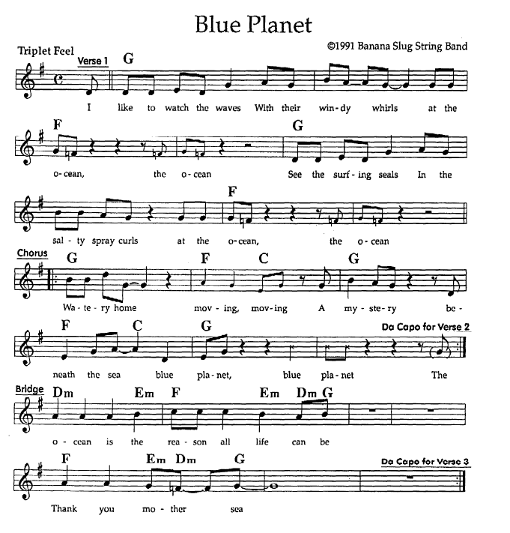

Lyrics

Blue Planet

I like to watch the waves
With their windy whirls at the ocean, the ocean
See the surfing seals
In the salty spray curls at the ocean, the ocean

(Chorus)Watery home moving, moving
A mystery beneath the sea, blue planet, blue planet

I like to watch the whales
as they breach and spout in the ocean, the ocean
I wonder what the whales
all think about in the ocean, the ocean

(Bridge)The ocean is the reason all life can be
Thank you, Mother sea

The little plankton plants
are floating in the ocean, the ocean
Breathing out and in life's oxygen
in the ocean, the ocean

The ocean is the reason all life can be
Thank you, Mother sea
The ocean is the reason all life can be
Thank you, Mother sea

Watery home, movin' movin'
Blue planet, thank you Mother sea. Thank you, Mother sea.

