A
SNAIL’S
PLACE

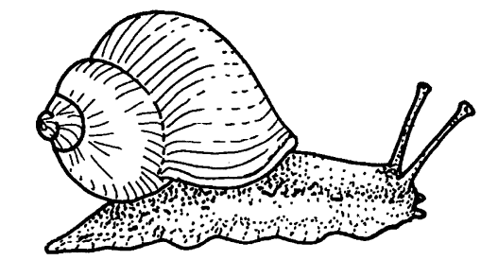

FOR THE TEACHER

Discipline
Biological Science

Themes
Scale and Structure

Key Concept
Snails, like all animals, have specific homes and special adaptations for living there. An animal’s home must provide food, water, shelter, and space.

Synopsis
Students build a snail home in a cup and then observe a snail and its behavior in the home to discover the ways they are adapted to live in their home on land or at the seashore.

Science Process Skills
observing, communicating, comparing, organizing

Social Skills
share ideas and information, check for understanding

Vocabulary
habitat, invertebrate, tentacle, radula, mantle, mucus

MATERIALS
INTO the activities
• pictures from magazines, newspapers, calendars or books of people homes (houses, trailers, igloos, apartment buildings, boats, etc.) and other animal homes (deserts, forests, seashore, ocean, jungle, pond, river, etc.). You can ask students and parents to help you gather these pictures.
• chart paper or chalkboard for class brainstorm
optional
• audio tape by Bill Oliver of “The Habitat Song” available for $10 fromBill Oliver 515 East 40thAustin, TX 78751(512) 454-5008

THROUGH the activities
• Key Concepts written in large letters on butcher or chart paper

For each pair of students
• one live garden snail (you will want to have some extras in case some die or are reluctant to emerge from their shells. Look for them in any shaded, moist spot—under leaves, window sills, large leafed plants, in shrubs, or by sprinklers and hoses)
• plastic cup with lid (yogurt or other small container)
• small pail of soil, twigs, and rocks
• one clear plastic cup
• stick (popsicle or other)
• lettuce, spinach and/or other garden leaves
• one unscented facial tissue
• 10-12 metal washers (all the same size)
• twist tie
• large paper clip (bent open to create a hook at each end)
• 1/2" x 1" piece duct tape
• Four 1/2" x 12" strips of black paper
• different surfaces/fabrics: Plexiglass, wood, sandpaper, metal, carpet scraps, mirror (have a variety available and let students trade)
• rulers or strips of wood and small blocks to create an incline
• Snail Record Sheet (about half a page )

SNAIL RECORD SHEET

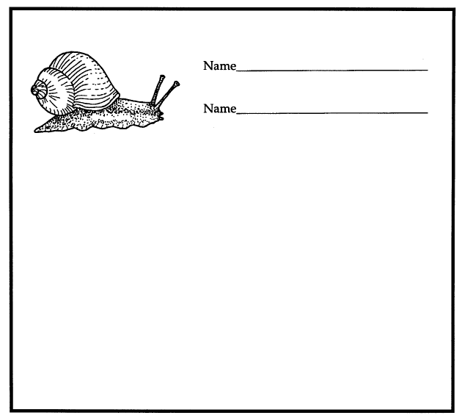

For the whole class
• large pice of butcher or chart paper
• spray bottle with a mist setting filled with water for each adult helping with the activity
• sponges to wash desks
• chart paper or chalkboard for snail diagram
optional
• tape of ocean sounds

INTRODUCTION
Every living thing—people, other animals, and plants—require a special place to live that provides them with the things they need to survive. All living things need a home where they can find necessary food, water, shelter, and space. These special places are often big areas that include many plants and other animals and are called a habitat.

Different types of snails make their homes in a wide variety of environments, from forests and gardens on land, to ponds, lakes, and the ocean. While there are several differences between land snails and those that live in water, most snails have many basic features in common. Snails belong to one of the oldest and largest groups of invertebrates (animals without backbones), the mollusks. Of the more than 100,000 living species of mollusks, about 40,000 are different kinds of snails. Mollusks come in a wide variety of sizes, shapes, and colors. This group of animals includes such interesting and diverse members as the squid, chitons, nudibranchs, and oysters. Despite the visible differences within the major classes of mollusks, all of them have several features in common. Their bodies are soft and generally divided into three main regions: the head equipped for feeding, the foot used for locomotion, and the main body containing organs for respiration, circulation, reproduction, digestion, and excretion.

Snails are in the class of mollusks called gastropods, a scientific name that literally means “stomach foot.” A snail's “foot” is the long, flat muscle on which it crawls. Joined to the front end of the foot is the snail's head, equipped with a mouth, and two pairs of sense organs called tentacles. At the end of the two longer tentacles are the snail’s eyes. The bottom, shorter tentacles are used for feeling. Most snails have one shell (univalves) unlike their close relatives such as clams and mussels with two shells (bivalves). The snail's internal organs are located in a kind of hump that fits inside the shell. Not all gastropods have a shell, however. Slugs, nudibranchs, and sea hares have no shell at all, but other forms of protection help them to live in their habitat.

By observing snails from the garden, we can understand how their relatives at the rocky seashore live as well. Surviving the pounding of the waves, the drying effects of the sun at low tide, and the threat of being eaten by other animals are only a few of the many dangers facing marine snails.

INTO
THE ACTIVITIES
Guided Imagery
Have students sit quietly and listen to you with their eyes closed. Ask them to imagine what you are describing to them. Pause slightly between sentences to let the students visualize what you are describing. Ask the students questions after each of the following stories.
“Imagine you are a bird.
Think about what it would feel like to be in your bird body.
You have a warm coat of soft downy feathers.
Where your mouth used to be is a sharp little beak.
You have two wings that you use to fly.
You jump from a tree and soar to the ground.
You hop to a nearby bush with ripe juicy berries and eat a few.
There is a small pond in the distance and you fly to the pond and take a drink of water.
A nice splash in the cool water feels good.
You preen your feathers.
Now it's time to rest so you fly back to your bird home.
Think about your cozy bird home.
What does it feel like?.
What does it look like?.
When you are ready, open your eyes.”

Ask students to describe their experience as a bird. What was your home like? Where was it located? What were the things you needed to be a bird?

“Imagine you are walking home from school.
You walk up to your front door and go into your house.
You're really hungry and you go to get something to eat.
Think about how and where you find your food.
Now that you have eaten a snack you are thirsty.
You get yourself something to drink.
Now that you have eaten and had something to drink you go into your bedroom and lie down on your bed.
What is like to be home?.
When you are ready, open your eyes.”

Ask students to describe their experience. What does it feel like to be in your own home? What kinds of things do you need to live in your house?

Ask students to list similarities and differences between the animal and the human homes they imagined. Record their responses on the chalkboard. What did both their imagined bird self and their human selves need? Discuss how every living thing needs a home and a neighborhood that provides food, water, shelter, and space.

Class Discussion
Give students pictures of different places where animals, including humans (who are also animals), live. Make a class list of all the different kinds of homes students can think of. Reinforce the concept that because a home must have everything needed for survival, it is actually bigger than just a house or a hole or a nest. It includes the surrounding area as well. The word habitat refers to an organism’s home and “neighborhood” can include many individual homes.

Partner Parade
See the Teaching Strategies section for how to present this activity.
This activity can also be accomplished as a teacher-led discussion, depending on your students.
1. Why do people need homes? What does a home provide for you?
2. What do homes protect you from?
3. A habitat is like an animal’s neighborhood. What is in your neighborhood that you really need?
4. Why do animals need homes and neighborhoods? What does their home and neighborhood provide for them?

Class Brainstorm and Clustering
See the Teaching Strategies section for how to present this activity.
After the Partner Parade or discussion write the word habitat on the chalkboard or on chart paper. Have students call out all of the things they can think of that a habitat provides for an animal. Cluster their suggestions into at least three unlabeled groups: shelter, food, and water. When they have finished, ask them to think of a name for the different groups they have listed.

Snail Collecting
You may want to have students, as home work, find and bring to school a snail from their backyard, nearby park, or even from the school yard. Snails are everywhere. Look in shaded, moist places and remind students to handle the snails they find with care.

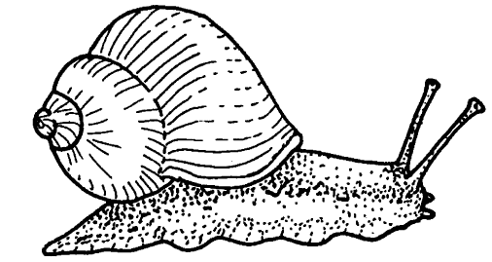
The Habitat Song
Teach students “The Habitat Song” by Bill Oliver (copyright Bill Oliver). Discuss the different habitats described in the song. See if students can make up some of their own verses.

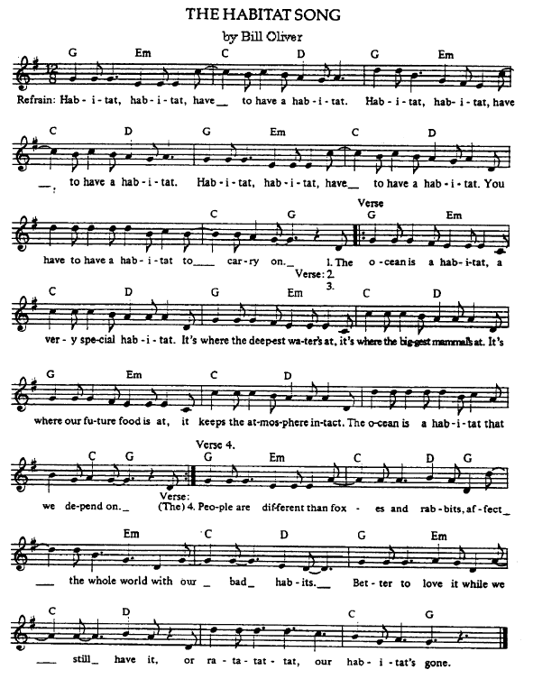

THROUGH
THE ACTIVITIES

Guided Imagery
Follow the directions for the previous guided imagery activity as you tell the story “If I Had A Shell.” A darkened room will help students focus on your voice and the guided imagery. You might play a tape of ocean sounds softly in the background to set the mood.

If I Had A Shell
“Imagine you have fallen asleep and when you wake up you find yourself at a rocky seashore.
You can hear the roar of the surf and the cry of the gulls.
You can feel the spray of the waves as they crash upon the shore.
Imagine you find yourself shrinking down . . . smaller . . . smaller . . . and smaller.
You are no bigger than the size of your thumb.
Imagine you are soft and smooth and have no bones.
You've grown a hard, whirled shell the color of the dark rocks around you.
Your shell is beautifully smooth and pearly inside.
Whenever you want to be safe or left alone, you can pull yourself all the way inside your shell and close its little door behind you.
On top of your head is a long pair of tentacles.
At the ends of the tentacles are your eyes.
You can glide your eyes smoothly up to the top of your tentacles when you want to look around.
When you're tired or afraid, you pull your eyes and your tentacles smoothly down inside your head.
You have a smaller set of tentacles near your mouth that you use to feel and search for food.
You've found a patch of delicious golden-brown seaweed.
Your tongue is equipped with hard, filelike teeth that you use to scrape the seaweed into your mouth.
Yummy, it tastes good.
You move slowly onto a nearby rock, sliding on your one, big muscular foot.
As you glide over the rock you leave a silvery mucus trail behind you.
There is a small tidepool you can see in the distance.
You make your way to the tidepool and slide into the cool, salty water.
A wave crashes over you but you hold on with your strong foot.
Your shell protects you from the wave.
You open your gills and take in a big breath of fresh oxygen right out of the water.
But wait! You sense danger! You smell an enemy very nearby. It is a sea star.
You pull your eyes and tentacles down into your head and quickly back your soft body into your shell.
You close up your door, making sure to keep some of the cold ocean water in your shell, so you can breathe.
You quietly wait until you sense the sea star has turned the other way and moved away.
You come out of your shell and head for home—back to the rock where you live.
As the tide goes out and the full moon starts to rise over the rocky seashore, you leave a beautiful silver path that marks your way home.
When you arrive back home on your rock, you pull your head and tentacles into your shell, and hang on tight to the rock with your powerful foot. You stay at home until the tide is high again.
When you are ready, open your eyes.”

SNAILS IN THE CLASSROOM

Build a Habitat
Group students in pairs. Give each pair a clear plastic cup. Tell them they need to create a home for a snail. What do they think they will need to provide for the snail? Have students recall what all living things need in order to survive. If possible, take students outside to a landscaped area or a park and have them collect soil, a few leaves, rocks, and twigs for the snail’s home. Provide spray bottles with water for misting to keep them moist. If you are classroom-bound, have lettuce, spinach, greens, and/or leaves available. Also bring in some twigs, rocks, and dirt so that students can add to the snail homes.

Snail Talk
Draw a simple diagram of a snail on chart paper or on the chalkboard. Label and describe to students the follows body parts: head, foot, shell, body hump (inside shell), mouth, radula (tongue), tentacles, and eyes. Have students try to find these parts on their live snails.

Snail Care
Snails do not bite and are easily picked up. However, their shells are very delicate and are easily broken, so remind students to be extremely gentle. The less the snails are handled, the happier they will be. Snail slime can be washed off hands and other surfaces with water and a little soap. Avoid touching snails after using soaps or lotions though. These products are immediately absorbed into the moist body tissue of the snails, and can harm them. Return snails unharmed to a natural habitat after you have finished your observations to reinforce responsible behavior towards all living things.

Snail Observation
Give each pair of students a snail to add to their cups. Allow time for students to watch their snail’s behavior in its new home. Tell them not to touch their snail, but to allow it to explore undisturbed. If some snails seem reluctant to emerge from their shells, try misting them with one of the spray bottles. When everyone has a snail that is moving around have students begin making observations about their animals. Give each pair of students a snail record sheet to log their snail’s movement.

Every two minutes they can put a dot on the sheet to represent where their snail is. Remember to have them number the dots. Later they can connect the dots with a line.

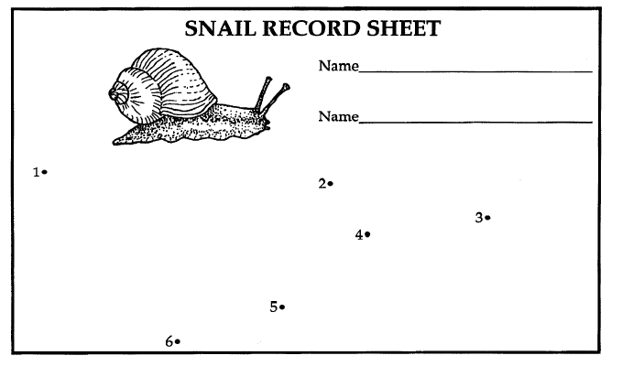

As students are watching their snails, guide them through the following observations. (Don’t forget to remind them when each two-minute interval ends so they can place a dot on their Snail Record Sheet)

Color
What color is your snail? Why would brown or gray be a good color for a garden snail? Do you think snails that live at the rocky seashore are brown? Why or why not? What would be a good color for them ?

Body
Look at the soft part of the snail’s body. The “foot” of the snail is the long flat muscle that the snail uses to crawl. Can you see how the snail’s head is attached to the foot? Watch how the snail uses its muscles to stretch out its whole body or draw up into a tight little ball to fit into its shell. What does the snail’s head look like? Can you see the two eyes at the end of the long feelers called tentacles? Find the two shorter tentacles below the eyes. These are used for sensing the snail’s surroundings. Can you tell by watching how the snail uses the two sets of tentacles.

Eating
A snail’s mouth is located on the front of its head below the two smaller tentacles. Inside its mouth is a radula. The radula is a kind of long, flat tongue covered with rows of tiny sharp teeth. The snail uses its radula to scrape off pieces of food and to pull them into its mouth. What kind of food do you think your snail likes to eat? Offer your snail some of the leafy greens. Does it have a preference for one kind or another? Can you see how its mouth works? Try watching the underside of the snail through a clear, plastic cup. What kinds of plants live at the rocky seashore that snails might use their radulas to eat? (seaweed)

Shell
The snail has a thin skin called the “mantle” that covers the top part of its body inside the shell. This mantle has special glands that use minerals in water and food to create a hard shell. As the snail grows, so does the shell. Most land snails have shells like the one you see on your snail, but the shells of snails that live in the ocean or along the rocky seashore have a variety of shapes.

Movement
How does your snail move? The snail’s foot contains strong muscles that tighten and release to move the snail forward or hang on tight. See if you can observe the muscles working through the plastic cup. Why would it be important for a snail to hang on tight if it lived at the rocky seashore? Make an incline with a few blocks and a ruler or stick and watch how the snail can climb up the ramp. How steep a ramp can it climb?

Mucus Trail
Watch how the foot glides along on a slippery liquid that leaves a silvery trail. This is called the mucus trail or sometimes the silver path. The snail secretes this mucus trail from a gland in its foot. Put your snail on a piece of black paper and watch it make a silver path. Give your snail different surfaces to explore and move across. On which surfaces does the snail move very fast? Very slow? How would this mucus trail help a snail live in its home on land or at the rocky seashore?

How Strong Is Your Snail?
Have an adult dry the shell of each snail carefully with a Kleenex tissue. Attach a twist tie to one end of an open paper clip and then carefully tape it to the snail’s shell with a piece of duct tape. Have the students guess how many washers their snail will be able to pull. Have them draw a line after the snail picture on their record sheet and record their guess. For each washer the snail can pull, the students should draw a circle on the line. Students can label this illustration to reinforce new snail vocabulary.)

When your snail seems pull the paper clip raise your hand to get a washer from your teacher. Gently hook one washer onto the paper clip on the back of the snail. Do you think the snail can pull more than its own weight? How could you find out? How would this help snails to live at the rocky seashore?

Debriefing
Collect all the snails and set them safely free in their natural habitat. Have students share the results of their Snail Record Sheets. Whose snail went the farthest and shortest distances? Whose snail was the most active? Did anyone get their snail to eat? How much? Of what? What materials were the snails able to move over? Does anyone have a mucous trail to share? How strong were the snails? Finally, discuss the differences between land snails and the tidepool snails: tidepool snails have gills for breathing in water, very thick shells to withstand the waves, and they eat seaweed and tiny algae growing on rocks.

Key Concept
Hold up the key concept and have one or two students read it aloud. Post it near other work from this activity.

BEYOND
THE ACTIVITIES

• Re-Read the story “If I Had A Shell” and have students act it out.

• Read the book A Snail’s Spell by Joanne Ryder (see the Literature Connections in the Interdisciplinary section) as a guided imagery activity. Read it a second time and have students act it out.

• Learn about other kinds of mollusks. Get library books about clams, oysters, squid, octopuses, sea slugs, sea hares, ect. What different habitats do they live in?

• Study pond snails. Visit an aquarium store and buy some pond snails, goldfish, and pond plants. Set up a habitat for a pond snail in your classroom. Observe the differences between land snails and pond snails.

• Visit the rocky seashore and observe the different kinds of snails that live there. How are they the same or different from your land snails.

• Read Animals Should Definitely Not Wear Clothing by Judith Barrett (see the Literature Connections in the Interdisciplinary section). Have students think of situations involving animals in the wrong kind of habitat. Have students draw and label pictures of their ideas.

