SCULPIN
HUNT

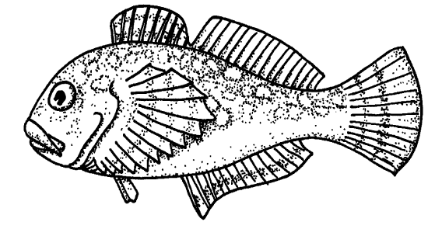

FOR THE TEACHER

Discipline
Art

Themes
Systems and Interactions

Key Concept
Many tidepool animals use camouflage to blend in with their surroundings and avoid being seen.

Synopsis
Students color sculpin cutouts and place them on similar color backgrounds around the classroom. Other students play the role of predators, “catching” as many as possible in the allotted time.

Science Process Skills
comparing, organizing, observing

Social Skills
share ideas and information, check for understanding

Vocabulary
adaptation, camouflage, heron, predator, prey, sculpin

MATERIALS
INTO the activities
• photos or illustrations (from old magazines, calendars, postcards, ect.) of common camouflaged animals in their habitats (e.g. deer, female bird, certain fishes, moth, etc.)
• photos of animals that are not camouflaged (e.g. some male birds, skunk, certain fishes, sea slug, etc.)

THROUGH the activities
• Key Concept written in large letters on butcher or chart paper

• color crayons
• one page of sculpin patterns for each student
• masking tape

INTRODUCTION
Many tidepool animals are colored to match their surroundings. This blending in with the environment is called camouflage. Camouflage is particularly important to tidepool animals, since the tidepools are often very small, and there is nowhere to escape danger. Sometimes the only way to avoid bbeing eaten is to avoid being seen. Tidepool sculpins are so well camouflaged that one right in front of your eyes can be almost impossible to see, unless it moves. These fish can even change color to match different surroundings. A tidepool sculpin amid sea lettuce (a green seaweed) would be bright green. If it swam into a clump of red seaweed, it would change to a red color to match the seaweed. On a mixed pebble and shell sand bottom, it would have different patches of color to blend in with the varied bottom. These amazing color changes are accomplished by expanding or contracting different pigment cells in its skin.

Camouflage helps the tidepool sculpin avoid being eaten by predators, such as great blue herons. Being hidden also helps them surprise smaller fishes, shrimp, and other prey. Some tidepool animals, like the sea slug, are not camouflaged. In fact, they are very visible. Like monarch butterflies, sea slugs taste bad to most predators, and they advertise this with their bright colors.

INTO
THE ACTIVITIES

Photo Sorting
Arrange the students into groups of 3–4. Pass out several photos and/or illustrations to each group.
Have students observe all the photos and group the photos into those that blend in with their environment and those that don't. Discuss why some animals are camouflaged. (Female birds need to avoid detection while they incubate eggs; blending in helps deer avoid mountain lions and hunters; lions' camouflage helps them sneak up on prey)
Discuss what helps them blend in. (Colors match with the environment, and they don’t move when danger is near) Discuss why some animals don't blend in. (Male birds need to advertise to find mates; skunks have obnoxious scents; some fish are poisonous.)

Hide and Seek
Have several students in shirts or coats of several different colors stand in the front of the room. Ask the class who could hide best in green bushes, in front of the chalk board, etc. Explain that fishes in tidepools pick hiding places where they blend in, and that they can even change color when they change surroundings. Have those students at the front of the room go to where the class directs them so they are camouflaged. Then have every student get up and stand near the surroundings that best matches their clothes. Have them explain why they chose their “hiding spot.” (“My coat is the same color as the curtain”)

THROUGH
THE ACTIVITIES

Sculpin Coloring
Hand out crayons and sculpin patterns to each student. Have them color each fish differently to match colors somewhere in the room. Help students cut out their fish. Have them put their names and make a loop of masking tape on the back of each fish.

The Hunt
Divide the class into two equal teams, the Sculpins and the Great Blue Herons. Have the Herons leave the room while the Sculpins place their fish on matching color surfaces on one side of the room (all must be in plain sight, not under desks, etc.). Have the Sculpins sit down. Slightly darken the room to match the decreased light you wuld find underwater in a tidepool. Let the Herons back into the room where they get three minutes to find as many fish as they can. They must walk, no running. Now have students switch roles and repeat the game. After the game, discuss which fishes were the hardest to find, which the easiest, and why.

Ask the students if they think they would improve their “catch” (or the speed of their catch) if the fishes couldn't be placed on a similar color background. Try it, and find out.

Key Concept
Hold up the key concept and have one or two students read it aloud. Post it near other work from this activity.

BEYOND
THE ACTIVITIES

• Return THE fishes to their makers. Have students draw a tidepool in which their fish could hide. If the class has constructed a model tidepool or mural, have them add their favorite fish to it.

• Go to the library and look for books and pictures of other animals that use camouflage.

• Write a group story about a sculpin that is camouflaged in a tidepool.

Sculpin Hunt
Cutout Patterns

