“TIDEPOOL BOOGIE”

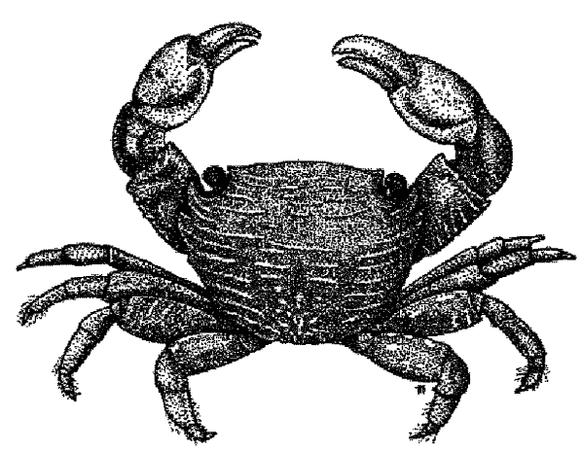
For the Teacher

Discipline
Biological Science

Theme
Diversity

Key Concept
There are many, very different types of animals and plants that make their home at the rocky seashore.

Synopsis
Students listen to and talk about the song, “Tidepool Boogie.” Then they work together in small groups to act out the organisms in the song. The class can then stage a performance of the song.

Science Process Skills
communicating, organizing

Social Skills
attentive listening

Vocabulary
crabs
pincers
sea stars
anemones
tentacles
sculpins
mussels
limpets
hermit crabs
sea palms

Materials

For INTO the activities
• Slugs At Sea audio cassette and a tape player (one with a
variable speed with be very helpful) or Dancing With The Earth video and a VCR (both by Banana Slug String Band) or piano or guitar to play “Tidepool Boogie.”
• Lyrics and musical score (included at the end of this activity)
• Labeled pictures of the eight animals listed under VOCABULARY

For THROUGH the activities
• Butcher paper or found materials for simple costumes for each student
• Sentence strips for each of eight lines in the song about an organism (listed under VOCABULARY)

For BEYOND the activities
• Children's books about the rocky seashore (see Beyond sectionfor titles)
• Approximately twenty 5 X 7 index cards and marking pens (2 to 3 colors)
• Art supplies for building animals

Introduction

The rocky seashore supports perhaps the greatest diversity of organisms of any marine habitat. On a typical walk outdoors we
might expect to easily find two or three different phyla (a "phylum" is a large taxonomic group just smaller than a "kingdom") of animals. At the rocky seashore we might find fifteen. “Tidepool Boogie” mentions eight different organisms and three larger groups of animals that are representative of the diversity of life in this unique and rigorous habitat.

Crabs and hermit crabs are arthropod crustaceans. Arthropods are a huge group of animals with jointed limbs, including insects; crustaceans are a class of arthropods that include crabs, lobsters, shrimp, and barnacles. In the song, the line “Crabs, they pinch out the rhythm,” refers to the two large pincers that crabs use for grabbing and tearing their lunch, and for fighting off predators such as birds or curious people. Crabs use their pincers to scavenge for just about anything, from dead fish to discarded apple cores. If you listen closely, with your head down at water level, you will hear crabs pinching out the rhythm. "Hermit crabs are looking for new homes," describes their perpetual search for bigger and better snail shells in which to live. As they outgrow each shell, they must find a replacement to protect their soft body, and they seem to be quite finicky. Hermit crabs are the clowns of the tidepools, constantly fighting with each other, exchanging shells, exchanging back and then continuing their search.

Sea stars, along with urchins, sand dollars and sea cucumbers, are echinoderms, or animals with "spiny skin" and tube feet. In the song, the line “Sea stars walk on hollow feet,” refers to the thousands of tube feet on the underside of each arm. Stars have an amazing hydraulic system that
turns each tube into a suction cup that can hold the animal fast to a rock against the strongest crashing waves, and a moment later, allow it to walk across a tidepool, grab, open, and eat a mussel. Sunflower stars, with 20 to 25 arms, practically gallop across the sand and rocks.
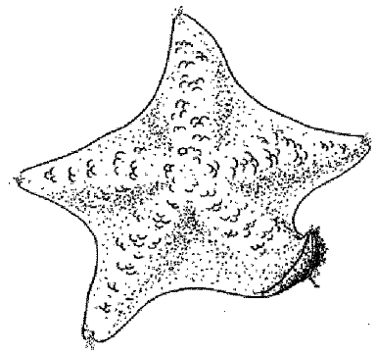
Anemones are cnidarians (the "c" is silent) and are related to corals and jellyfish. They are "waving their tentacles" at high tide or in a deep pool to catch prey with the stinging cells on the tip of each tentacle. Each stinging cell fires a tiny dart-like structure when it touches a prey, and the tentacle contracts to pull the prey toward its central mouth. Other tentacles touch the prey, fire and help to reel it in. Anemones eat fishes, crabs, snails, mussels (torn loose by waves) and plankton. If you touch a tentacle with your finger, your skin is tough enough that all you will feel is a sticky sensation.

Sculpins are chordates in the class pisces—fish! They are small fish, especially adapted for life in a tidepool. They have no place to escape to when chased, but they have large modified pectoral fins for holding onto rocks against the wave surge. Sculpins are “lay and wait” predators. They are extremely well camouflaged, so when a tasty morsel swims by, they lunge out, grab their prey, and disappear against some matching algae or rocks. If you are patient and have sharp eyes, you may find that an "empty" tidepool is home to dozens of sculpins. In the song, while “sculpins are looking for something to eat,” you can be looking for them.

Mussels and limpets are both mollusks, but they are from different groups. Mussels are bivalves (two shells) that live their adult lives
attached to a rock or another mussel. They have long byssal threads that grow from the hinge of their shell and glue them down to the substrate. These threads are extremely strong, able to withstand direct wave shock even in storm conditions. Indeed, as the song says, “mussels are holding on tightly” their entire adult lives. Limpets are gastropods ("stomach-foots"), related to snails. They wear their single shell like a hat over their body, and move quite efficiently across the rocks, grazing algae, on one large, powerful foot—“limpets do the one foot slide.”

Sea palms are a type of kelp, adapted specifically for life in the roughest, most exposed parts of the intertidal where little else can survive the violent pounding of the waves. They have a thick, solid holdfast that keeps them attached to the rocks, and extremely pliant stipes that can bend and bend and bend without snapping. When the songs says, “Sea palms sway in the tide,” it’s quite an understatement.

INTO
the Activities

The Music
Have the class listen to “Tidepool Boogie” on tape, watch the video or play it for them live. Have a picture of each animal mentioned in the song posted on the wall with its name under it. As each animal is mentioned in the song, have students point to it.

My Buddy Says
See the Teaching Strategies section for how to present this activity.

Have the students think about the song they just heard.
Questions
• What is the song about?
• What animals or plants are mentioned in the song?
• Which is your favorite tidepool animal or plant? Why?
• What was your favorite part of the song? Why did you like it?

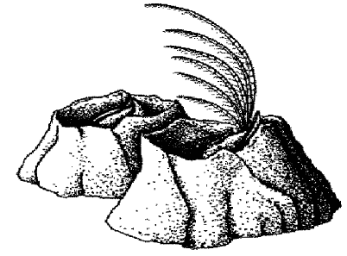
Barnacles

THROUGH
the Activities

Song Review
Read through each line of the song and discuss its meaning with students. Perhaps they can guess about some of the meanings. Use the information above to explain a little about each animal and plant. Don't forget that the chorus also has special meaning: “the ocean beat” is the constant sound of waves crashing, and “you do it (the ‘Tidepool Boogie’) now twice a day” because on most coastlines, including the west and east coasts of North America, there are two low tides each day. On the Gulf of Mexico coast, however, there is only one low tide each day.

Do The Boogie!
Divide students up into eight groups, one for each organism mentioned in the song (crabs, sea stars, anemones, sculpins, mussels, limpets, hermit crabs, and sea palms). You can provide students with simple paper costumes for their arms and heads, for example, two V-shaped pieces of paper can be stapled together to make pincer-gloves for the crabs, etc. Post sentence strips (eight total) with each appropriate line in the song underneath the picture of the matching organism. Teach each group, in front of the class, the high tide and low tide charade that goes with the posted line in the song about their organism as follows:

Crabs
Do the crab walk by walking sideways on hands and feet with bellies in the air. At low tide they are hanging on tightly under a rock (table or chair). At high tide they are walking around and pinching out the rhythm (by snapping fingers) while scavenging.

Sea Stars
They have five arms (students can wear paper mitts on their arms, legs, and head) covered on the undersides with tube feet. Their stomach comes out through their belly button "mouth" to digest food outside their bodies. At low tide they use all their tube feet to stick down to a rock (table, chair or wall). At high tide they walk on their hollow feet up to mussel bed for lunch.

Anemones
Three students sitting or standing in a circle make one giant green anemone. They are stuck to a rock and at low tide they are closed up with their tentacles (heads and arms) pulled into the center of the circle. They have sand and bits of shells stuck on their backs to protect them from the sun, and they hold a mouthful of water to stay moist. At high tide they are waving their tentacles catching food.

Sculpins
Students can wear a big pectoral fin on each hand to hold onto a rock. Sculpins’ colors camouflage them against a rock (wall or carpet). At low tide they hide quietly at the bottom of a tidepool. At high tide they swim around, darting from rock to seaweed to rock looking for something to eat.

Mussels
Two students can make a mussel. One is the bivalve shell. Each arm is half the shell. The shell is hanging on tightly to a rock with byssal threads (you can tape the shell's feet to the floor). The other student is the animal inside the shell. She stands in front of the shell with the shell's arms around her. At high tide, the mussel is closed up tight, not moving. At low tide, the shell opens up and the animal inside uses its gills (hands) to filter the water for food and oxygen.

Limpets
They hold a large sheet of butcher paper rolled into a cone over their head as a shell. At low tide they pull their shell down around them and use their one big foot to hang onto a rock. At high tide they lift their shell a bit and slide around on one foot grazing algae off the rocks with their radula (tongue).

Hermit Crabs
Three students make a hermit crab. Two make a snail shell by facing each other, joining hands and opening a hole for the crab to crawl into. The third is the soft-bodied crab inside the shell. His head and two pincers stick out through the hole. At low tide, the crab hides inside the shell, blocking the entrance with a pincer. At high tide, the crab drags his shell around scavenging for food and checking out potential new upgrades.

Sea Palms
It takes two students. One student is the extremely flexible and pliant stipe (the student's body) and blades (her arms). The other is the holdfast that glues (holds down) the stipe's feet to a rock. At low tide, the stipe and blades hang limp in the sun. At high tide, the blades float and sway in the tide. An occasional large wave crashes and the stipe bends sharply but doesn't break.

As you teach each charade, point out the sentence strip and discuss it with the class. Each group can rehearse its charade a few times and learn its line of the song. Then teach the whole class the body motions that go with the chorus: When the singer sings, "You do the Tidepool Boogie," the students jump up and sing back, "Boogie Woogie Woogie," while alternately raising their right and left hands high in the air and shaking their rear ends—with feeling!

When everyone has practiced and is ready, you can put it all together into a performance. Gather the organisms in different parts of the room/tidepool and have them assume their low
tide behavior. Begin playing the song (it will be easier if you play it yourself on guitar or piano, since you can sing it slower than the taped version, but this is not necessary. You could also use a variable speed tape player.). Each group, in turn, sings/yells out their line and acts out their high tide charade at the appropriate part of the song. Everyone together sings along and does motions for the bridge and chorus. Everyone can also sing the last verse together.

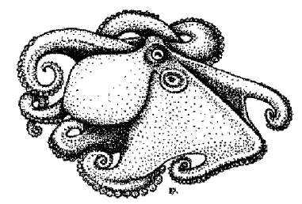

Have the class practice several times until each group gets good at hitting its cues. The class can then perform the entire choreographed song for another class or a school assembly.

BEYOND
the Activities
Music Connections
Have students brainstorm together all the tidepool words they know. Write them down on the board. Teach the students the following to make music from their list. Everyone keeps rhythm by alternately slapping their knees and hands. Everyone chants this chorus together to the beat.

Down By The Ocean
Down By The Sea I See
Down By The Ocean
Down By The Sea I See

You or a designated caller calls out a word from the list and the group calls it back. Call out three more words one at a time, waiting each time for the group response. Repeat the chorus, and call out another four words, etc. Let students take turns being the caller. You might make up with a verse such as
waves WAVES
crash CRASH
sculpins SCULPINS
hiding HIDING

Poetry Brainstorm
Have students brainstorm together all the tidepool words they can think of. Write each word on a card and tape it to the wall or put it onto a chart with pockets. Let the group rearrange the words into a poem about the tidepools.

Literature Connections
Read to the class a story or book about tidepools such as:
Why the Tides Ebb and Flow by Joan Chase Bowden
A House for a Hermit Crab by Eric Carle
When the Tide is Low by Sheila Cole
Why the Crab Has No Head by Barbara Knutson
Follow Me! by Nancy Tafuri

While you are reading, have students listen for any of the animals mentioned in “Tidepool Boogie.” Keep a list and see if you can learn something new about each one. For more children’s literature books, see literature connections in the Interdisciplinary section.

Library Research
Send students to the school or public library to find books about the organism that they acted out from “Tidepool Boogie.”

Build an Animal
Students in their groups can design and build models of the animal they acted out. These can be added to the 3-D class rocky seashore model.

Field Trip
Visit a rocky seashore. Have students work in the same groups they formed for acting out the song. They can be the experts on their organism. Can they find it? What else lives with it? What does it eat? What eats it? Be sure to bring your portable cassette player and sing “Tidepool Boogie.” in the tidepools!

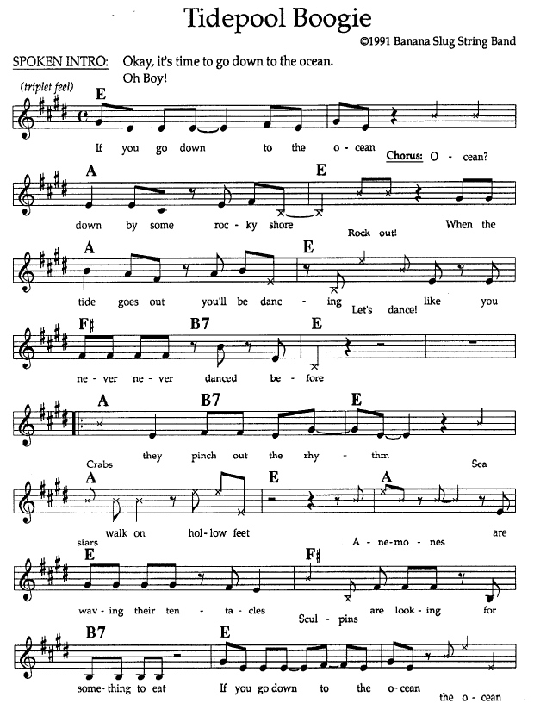

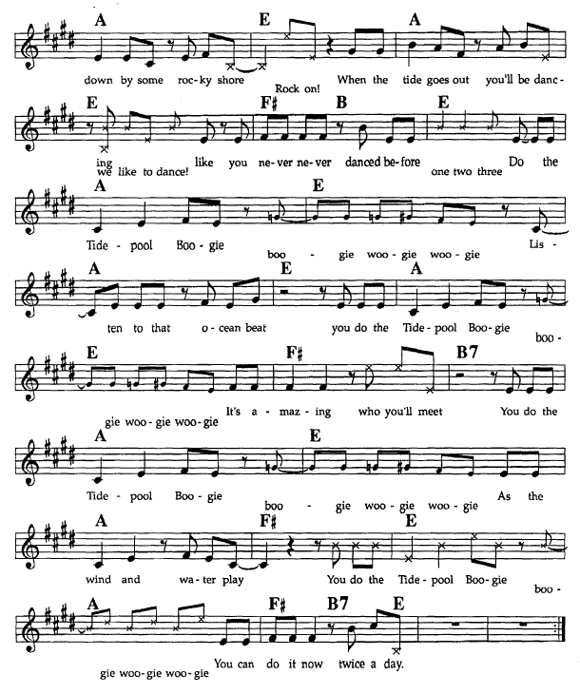

COMPLETE LYRICS TO "TIDEPOOL BOOGIE"

If you go down to the ocean
down by some rocky shore
When the tide goes out you'll be dancing
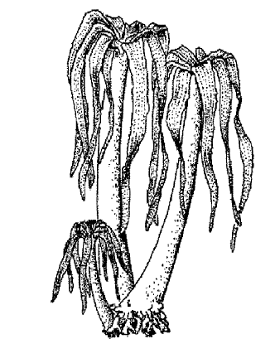
like you never never danced before

Crabs they pinch out the rhythm
Sea stars walk on hollow feet
Anemones are waving their tentacles
Sculpins are looking for something to eat

Do the Tidepool Boogie
Listen to that ocean beat
You do the Tidepool Boogie
It's amazing who'll meet

You do the Tidepool Boogie
As the wind and water play
You do the Tidepool Boogie
You can do it now twice a day

Mussels are holding on tightly
Limpits do the one-foot slide
Hermit crabs are looking for new homes
Sea Palms sway in the tide

Echinoderm have skin that is spiny (a sea star)
Cephalopods means a head with feet (an octopus)
Gastropods, a foot with a stomach (a sea slug)
Tide pool critters are the strangest you'll meet.

