ACTIVITY
31

GETTING TO THE BOTTOM OF THINGS
CAN SCIENTISTS MAP THE BOTTOM OF AN OCEAN OR A LAKE WHEN THEY CANNOT SEE IT?
CONCEPTS:
- Students can describe something they cannot see by measuring it and correlating their data.
- Scientists can explore and map the structure of habitats using techniques which sense the bottom contours.
- The greater the number of samples taken, the greater the accuracy in predicting an outcome.

SCIENCE SKILLS:
- measuring
- organizing
- inferring
- predicting
- communicating

MATH AND MECHANICAL SKILLS PRACTICED:
- finding coordinates on a map
- measuring depth

SAMPLE OBJECTIVES:
- Students will be able to map the bottom contours of a body of water.
- Students will be able to observe the value of repeated samples in making predictions.

INTRODUCTION:
In this activity you will make a model ocean for the students to explore using a technique that served sailors and oceanographers for thousands of years. Until recently the depth of coastal waters, rivers and lakes was measured by a weighted, marked line. Charts were laboriously made from these measurements, although any prudent sailor got out the line in shallow water as the channels could change overnight. Now depth sounders and sonar accomplish the same task electronically.

MATERIALS:
For each group:
- large watertight Styrofoam cooler
- dark plastic garbage bag
- water to fill cooler
- dark food coloring - blue or green
- bricks, rocks, sand or gravel
- straight pins
- one meter sticks or thin wands (push plastic straws together)
- two strings marked at 1 cm intervals with a waterproof marker
- 2 small metal nuts or washers
- data sheets for each pair of students
- one enlarged data sheet on paper or chalk board
- bucket and pan to bail cooler out or siphon hose

LESSON PLAN:
BEFORE CLASS: Make the model ocean. Take a large, sturdy Styrofoam cooler and test it, letting it sit overnight full of water. Do this at home in your bathtub or outside (this is the voice of experience speaking). In your classroom place the cooler where you plan to use it. Place bricks, rocks, gravel and/or sand on the bottom to make underwater mountains and trenches. The items must be heavier than water or they will pop up. You want your ocean to have an interesting, but not wildly cluttered bottom. Cut the trash bag open. Cover the bottom and sides of the cooler with it. Fill the cooler with water. It does not need to be filled to the top. You might even leave an island in your ocean. Add food coloring until the water is so dark that the bottom is invisible. Make the lead lines by tying string to two nuts or washers and marking it in centimeters with a permanent marker.

Write north, east, south and west on the sides of the cooler so your students' maps will all have the same orientation. Using pins and paper tags marked with waterproof pens, put tags every inch in each direction with a,b,c's going north to south and 1,2,3's across east to west. Make data sheets by modifying the included sample sheet to get it the correct size to make a map of the possible coordinates to be sampled on your ocean.

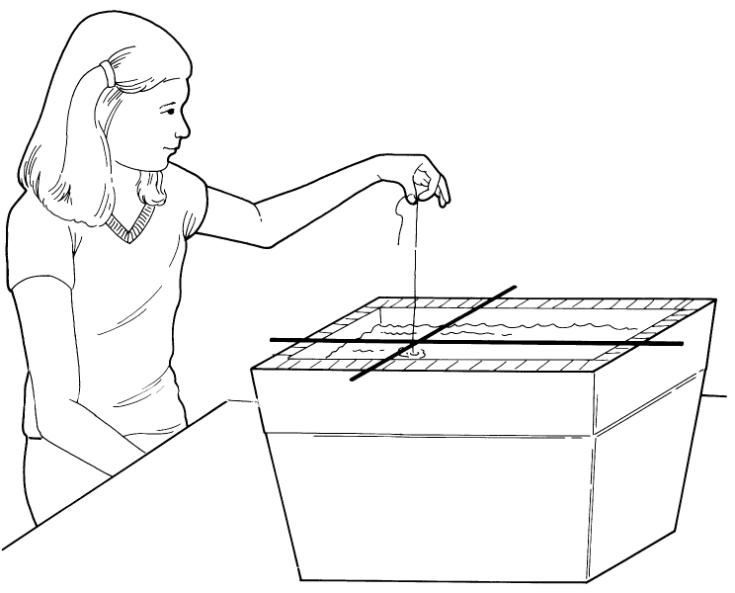
DURING CLASS:
METHODS: Introduce the question of how a scientist can make a map of the ocean bottom without ever seeing it. Have students suggest possible ways. In the "old days" people used weighted, marked lines to test depths. Mark Twain, who worked on a river boat, took his pen name from a call given by a person who rode the bow of the river boat and used such a line to measure the water depth as the boat moved. It means mark at two fathoms or 12 ft of water or enough water for a paddle wheel steamer. His real name was Samuel Clemens.

The more modern way to accomplish the same thing is to use SONAR, in which a sound is sent down through the water. The time it takes the sound to travel to the bottom and bounce back to the boat is measured. The length of time is a function of how deep the water is. The results are displayed on a screen like a small TV. You can get it in color. You can even get sonar that shows the fish. Sonar also shows the texture of the bottom and looks different for mud, sand or rock.

For this activity we are going to use the old fashioned method, a marked line to sample the model sea, an unknown ocean whose bottom contours the students are going to explore during the day.

How many samples do you need to take? Have a discussion about the fact that more samples give a greater accuracy in prediction. During the class or classes, pairs of students will make 10 depth measurements and record the location and depth on their own data sheets. They will mark off the COORDINATES they have sampled by putting an X on that spot on a data sheet left by the model sea. They will need to understand the concept of imaginary lines on the surface of the world that run north and south or east and west. Any location can be defined by giving the north to south (longitude) and east to west (latitude) of its location. In this case the scale is marked on the sides of the box and wands or sticks, one running north to south and the other east to west intersect at a point which corresponds to a point on the map. Make sure the students understand that the data sheets they have are a map of the surface and that they are going to record depth at specific locations on that surface. The depth of the water in centimeters is written on the map on top of this point.

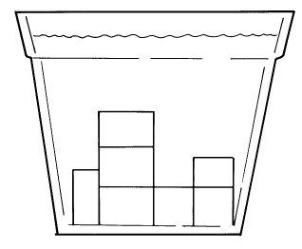
RESULTS:
When each pair of students has made measurements, the pair will predict the bottom contours based on the 10 data points taken. Each will draw its idea of what the bottom looks like from a few points. Near the end of the class each pair of students should record its data on the large map in the front of the class. When everyone has done the activity, draw lines that connect the points of common depth to make a contour map of the bottom for the whole class. Are there differences in their predictions based on a few data points and the results following the collection of many data points? There should be.

CONCLUSIONS:
Now for verification. Can marine oceanographers drain the ocean to see if they are really right in their predictions? No, but we can. Ask the students how they would get the water out of their ocean to test the validity of their predictions. Pouring or bailing might disturb the bottom. The best way is to siphon the water out of the "ocean" into a bucket using a piece of hose. Did the measurements taken and the final map drawn make a good picture of your ocean floor? Can oceanographers ever make a perfect picture of the ocean floor? No, but as they collect more and more data, their maps get better and better.

USING YOUR CLASSROOM AQUARIUM:
These fish can go in your aquarium. You can use fish from the aquarium with no ill effects if you use goldfish.

EXTENSIONS:
1. The history of exploration of the Earth has been closely tied to human technological ability to figure out where one is in relation to a fixed point and to make maps showing features and relative locations so that others can follow. Map making and the science of moving from place to place accurately (navigation) have helped early explorers move over the two dimensional surface of the Earth and now through the three dimensions of the oceans and space. Compare maps of the oceans made at different periods in time. Examine the range of navigation technology used from that of early sailors like the Phoenicians to the Vikings to the Portuguese to modern day sailors that use satellite navigation. For about $500 you can buy a hand-held instrument that tells you within 10 meters where you are on Earth.
2. Do a map-reading activity or a map-making activity on your
playground or a nearby park using a compass. You might make it a contest to find buried treasure in which the clues on the treasure map require doing math problems to find distances and fill in the blank questions to give clues to important features like trees or basketball hoops.

