ACTIVITY
28

COMPETING FOR FOOD
WHAT IS THE RELATIONSHIP OF FOOD AVAILABLITY TO THE NUMBER OF HERBIVORES AN AREA CAN SUPPORT?
CONCEPTS:
- Plant (food) availability may limit how many herbivores live in an area.
- When plants are limiting, herbivores compete with each other for their food.
- Predators may balance the lack of food by keeping the herbivore numbers low enough to prevent competition for food.

SCIENCE SKILLS:
- organizing
- inferring.
- predicting
- experimenting
- communicating

MATH AND MECHANICAL SKILLS PRACTICED:
- averaging
- graphing

SAMPLE OBJECTIVES:
- Students will be able to use a model of a simple food chain.
- Students will be able to explain how the availability of food can limit the population which depends on that food.

INFORMATION:
This game is a SIMULATION of how food availability can limit the numbers of the animals that feed on that source. In this game or MODEL your students are the animals that are COMPETING for food. They will be zooplankton searching for phytoplankton in a small pond so they are HERBIVORES. The limits may be expressed in several ways. In extreme cases, the herbivores may starve to death. In the wild, animals that are suffering from lack of food frequently fall prey to predators or disease before they starve. Predators prefer weak animals as they are less effort to catch. If there are no predators, however, food availability frequently limits the number of herbivores in a population.

Another result of insufficient food supply is that the number of offspring an animal has decreases when it does not get enough food. The result of the combination of increased MORTALITY (death) and decreased BIRTH RATE caused by low food supply is a decline in the number of animals COMPETING for the food which means there will be more to go around for the next generation. The number of animals that an area can support on a permanent basis is called the CARRYING CAPACITY.

MATERIALS:
For each student:
- 15 markers (poker chips, plastic counters, or other non-destructible small items - do not use seeds or items that easily break in half)
- small paper or plastic bag
For the teacher:
- five data sheets and a clipboard
- pencil
- whistle

LESSON PLAN:
BEFORE CLASS: Plan the location for the activity, including an alternate site in case of rain if you are planning to do it outside. Do not try this in a classroom. Working around furniture is interesting, but children get very enthusiastic and can get hurt. This exercise works best in an open space such as a gym or outdoors.

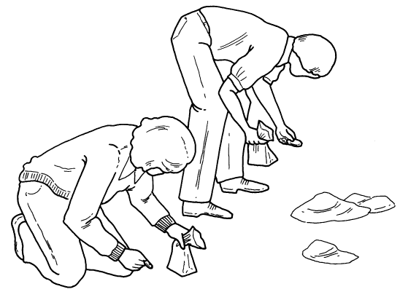

DURING CLASS:
METHODS: Ask the students questions which review Activity 18 in which they learned the words ZOOPLANKTON and PHYTOPLANKTON. If you did not do this lesson, review these words. Make it clear that many zooplankton feed on the tiny phytoplankton that drift through the water. Explain that the students are now going to pretend that they are zooplankton that eat phytoplankton in a pond and see what happens when herbvivores have to compete for food. Have them predict what might happen to them if they do not get enough to eat. They might starve and die or they might not have any offspring.

Start with a pond that produces a limited number of phytoplankton and has only a few zooplankton. There will be the same food supply from one period (generation) to the next. The phytoplankton are the counters or poker chips. Start by designating about 2/3 of the class as zooplankton and give each student a plastic bag to collect phytoplankton. The rest of the class are the reserves.

Scatter 10 food items per student (for the 2/3 of your class playing) around the area. Tell the students that each will try to eat as much as they can without taking any away from another zooplankton. One way to reduce the chance of accidental collisions is to make the rule that one foot must stay on the ground at all times; that is, the student must drag one foot. Say "go" and let them pick up all the food. It will be over pretty fast. Use the whistle to stop the action, if it gets out of hand.

Have everyone sit down. Did they all get the same amount of food? No, some individuals are more efficient searchers than others. Record the results on the data sheet. Some of the zooplankton did not get enough food to reproduce while others did. Those that got more food left more offspring. Herbivores that got fewer than nine phytoplankton, starved to death. Those that got nine to eleven left one offspring. With twelve or thirteen phytoplankton, they make two offspring. More than thirteen, they leave three offspring.

Repeat the game. After reproducing, the parents die, leaving behind the number of offspring indicated on the data sheet which are the zooplankton of the next generation. Change the number of players to match the number of offspring. Recruit from the reserve and allow substitutions for tired "zooplankton." Scatter the same number of food items that you did in the first game regardless of whether the number of players went up or down. Assume the same number of phytoplankton will be produced. The amount of food is limited. Run the game again and calculate the results.

Repeat. If possible, do four or five generations. You should find that as long as the food supply remains the same, approximately the same number of animals are produced in each generation.

RESULTS:
Back at their desks, have the students discuss what happened. Put the results of the simulation on the board. Ask them to give you some answers to the following questions. Did all the zooplankton get enough to eat? No; even though there were food items enough for everyone to survive, some were better at competing for food than others. What happened to those that got more food? They used their extra food to reproduce. The best competitors had the most offspring. Did anyone find a particular trick to help them compete more successfully for food? If this trick or adaptation was one that was inherited, would their offspring also be better at finding food? Would more animals in the next generation be better at catching food? Yes, because those that got the most food left the most offspring. Have the students complete the worksheet and answer the questions.

Once you have your data, you might allow the students to change the rules, one rule at a time, and see what happens to the population. Some suggested rule changes (new experiments) are listed with the extensions. The next two activities build on this activity also.

CONCLUSIONS:
Animals compete for food. Those that do not get enough to eat die or are caught by predators because they are weak or diseased. Those that compete most successfully leave more offspring. If the limit to the number of herbivores in an area is the food supply, their number remains more or less the same from one reproductive period to the next if the food supply remains constant. This average number of animals is the CARRYING CAPACITY for that habitat. If predators are added to this system, the number of herbivores may be reduced so that food is no longer the thing that limits the population. Under these circumstances fewer animals starve.

USING YOUR CLASSROOM AQUARIUM:
Do you have any plants in your classroom aquarium? Any plant eaters? If so, how well does the balance work between the two? Does one ever "win?" Sometimes algae in the tank may threaten to take over and look like the creature that ate New York. How do you control it? Add herbivores.

EXTENSIONS:
1. Ask the students to think of one change that would increase the number of zooplankton that survive. An immediate answer would be to increase the amount of food. Multiply the amount of food by 1.5 and run the game several times. Eventually a new limit is reached, although at a higher level.
2. Once the students have gotten the basic idea of this simulation, they should be able to continue it on their own. Several children living near each other could recruit friends to play this game repeatedly to test new variables or to check if the number of herbivores remains relatively constant over many generations when they are limited by food. This could make a good science fair project. Have the students go over the questions that they plan to test with you ahead of time and discuss what they plan to do to make sure that they are testing only one variable at a time and that they are going to be keeping good records.

