ACTIVITY
25

LIGHT TO SEA BY
WHAT HAPPENS TO LIGHT WHEN IT MOVES THROUGH WATER?
CONCEPTS:
- Water absorbs light.
- Water absorbs different wavelengths at different rates.
- Things suspended in the water absorb light.

SCIENCE SKILLS:
- observing

SAMPLE OBJECTIVES:
- Students will be able to observe the effect of water on light transmitted through it.

INTRODUCTION:
This activity may be done in several ways. One is very short and simple. It requires pictures from dive magazines or other underwater pictures. The second level is wet and messy and requires certain kinds of equipment. Both ways are given because you just might have the right equipment.

This teacher demonstration asks questions about changes in light INTENSITY (the quantity) and QUALITY (the colors present) when light shines through water. The results are not clear-cut measurements, but value judgments (observations) made by students who may have different sensitivity to colors. This is a nice place to discuss the use of instruments to make measurements that are standardized and do not include as great a possibility for error as simple observations do. If you have computer probes that measure light, you can demonstrate their use in this lab or have the children use them and compare results with student perceptions. Variability in their own perceptions and slight differences in responses means that there will be more than one answer. That is why scientists repeat their work. It is also why they go to great lengths to avoid value judgments and to use instrumentation which is standardized.

Different amounts of preparation for this exercise are appropriate depending on the background of your students. Have they ever looked at a spectrum? Do they understand that light bouncing off of an object is reflected to their eyes? Do they know that the colors of objects are determined by which colors (wavelengths) of light they reflect?

MATERIALS:
Simple Plan:
- underwater pictures from a scuba magazine or National Geographic
- prism
- two sheets of stiff white paper
- cardboard slide with thin slit to fit projector
- light source ( air-cooled slide projector, sun, etc.)
- glass jar of clear water
- glass jar of dirty water (about 1/2 cup dirt added)
Additional for Larger Project:
- aquarium tank 30 gallons or more (may be your classroom aquarium with sides that are clean and do not have algae
- aircooled 35mm slide or filmstrip projector

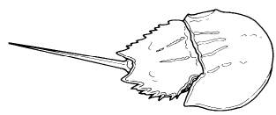
LESSON PLAN:
BEFORE CLASS: The aquarium will need to be accessible. Remember to fill it after it is in its correct location and to siphon the water out before moving it after class. Never move an aquarium with water in it. If using your classroom aquarium, make sure the sides of the tank are clean. Make a cardboard square the size of a slide or part of a filmstrip and cut a thin slit about 1 in long and 1/16 in wide with a mat knife or razor blade. This will allow you to create a nice spectrum when a beam of light is directed through the prism. Find two or more underwater photographs that show the contrastbetween shots made under natural light (very blue colors) and those made with artifical light (will show bright colors such as red and yellow). Glue these to cardboard and laminate them to make them last.

DURING CLASS:
METHODS: Begin with a discussion of what your students know about light. Make sure they remember the difference between quantity or brightness (INTENSITY) and QUALITY or color. Use a prism and the slide projector or a beam of sunlight (the best beam I ever saw was made by a hole in an old window shade in a school) to show the colors that make up white light. Make your classroom dark so the students can see this clearly. What are the colors? What is their order in the spectrum? The order is in increasing wavelength from blue (short) to red (long).

Now for questions about how water affects light quantity and quality available to plants and animals living in water. Choose among these.

Demonstration 1: Does water absorb light? Have the students make predictions on the basis of their experiences before trying this. Compare the brightness of a light shining through the short and long dimensions of an aquarium onto a plain white paper. Which is brighter?

Demonstration 2: Does water absorb some colors of light more than others? Again, ask for predictions. Put the cardboard slide into the projector. Shine light through the prism, then through the long dimension of the water onto white paper. Are some colors brighter than others?

Compare with the relationship of colors not passing through water by putting the white paper in front of the aquarium in the spectrum and then behind it. If you do not have a fairly big tank, do not do this. It takes a lot of water to make this obvious to the naked eye.

Demonstration 3: What is the effect of material suspended in water on the light available to plants and animals living in water? Again, ask for predictions. Shine a bright light through a jar of clear water onto a piece of white paper. Then shake a jar with dirt in it and shine the light through it. Compare the brightness of the light shining through the dirty water versus the light shining through clear water. Does the suspended material absorb light? What problems could this cause for animals or plants living in the water that need light?

Demonstration 4: Show the students pictures taken underwater under natural light (everything looks blue) and with a flash (bright colors show). What is the difference? How can this be explained? If you have done the aquarium exercise, they may have been able to observe the absorption of different wavelengths by water. How does this relate to what they can see in these pictures?

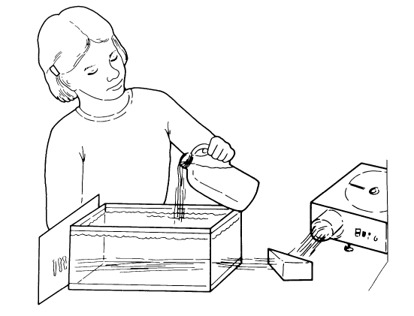

RESULTS:
The results from these exercises may be subject to debate because they are based on human perceptions. Generally, the students should see that light is absorbed as it passes through water. Some wavelengths (colors) are absorbed more than others. Blues (short wavelength and high energy) are absorbed least. Reds, at the other end of the spectrum, are the longest wavelength and the lowest energy. They are absorbed quickest. Particles suspended in water really block the light.

CONCLUSIONS:
How do these results relate to marine and aquatic environments? Students should be able to conclude that the deeper you go in a big lake or in the ocean, the darker it gets. They should also be able to understand that suspended sediment or particles in water will block light, even in very shallow water. It is a bit harder to understand that as you go deeper, things have different colors than they do in shallow water or when a diving light is used. Illustrate your conclusions with photographs taken under water. Those that are taken with natural light look very blue. Those taken with a flash show the true colors of things, colors that are never seen under natural conditions. The only way the colors show is if the wavelengths that give bright colors are brought down with the diver. In subsequent exercises, you can explore the implications of these conclusions for the plants and animals that live in aquatic and marine systems.

USING YOUR CLASSROOM AQUARIUM:
If these activities are done one at a time, the first two can be done with your classroom aquarium. Try not to scare your fish to death with movement and noise.

EXTENSIONS:
1. Some animals that live in the deep ocean communicate with light they make themselves since there is not any natural light. This light is referred to as bioluminescense because it is light made by a living thing. Fireflies are another example of the use of "living light". If you have a flashlight for each student, divide them into "species" pairs and see if they can figure out how to find their mate in a dark room. They will have to work out coded sequences to go with their "species." In the wild, different patterns of many lights on one animal would also work to distinguish different species in the dark.
2. Sediment in runoff may be a problem for vegetation that grows rooted to the bottom. If you know of an example of this kind of problem in your area, discuss it with your students. In the Chesapeake Bay suspended material may have contributed to the decline of underwater vegetation essential to many animals for food or refuge.

