ACTIVITY
24

AT THE RACES!
HOW DO FISH SWIM? WHAT ARE THE CORRELATIONS BETWEEN BODY SHAPE, SWIMMING TECHNIQUE, AND SPEED?
CONCEPTS:
- Fish are adapted to movement in water in many different ways.
- There is a correlation between the body shape and swimming speed of different fish.

SCIENCE SKILLS:
- observing
- measuring.
- organizing
- inferring

MATH AND MECHANICAL SKILLS PRACTICED:
- measuring time and distance
- calculating average speeds

SAMPLE OBJECTIVES:
- Students will be able to calculate rate of movement (speed).
- Students will be able to correlate fish body shape and swimming technique with swimming speed.

INTRODUCTION:
In this activity, students are introduced to some of the physical adaptations for movement found in fish. They will measure differences in terms of speed. This activity is designed to be done at an aquarium, science center or zoo which displays a variety of fish species. It works particularly
well with sharks if they are exhibited in such a way that they can swim continuously in one direction. Unlike most activities done at such sites, "At the Races" collects numerical data.

Fish must overcome drag and have a means of propulsion and maneuverability in order to move through water efficiently. A variety of body shapes and structures meet this goal. Not all fish are swift and agile, however. Losses in swimming efficiency in certain species are offset by other adaptations. All adaptations for movement reflect an animal's "lifestyle" which is in turn influenced by the physical factors of its particular environment.

MATERIALS:
For each team of two:
- clipboard with pencil tied on
- data sheet
- stopwatch or watch that measures seconds
- "Moving Through Water" handout

For the class:
- tape measure or carpenter's rule

LESSON PLAN:
BEFORE THE TRIP:
Have students read "Moving through Water" which is in the worksheet section of this curriculum. Review the terms used in it. Discuss the research project for the field trip so that students know what they are going to be doing ahead of time. Pick the exhibit in which you will be working. It should have fish which swim freely and be large enough for the students to work in it. For example, at the National Aquarium in Baltimore, both the Open Ocean (sharks) and Western Atlantic Coral Reef are large exhibits which allow the fish to swim in giant circles.

ON THE FIELD TRIP:
Hand each team of two students one clipboard, data sheet, pencil, and a stop watch. Determine the "race course" and measure and record its distance. The race course might extend from one end of the tank to another, or if it's a very large exhibit, the width of one or two viewing
panels. Each team should choose two species of fish to time. Try to get a variety among the teams. Have them watch the fish for several minutes to make sure the fish they choose swim relatively straight.
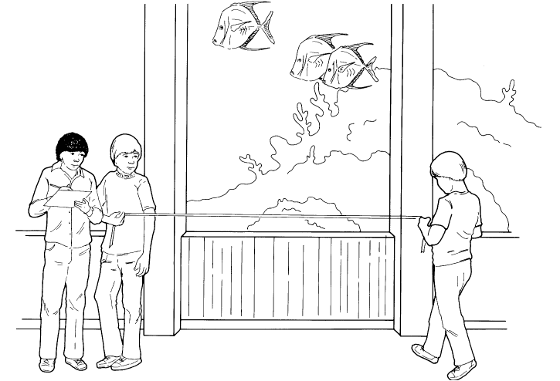

Before conducting the "trials", the team must identify the fish, placing their names in the spaces under "Fish #l" and "Fish #2" on the worksheet. If the facility does not have an identification label system, make arrangements for a docent or staff member to briefly help your students with identification if you are not comfortable with this. Record each fish's body shape and the fins it uses for swimming.

Now for the races! Let the students look at each others' fish and "bet" or predict which they might think is faster. Next the students will time each fish as it swims its "course," recording three trial times.

BACK IN THE CLASSROOM:
Compute the average swimming speed for each of the two species for each team. Rank the fish in terms of fastest to slowest on the board.

RESULTS:
Which was the fastest fish? Fish that are streamlined and swim using their caudal fins are the fastest fish. However, some species with these characteristics will be observed to move very slowly, such as the tarpon. These fish do not move quickly unless they have to. Then they are capable of short bursts of very fast speed. These fish have a broad base on their tail.

Which are the slowest fish? Depressed fish and those that move with their dorsal and anal or pectoral fins are not extremely fast in terms of forward movement, but can dart and turn swiftly, and maneuver in tight spaces.

As you determine the relative speeds of the fish tested, look for other adaptations that may offset an animal's deficiencies of speed. How does it protect itself? Where in the habitat does it live? What food might it be adapted for catching if it can't go after swiftly moving prey?

CONCLUSIONS:
Fish have different methods for moving through water. Some methods are better than others. Speed is not the only thing that is important in terms of survival. A fish that is not speedy has other adaptations for survival.

USING YOUR CLASSROOM AQUARIUM:
You can hold fish races in your own tank if it is a big one. Most likely the aquarium fish you have chosen will not be fast swimmers. Have the students analyze ways that your fish move and which fins they use. If you have any invertebrates in your aquarium, compare their swimming habits with those of fish. There are not too many invertebrates which have mastered swimming. The jet-propelled squid is one. Most move over surfaces or drift with the currents.

EXTENSIONS:
1. Build a Fish. After visiting the aquarium or science center, have the students construct a fish. Have the student write a label describing the fish's habitat and its behavior and build a fish whose body shape and structures would enable it to survive in the habitat described in the card.
Some suggestions for materials to be used include:
fruits buttons papier mache
vegetables wire aluminum foil
clayping pong balls Styrofoam
pine cones construction paper tissue paper
toothpicks rocks pipe cleaners
wood scraps sequins

