ACTIVITY
23

LIFE AT THE SURFACE
WHAT IS THE SURFACE OF THE WATER LIKE? CAN ANIMALS TAKE ADVANTAGE OF THE WATER SURFACE AS A PLACE TO LIVE?
CONCEPTS:
- Water has a strong, elastic "skin" on its surface which forms surface tension
- Some animals ride on the surface tension.
SCIENCE SKILLS:
- observing
- predicting
- experimenting

MATH AND MECHANICAL SKILLS PRACTICED:
- careful hand/eye coordination
- graphing
- averaging

SAMPLE OBJECTIVES:
- Students will be able to demonstrate the existence of surface tension.
- Students will be able to create a model of a living organism from simple materials.

INTRODUCTION:
These exercises examine the tendency of water to stick to itself. This cohesive property of water is perhaps most obvious at the surface. The top layer of water molecules forms a film or "skin" which is relatively strong which we refer to as SURFACE TENSION. Many animals and plants live directly on the surface of bodies of water. Even though they are heavier than water and cannot float, they stay at the surface by "riding" on the surface tension. In these activities students will experiment with surface tension and then try to design an animal that is heavier than water, but stays at the surface because of surface tension.

MATERIALS:
For each student:
- cup of water (cup rinsed clean, no soap)
- 2 paper clips

For each team:
- small pie tin
- 50 pennies or 20 marbles (the whole class should use the same item)
- eyedropper
- plastic deli container - 1/2 to 1 gallon, or bowl
- dishwashing detergent

For the class:
- very thin wire for model animals and other materials that ride on surface tension
LESSON PLAN:
BEFORE CLASS: Try making the model yourself. Very thin wire makes a nice "water strider." This is not easy. The students will learn more if they are allowed to work through trial and error rather than by copying your design. NOTE: be careful not to refer to things that are supported by surface tension as floating. They are heavier than water and DO NOT FLOAT. If you demonstrate parts of this, try using the overhead projector to enable all the students to see.

DURING CLASS:
METHODS: Introduce the activity by referring back to earlier activities in which students used spoons to remove water from a container. Ask students if they noticed how the water in the spoon formed a nice, rounded top. What causes this? Have each group put a clear plastic glass in a small pie pan and fill it until the water is exactly level with the top of the glass. Would they say the glass was full? Yes.

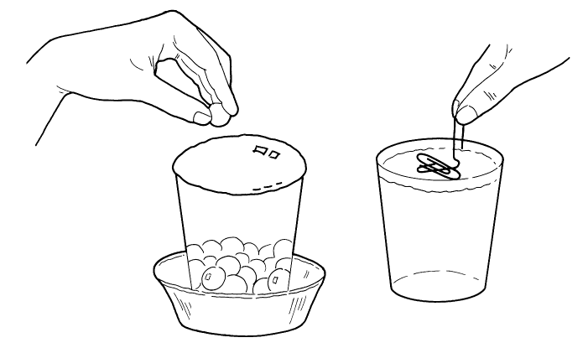

How many marbles (pennies) could they put in before the glass runs over? Have them estimate the number. Now drop pennies or marbles into the cup one at a time, counting as they go. What happens? The water piles up into a rounded bulge until it finally appears to break. How many marbles (or pennies) did it take? Have each group write their numbers on the board and then plot the results. Then add the numbers and calculate the average number of marbles dropped in before the rounded top was "stretched" too far.

Now discuss what happened. The water molecules are attracted to each other: they stick together. At the surface this produces a "film" that covers the surface and holds it. Eventually so much water was pushing against the film, called SURFACE TENSION, that it broke and the water fell over the sides of the glass.

How strong is this film? Would the students predict that a paper clip would float or sink? Try it. The illustration shows how a paper clip can be lowered onto the surface so it rides on surface tension. After they have tried, if none of the students are successful, demonstrate this method and let them try it. Can you prove that the paper clip is not floating, that it is not lighter than water? Touch it gently and it sinks. Try adding a drop of dilute detergent to the water. It should also sink as detergent destroys the surface tension.

Have any of the students ever seen animals that use surface tension? Some kinds of beetles and bugs walk on water in search of prey. The water strider, a familiar pond bug, has special hairs on its first and third pairs of legs which form dimples on the water surface. The strider's second pair of legs actually penetrate the surface tension and work like oars to propel the insect over the surface. There is a marine species of water strider as well. Other kinds of insects, like mosquito larvae, hang upside down from the surface film and poke a breathing tube up through it. A pond insect called a springtail has a spring-like appendage with which it jumps around on the surface of ponds and temporary water holes. Whirligig beetles are so well-adapted for life on the surface tension of ponds that each eye has two halves: the upper half can see above the surface while the lower half simultaneously views the underwater world! Some insects that might otherwise be preyed upon by water striders are able to spit small amounts of detergent into the water and cause the strider to go under before grabbing its meal!

Can your students design an animal that uses surface tension? This is very difficult and may be frustrating. The winner is the student who designs the heaviest model organism that can ride on the surface tension. Provide them with very thin wire with which to build their "creatures." Remind them that the model must sink when detergent is added to the water, yet must ride on surface tension when placed gently on the surface. You might want to turn this exercise into an elaborate contest. If so, have the students with viable entries bring their creatures to the front of the room. Allow them to place their models, one at a time, on the surface tension of a large, clear container of water in full view of the class. Weigh the ones that are successful and determine the heaviest. Award a prize to the winner.

RESULTS:
The students generally make very low predictions for the number of objects that can be added to a full container. Why did different groups get different results? They may have started with slightly different amounts of water; the way they dropped the objects may have been different; or the glasses may have been a bit dirty which changed the surface tension. It is normal for there to be variability in results which is why experiments must be repeated over and over to be sure. The use of statistics enables us to compare variable results.

Initiate a follow-up discussion concerning which model shapes and parts worked best. It will probably be clear that the models with their weight evenly distributed over the surface area, not all in one spot, work best.

CONCLUSIONS:
While water has surface tension which can be exploited by some animals, only a few designs work. It is very hard to "ride" on surface tension. Only designs that spread the animal's weight over a very wide area work. This can be likened to what happens when people try to walk on the thin ice of a pond. They break through. To save themselves they may crawl to shore by spreading their arms and legs while lying flat and inching along carefully. They do not weigh less, but have spread their weight over more of the ice surface.

USING YOUR CLASSROOM AQUARIUM:
If any of your students live near a pond, ask if they can safely collect some water striders. Add them to your aquarium while all the students are watching. In addition to seeing animals ride on surface tension, they may get to see how the water striders deal with hungry fish.

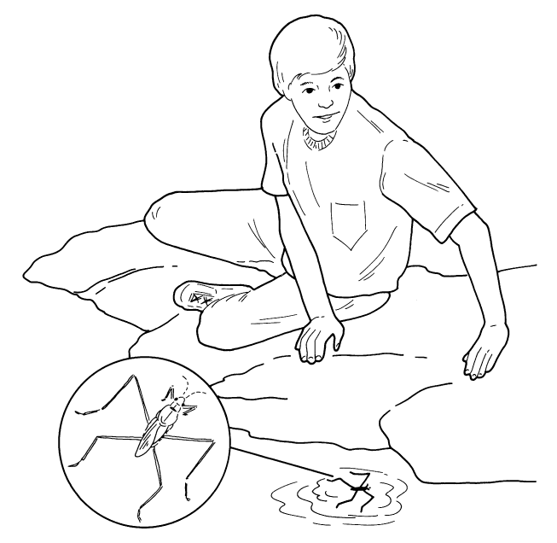

EXTENSIONS:
1. Begin a discussion of the creatures that live on the surface tension and their special adaptations for this environment. Have students research the animals mentioned in this exercise and look for other examples of animals that "walk on water." They might be surprised to learn about spiders that live on the surface of the ocean. The most amazing are young Basiliscus lizards which can escape from predators by running across a river on surface tension, using the long toes of their hind legs. These lizards are common in Central American rain forests. Use pictures the students draw along with descriptive paragraphs for a bulletin board.
2. Discuss strategies for reducing the local mosquito population. Since the larvae develop while hanging upside down on the surface tension and use a snorkel-like breathing tube, spreading oil on the water's surface to block their air supply can act as a "natural" pesticide. What harmful effects to other plants and animals may be the result of this practice? Oil can prevent oxygen from diffusing into the water.

