ACTIVITY
22

GRACE UNDER PRESSURE
DOES WATER PRESSURE VARY WITH DEPTH?
CONCEPTS:
- Water pressure increases with water depth.
- Water pressure pushes in all directions on objects in the water.
- Air is compressed into a smaller volume in deep water due to water pressure.

SCIENCE SKILLS:
- observing
- measuring
- experimenting
- communicating

MATH AND MECHANICAL SKILLS PRACTICED:
- averaging
- graphing

SAMPLE OBJECTIVES:
- Students will be able to give evidence that pressure increases with water depth.

INTRODUCTION:
The difference between this exercise and many similar activities on water pressure and depth is two fold: 1) your students will collect numerical data rather than just observe and 2) your students will compare containers with different cross sectional areas. An interesting additional feature is to compare the differences in results for different groups and try to identify the variables that may give rise to these differences. The use of balloons to observe the effect of increasing pressure on gases is a wet activity and should be done outside in warm weather. It may be deleted if you need.

MATERIALS:
For the class:
- a large trash can (at least 2 ft deep) filled with water, such as a custodial can with wheels
- several small balloons (slightly inflated)
- water source
- waterproof marker to mark water level

For each team:
- flat large baking pan such as aluminum disposable turkey roaster
- two containers that are the same height but different size in cross-section and made of the same material; a quart and half gallon cardboard milk carton or quart and half gallon plastic soda bottles or half gallon and gallon plastic milk jugs; increased top opening needed so that kids can pour water in easily must be identical for all groups What ever is used, ALL groups must have the same thing, the same size!
- measuring cup or other item which pours easily
- plastic ruler
- 3 nails of same size (finishing nails best; use two different diameters for different groups but all the nails within a group are the same)
- tape
- brick, block or something similar to set milk carton on for elevation

LESSON PLAN:
BEFORE CLASS: Organize the materials. If you have only two groups working, use only one size of nails. If you have four or more groups, divide the materials half with larger nails, half with smaller nails. Large nails would be more than 2 in long. Mark an upper water level on each that is an identical height from the BOTTOM. The shortest container determines the water level for all. If using plastic jugs or bottles, make the three holes in each container with the nails to be used by the kids. Measure the hole position and mark. The lowest hole should be 2 inches above the bottom and the other two should equal distances apart with the upper hole at least an inch below the water mark. ALL THE HOLES ON ALL THE CONTAINERS SHOULD BE THE SAME DISTANCES APART.

To make clean holes in plastic jugs, hold the finishing nail with pliers and heat it on the stove. Then melt the holes cleanly, perpendicular to the side of the container. Kids can make their own holes in the paper milk cartons. Plastic gives a much cleaner hole if it is melted in, and kids should not be handling hot items. Punched holes in paper cartons do not give as clean a results as melted holes in plastic.

The tops of the containers need to be opened up for ease of pouring water into them. The smaller ones can then nest inside the larger, reducing storage space. Once you make a set of containers, they get used year after year.

DURING CLASS:
METHODS: Introduce the idea of water pressure by asking what happens to your ears when you dive to the deepest part of a swimming pool? Hold up a milk carton and ask the students if they think the greatest water pressure would be near the top or the bottom. How could they test this? One way to test their hypothesis is by measuring the differences in streams of water flowing simultaneously from the top, center, and bottom of the milk carton. (If they are making their own holes, see below for instructions.) Would they expect the lengths of their water streams to remain constant or to change with time? Let them experiment to find the answer to this question, but collect their data with a constant water level which is achieved by gently pouring water in the side away from the holes as it drains out. Here is how.

The set up looks like this:

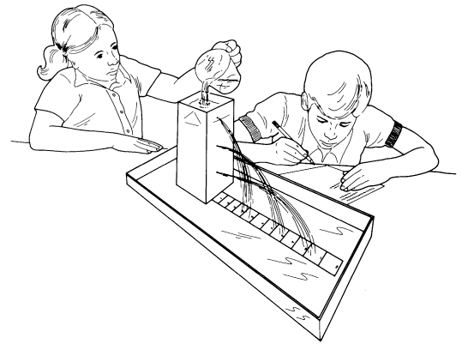

Results may be improved by placing the milk carton on a brick or wooden block to get better elevation. This is not shown in the picture.

Use the ruler to punch all the holes at the same distances from a water level mark you make at the top of the containers for each group. Leave the nails in the holes until after the carton is filled. Tape the ruler to the pan to keep it from floating away. When ready to begin measuring, remove all nails at the same time. Measure the distance from the container that the water flows. The farther the water squirts, the greater the force pushing it out the hole. Think eye droppers, squirt guns, and hoses. What happens if the water that runs out is not replaced by pouring in the top? What happens if you do replace the water?

Now, would it make a difference if the volume of water were greater with the same depth? Compare what happens when the depth is the same and the volume is double. Make sure the nail holes are identical size! Students are surprised to find that only depth is important. The readings for gallon and half gallon should be the same if the nail holes are the same size and the distances are identical.

What about the size of the holes? Little holes have more resistance to flow than big ones. Compare groups that had similar containers but different hole sizes. Which squirt farther under the same pressure?

Have the class discuss their results and generate some rules about depth and pressure. Then prepare to get wet.

A separate question is how water pressure affects gases trapped in animals or submersibles that descend into the water? Introduce a challenge, to be attempted in teams of no more than two at a time: can the students observe (feel) a difference in the volume of air in the balloon as it descends to the bottom of a trash can full of water? This is a wet activity! Students should roll up their sleeves and reach down only as far as they comfortably can. They should try to keep their hand in the same position around the balloon as they move down into the barrel. They should be able to feel the balloon shrink in their hand. Another method is to squeeze the balloon at the surface and then observe how much they can ease up on their squeeze as the balloon descends. Can they devise a way to measure the change in size? Establish rules in advance concerning the whereabouts of the water and the balloons.

RESULTS:
Compile the data on the blackboard. Compare the results from the different groups. Students should be surprised to learn that hole height (depth) and hole diameter are important, but that the volume of the container is not. Smaller holes have greater resistence to flow and will reduce the force of the water moving through them. Average the data and draw a bar graph to show the length of the water stream from each different hole.

CONCLUSIONS:
Water pressure is greater with depth. That is why the stream of water flows farther out at the bottom of the milk carton than at the top. The water pressure provides the push. As trapped gases descend in depth, they are compressed by the water pressure until the internal pressure of the gases is equal to the external water pressure. Pressure increases by one atmosphere with every 33 ft deeper you go!

EXTENSIONS:
1. Invite someone who is a scuba diver to speak to the class and expand on the pressure/depth relationship and its importance to people using self contained underwater breathing apparatus (SCUBA). If you do not happen to know a diver, you might be able to enlist the help of someone who works at a local dive shop or YMCA.
2. If you did Activity 21, have the students predict what might happen to the swim bladder of a fish that was caught in deep water and brought to the surface. The swim bladder is full of trapped gases. It quickly expands as the pressure decreases. Sometimes it inflates until it pops out the fish's mouth. It may also "blow up."

