ACTIVITY
18

TO EACH ITS HOME
WHERE DO ANIMALS AND PLANTS LIVE AND WHAT MAKES THEM SUITED TO THEIR HOMES?
CONCEPTS:
- Bodies of water can be divided into different kinds of places.
- The characteristics of these places determine the plants and animals that can live there.
- Not all aquatic animals swim; some float, sink, sit still, or even walk on the water's surface.
SCIENCE SKILLS:
- classifying

MATH AND MECHANICAL SKILLS PRACTICED:
- use of a flow chart type key

SAMPLE OBJECTIVES:
- Students will be able to list the different kinds of places to live in an aquatic habitat.
- Students will be able to classify living things by the location in which they live in an aquatic habitat.

INFORMATION:
This activity introduces the concept of different places to live within a body of water and teaches the vocabulary needed for the following activities in this section. It is done by individual students who trade animal and plant Identity Cards to complete their Aquatic Homes flow chart/key. The vocabulary used in this activity is commonly used in oceanography books.

MATERIALS:
For each student:
- Aquatic Homes flow chart/key to animal or plant identities

For the class:
- Identity Cards set (enough for at least one per student)
- construction paper or poster board
- optional: pictures from magazines to decorate the cards

LESSON PLAN:
BEFORE CLASS: Review the lesson and collect the materials. There are 16 Identity Cards, so you may have to make a duplicate set. Cut out the Identity Cards. Glue them to poster board or construction paper. You may decorate the reverse side of the cards with pictures from old magazines like National Geographic or Ranger Rick. You may want to write the list of animals and plants found in each location on the back of your Identity Cards too. It is entirely possible to do this activity without pictures, but not as much fun. Laminate the cards or protect them with clear Contact paper for reuse. If you blow up the Ocean Cross Section using an overhead projector to draw it on butcher paper for a bulletin board, the students can place their cards in the correct location in the ocean when they are identified.

DURING CLASS:
METHODS: Draw a cross-section of a pond or lake on the blackboard or make a bulletin board as suggested. Ask the students to suggest some different kinds of animals and plants that might live there and where they might live. Be sure to draw in some plants near the shore and some animals in the water and on the bottom. (Do not introduce any terms yet. Let the students discover them in the key.)

Explain that animals and plants live in different places in aquatic environments, whether they are in the ocean you have drawn or a pond or river. Each kind of animal and plant has its own home. Distribute the Aquatic Homes flow chart or Key. Note that it starts with very broad divisions that get more precise with each level, so students must start at the left and go one step at a time, making a choice between two characters each time. It assumes that students can distinguish plants (which make their own food) from animals (which eat other organisms).
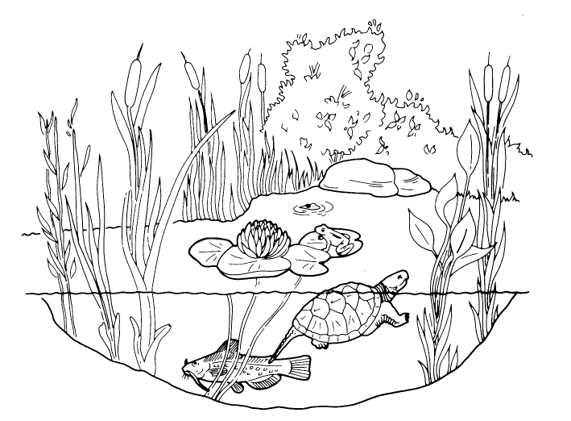
Draw a cross-section of a pond or lake on the blackboard or make a bulletin board as suggested. Ask the students to suggest some different kinds of animals and plants that might live there and where they might live. Be sure to draw in some plants near the shore and some animals in the water and on the bottom. (Do not introduce any terms yet. Let the students discover them in the key.)

Explain that animals and plants live in different places in aquatic environments, whether they are in the ocean you have drawn or a pond or river. Each kind of animal and plant has its own home. Distribute the Aquatic Homes flow chart or Key. Note that it starts with very broad divisions that get more precise with each level, so students must start at the left and go one step at a time, making a choice between two characters each time. It assumes that students can distinguish plants (which make their own food) from animals (which eat other organisms).

The clues to figure out where they live. Fill in the card number in the space at the end of the key. Trade cards until each has inhabited all of the different places one can find within aquatic habitats. If you are short of time, do several cards and stop.

Do the language arts worksheet for this exercise after working with the flow chart/key. This gives the students a chance to used some of the words from the key and apply them.

RESULTS:
Have your students name the different areas of the ocean that may be occupied by the different groups of plants and animals they keyed out. Have them list the vocabulary words such as benthic or sessile they learned which name the different places or aquatic homes

CONCLUSIONS:
Environments are divided into many places that are used by different types of animals and plants. Where an organism lives is determined by many things such as the available food sources, light, depth and bottom characteristics as well as the mobility, weight, age and size of the animals and plants themselves.

USING YOUR CLASSROOM AQUARIUM:
If you have several different kinds of animals and plants, the students can key them or make their own keys. Things to look for are: animals that stay near the bottom or clean the tank, such as catfish, Plecostomus and snails; fish that swim in the water column, such as goldfish, guppies and mollies; plants that float at the surface; plants that grow rooted to the bottom. If you have both small and large fish, find their preferred spots in relation to real or fake plants.

EXTENSIONS:
1. Included with the set of Identity Cards are short lists of typical animals or plants that have those identities. You can glue these to the reverse side of the Identity Cards. You may also send your students on a picture hunt. After they have finished their key, have them choose one identity and check the list to find some organisms that have this place for a home. Have your students research the plant or animal they choose
from the list.
2. Do you have a dictionary that gives the Greek or Latin roots for words? Have your students research other words that use the parts in the worksheet. Find out what words they were derived from and what they mean. Most names which sound obscure to use are just the common names from ancient times.

