ACTIVITY
17

A CHANGE IN THE WEATHER
PREDICTING SEASONAL CHANGES IN WATER ENVIRONMENTS
CONCEPTS:
- Seasonal changes take place in water habitats, many of which are related to temperature.
- These changes affect the plants and animals living in water environments, resulting in seasonal cycles in their life histories.
SCIENCE SKILLS:
- observing

SAMPLE OBJECTIVES:
- Students will be able to describe the seasonal changes that take place in a pond.

INTRODUCTION:
Physical factors which change with the seasons have imposed seasonal changes in the LIFE CYCLES of the plants and animals that live in water environments. While you may be fortunate enough to have a pond or a stream near your school that you can visit regularly, you may condense that whole year in the life of a water habitat by showing one of the excellent films available which focus on the changing seasons and their effect on the inhabitants of a body of water.

MATERIALS:
Film showing seasonal changes in a freshwater environment such as:
Still Waters, 59 minutes, 1978, WGBH-TV (excellent; may be available on videotape; was shown on NOVA)
Spring Comes to the Pond, 10 minutes, 1970, Coronet

LESSON PLAN:
BEFORE CLASS: Order the film. Your county school film library may have a different film than those listed here. The film Still Waters is beautifully filmed, but may be too advanced for younger children. If you use a long film, show parts of it on several days; perhaps by season on four days. If you choose a short film, you may be restricted to a discussion of two seasons.

DURING CLASS:
METHODS: Ask your students to observe carefully. Be able to describe the changes that take place in the yearly life of one plant or one animal that are caused by temperature changes in the water. They should be able to describe these changes in terms of what happens in each season. After the film, fill in the chart for the animal or plant.
Have the entire class share their observations with a large chart on the board. Compare the changes with the seasons for the animal and plants they picked.

RESULTS:
Seasonal changes which your students observe will vary, depending on which film you find.

CONCLUSIONS:
Animals and plants living in TEMPERATE regions do different things during different seasons of the year. They often have life cycles timed to suit the seasonal changes in their environment which range from freezing during winter to warm summer days.

USING YOUR CLASSROOM AQUARIUM:
Did you choose to stock your aquarium with freshwater tropical fish? This is a good opportunity to contrast temperate with tropical. Tropical climates generally do not fall below freezing temperatures during any part of the year. The plants and animals in tropical climates are not able to survive freezing temperatures. How did you make sure your aquarium remained tropical? With heaters.

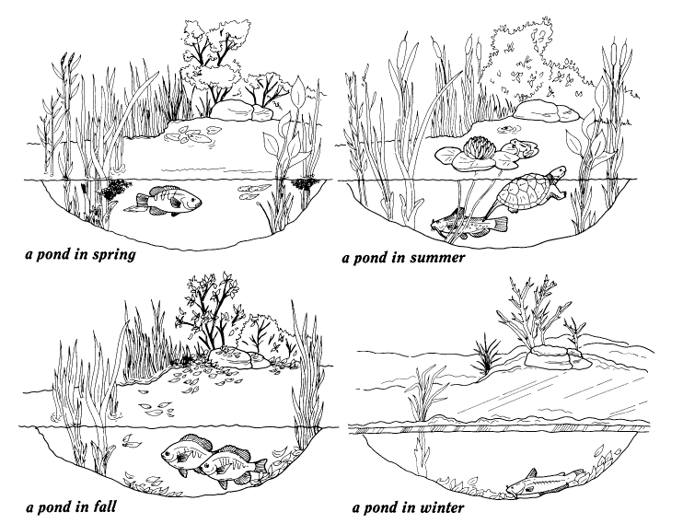
EXTENSIONS:
1. If there is a stream with quiet pools or a pond close to your school which can be visited on a weekly basis, start recording the temperature of the surface and bottom waters each week. If you have a water sampler, try recording surface and bottom oxygen as well. If you have a plankton net, take plankton samples each week and preserve them in alcohol in a baby food jar which is labeled with the week and location. Save these for your field study near the end of school. Remember water safety.
2. Have your students start a photo essay or video essay to document the change from one season to another.
3. Do you live in an area near the coast where herring run? If you do, you might be able to arrange a field trip to observe the run. Check with the Fisheries section of your state department of natural resources or contact your local nature center to find out if this is possible. The run usually takes place in very late winter to very early spring, depending on where you live.

