ACTIVITY
15

IN HOT WATER?
WHICH WEIGHS MORE: HOT OR COLD WATER?
CONCEPTS:
- Water is heaviest at temperatures near freezing. It weighs less when hot or when frozen.
- Water of different temperatures may form stratified systems.
SCIENCE SKILLS:
- observing
- measuring
- inferring.
- predicting
- experimenting
- communicating

MATH AND MECHANICAL SKILLS PRACTICED:
- measuring volume
- using a balance, spring scale or triple beam balance

SAMPLE OBJECTIVES:
- Students will be able to compare the relationship between water temperature and weight per unit volume (density).

INTRODUCTION:
This exercise examines the relationship of water temperature to weight per unit volume, or density. This relationship may have important consequences for aquatic habitats. Warm water floats above the cooler water without much mixing in the absence of wind, waves or tides. Under calm conditions a body of water may become layered or stratified with regard to the temperature of the water. The point at which the warm and cold water meet is called the THERMOCLINE. If you have gone swimming in a lake or pond, you may have experienced this sudden temperature change.

Animal distribution may be determined by the distribution of different temperatures of water. For instance, trout may concentrate in the lower water of a lake in the summer where it is cooler. Changes in water temperatures with the seasons may result in exchanges of surface and bottom water called TURNOVER that effect distribution of nutrients and dissolved gases.

MATERIALS:
For the class:
- hot tap water (120°F maximum)
- ice cubes
- cold water (from refrigerator or ice water)
- unbreakable thermometers
- several colors of food coloring
- simple balance, spring scales or triple beam balance
- volume measuring devices (measuring cups or unbreakable graduated cylinders)

For each group:
- four clear plastic cups
- a plastic spoon

LESSON PLAN:
BEFORE CLASS: Practice this experiment at home. If you do not lay the colored water into the uncolored water VERY gently, it will mix. If you are not able to do it, consider doing this as a demonstration and siphon the cold water under the warm water (as in Activity 4) to get two distinct layers. The key is to very gently rest the spoon with the colored water into the surface of the uncolored water and then rotate the spoon out from under it. There is no pouring. The spoon should just slide out from under the water.

Plan to do this experiment early in the morning if you do not have access to a refrigerator or ice chest. Bring ice cubes from home. If you do not have an ice chest, put them into watertight plastic bags and wrap in newspaper, which is a wonderful insulator. You need hot tap water somewhere at school. The temperature should not be high enough to burn students if spilled. Plastic half gallon milk jugs are good water containers.

DURING CLASS:
METHODS: Tell the class they are going to ask some questions about whether warm or cold water is heavier. What are some ways they could test this question? They might suggest weighing the same volumes of warm and cold water. Try this. What about warm and cold water? If one is heavier than the other, what would happen when warm water and cold water meet? Have they done an experiment like this before? How did they address this kind of question with salinity? Some may predict cold water is lighter because ice floats.

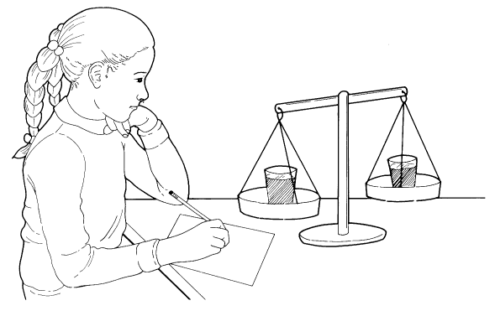
To compare weights, exactly the same volume is needed. If the students do not use the exact same amount of water in each cup, it will not be a fair test. Fill one cup with very hot water (but NOT hot enough to burn a child's skin) and another with refrigerated (cold) water. Measure the water carefully before adding it to each cup. Either measure them separately if you have a spring scale or triple beam balance or put each on one of the two pans of a simple balance. The cold water should be heavier if they used a large sample and if they got the exact same amount of water in each cup. This is hard for children to do accurately, so you should get different results from groups. How can they do this another way?

Stop and discuss the results. What happened when they layered salt and fresh water? What would happen if cold and warm water meet in a natural habitat? What would they predict? Would one float on the other? Would they mix? Here is a way to test this. Each group needs two cups of ice water and two of hot water. Add the same color of food coloring to one of the hot and one of the cold water cups. With a plastic spoon very carefully lay a sample of the cold colored water on the surface of the hot clear water cup. What happens? Try the reverse, hot colored water on the surface of the cold clear water cup. What happens? For controls, try the colored water with water of the same temperature. Layering is so precise that it will give good results even when you cannot measure the difference with a scale.

RESULTS:
Cold water (down to 4°C) is more dense and should sink when added to the hot water. The hot water should float on the surface of the cold water because it is lighter.

CONCLUSIONS:
Warm water is lighter (less dense) than cold water. When warm and cold water come together and are not stirred, the warm water floats on the cold water. This stratification means that one body of water has two totally different kinds of places for animals to live in terms of temperature. Lack of mixing can also cause an unequal distribution of things in solution in the water such as oxygen, which diffuses in at the surface or comes from plants at the surface, and nutrients, which are released near the bottom as bacteria decompose dead plants and animals. Stirring mixes the water. What would "stir" water in a real habitat? Wind, which also causes waves, currents, tides or running water, would mix warm and cold layers.

USING YOU CLASSROOM AQUARIUM:
Looking for a quick way to demonstrate the principles of this lab? Fill a small balloon with very cold water (stick a water balloon in the refrigerator) and drop it into the aquarium. Does it sink or float? What happens as it warms up?

EXTENSIONS:
1. What happens when a pond or lake freezes? Does it freeze from the bottom up? Where does the ice form? If you have a refrigerator in your classroom, you might investigate this question at school. Perhaps a better technique would be to have one or several students check this question at home.

The students will need a model pond that is realistic. Ponds are surrounded by dirt which is an excellent insulator. A thin-walled plastic cup will not be a good modeling pond. Put several Styrofoam coffee cups inside one another for insulation. Fill with cold water and place in the freezer. Check it every 15 min. Where does the ice form first? Record when the ice forms and where. If a pond works in the same way, where does the ice form first? Do not try to freeze the whole thing solid as it might break.
2. To demonstrate why ice floats, fill a clear plastic cup with cold water. Mark a line at the top of the water with a marker. Freeze the water and compare with the line. The water expands. If the same amount of water takes up more space, then it must be less dense than it was. Ice floats because water expands as it freezes. The water molecules get farther apart. For this reason water freezing in a crack can break a rock or concrete.
3. Water temperature has implications for the mixing or lack of mixing of human sewage from outfalls. If the waste has a temperature different from the receiving body of water, it will not mix unless there are winds or currents. Many times the engineers assume that waste products will be diluted enough that it is not harmful. Often this does not happen because of temperature differences.

The combined effect of warm, freshwater sewage entering cold salt water is that the sewage floats to the surface. This can be demonstrated. A cup of cold salt water is the ocean. Fill a straw with hot colored fresh water, the waste water. Lower the straw tip to the bottom of the cup and slowly release the water. The warm colored water does not mix, but comes to the surface. Do the waste products get diluted? No, they form a dangerous cloud floating in clean water.

