ACTIVITY
14

WHEN THE OXYGEN IS GONE
HOW DO ANIMALS RESPOND TO LOW OXYGEN ENVIRONMENTS?
CONCEPTS:
- Two possible animal responses to low oxygen environments are:
- increased movement of water over the gills and moving to higher oxygen habitat.
- Animals experiencing low oxygen may be under stress.
SCIENCE SKILLS:
- measuring
- organizing
- inferring
- experimenting
- communicating

MATH AND MECHANICAL SKILLS PRACTICED:
- averaging numbers

SAMPLE OBJECTIVES:
- Students will be able to list ways animals respond to low oxygen environments.

INTRODUCTION:
This activity demonstrates the responses of fish to exposure to low oxygen levels. It does not take long as the fish behave in obvious ways which are expressed promptly: they do not like doing without oxygen. Use fish from your aquarium if they are the correct kinds. Guppies and goldfish will not be hurt by this experiment if returned promptly to their aquarium home.

MATERIALS:
For each group:
- 2 small (1 inch) guppies or goldfish (do not substitute other kinds of fish)
- 1 quart tap water briefly boiled and sealed in a wide mouth jar with no air space at the top; should be at room temperature
- 1 quart of aged tap water unsealed
- watch or clock that has seconds

LESSON PLAN:
BEFORE CLASS: Make the boiled water at home. It should be at room temperature when used. Do not substitute fish species. Do not use bigger fish.

DURING CLASS:
METHODS: Most aquatic animals get oxygen from the water with GILLS. What would the students do if they were an aquatic animal that gets oxygen from their water environment and, suddenly, there was not enough? How might they test this question? One obvious way is to compare aquatic animals in low and normal oxygen environments and see what differences in behavior can be observed. How do we make water that is low in oxygen? Remember what they learned about water temperature and dissolved oxygen? Water that is heated has little dissolved oxygen so use boiled water that has been sealed in canning jars. Here are two tests they might do. With younger children, do only the second part. Students must NOT tease or otherwise disturb the fish. If they do, the experiment will be invalid and the fish will suffer. They must be quiet and never tap on the jar or otherwise disturb the fish.

1. Fill a jar with regular room temperature aged tap water and carefully place a fish in it. After 15 seconds record the number of times it opens and closes its gill covers (opercula) and/or mouth in a 15 second period. This is a way to measure how much water it is passing over its gills. Remove the fish and place it in a newly opened jar of room temperature boiled water. Watch it closely. Wait 15 seconds and then count the number of times in 15 seconds that the fish opens its gill covers and record the results. If there is time, repeat this with a second fish. Do not leave the fish in the water lacking oxygen for more than 3 minutes. Note that the goldfish may exhibit an alternative strategy to increasing its rate of moving water over its gills (ventilation rate).

OR

2. Compare the behaviors of fish placed in water with dissolved oxygen and oxygen depleted water. Put them in at the same time and put the jars side-by-side to compare. Do they show the same responses? Where do they go in the jar? Is one more calm than the other? The fish without oxygen goes to the surface, gulping air. Remove it promptly to oxygenated water.

Convert the gill ventilation counts to number per minute by multiplying by 4.

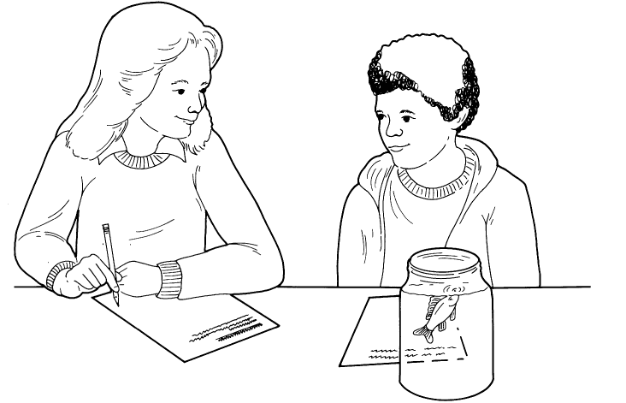

RESULTS:
Fish in low oxygen move water over their gills more rapidly than those in oxygenated water. If the water is very low in oxygen, the only response you may see is the oxygen deprived fish going to the surface and gulping. Goldfish can get oxygen from the air if their gills are wet. Goldfish are well adapted to life in low oxygen habitats.

CONCLUSIONS:
In these experiments you have looked at two ways animals respond to water which is low in oxygen. One way is to increase the rate at which water moves over the gills. If you have ever watched a crab or shrimp in a small container, you may have noticed increased movement of the water across its gills. This reflects increased ventilation, just as the fish increased movement of water by "swallowing" faster.

A second tactic is to move to an area of the water that has a higher oxygen concentration. Both responses use energy. Animals that can migrate within an environment are relatively lucky. Can your students name some animals that cannot move to an area with higher oxygen? Any aquatic animal that is sessile, that grows attached to a surface, cannot move. Oysters, barnacles, mussels, worms that live in tubes...these are just a few. If they cannot move, they may die during periods of unusually low dissolved oxygen.

USING YOUR CLASSROOM AQUARIUM:
These fish can go in your aquarium. You can use fish from the aquarium with no ill effects if you use goldfish.

EXTENSIONS:
1. Can you identify a local problem caused by low oxygen? Have your students research this question by writing or calling one or more local organizations responsible for water quality. Try county government or a local conservation organization. You may already be aware of such a problem. Once a problem is identified, have your students try to find out when it occurred, the magnitude of the problem, the possible causes and any responses that were made. Common problems are related to cooling of power plants and the releasing of water with a high oxygen demand from sewage plants during warm weather. The point is to follow the process of the discovery of a problem and the responses to it.

