ACTIVITY
11

PLANTS USE OXYGEN?
DO THE PLANTS AND ANIMALS THAT LIVE IN WATER USE OXYGEN?
CONCEPTS:
- Animals and plants that live in water oxygen from the water.
- Oxygen is used in a process called respiration.
SCIENCE SKILLS:
- measuring
- organizing
- inferring
- predicting
- experimenting

MATH AND MECHANICAL SKILLS PRACTICED:
- use of dissolved oxygen test kit
- averaging results
- weighing
- calculating rates

SAMPLE OBJECTIVES:
- Students will be able to give experimental evidence that plants and animals use oxygen.

INTRODUCTION:
This activity proves that both plants and animals use oxygen. Most people forget that plants constantly use oxygen in RESPIRATION because they think only about the daytime when plants are doing enough PHOTOSYNTHESIS that they produce more oxygen than they use. Plants do respiration all the time, not just at night, but have to be tested in the dark to remove the complication of photosynthesis.

This exercise will work fine with plants alone. Animals may also be used. Those in your classroom aquarium are ideal. It is most interesting when several kinds of animals are compared. At least two groups should do each experiment to be able to check for consistent results.

This activity begins one day and is completed on the following day. The materials used in this exercise are the same as Activity 12 and the two may be done at the same time, although results should be interpreted separately.
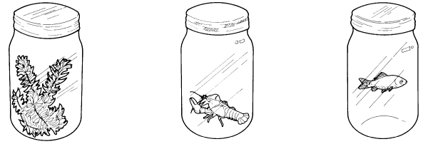

MATERIALS:
For each group of students:
- two quart or pint glass jars with wide screw tops; must all be the same size to compare results
- one big bunch of freshwater plants (Elodea, which is also called Anacharis, is the kind most commonly available from biological supply houses and pet shops); need six 6 inch strands per quart
- aged tap water at room temperature
- brown paper grocery bag or dark place

Shared by class:
- dissolved oxygen test kits
- turkey baster or large syringe (see Recipes)

Optional for each group:
- 1 quart glass jar with top
- 1 guppy or goldfish less than 1 inch long or 1-2 dozen freshwater snails or a small crayfish (from pet shop, biological supply house or bait store)
- 250 gm spring scale or triple beam balance
- mineral or cooking oil
- 2-3 ft. aquarium tubing for siphon

INFORMATION:
Plants and animals both use oxygen in a process called RESPIRATION which takes place in the cells of organisms. Respiration is not breathing in and out; it is a cellular process. Like all cellular processes, the rate at which respiration happens is dependent on temperature so be careful that the temperature is the same for all the test containers. Use room temperature.

LESSON PLAN:
BEFORE THE CLASS:
Set out jars with water to age two days ahead of time. Read through the lesson and decide what and how much will be used. Students will set the plant experiment up one day and finish it the next. The plant experiment can be completed in one class period. The animal experiment runs longer than one 45 minute class. If you have the same students all day, it can be completed by one group. Otherwise, start it in one class and finish it in others.

DURING THE CLASS:
METHODS (PLANTS): Do plants use oxygen? Many students will answer no. Do not tell them they are wrong. Ask them to design an experiment that will test this question. Show them the jars and plants. They already know how to use the dissolved oxygen test kits.

Here is one way to test this question: test the dissolved oxygen in a jar that has been standing open. Refill to the brim with aged tap water, place a lid on the jar and label it as the control. Since all the jars have been treated in the same way, you may assume the dissolved oxygen is the same in all. To the second jar, add the bunch of Elodea. Use about 6 strands 6 inches long per quart, or half that amount per pint. Each jar should be full to the top. Screw the caps on tightly.

Place both jars in a dark location at room temperature (around 70-75° F or 25° C) overnight. The plants must not be in the light. Put them in a cupboard, closet, or grocery bag. If you do this in winter and your school turns the heat way down at night, you might not get very good results as cold temperatures slow the chemical reactions of respiration.

Ask the class to predict which jar will have the most oxygen. The least. Do they have reasons for their predictions? The next day test the water from each of the jars using dissolved oxygen test kits.

RESULTS:
Did the results match the predictions? Since all the jars were treated the same before the plants were added, they should have started with the same dissolved oxygen levels. If you want to be sure of this, you could have tested them before the plants were added. You should find that the jars with nothing (controls) have the most oxygen and that the levels are lower in the jars with plants. Four jars averaged 0.8 ppm after sitting overnight in an experiment done by children at the Aquarium.

METHODS (ANIMALS):
During the second day of class use the third jar to test animal use of oxygen. Make sure that you handle the animals very carefully and do not use more of them or different kinds that are recommended. Fish may be transferred in an aquarium net or small plastic bags with water. Do not handle the animals.

Since this jar has been sitting open, you may assume the same starting dissolved oxygen as for the control the previous day. Gently place the animal(s) in the jar. Do not use large animals. A small crayfish or fish should have a quart jar. Seal the jar and let it sit quietly for about one hour. Do not leave it where students are moving and do not let them tap on it or bother the animal.

After one hour test for dissolved oxygen. IF THE OXYGEN IS BELOW 4 PPM, STOP AT THIS POINT. A 20 gm crayfish in a one-quart jar at room temperature will use enough oxygen to hit 4 ppm in one hour. Snails or small fish will not. If you want to continue the experiment, pour about 1/4 inch of oil on the surface of the water to seal it. You cannot just put the lid back on, as there will be an air space. Take subsequent samples by putting your syringe or turkey baster below the oil. Siphon or pour off the oil before removing the animal when you are done.

RESULTS:
Animals also use oxygen. If you want to compare oxygen use among different species, including plants, you may do so on a weight basis. It is not entirely fair since weight does not take into account the inorganic fraction such as the exoskeleton of the crayfish. You are not about to do what an ecologist would do: cook the animals to inorganic ash to obtain ash free dry weights. Shake the plants, snails or crayfish to remove excess water before weighing. Weigh fish in a small bag of water and then weigh the water alone after straining the fish into a net and returning it to its aquarium.

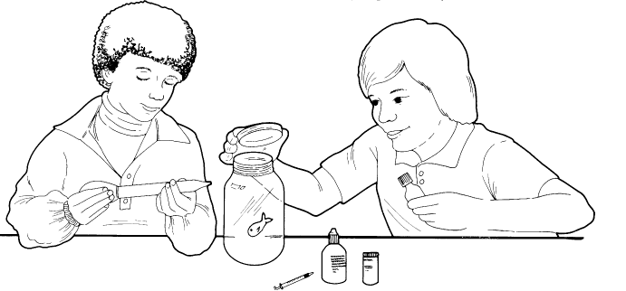

CONCLUSIONS:
What Students who have had lessons on photosynthesis may insist that plants make oxygen, not use it. This experiment should prove that both plants and animals do respiration and use oxygen from the water in which they live. Do the students think it is important to have good, high levels of dissolved oxygen for animal and plant health? Yes! Without oxygen, the plants and animals will die just as the students would die if deprived of oxygen, which is why we were careful to keep the animals above 4 ppm dissolved oxygen.

USING YOUR CLASSROOM AQUARIUM:
The plants and animals in this experiment come from a freshwater aquarium. With careful handling, they will go right back after the experience. Siphon the oil off the surface of the animals' jars before removing them. Following this exercise, discuss the means you use to make sure the oxygen levels remain high in your aquarium.

If you have a large number of plants in your aquarium, test the dissolved oxygen first thing and compare it with later in the day after the plants have started doing photosynthesis as well as respiration. It should be lower early in the morning since both the plants and animals were using oxygen all night. Discuss what might happen if the electricity went off during the night.

EXTENSIONS:
1. If you take a field trip to a pond with plants, follow the level of dissolved oxygen over a 24-hr period. You should see it go down at night and up in the day when plants are adding more oxygen than they use.

