ACTIVITY
8

DIRTY WATER
WHAT HAPPENS WHEN SOIL WASHES FROM THE LAND AND ENTERS AQUATIC HABITATS?
CONCEPTS:
- Plant nutrients from soil dissolve in water.
- Plant nutrients increase the growth of algae in aquatic habitats.
SCIENCE SKILLS:
- observing
- inferring
- experimenting.
- communicating

MATH AND MECHANICAL SKILLS PRACTICED:
- use of a camera

SAMPLE OBJECTIVES:
- Students will be able to compare the results of soil erosion and nutrient enrichment on aquatic systems.
- Students will be able to describe the effects of soil erosion on aquatic habitats.

INTRODUCTION:
This activity will take several weeks to complete. Model "ponds" in clear jars reveal what happens when soil ERODES from land and washes into an aquatic habitat. The NUTRIENTS from the soil over-fertilize the pond, causing abnormal growth of ALGAE. Data collection is difficult due to subjective evaluation. The use of a camera to record changes simplifies this problem. To be scientifically correct, each test should be done twice to insure that the results can be repeated. If possible, double the materials and do two replicates of each treatment group.

MATERIALS:
For each group:
- five clear containers one quart or more (plastic soft drink bottles or canning jars)
- water with algae from a freshwater classroom aquarium or a pond; may also be purchased pond water from a biological supply company
- real dirt from a yard or flower bed or garden (not potting soil)
- cloth to filter soil from water; old sheeting is okay
- plant fertilizer such as Rapid-Gro, Peters or other well-balanced mix (some have green dye that goes away when exposed to light)
- aged tap water
- good light source, either indirect sun light or strong artifical light
- camera and roll of 12 exposure print film (35mm or Polaroid best)

LESSON PLAN:
BEFORE CLASS: After reading this exercise, consider starting this exercise and Activity 9 at the same time if you have sufficient containers. Otherwise, start Activity 9 after completing this one if the same containers must be used again.

Do these preparations before class. Mix two cups of soil with a quart of water and shake vigorously. Let the mix sit until the dirt settles and then strain the water through cloth into another container. Wash the dirt out of the jar outside so that it does not clog your sink. Collect the algae-pond water sample or order a sample. In northern climates you will have trouble finding good natural samples during cold months.

DURING CLASS:
METHODS: Ask if the students have ever seen a creek, pond or river after a very hard rain. Is the water a different color? Why? The rain running over the surface of the soil has picked up soil particles and carried them into the water. Can the students identify human activities that increase this process called EROSION? Housing developments, newly logged forests, plowed fields, and tire tracks from recreational vehicles all destroy vegetation and leave soil vulnerable to erosion. Plants help hold the soil in place.

What is the immediate effect of erosion? Have students help you with these preparations. Add soil to water in one of the jars and shake. The water becomes TURBID as the soil particles become suspended. What are the short term consequences of soil erosion? Would animals and plants be affected by sediment in the water? Plants would have light blocked. Animals might have their gills clogged. Put this jar aside for future observation.

What does the soil do to the bodies of water it enters? How would we do a test to find out? Label the remaining four jars tap water (your control), 1 tsp fertilizer, 1 tbs fertilizer and soil. Fill three jars with aged tap water and the fourth (soil) with the water you prepared at home plus aged tap water to fill. (Explain that this water was prepared in the same manner as the shaken soil and water demonstration.) Add the correct amount of plant fertilizer to two jars. Now add aquarium water with algae or pond water with algae to each jar. Use equal amounts up to one cup in each. Why did one jar just get tap water? It is the CONTROL against which the other jars are measured. The control gets no treatment and differs by just one VARIABLE from each of the tests. Set all four jars where there is good light. Do not place them in a location that gets very cold. Observe them over the next several weeks to a month, recording changes two to three times each week by photographing the jars side-by-side in good light from close-up. Write the date on a piece of paper that shows in the photograph and make sure the labels show. Keep the plants in the same place in each picture.

What does the soil do to the bodies of water it enters? How would we do a test to find out? Label the remaining four jars tap water (your control), 1 tsp fertilizer, 1 tbs fertilizer and soil. Fill three jars with aged tap water and the fourth (soil) with the water you prepared at home plus aged tap water to fill. (Explain that this water was prepared in the same manner as the shaken soil and water demonstration.) Add the correct amount of plant fertilizer to two jars. Now add aquarium water with algae or pond water with algae to each jar. Use equal amounts up to one cup in each. Why did one jar just get tap water? It is the CONTROL against which the other jars are measured. The control gets no treatment and differs by just one VARIABLE from each of the tests. Set all four jars where there is good light. Do not place them in a location that gets very cold. Observe them over the next several weeks to a month, recording changes two to three times each week by photographing the jars side-by-side in good light from close-up. Write the date on a piece of paper that shows in the photograph and make sure the labels show. Keep the plants in the same place in each picture.

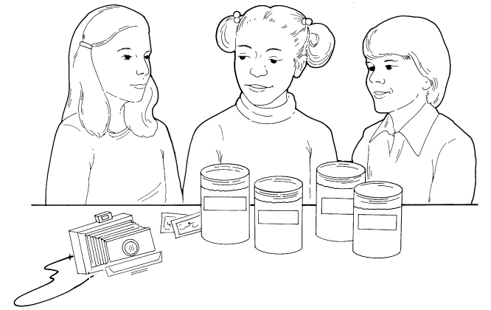

RESULTS:
What happened? The exact results will vary depending on your algal source and growing conditions. Arrange the photographs in order. Over the weeks, the jars with soil water and fertilizer should show a much more luxurious growth of algae than the plain tap water. Why? Plant growth was facilitated by something that stayed in the water as the soil particles settled out: PLANT NUTRIENTS which DISSOLVED in the water. Plant nutrients are chemicals that are in SOLUTION in the water. Was there a difference in the amount of growth with the two dosages of fertilizer? Compare all with the control.

You may be surprised at the amount of growth in the control. Many water supplies are polluted with fertilizer or plant nutrients from farms, golf courses, manure, human sewage and other sources.

CONCLUSIONS:
Soil erosion can cause serious problems in aquatic environments. What are some long term results that you observed? The plant growth in the container with soil was greater. It should have resembled that of the fertilized water. A little plant growth is good. Plant nutrients in natural systems come from the surrounding land. Too much plant growth can cause serious problems, however. Under over-fertilized conditions, the kinds of algae that grow may change to undesirable toxic or foul-smelling species. Also, when the algae die, the bacteria and fungi that feed on them may use up much of the oxygen in the system during decomposition.

USING YOUR CLASSROOM AQUARIUM:
Compare your classroom aquarium with these small environments. How are they the same? Different? Where do the nutrients that support algal growth on the walls of your aquarium come from? The waste products from fish urine and feces. Think about what is used as fertilizer in organic gardens. Animal manure. Where did the animals get the nutrients in the wastes. From the food they ate which directly or indirectly came from plants. Nutrients CYCLE between plants and animals.

EXTENSIONS:
1. If you have a nitrate test kit (LaMotte kit #3354 is good and uses zinc which is safer), measure the actual amount of nitrate in each jar. You could even adjust the levels so that the dirt and fertilizer amounts in the lower fertilizer sample were the same.
2. Demonstrate erosion. Have each group make two paper "sails" about 3 inches square on pencils with the points down. Go out to the playground and put one in the bare dirt and one in the grass. Water each vigorously with a watering can. Check to see which sail gets dirty. Rain drops cause the dirt particles to splash and run away with the rain on bare dirt whereas grass holds the soil and helps the water to sink in.
3. Study the label of the plant fertilizer container to discover what some plant nutrients are. Students should find compounds containing nitrogen, phosphate and potassium, three primary plant nutrients. Many brands have a number of other chemicals as well.
4. Can you identify a problem with soil erosion in your area that affects aquatic environments? If you cannot, you might call your local soil conservation district and ask about a local problem that your class might study. Sediment from farms and development contributes to the problems of the Chesapeake Bay. Erosion from logging smothers fish eggs in Pacific Northwest streams. Midwest farms are losing soil at an alarming rate.
5. Conserving Soil is an excellent book with classroom activities ready for duplication. To inquire about getting a copy, contact:
National Association of Conservation Districts
P.O. Box 8855
League City, TX 77573.
It was first published by the U.S. Department of Agriculture, which cares because soil that stays on farms keeps the farms fertile.

